■ Listening ☐ Speaking ☐ Reading ☐ Grammar ☐ Writing

Topic: Talking about people

Instructor:  EUN SUN YANG | Level:  Intermediate | Students:  10 | Length:  50 Minutes

Materials:
- Photo of celebrities
- Character Traits sheet
- Worksheet: Complete the chart
- Question Sheet
- Recording

Aims:
- To recognize various adjectives that describe personalities by brainstorming and going over the Character Traits sheet word by word
- To identify personality adjectives and their meaning from real-life speaking (Rebecca’s recording) by completing the chart on worksheet
- To comprehend the details of someone describing themselves and their family by answering the Question Sheet
- To practice describing personalities of themselves and/or people that they know by making up their own sentences and discussing them with partners
- To understand the function and grammar of “Wish + simple past” sentence and to apply it to their own situation by practicing making up their own sentences using that sturcture.

Language Skills:
- Reading: Question Sheet
- Listening: Rebecca describing various members of her family
- Speaking: Discussion of answers to the Question Sheet, talk about personalities of people they know and themselves together with reasons for such personalities
- Writing: Writing I wish I was… / I wish I wasn’t so…sentences about themselves

Language Systems:
- Vocabulary: adjectives describing people’s personalities
- Grammar: Wish + simple past
- Function: describing personalities of themselves and people that they know

Assumptions:
- Students have been taking the teacher’s class (not the first class).
- Students are the upper grade elementary school students.
- Students themselves have been in class together (not awkward in working in pairs).

Anticipated Errors and Solutions:
- Students may not know the words coming from the recording. (not on the Character Traits sheet)
After main activity, ensure students’ understanding of the words from the recording. If there are the word that they are not clear, then try to explain to them by using visual aids (i.e. picture).
- Students may have adjectives that they would like to express, but not on the Character Traits sheet, during free production.
Monitor activities of students aside and support them when they need.
- If time is short
Reduce the time for post-activity by controlling the time allocated for discussion in pairs.

References:
https://www.google.co.kr/search?q=personality+adjectives+argumentative&source=lnms&tbm=isch&sa=X&ved=0ahUKEwj1pIXZ_o3UAhWFGZQKHSCpAL0Q_AUIBigB&biw=1366&bih=613#imgrc=ZZ1AAwGMh6eitM:
Listening Skills section from Onestopenglish, www.onestopenglish.com

Lead-In
Materials: Photo of Psy, Photo of Yoo Jae-Suk
Time | Set Up | Student Activity | Teacher Talk
3 min. | Whole Class | Warm-up | Hi, everyone.  (Show the pictures of celebrities to students.)  Do you know who they are?  How would you describe them based on what you’ve seen from TV?  (Expected answers are;  Psy: funny, energetic, enthusiastic, etc.  Yoo Jae-Suk: considerate, friendly, gentle, etc.)  These are adjectives that describe people’s personalities, and personalities are characters of people that are revealed in a particular pattern of behavior.  Today, we will learn how we can describe people’s different personalities.

Pre-Activity
Materials: Board, Character traits sheet
Time | Set Up | Student Activity | Teacher Talk
10 min.  2 min. | Groups  Whole Class  Whole  Class | Brainstorm | Vocabulary  Instruction  In your groups, please try to think of and to list as many adjectives as you can that describe personality.  Write annoying on the board as an example.  (Give 3 minutes to think of as many personal adjectives as they can.)  CCQ  Are you allowed to work with your partner?  How much time do you have?  How many personal adjectives do we have to think of?  Each group in turn, please call out one adjective to me.  (Write all the adjectives called out on the board.)  Read out each of them one by one and let students speak after.  Ask students to tell a plus sign (+) next to the positive adjectives and a minus sign (-) next to the negative adjectives.  (Mark it on the board.)  (Hand out Character Traits sheet to each student.)  This is a list of some adjectives that describe personal characters. Some are what we’ve just already talked about, and some are not.  If you have any adjective of which you do not know the meanings, please ask.  (Answer students’ questions.)

Main Activity
Materials: Worksheet: Complete the chart, Question Sheet
Time | Set Up | Student Activity | Teacher Talk
4 min.  10 min.  4 min. | Whole Class  Pairs  Whole Class  Whole Class | Listening | Listening for specific information  Instructions  Now, you are going to hear a young woman called Rebecca describing various members of her family, as well as herself.  First, just listen to it without doing anything.  CCQ  What is the name of a young woman who will describe her family and herself?  Are you supposed to do something while listening?  (Distribute the chart from Worksheet.)  Please take a look at the chart. Now, you will listen to Rebecca’s talking again and this time complete the missing information on Worksheet.  CCQ  What are you supposed to do on Worksheet?  (Play the recording.)  Do you need to listen again?  - Yes Play the recording again.  - No Continue.  Okay, let’s check the answers.  (Check the answers as a whole class.)  Listening for details.  Instructions  (Give each student a copy of the Question Sheet. Put students into pairs.)  Now, based on what you have listened to, please complete the answers on the Question Sheet. Discuss and share your ideas with your partner.  You will have 10 min. for this.  CCQ  Who are you working with?  How much time do you have?  Are you allowed to discuss with your partner after you complete?  Now, you will listen to the recording again. Please complete any remaining answers, if you have not done.  Okay, let’s check the answers.  (Check the answers as a whole class.)  Grammar: Learning I wish I was… / I wish I wasn’t so…sentences  Instructions  (Write I wish I was… on the board.)  Is anyone familiar with this type of sentence structure?  Wish with the simple past as you can see from this sentence is for things that you would like to change at the present time.  (Write the sentence I wish I had a $1 million! as an example.)  What this sentence means is that I don’t have $1 million, but I would like to have it!  Now, I will play the recording again. While listening to it, please pay your attention to note 2 sentences Rebecca says using this construction and write them down.  (Play the recording.)  Have you noticed those 2 sentences?  What were they?  (Students answer.)

Post Activity
Materials: Board
Time | Set Up | Student Activity | Teacher Talk
15 min.  2 min. | Individually  Pairs | Speaking | Free Production  Please come up with 3 people you know well, either family or friends, and make a list of two personality adjectives to describe each person. Please try to think of one positive adjective and one negative adjective for each person.  Also, do not forget to add a reason for your choice of adjectives.  I will give you an example.  (Write an example on the board.)  James (my brother)  Amusing (+) – he loves to tell jokes.  Selfish (-) – he never thinks of anyone but himself  Please start.  CCQ  What are you supposed to think of?  Are they all positive or negative adjectives?  Do you also provide your reason?  (Students complete.)  Now, please talk with your partner about what you have on your list.  In addition to that, please talk each other what they would like to be different about each person.  (Refer to an example on the board.)  Let’s have a look at this example.  He’s amusing because he loves to tell jokes. I think he’s selfish, though, because he never thinks of anyone but himself. I wish he wasn’t so selfish.  CCQ  What are you supposed to talk with your partner?  (Students work.)  Now, think about yourself and try to list 3 adjectives that describe your personality together with reasons why you think those adjectives apply to you.  (Students work on the list about themselves.)  Then, please talk with your partner and exchange your ideas. Try to tell your partner whether or not you agree with the adjectives that they chose.  CCQ  About who do you describe?  How many adjectives do you have to think of?  Conclude lesson  Elicit today’s vocabulary (personality adjectives) for students.  See you tomorrow!

SOS Activity
Materials:
Time | Set Up | Student Activity | Teacher Talk
 | Individually or Pairs (depends on remaining time) | Writing | (Write I wish I was more… / I wish I wasn’t so… on the board.)  Using this sentence structure, make your own sentences about yourself.  If time allows, exchange opinions with your partner.

Attachment #1: Photo of celebrities

Attachment #2: Character Traits

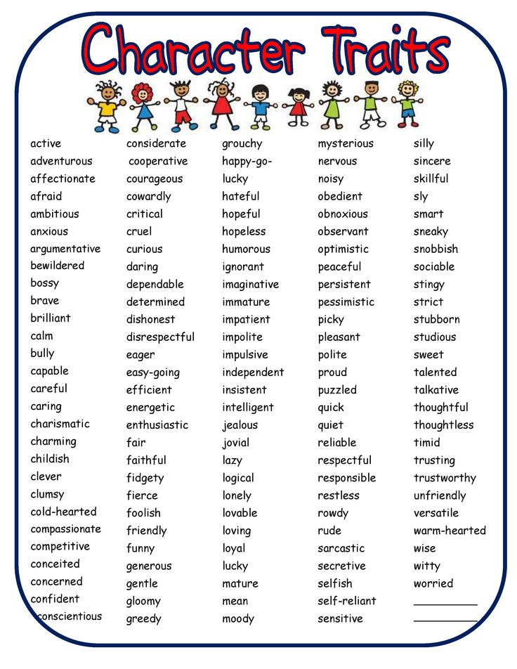
Attachment #3: Recording script

Rebecca : Well, there are four people in my family. There’s me: my name’s Rebecca… and I have a brother, Brad. My mom’s name is Judy and my dad is Bill. We’re all very different. My mom is always sympathetic when we’re upset or worried about things: we always talk to her when we have problems. She’s also very even-tempered. She never gets mad or annoyed. I wish I was like her! My dad, well, he’s really sociable. He has lots of friends, and he loves to meet people. I get really embarrassed, because he always talks to people in the street! But he’s really annoying sometimes, no one can stop him! My brother Brad … well, he’s really bossy. He always tries to tell me what to do. He’s also very argumentative. We have arguments every day. I wish he was a little more easygoing. As for me, well, my friends say I’m really generous, because I like to give presents and help people. But I am a little moody: sometime I get really annoyed and upset about things. So that’s my family.

Attachment #4: Worksheet

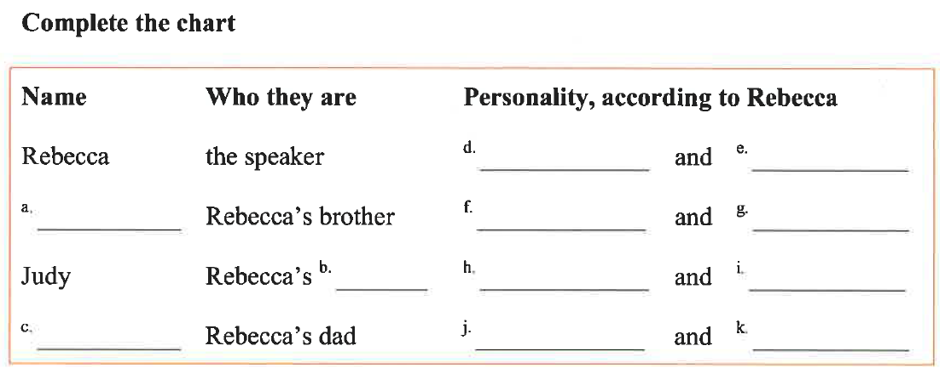

Attachment #5: Question Sheet

