What Makes a Supercar a Supercar?
By Tony Markovich
Assistant Editor. Mizzou Journalism. Indiana. Hip-Hop. Ice cream. Cars. Bulls/Packers/Hawks/Cubs.
Follow Tony on Twitter, Instagram, and Google+
Jun 09, 2014
- Share
- Tweet
<div class='no-js-nav clearfix'><a class='no-js-nav__next-page' href=http://www.complex.com/sports/2014/06/what-is-definition-of-supercar/jeff-glucker alt=Next Slide>Next Slide</a></div>
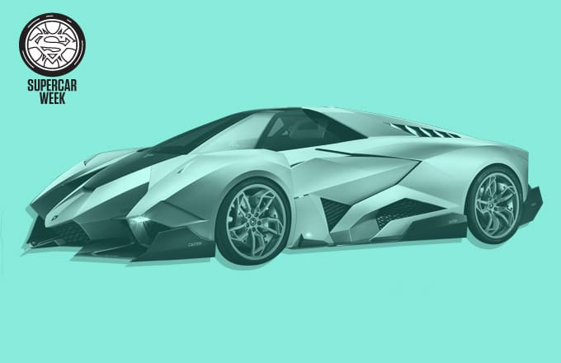
Image via Lamborghini / Art by Danny Scanzoni
What is a supercar? It's a term these days that's so casually used it seems that nobody really knows what the true meaning is anymore. There aren't just a few brands making insanely high-performance, high-design vehicles anymore. There are cars coming out of places you rarely hear about, like Dubai (W Motors) or Croation (Rimac). And with the rise of car blogging, where anybody can say anything on the Internet, it seems that so many cars these days are catching the tag "supercar" that don't really deserve it.
So what really makes a supercar a supercar? We turned to the opinions of people we know, respect, and trust in the auto industry, whether that be writers, editors, photographers, racecar drivers, or videographers, to find the answer. To get the conversation going, we prompted them with these questions:
- How would you classify something being a supercar? How would you define a car as being "super?"
- Or what about a hypercar—where is that line?
- How do you think the term is overused/misused?
- Are there any cars that are widely considered supercars that you don'tactually think are supercars? If so, how do you determine that?
- Do you think that older supercars that have stats that aren't really impressive now should still be called supercars?
Some responded with a simple but effective paragraph, others responded by directly answering each question, and several responded with mini essays, describing exactly how this word has been shaped. See what they all had to say ahead.
[What Makes a Supercar a Supercar? is the first article of Complex Rides' "Supercar Week," seven days of nothing but features and coverage about everything supercar. Stay locked for a new feature everyday detailing the corners of the supercar world, including interviews, essays, and best-of lists.]

Jeff Glucker
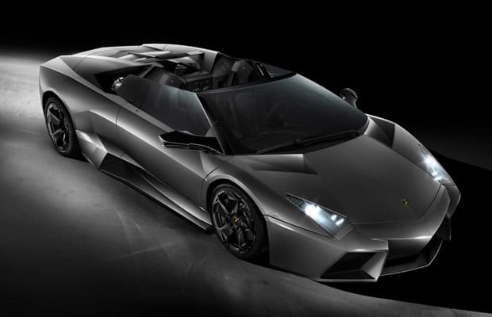
Image via Lamborghini
Professional Title: Owner/Executive Editor/Business Development Manager, Hooniverse
Twitter: @JGlucker
Website: hooniverse.com
The term supercar has gotten tricky in the last few decades. When I was growing up, I remember seeing posters of cars like the Lamborghini Countach, Porsche 959, and Ferrari F40. Those were the first supercars my brain remembers, and they fit the bill perfectly. The outrageous performance was backed up by styling that appeared to come not from this planet. On top of all of that, the noise was otherworldly.
Today it seems people are quick to apply the supercar moniker to a wide range of cars. The Nissan GT-R is not a supercar. Instead, it's a pretty amazing machine that can do tremendous things, yet I don't think it will inspire a generation of future gearheads. I say that as a tremendous GT-R fan, mind you.
A car can't simply be exotic either, to warrant the supercar title. A Ferrari California is no supercar, but the LaFerrari certainly should be considered one. Likewise, a Lamborghini Huaracan is an exciting exotic... but a car like the Reventon is a supercar.
Supercars are mystic creatures that stalk empty backroads where they can't be bothered by lesser machines. They inhabit our hearts, our minds... and the posters of the walls belonging to our younger selves.
I don't necessarily think we need the term hypercar. What we should be doing is reducing the amount of vehicles that we call super, and there will be no need for the word hyper... unless someone makes the first street car that can break 300 miles per hour, then we need to reevaluate things.
As for the original (to me) supercars, I think they still hold a special place in the hearts of many. Additionally, the true supercars could still show the current crop of machines a thing or two. Well, the F40 and the 959 could... the Countach would just sit still while still looking badass.
Queue the Miami Vice theme song...

Noah Joseph
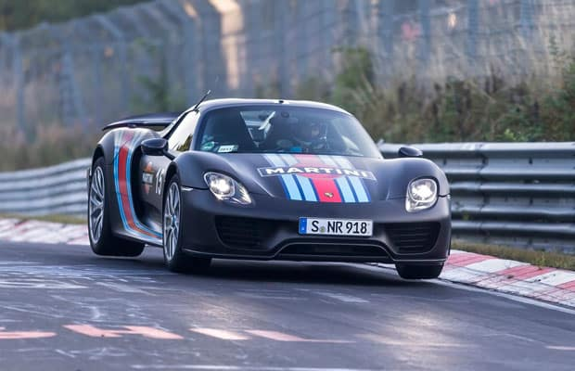
Image via Porsche
Professional Title: European Editor, Autoblog
Twitter: None
Website: noah-joseph.com
There are terms we use in the automotive industry that are easy to define, and those that aren't. Though the lines between various body styles and segments are getting blurred all the time by four-door coupes like the Porsche Panamera or Mercedes CLS, or pseudo-premium/near-luxury marques like Mini or Chrysler, a convertible still has an opening roof, and a pickup truck still has a cargo bed. Supercars, however, are a bit more difficult to define.
So what is a supercar? In this writer's humble opinion, it's a car that's singularly focused on performance with little regard towards other factors like accommodation or cost. It doesn't need to be manufactured by an exotic automaker, but usually is. It similarly doesn't need to be a two-door coupe or convertible, but tends to be.
They also tend to cost more than just about anything else on the road, but all that really matters is how it performs – or rather, how it performs relative to other cars of the same era. So, while even a base Porsche Boxster today might be able to run circles around, say, an original Lamborghini Countach or Ferrari Testarossa, the Lambo and the TR will forever remain supercars – more capable and exotic than most cars in the 1980s – while the Boxster, nimble and superb though it may be, never will. That, after all, is why Porsche made the 918 Spyder.

Tim Burton aka Shmee150
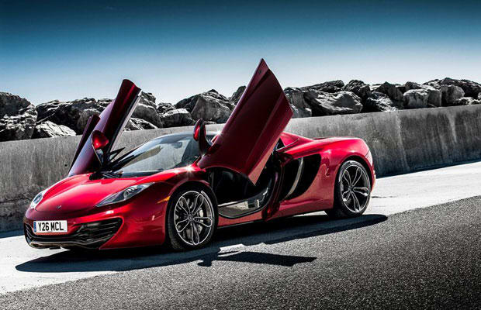
Image via McLaren
Professional Title: Supercar Spotter
Twitter: @MrShmee150
Website: shmee150.com
The definition of a supercar is one that has to constantly change as technology changes the playing field; a hatchback now can be faster than the Ferraris of not too long ago. Again, the quantities play a part, for example a 911 is a fantastically fast car, but there are so many of them built that it's hard to position where it sits. Likewise obviously a Ferrari 458 Italia is a supercar, but is the older F430? What about the previous 360 Modena? These cars start their lives as supercars, but over time fall out of the fray leaving it to a newer niche.
My view on the definition of a supercar covers cars from Audi R8 V10, Porsche 911 Turbo and Aston Martin V12 Vantage up; the small quantity, faster versions of their respective models. Any current model Ferrari, Lamborghini, McLaren sits within this fold too.
As more and more cars reach the supercar fray, where before you would have said the Ferrari Enzo, Porsche Carrera GT and so on would be supercars a decade ago, there are now so many cars with performance in reach of these that the newer term 'hypercar' has naturally been created to encompass the latest models; Bugatti Veyron, LaFerrari, McLaren P1, Koenigsegg Agera, Pagani Huayra and all. We're now in a world where the Koenigsegg One:1 that has recently been announced is being position as a 'megacar' to create a new league above these others.
The term is so varied that different people will always use it in different ways, and albeit some will overuse it, I don't see that as a problem. For example, for somebody who rarely sees a special car, a Ferrari F355 could be incredible and to them quite rare. Whereas for someone based in central London for example, you could see a constant stream of 458 Italias, which barely catch your glance any more.
Whether I personally see a car as a supercar as I say can differ vastly from someone else. To me an Audi R8 V8 isn't particularly rare, nor special, any more and equally the price has now reached reasonable levels for purchasers. It certainly looks fantastic, but the performance is lagging behind, whereas there would be many people who would class it as a supercar immediately, which is equally fine. Location and involvement in the automotive world plays a big aspect in this, because at the end of the day, it's down to how rarely you personally see a car of that class.
Regarding the 'worst supercars', I'd argue that's a title that can't really exist! Every car is built as the dream of the founder or designer, and ultimately it's down to a customer to choose to buy it or not. If there are few purchasers then the car becomes rarer and in turn that makes it more special. Take the McLaren F1, now considered one of the very greatest cars out there, but in it's day only 64 road-going models were ever made due to lack of demand.
POST CONTINUES BELOW

Stuart Hayim
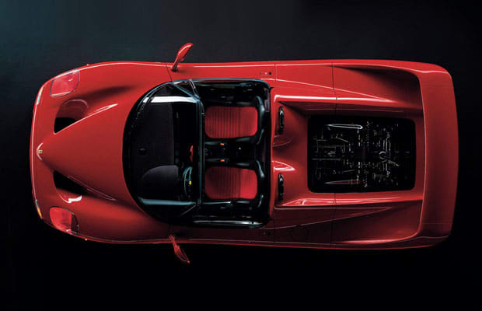
Image via Ferrari
Professional Title: Founder, The Experience Auto Group
Twitter: None
Website: experienceautogroup.com
There are many arguments that debate the difference between the term “Supercar” & “Hypercar”. To me, both have big price tags and extremely limited production. Performance & design reach a limit where it teeters of car and spaceship. If you are lucky enough to own one, it usually means your passion for a particular brand goes above and beyond a “love of cars."
We are at an exciting time in the exotic automobile industry, where we have 3 ground-breaking supercars out or on their way out at the same time. Some would say that the Porsche 918, Ferrari LaFerrari and McLaren P1 are even hypercars. With each of these models containing horsepower that reaches almost four figures, if it weren’t for the advanced technology and safety “nets,” these cars would only be available for a professional race car driver rather than the super/hypercar enthusiast. Even if someone were able to afford one with their wallet, if it weren’t for the advanced safety features that have been so far developed over the years, it could potentially cost them their life.
The technology in these cars today compared to my younger years is unimaginable. It makes the driver smarter than they really are. If Emerson Fittipaldi had one of these cars in his garage, it’s very likely that even HE could only use it to up to 90% of its potential. My point is, comparing even the Enzo (2002) to the LaFerrari (2013) or the Carrera GT (2003) to the 918, you are looking at a world of a difference of technology and design.

Zach Doell
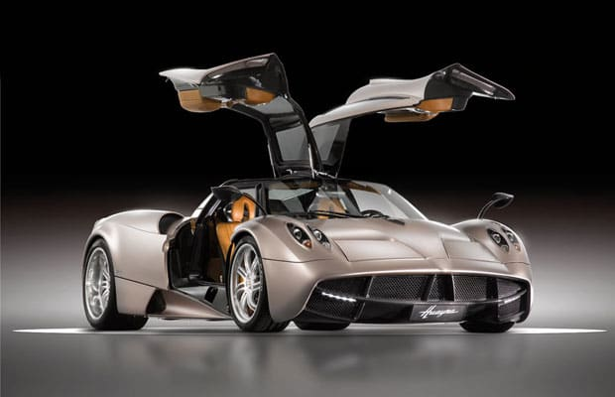
Image via Pagani
Professional Title: Writer, Complex Rides
Twitter: @TheTireKicker
Website: complex.com
Supercars tread that fine line between being too crazy to be a roadcar and too civil to be a racecar. They come with that special aura where just the utterance of "Hyuara" or "Aventador" send you into cold shivers. That being said, a lot of the older supercars – your Miuras and the like – don't exactly perform up to today's sports sedan standards, but there's no doubting their significance in launching supercardom.
Is the term misused? Yeah, probably. The Toyota Supra is certainly a super car, but it isn't exactly a supercar.

Douglas Sonders
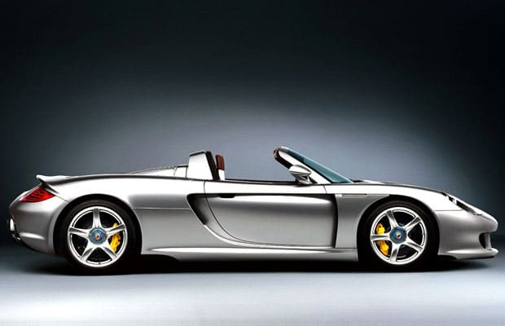
Image via Porsche
Professional Title: Photographer/Filmmaker/Producer/Writer
Twitter: @DouglasSonders
Website: sondersphotography.com
The supercar is like the genetically superior "supermodel" of the automotive world. Vehicles that stand apart from the boring appliances us average mere mortals drive. They ignite our passions while scaring the hell out of us at the same time. The supercar represents the extremes of high performance technology and style.
They stand apart from our daily 4-wheeled appliances and give us something to dream about. They remind us what the open road truly represents, excitement and freedom at its extreme limits. Not always safe, let alone practical, they are the epitome of what every mere mortal car dreams to be.
POST CONTINUES BELOW

