☐ Listening ☐ Speaking ☐ Reading ☐ Grammar ☐ Writing

Topic:
Add some salt and pepper and stir-fry it

Instructor:  Chloe Eunju jo  153WD | Level:  Intermediate | Students:  15 | Length:  50m

Materials:
-RECIPE Vocabulary sheet 1 2 (3)
-Worksheet: Complete the blank
-Audio File

Aims:
To recognize various verbs that describe cooking by brainstorming
To identify cooking recipe vocabulary and their meaning from AUDIO FILE
To comprehend the details COOKING RECIPE and verbs
completing the chart on worksheet
To practice describing how to cook their favorite meal/dish by making up
their own sentences with verbs

Language Skills:
Listening: dialog
Speaking:
talk about cooking recipe they know and share
Writing:
Writing my favorite dish : how to make a ~~~

Language Systems:
Lexis: learn new vocabulary from the script and work sheet
verbs describing cooking recipe technique

Function: describing favorite recipe that they know
how to cook
Discourse: discuss ideas and experiences involving cooking

Assumptions:

Students themselves have been in class
Students are of Intermediate level and can understand create their own sentences

Anticipated Errors and Solutions:

Students may not know vocabulary words in the dialog encourage students to guess from context and pictures
The listening script may be too fast for students: replay few times or read it out loud
Monitor activities of students aside and support them when they need.

References:

https://kr.pinterest.com/ - pictures
미국 현지 영어 무작정 따라하기 11과 레시피 따라하기 저자 KEVIN LEE 길벗 이지톡

Lead-In
Materials:
Time | Set Up | Student Activity | Teacher Talk
3min | Whole  class | Warm up | Greet students and ask about their weekend  Hi, everyone.  How are you doing today?  How was your weekend ?  What did you do?  what did you have for dinner ?  I had a great chicken salad last night!  and I learned how to make it !  do you cook sometimes ?  can you tell us how to make it ?  Expected answers are;  Boiling water ~  Pour the egg yolk ~  These are verbs that describe how to cook ,  Today, we will learn how we can describe using verbs

Pre-Activity
Materials: board / vocabulary sheet
Time | Set Up | Student Activity | Teacher Talk
15min | Groups | Brainstorm | Vocabulary  Instruction  In your groups, please try to think of and to list as many verbs as you can that describe how to cook  Write mash / grill on the board as an example.  (Give 3 minutes to think of as many useful cooking verbs as they can.)  CCQ  Are you allowed to work with your partner?  How much time do you have?  How many cooking verbs do we have to think of?  Each group in turn, please call out one verb to me.  (Write all the verbs called out on the board.)  Read out each of them one by one and let students speak after.  (Hand out cooking sheet to each student.)  This is a list of some verbs that describe cooking  Some are what we’ve just already talked about, and some are not.  If you have any verbs of which you do not know the meanings,  please ask.  (Answer students’ questions.)

Main Activity
Materials: dialog audio file

Time | Set Up | Student Activity | Teacher Talk
15min |  | Whole group | Listening for dialog  Instructions  Now, you are going to listen describing how to cook chicken salad  First, just listen to it 2people`s conversation  CCQ  What do they will talk about ?  what meal do they making ?  Are you supposed to do something while listening?  (Distribute the chart from Worksheet.)  Please take a look at the chart. Now, you will listen to 2people`s conversation again and this time complete the missing information on Worksheet.  CCQ  What are you supposed to do on Worksheet?  (Play the recording.)  Do you need to listen again?   Yes → Play the recording again.   No → Continue.  Okay, let’s check the answers.  (Check the answers as a whole class.)

Post Activity
Materials:
Time | Set Up | Student Activity | Teacher Talk
15min | Individually  Pair  group | Speaking | Free Production  Please come up how to cook your favorite meal / dish  simple recipe using verbs at least 3 verbs  make your own recipe  Please start.  CCQ  How many verbs you need ?  (Students complete.)  Now, please talk with your partner  In addition to that, please talk each other  Share with whole group  CCQ  What are you supposed to talk with your partner?  (Students work.)  please talk with group and exchange your ideas  CCQ  How many verbs do you have to think of?  Conclude lesson  Elicit today’s vocabulary for students.  See you tomorrow!

SOS Activity
Materials:
Time | Set Up | Student Activity | Teacher Talk
 |  | Reading | More vocabulary sheet

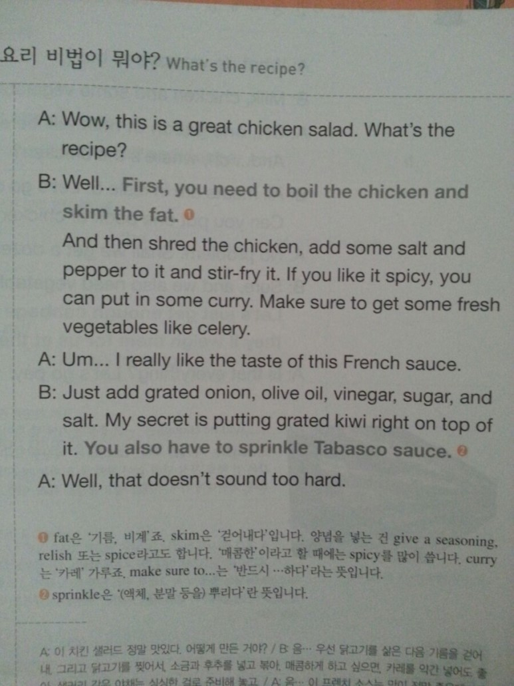

Work sheet
Complete blank

