The Two Frogs and the Well

It was hot. It was so terribly hot that the trees were sweating. The ponds were empty. The wells were dry. The ducks were thirsty. Now there were two frogs who were so parched that the younger one said:
“Any more of this heat and we’re going to shrivel up so small that we’ll be tadpoles again.”
The old frog croaked back, “If we don’t find a well with some water in it, we’re going to die!”
And so they both decided that their only chance was to search far and wide until they found a better place to live. And so off they hopped over the fields and far away. At last, just as their legs had the final bit of energy left in them, they found a well.
“This better have a few drops left or that’s it for us,” said the older frog. They both peeped over the edge and low and behold – lovely water that was deep, deep deep. In they both tumbled, head over heals, and drank their fill.
The young frog exclaimed, “Oh my, this is the life, let’s stay here in this well forever!”
But the older one shook his head and said, “No dear boy, it is wiser to climb out of this well right away. For if the hot weather continues, the water here will sink down, and we shall go lower down too, and what do you think will happen?”
“Er, it will all dry up?” suggested the young frog.
“Yes, and then what shall we do? For we shall be right at the bottom of a very deep dry well, and it will be impossible for us to jump out.”
And so the moral of this story is –
‘Look before you leap.’
Vocabulary worksheet
1. Read vocabularies and meanings that we will listen in the story
Vocabulary | Meaning
Pond | A pond is a small area of water that is smaller than a lake
Well | A well is a hole in the ground from which a supply of water is extracted
Shrivel | To become dry and develop deep lines because of heat, lack of water
Tadpole | Tadpoles are small water creatures which grow into frogs
Croak | When a frog or bird croaks, it makes a harsh, low sound
Peep | If you peep, or peep at something, you have a quick look at it
tumble | If someone or something tumbles somewhere, they fall there with a rolling or bouncing movement
Head over heals | used to describe the feeling of falling in love
Shook | Shook is the past tense of shake
Sink down | move downwards

2. What is the name of the pictures? (write below the picture)
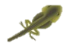 | 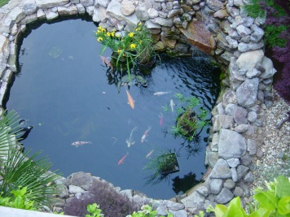 | 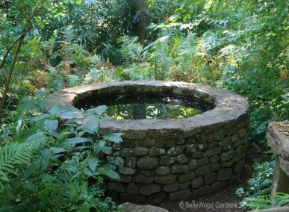

3. Using vocabulary we read #1, make sentences complete.
- He injured his ribs in a from his horse
- A man at her over the fence
- The cake will rise and then again
- Autumn came and the leaves started to up
- Frogs began to with the rainfall

Listening worksheet – fill in the blank

The Two Frogs and the Well

(A story by Aesop)

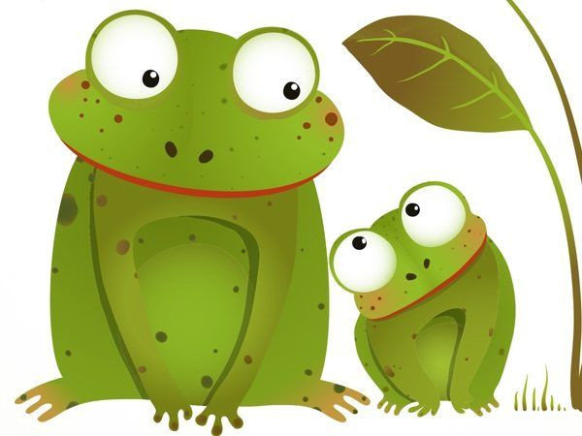
It was hot. It was so hot that the trees were sweating. The ponds were empty. The wells were dry. The ducks were . Now there were two frogs who were so parched that the younger one said:
“Any more of this heat and we’re going to so small that we’ll be t again.”
The old frog croaked back, “If we don’t with some water in it, we’re going to !”
And so they both decided that their only chance was to search far and wide until they found a better . And so off they hopped over the fields and far away. At last, just as their legs had the final bit of left in them, they found a well.
“This better have a few drops left or that’s it for us,” said the older frog. They both peeped over the edge and low and behold – lovely water that was , . In they both tumbled, , and drank their fill.
The young frog exclaimed, “Oh my, this is the life, let’s here in this well !”
But the older one and said, “No dear boy, it is wiser to
of this well right away. For if the hot weather continues, the water here will , and we shall go too, and what do you think will happen?”
“Er, it will ?” suggested the young frog.
“Yes, and then what shall we do? For we shall be right of a very deep dry well, and it will be for us to .”
And so the moral of this story is –
‘ .’

