☐ Listening ☐ Speaking ☐ Reading ☐ Grammar ☐ Writing

Topic: Comparison between ‘can’ and ‘be able to’

Instructor:  Stilla | Level:  Intermediate | Students:  2 | Length:  45 Minutes

Materials:
- 2 copies of f work sheets
- Marker and board
- Power point presentation
- Computer and projection
- A song ‘I believe I can fly’ by R.Kelly

Aims:
- To learn past/ present/ future tense of ‘can’ and ‘be able to’.
- To practice common features or usage of ‘can’ and ‘be able to’.
- To learn several differences of ‘can’ and ‘be able to’.

Language Skills:
- Listening: Listening to a music in the beginning of class, instructor’s explanation, other students’ opinions.
- Speaking: Sharing the opinions or own answers.
- Reading: Reading the diagram and charts from PPT, reading the sentences on the boards and work sheet.
- Writing: Writing the answers on the worksheet.

Language Systems:
- Phonology: Different and confused pronunciation while making the sentences using ‘can’ and ‘be able to’ foams or drilling
- Lexis: New vocabulary used in speaking
- Grammar: Can, could, was(were) able to, am(is) able to, will be able to
- Function: Taking a note and fill in the blank about a possibility or ablitiy
- Discourse: Drilling, discussion

Assumptions:
Students already know:
- All students are college students or graduates (Age 18 and up)
- Students understand basic sentences.
- Students know how their seats are arranged during the class: a pair group but sometimes individual works
- Students share their opinion frequently
- Students are accustomed to listening the song ‘I believe I can fly’ or the melody

Anticipated Errors and Solutions:
- Students might be confused about the concept of ‘can’ and ‘be able to’
- Explain again by using PPT slides which contains diagrams as well
- Practice by drilling
- Students are not participated in the sharing opinions or ‘fill in the blank’ activity
- Ask induced question to them
- Students finish the class earlier than what the instructor expected
- Use S.O.S activity

References:
- https://en.islcollective.com/resources/printables/worksheets_doc_docx/can-could-will_be_able_to/modals-elementary-a1/64647
- https://youtu.be/GIQn8pab8Vc
- The binder ‘teaching grammar’ section

Lead-In
Materials:
- Computer and projection
- The song ‘I believe I can fly’ verse 1
- Marker and board
Time | Set Up | Description of activities
6mins  2mins  2mins  2mins | Whole class | Procedure:  - Greeting and introduction  Instruction  Hello everyone, how was your weekend? Did you have any special thing to do during the weekend?  If no one replies to the answer, the instructor said instead of Ss.  In case of me, I practiced how to ride a bike last weekend. And finally I achieve to ability to ride a bike. It makes me feel so happy.  Contextualization  Does anyone know how to express the ability or possibility in one word?  From now on, I will show you one short music video clips and there is a clue. Please, try to find what word is mostly and repeatedly listened on the music video. And try to write down the sentences including that word if possible.  Ok, let’s watch it.  - Watching the video clip  Watching the music video ‘I believe I can fly’ verse (cut the clip at 2:05)  CCQs:  -What do we have to do when we watch the music video clip?  - Guided Warmer Activity  After watching the video clip, talk about what is the word mostly and repeatedly listened to the Ss and write down on the board.

Presentation
Materials:
- Marker and board
Time | Set Up | Description of activities
10min | Whole class | Procedure:  - Recall  Instruction  Did you enjoy the song? What word was the most repeated while the music is played do you think?  Yeah, as you guess, it is ‘can’.  This song is R. Kelly’s song ‘I believe I can fly’ and talking about a possibility comes from my mind  We will learn about past/ present/ future tense foams of ‘can’ including ‘be able to’. Also practice about this foams and learn some differences of ‘can’ and ‘be able to’ as well.  Elicitation  Does anyone know who sing this song and what is the name of the song?  CCQs:  -Can you remember any sentences including ‘can’ in the song?  Demonstration  I can fly  I can do it  I can see it  I can soar  I can touch the sky  - Reflect  Instruction  There are some lists of sentences used in the song on the board. ‘Can’ verb express ability and possibility to make it something. And it is used not only human being and animals but also nonliving things such as eraser!  ‘Can’ has past and present form as ‘could’ and ‘can’.  As I explained, ‘Be able to’ explains future form as ‘~ will be able to ~’. Also this ‘be able to’ form also have past and present tense too.  Past and present form of ‘be able to’ is ‘was/were able to’ and ‘is/ are able to’.  In addition, ‘be able to’ form is only valid for living thing, however, ‘can’ verb is used both living things and non-living things.  Elicitation  How do we use the form for ability which we cannot use ‘can’ for future?  (explain the usage of ‘be able to’ from after this elicitation)  Anyone who knows be verbs formation changing from past – present- future?  CCQs:  -Is ‘be able to’ used for living thing?  -Do you remember that ‘can’ is used what situation?  Demonstrations  Make a chart as below with examples:  Cf)  -  - Conclude  Procedure:  Meaning  Great job guys! What we have learnt right just before, ‘can’ and ‘be able to’ are called as ‘modal verbs’

Practice
Materials:
- 2 copies of f work sheets
Time | Set Up | Description of activities
25min  15min  5min  5min | Whole class  Individually  Whole class | Procedure:  - Controlled Practice  Instruction  I will give you a piece of worksheet paper and fill in the blank from no.1 to no.29. Pretty many practice blanks (as a small joke). I will give you 15 minutes for filling the blanks. If you need more time, I will give more.  CCQs:  - How much time do you have?  - When do I use can/ could/ be able to?  - What is the past/ present/ future tense of ‘can’/‘be able to’?  (Pass out the worksheet and run task)  Feedback  Do you need more time to fill it out?  (If yes - give 5 minutes more/ If no – check answers together)  - Less-Controlled Practice  Instruction  From now on, we will do a chain- drill activity by using the work sheet paper. There are 29 sentences on the paper and we change the positive sentences to negative sentences by putting ‘not’ on the sentence structure. Also other words as well if you think it is needed. Let’s do with your pair classmate. I will give you 5minutes.  Demonstration  No.1  Tom is a clever boy and he can solve any problems very easily to  Tom is not a clover boy so he cannot solve any problems very easily  CCQs:  - What is negative foam of can/ could/ be able to?  - How much time do you have to practice it?  - Which number are you practicing now?

Production
Materials:
- Computer and projection
- Board and maker
Time | Set Up | Description of activities
4min | Whole class | Procedure:  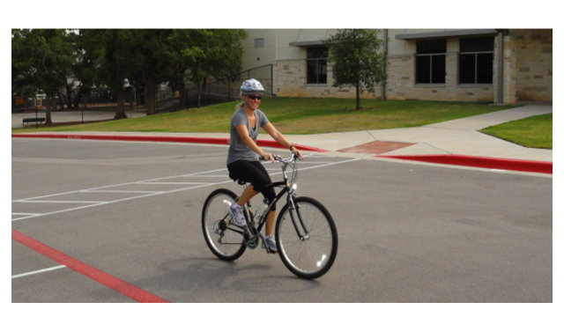  - Free Practice  Show the PPT slide and let student make their own sentences by using ‘can’ and ‘be able to’ seeing the slide (same as above).  Instruction  Now, let’s make our own structures as seeing the picture of the slide.  Demonstration  The helmet can protect her head if she falls down to the ground.  CCQs:  - What can you see on the slide?  - Who is there?  - What kind of grammar structure do we use when make the sentence?  - Warm up  Instruction  Today we learn about ‘past/ present/ future tense of ‘can’ and ‘be able to’, common features or usage of ‘can’ and ‘be able to’. And several differences of ‘can’ and ‘be able to’ as this chart and diagram.  Did you get to know the usage of ‘be able to’ and ‘can’?  See you  Demonstration  Use the chart and diagram.  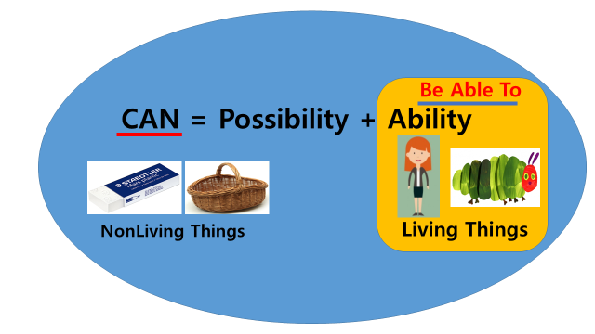  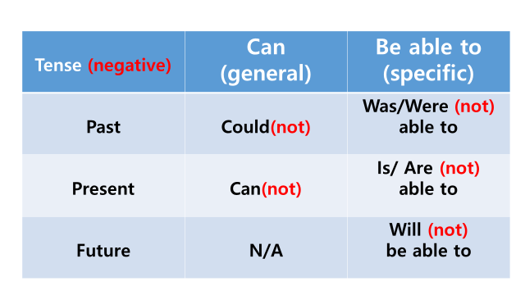

SOS Activity
Materials: N/A

Time | Set Up | Description of activities
5min | Whole group | Procedure:  Instruction  Let’s make own sentence which introduce one of your family members by using ‘can’ and ‘be able to’ to us. Take turn from me(instructor) as clock counters.  Demonstration  My brother is able to play violin.  CCQs:  -What is your mother(family member)’s favorite cooking(activity)?

The lyrics of song

<I believe I can fly – verse 1 >

I used to think that I could not go on
And life was nothing but an awful song
But now I know the meaning of true love
I′m leaning on the everlasting arms
If I can see it, then I can do it
If I just believe it, there′s nothing to it
(Chorus)
I believe I can fly
I believe I can touch the sky
I think about it every night and day
Spread my wings and fly away
I believe I can soar
I see me running through that open door
I believe I can fly
I believe I can fly
I believe I can fly

