☐ Listening ☐ Speaking ☐ Reading ☐ Grammar ☐ Writing

Topic: FOUR SEASONS

Instructor:  MICA | Level:  2 (Age: 5-6) | Students:  6 | Length:  30 Minutes

Materials:
- 4 trees cards (to show each season)
- Lap top computer (power point)
- 4 Boxes
- Small pictures of fall season
- Letters of four seasons

Aims:
- Main aim-Students will distinguish four seasons when they see related pictures.
- Secondary aim-Students will understand how four seasons are changing by seeing changing trees.
- Personal aim -They can express feeling of each four seasons.
- (ex-Winter is cold, Spring is warm.)

Language Skills:

- Listening- Students listen to the song ‘the seasons song’
Students listen to what teacher said.
- Speaking- Students sing a song.
Students try to answer for teacher’s question.
- Reading - Students read lyrics with listening ‘the seasons song’
- Writing- Students can fill out four seasons on handed work sheet.
Language Systems:

- Phonology- The pronunciation of S through word spring and summer.
The pronunciation of L/R sound through word fall and winter.

- Lexis- Four seasons: spring, summer, fall, winter, warm, hot, cool, cold

- Grammar- Simple Present Tense- I like + N.
Be + adjective (It’s cold. It’s warm)
- Function – Teacher -Mica. Students – 6 persons in class.
- Discourse -Role play with singing a song.

Assumptions:

- Students already know about weather expression as rainy, sunny, hot, cold, warm, cool.
- Students already know ‘the hello song’ and dance routine as results of every day repeat.
- Students already know some sign of teacher.
(Clapping hands: Stop everything and listen what teacher say)
- Students learned the ‘season song’ in before class.

Anticipated Errors and Solutions

- Some students might have difficulty remember some words as buds, snow man. Encourage students can guess through pictures.
- Students may not understand rule of activity.
Encourage students understand to show examples.

References:
- Song- The seasons song
http://goo.gl/XGdh8P
- Activity “Play "Find the Season Pictures"
https://www.eslkidstuff.com/
- Google images for seasons pictures and work sheet of home work.

Lead-In
Materials
- Power point (to show lyrics and listen to the hello song)

Time | Set Up | Student Activity | Teacher Talk
1m | whole class | S: Hello! Mica!!  Students sing a “hello song” with dance routine.  (They already know this song and dance routine) | Greeting  T: Hello class! Nice to see you!  Rapport  T: Let’s start ‘the hello song’  Here we go!  (Sing together with dance routine)  Hello, Hello, how are you?  Hello, Hello, how are you?  Hello, Hello, how are you?  How are you today?  I am fine, I am great. I am fine.  I am just great. I am fine, I am great  I'm very well today!  Great!

Pre-Activity
Materials
- Power point (to show lyrics of ‘the season song’)

Time | Set Up | Student Activity | Teacher Talk
8m | Whole class  Pairs | Students listen to clapping sounds of the teacher and stop singing.  Students answer about the questions.  Students listen demonstration of the teacher.  Students make sure a rule of this activity and do it with pairs.  Students sing a song with pairs | Warm-up  Making “clap hands”  Monitoring  Check all students are ready to listen what teacher say.  CCQ  T: How is the weather today?  (Waiting student’s answer)  Nice? Lovely weather?  (Based on situation weather that day.  Waiting if they can say ‘it’s hot’.)  Is it cold today? No?  Yes. It’s hot. It’s summer.  Demonstration (Song activity)  T: Do you remember ‘the seasons song’ we learned before class?  We’ll have a simple activity with using ‘the seasons song’  (Turn on the page of power point to show the seasons song lyrics)  T: What’s this? It’s a magic box. There are four seasons here.  Work with partner. You guys are partner, you are partner and you guys are partner.  One person sang a song like this.  Spring, summer, fall, winter.  What’s your favorite season?  (Sing and encourage students sing together when teacher sings)  And other partner need to pull out one thing in the box (show action)  What’s theses? Yes, tulips.  Then you can sing like this.  I like tulips in the spring.  They’re beautiful.  (Sing and encourage students sing together when teacher sings)  And you guys change each other.  Spring, summer, fall, winter.  What’s your favorite season?  (Sing and encourage students sing together when teacher sings)  As said, the other pull out one thing from the box.  I like snow in the winter. Brrr, it’s cold.  (Sing and encourage students sing together when teacher sings)  ICQs & Drills  Point two students.  T: You guys are partner.  A, can you sing first?  (Teacher sing together with pointing lyrics so that make sure student A is clear)  OK, B, let’s choose whatever you want.  You can sing.  (Teacher sing together with pointing lyrics on the board so that make sure student B is clear.)  Great. You guys did very well.  So, let’s sing a song with your partner.  I’ll give you 5min.

Main Activity
Materials:

- Trees papers on each season
- 4 boxes with four seasons pictures
- Letters on each season

Time | Set Up | Student Activity | Teacher Talk
about  15m | Whole class | Student stop the singing activity and listen the teacher’s instruction.  Students give back to season box to the teacher.  Students answer for the teacher’s question.  S: It’s spring.  S: Little shoot.  S: There are tulips.  S: It’s summer.  S: Big leaves!!  S: It’s fall.  S: Red leaves!  S: It’s winter.  S: There are snow!  S: Winter box!!  Everyone rushes around picking up pictures and placing them in the right boxes. | Elicit  Making “clap hands”  T: Did you enjoy the seasons song?  How many seasons we have?  Yes, we have four seasons.  Give back to me your magic box with season materials.  Ok, loot at this tree picture.  What’s the season of this picture?  Yes. It’s spring.  How did you know that?  Yes. Little shoots are peaking out of the earth.  Yes. Flower tulips are blooming.  (Teacher’s answer can be changed as per student’s answer.)  Now, this box is spring box.  (Put spring picture and letter on the box. Do same things for other seasons)  Look at this tree.  What’s the season of this picture?  Yes, it’s summer.  How did you know that?  Leaves on trees are so green.  Leaves are growing bigger and bigger.  (Teacher’s answer can be changed as per student’s answer.)  Now, this box is summer box.  (Put ‘summer tree picture and letter on the box)  Look at this tree.  What’s the season of this picture?  Yes, it’s fall.  How did you know that?  Yes, Leaves are changing color.  (Teacher’s answer can be changed as per student’s answer.)  Now, this box is fall box.  (Put ‘fall tree picture and letter on the box)  Look at this tree.  What’s the season of this picture?  Yes, it’s winter.  How did you know that? (Teacher’s answer can be changed as per student’s answer.)  Yes, there is no leaves on the tree, and you can see snow.  Now, this box is …??  Great, it’s winter box.  (Put ‘winter tree picture and letter on the box)  Demonstration  [Play "Find the Season Pictures"]  We’re going to have a play with  season boxes.  There are many pictures here.  I’ll scatter them around the room.  (do action)  If I say “Find summer pictures!”  And you put them in the summer box.  (Show actions to students)  And if I say “ICE!”, you guys should stop. Any question?  No? OK, here we go!!  Ok, find winter pictures! Go go!  ICE! Ok, now find spring pictures!!  (Do the same for the other seasons.)

Post Activity
Materials:
- 4 boxes with four seasons pictures
- Letters on each season

Time | Set Up | Student Activity | Teacher Talk
6min |  | Listening sign of teacher  Put each season pictures on the board.  Listen teacher’s question and answer.  Take the work sheet,  And fill out each season’s name.  (If they feel it’s hard, they just can see each season letters on the board)  S: It was fun!  S: Bye bye!! | (Put four season letters on the board)  Wrap up  Singing “clap hands”  Monitoring  Check all students are ready to listen what teacher said.  Elicit & Feed back  T: Let’s see if you put right pictures on each season box.  (Pointing one student)  Would you help me pictures on the board?  (Do it together with pointed student, and do it same things with other seasons)  OK, Let’s see.  What’s this?  Yes, Buds are budding green.  Let’s say buds are budding green.  What’s this?  Yes, they are tulips.  You can see tulips in spring.  How is the weather in spring?  Yes, it’s warm.  (Do the same things with other seasons)  Ok, take this work sheet.  You can see 4 trees.  Let’s fill out name of four seasons on each blank quickly. And write four seasons according to the dotted line.  Let’s do it.  (Check if students write well, if it’s not, approach them and correct them.)  Wrap up  Singing “clap hands”  T: We learned about four seasons.  How was it?  Now, you can distinguish four seasons!  You were great today.  Now, time is up.  Good bye! See you next time!!

SOS Activity
Materials:
Prepared work sheet and pens.

Time | Set Up | Student Activity | Teacher Talk
5-10  min | Whole class | Listen what teacher say and answer using patterns | Warm up  Spread out work sheet on each student. And show some pictures of under the sea.  Drill  T: You can breathe under the sea.  Now it’s time to travel under the sea.  Let’s answer below questions.  (Explain questions and make some example sentence, and make students speak their sentence using some patterns.)

Materials
*PPT (with song lyrics)
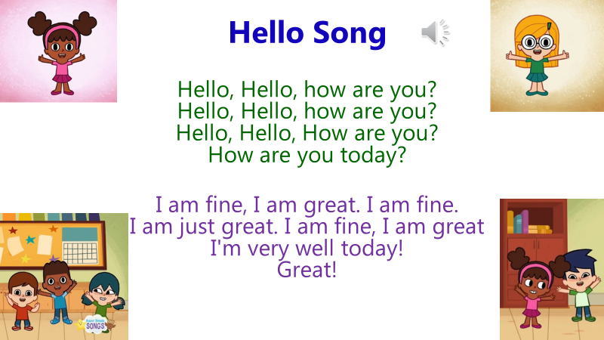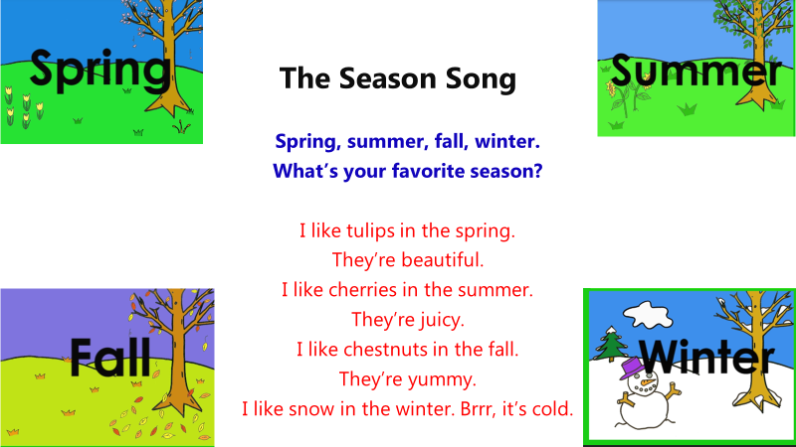
*Tree pictures of four seasons
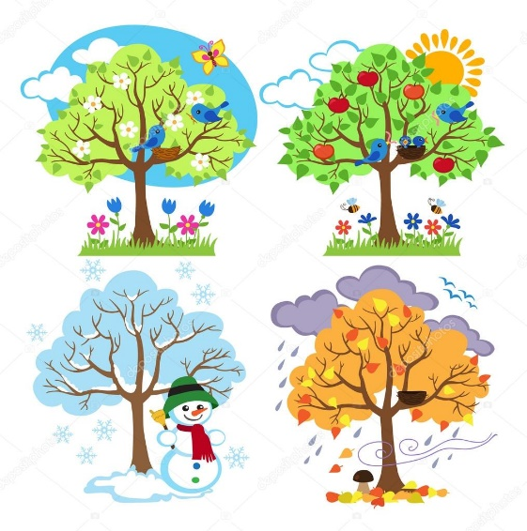
*picture card & letters of four seasons
*4 boxes on each season
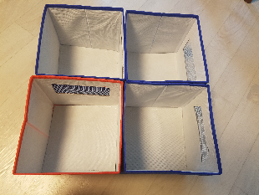
*Work sheet

*SOS work sheet

