|  |
| --- |
| ☐ Listening ☐ Speaking ☐ Reading ☐ Grammar ☐ Writing |
| **Topic:**  Let me introduce my family members. |

|  |  |  |  |
| --- | --- | --- | --- |
| Instructor:  SERL HEE PARK | Level:  1~2 grade students | Students:  **6 students** | Length:  **30 Minutes** |

|  |
| --- |
| Materials:  YouTube videos ( “baby shark song” ,”hello song”, “clean up song”)  Pictures of paper painted a variety of trees, circled small white blank papers, Glue, cigars, colored pencil  PPT ( Explanation of “I have”, “He(she) has”, “Uncle, aunt, cousin, nephew”, “I don’t have, She(he) doesn’t have)  Realia of bananas, oranges |

|  |
| --- |
| Aims:  Main aim- SS can introduce his(her) family tree to classmates  Secondary aim- SS understand the grammar of “I have…”, “He(she) has…”,” I don’t  have”, “He(She) doesn’t have”  SS understand the new words of family members (“uncle”, “aunt”,  “cousin”, “nephew” )  Personal aim- SS know their friends’ family members to GKEO. |

|  |
| --- |
| Language Skills:  Listening- SS listen to the song ‘”Hello”, and watch the video “baby shark song”  Speaking- SS describe his(her) family members in front of class  Reading- SS read PPT pages together 1) the explanation of “I have”, ”he(she) has”  2) “I don’t have, He(She) doesn’t have “3) the new words of “uncle”, “aunt”,  “nephew” ,”niece”  Writing- when pair works, SS can summarize and write down the partner’s family  information. |

|  |
| --- |
| Language Systems:  Phonology - The pronunciation of/ ˈəŋ,/primarystressant/,/primarystressnef/, ˈnē’  Lexis - the vocabulary of “uncle”, ”nephew”, ”niece”, ”aunt”  Grammar - Simple Present Tense- “I have”, “He(She) has”, “I don’t have”, “He(she) doesn’t have”  Function - Describing and introducing people  Discourse - talk to a partner, and talk to everybody in front |

|  |
| --- |
| Assumptions  SS already know basic vocabulary of family members such as “father”, ”mother”, “sister”, “brother”, “grand-parents”  SS know how to sing the song of “hello song” and “clean up song” as a class routine.  SS want to show their family members in front. |

|  |
| --- |
| Anticipated Errors and Solutions  Ss might have difficulty of using new words (uncle, nephew, niece, aunt) for introducing their family members as soon as they learn the words in class.  -Teacher can help the student closely, and show a teacher’s family tree on PPT page  SS may feel shy to talk about people in their families in front.  -a pair work can help to less be shy to talk. Teacher also can help to talk in close |

|  |
| --- |
| References  YouTube video- Hello song for Kids- [www.goo.gl/AJFFV4](http://www.goo.gl/AJFFV4)  YouTube video-Baby Shark Dance - [www.goo.gl/UbBPGp](http://www.goo.gl/UbBPGp)  YouTube video- Clean up for children- [www.goo.gl/kLv6Tc](http://www.goo.gl/kLv6Tc) |

|  |  |  |  |
| --- | --- | --- | --- |
| Lead-In | | | |
| Materials:  YouTube video -Hello song for Kids- www. goo.gl/AJFFV4 | | | |
| Time | Set Up | Student Activity | Teacher Talk |
| 2m | whole class, | S: Hello teacher.  S: I am good.  S: I am happy.  (sing a song together) | (with youtube video)  (When the song ends, greeting)  T: Hello class! Nice to see you!  (Waves excitedly at SS.)  (Rapport)  T: How are you today? (ask each students).  Let’s start with “hello song” as always.  (playing “hello song” again, and sing a song together) |

|  |  |  |  |
| --- | --- | --- | --- |
| Pre-Activity | | | |
| Materials:  YouTube video - Baby Shark Dance - [www.goo.gl/UbBPGp](http://www.goo.gl/UbBPGp)  PPT  Tree pictures of paper, circled small white papers,  Glues, cigars, colored pencils | | | |
| Time | Set Up | Student Activity | Teacher Talk |
| 5m | whole class, | Amy: there are eleven in your family; Grand-pa, Grand-ma, father, mother, sister, brother, uncle, aunt, cousin, nephew, and you.  Jero: there is one in your family.  Yu-jin: I have a brother.  SS dance together. | Warm-up  T: We learn how to say how many people in your family.  I will show you my big family tree.  (with PPT)    Amy! Can you tell me How many people in my family are?  Jero! How many sisters in my family?  Ok~ I don’t have a brother. Who has brother in class? Wow~ good.  Let’s review with sing a song together “baby shark song” first.  Everybody stands up! Let’s sing a song together. Look teacher carefully, and you can follow me easily.  (explain a little bit about music and dancing points)  (play a video and dance together) |

|  |  |  |  |
| --- | --- | --- | --- |
| Main Activity | | | |
| Materials:  Realia of bananas, oranges  PPT (“I have…“,He(She) has…”, “uncle”, ”nephew”, ”niece”, ”aunt: )  YouTube video  Tree pictures of paper, circled small papers,  Glues, scissors, colored pencils | | | |
| Time | Set Up | Student Activity | Teacher Talk |
| 18m | whole class,  Individual work    Pair  work  Whole class | S: I have two bananas.  S: I have three oranges.  S: I don’t’ have a grand-father.  S: I don’t’ have a brother.  SS: She has a banana.  He has a sister.  She has a grand- father.  SS:  He doesn’t have a banana.  She doesn’t have a brother.  He doesn’t have a grand- mother  S: yes. I have a uncle  S: I have an aunt.  S: uncle is my daddy’s brother.  S: I don’t know.  S: he is a uncle.  S: she is an aunt  S: he is a nephew  Jina: there are four in amy’s family. She has sisters and brothers. She doesn’t have grandmother*,* grandfather. She loves her family.  Amy: there are three in  Jina’s family. She has sisters and brothers. She doesn’t have grandmother, grandfather. She loves her family. | *.*Today, we are making family tree, and introduce my lovely family to friends.  (using realia of bananas, oranges with PPT)  first, elly and yu-gin give two bananas to teacher. So, there are two bananas. I can say with I have…  “I have two bananas.”  If you have three oranges, how can you tell me?  Good job.  (with PPT)    Let’s read it together.  If I have one banana, you can say “I have a banana”  If I have a sister, you can say “ I have a sister.”  If I have a grand-father, you can say “I have a grand-father.”  Good job.  (with PPT)    There are two bananas, but hungry teacher ate two bananas. Then, i can say with I don’t..  I don’t have a banana.  If I don’t have a grand-father, how can you say  “I don’t have a grand- father”  Good~ yu-jin! Do you have a brother?  (with PPT)    But, be careful, if you want to say he or she instead of I, you should say,  (speak with students)  She has a banana.  He has a sister.  She has a grand- father.  (with PPT)    Also, if you don’t have something or someone, you should say,  (speak with students)  He doesn’t have a banana.  She doesn’t have a brother.  He doesn’t have a grand- mother.  (with PPT)  Perfect. And, let’s talk about new word friends. Have you ever heard uncle? Aunt? Nephew?  (if yes) can you tell me who uncle is to your friends?  Good. Uncle is our daddy or mommy’s brother.  Aunt is our daddy or mommy’s sister, also aunt is a uncle’s wife.  Nephew is our uncle or aunt’s son.  Do you knows what’s the name of our uncle of aunt’s daughter?  You can call a niece.  (with family tree PPT)    Let’s play a quiz.   1. How can you call your daddy’s brother? 2. How can you call your mommy’s sister? 3. How can you call your daddy’s brother’s son?   Good~ let’s make a family tree now.  You can see a paper in front. You can make your own family tree. Every student has different trees. And, you can draw your family members’ face on this circle papers, and write their name in the bottom of the paintings..    You have five minutes until alarm rings.  (walking around students, and help them)  Ok~ times up. And, let’s introduce my family members to your friend who next to you. I will give you this hand-out to write down the information.  (pass hand-out paper to SS)  I will give you two mintues until alarm rings.  Ok~times up. Let’s introduce my friends’ family.  Which team wants to go first?  Ok. Jina and amy come here. And tell your friend’s family members to friends.  (show example sentences on PPT)   |  | | --- | | There are__ in her family.  She has _____and _____.  She doesn’t have ____ and _____.  juna talks about amy’s family |   Great.it’s amy’s turn. Amy can you tell us jina’s family?  (elly- yujin), (jero-, mika) teams come in front, and introduce their family members.  Great job everybody~! |

|  |  |  |  |
| --- | --- | --- | --- |
| **Post Activity** | | | |
| Materials:  YouTube song - Clean up for children- [www.goo.gl/kLv6Tc](http://www.goo.gl/kLv6Tc)  Tree pictures of paper, circled small papers | | | |
| Time | Set Up | Student Activity | Teacher Talk |
| **5m** | WholeClass | SS: amy, jina  SS: amy has two sisters.  SS: nephew  SS: jero doesn’t have an aunt.  SS: we all love our family  (SS now know who they are. )  SS: Yes  SS: one question.  SS :Amy  (They ask to each other)  Amy: are you boy?  Elly: Amy! are you old?  …  Yu-Jin: no, Jero! do you have a son?  ….  Elly raises her hand  Elly: Amy is a sister.  …  …  … | Today, we learn about our friend’s family members.  Who has a sister?  Good~. How many sisters does amy have?  Good~ how can you call your uncle’s son?  Great. who doesn’t have an aunt?  Good~ and, who loves their families?  (GAME-Role-playing finding who they are)  Let’s play a final game together. Can you see the back side of your family tree paper? You can see the name of family members in the bottom of the page. Don’t show and tell who you are to others. We can figure out by questioning to each other. One student can ask one question at one’s turn. The order starts with Amy to the right. As soon as you notice who another is, raise your hand.  Does everyone find who you are?  How many question can we ask at once?  Who can ask a question for the first?  The winner will get a surprise gift.  Are you excited? Ok, let’s start.  T:Good~ elly! You get one point!  And since we know who amy is, amy is out! Sorry Amy!  Let’s keep going~!  (If SS feel difficult to make a question)  T: why don’t you ask “how many letters in your name?” , or, “do you think you are the oldest of us”?    (keep playing a game)  (when the game finish)  The winner is Elly! Good job. Everybody works well, so I will give a chocolate for everybody, and the winner elly will get two chocolates. Good job elly. (give a chocolate everybody)  It’s time to clean up. Let’s sing a song together and clean up together.  (playing video: “Clean up for children)  Good bye~ students~ |

|  |  |  |  |
| --- | --- | --- | --- |
| **SOS Activity** | | | |
| Materials:  Hand- out for word search  YouTube video -Clean up for children- [www.goo.gl/kLv6Tc](http://www.goo.gl/kLv6Tc) | | | |
| Time | Set Up | Student Activity | Teacher Talk |
| 2 m | individual | SS: we need 2minutes.  SS work on the game. | T: let’s play a word game. I will give everyone paper of word search game. You only need to find 10 words we know now. how long do you need to find every words? Ok~ I will give you 2minutes to finish up.  T: times up. Everybody look good job.  Like we do always,  Let’s finish our class with “clean up song” . As you know, while you can hear, you can clean your area, please/ |

|  |
| --- |
| **Hello Song for Kids**  Everyday  I go to school  I meet my friend  And we all say  Hello hello  How are you  I am good, I am great  How about you (x2)  Everday  I go and play  I meet new friends  And we all say  Hello hello  What’s your name?  Nice to meet you  Do you want to play? (x2) |

|  |
| --- |
| **Baby shark dance**  Baby shark, doo doo doo doo doo doo  Baby shark, doo doo doo doo doo doo  Mommy shark, doo doo doo doo doo doo  Mommy shark, doo doo doo doo doo doo  Daddy shark, doo doo doo doo doo doo  Daddy shark, doo doo doo doo doo doo  Grandma shark, doo doo doo doo doo doo  Grandma shark, doo doo doo doo doo doo  Grandpa shark, doo doo doo doo doo doo  Grandpa shark, doo doo doo doo doo doo  Let’s go hunt, doo doo doo doo doo doo  Let’s go hunt, doo doo doo doo doo doo  Let’s go hunt  Run away, doo doo doo doo doo doo  Run away, doo doo doo doo doo doo  Run away  Safe at last, doo doo doo doo doo doo  Safe at last, doo doo doo doo doo doo  Safe at last  It is the end, doo doo doo doo doo doo  It is the end, doo doo doo doo doo doo  It is the end |

|  |
| --- |
| **Clean up song for children**  Clean up, everybody clean up  Clean up, everybody clean up  Clean up, everybody clean up  Time to clean up  Pick up, everybody pick up  Pick up, everybody pick up  Pick up, everybody pick up  Time to pick up  Pick up the toys, put them away  Pick up the boxes, put them away  Pick up the books, put them away  Put your things away  Pick up the toys, put them away  Pick up the boxes, put them away  Pick up the books, put them away  Put your things away  (x2) |

<SOS– word search>

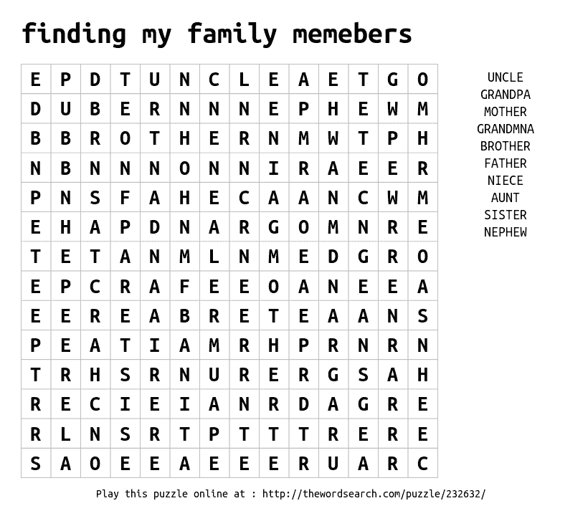

**PPT1**

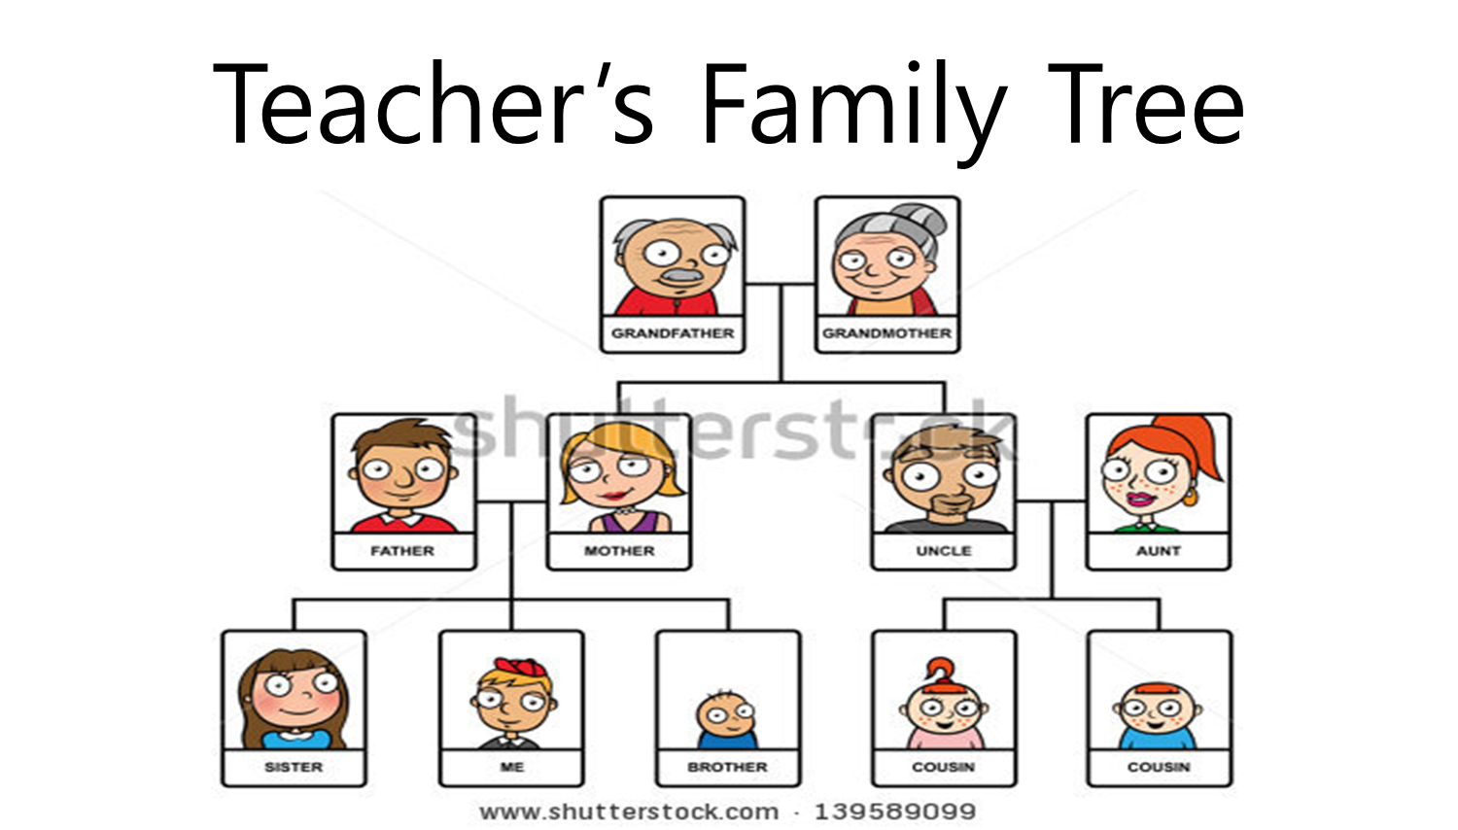

**PPT2**

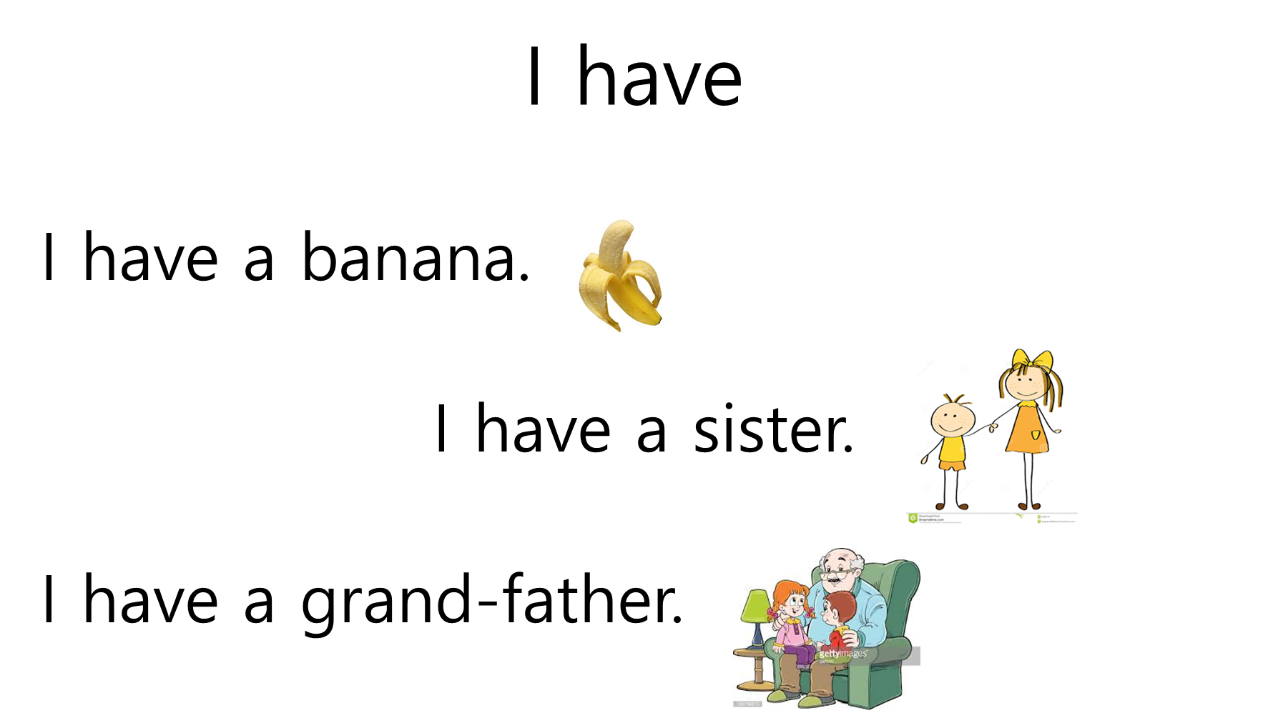

I don’t have

**PPT3**

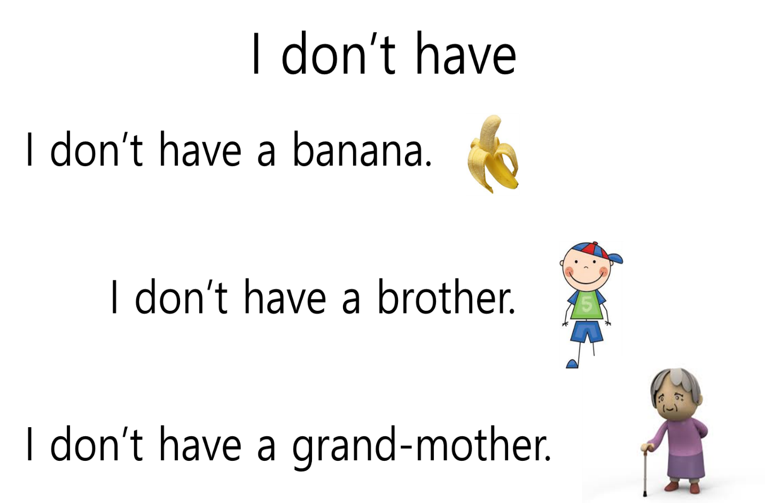

**PPT4**

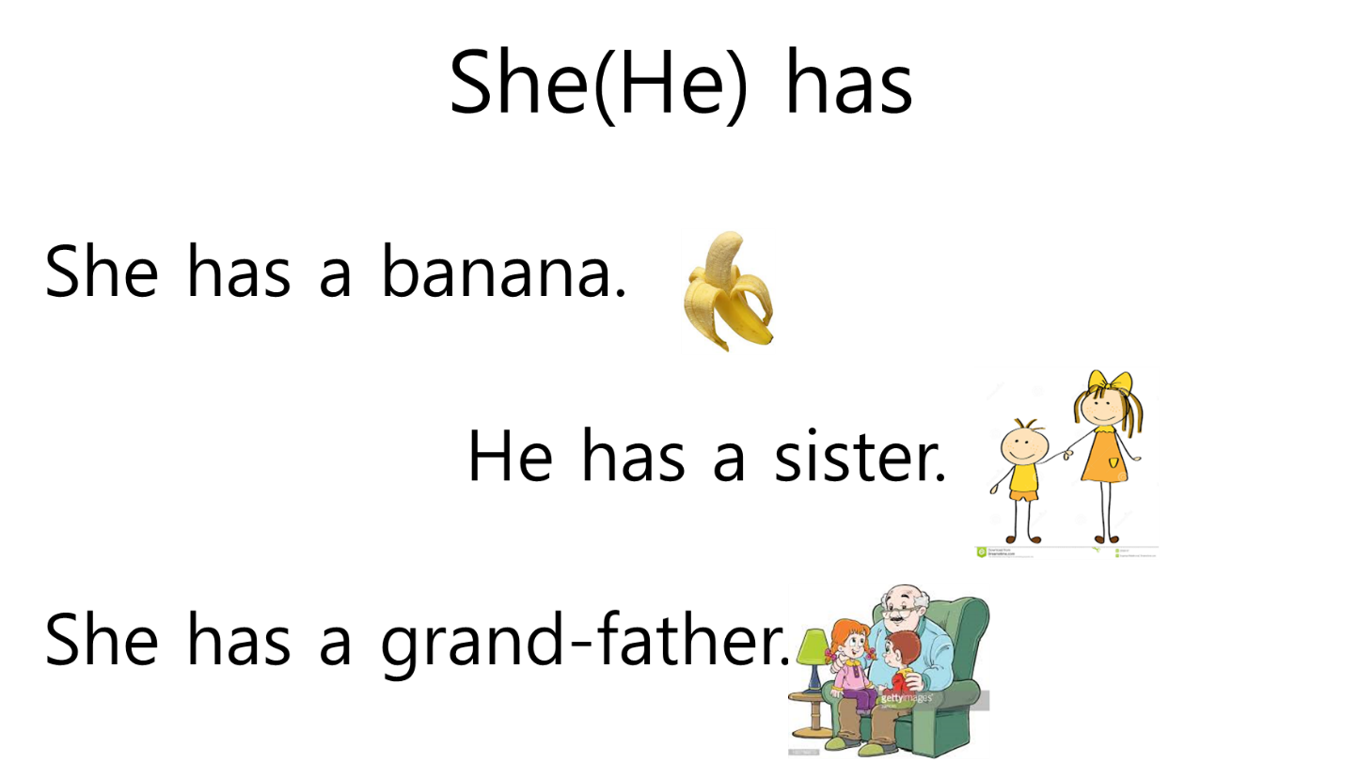

**PPT5**

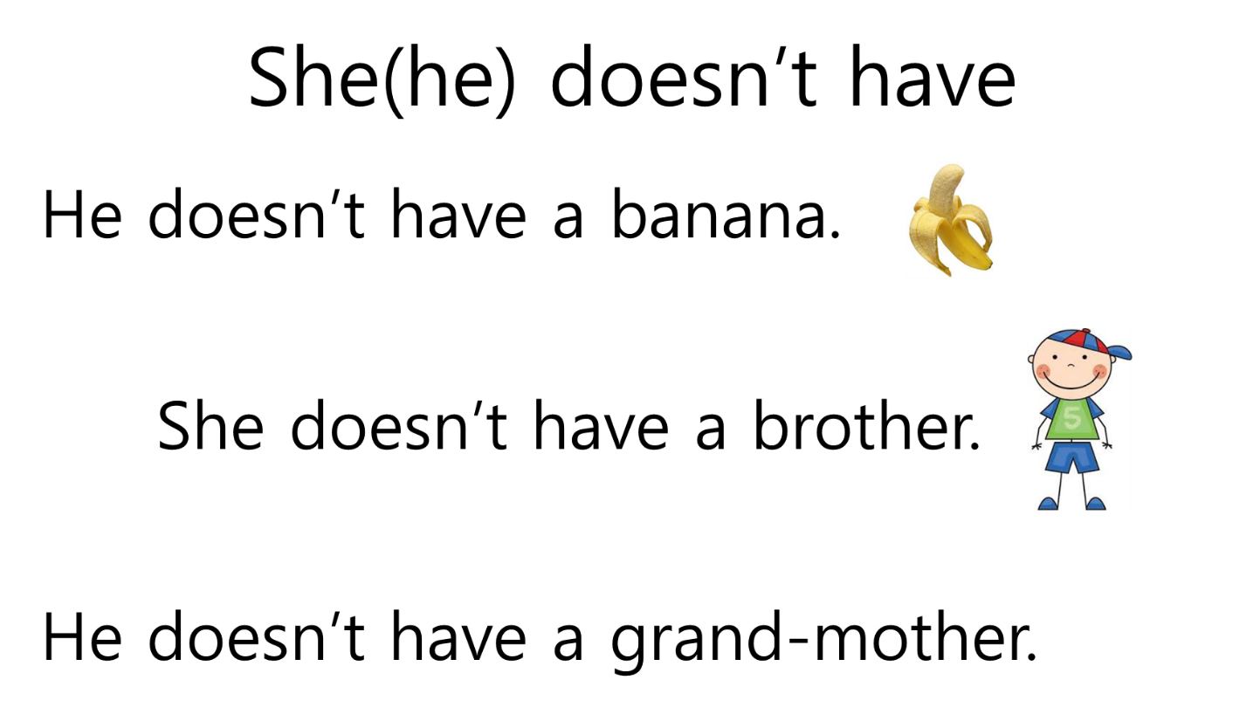

**PPT6**

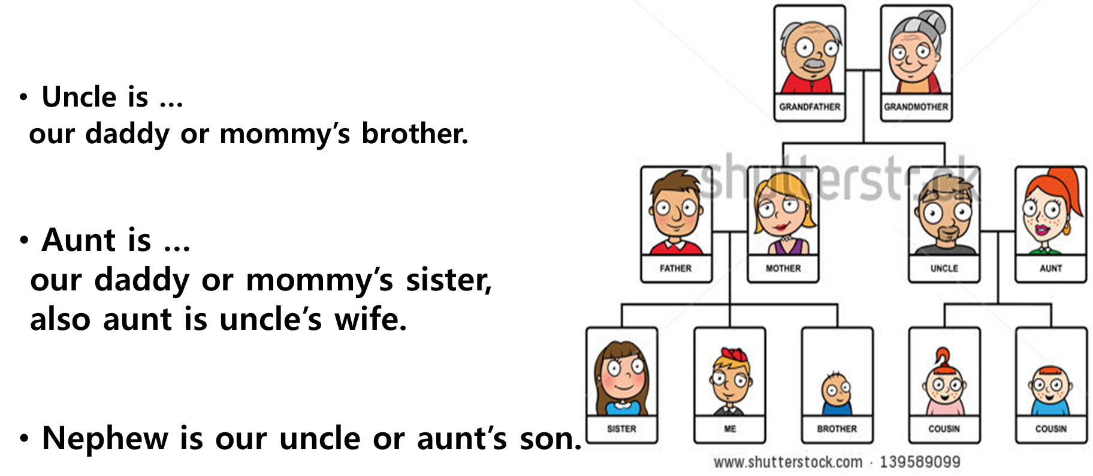

**PPT7**

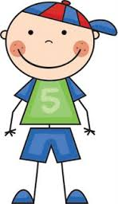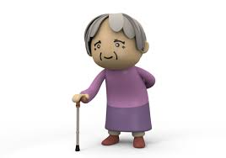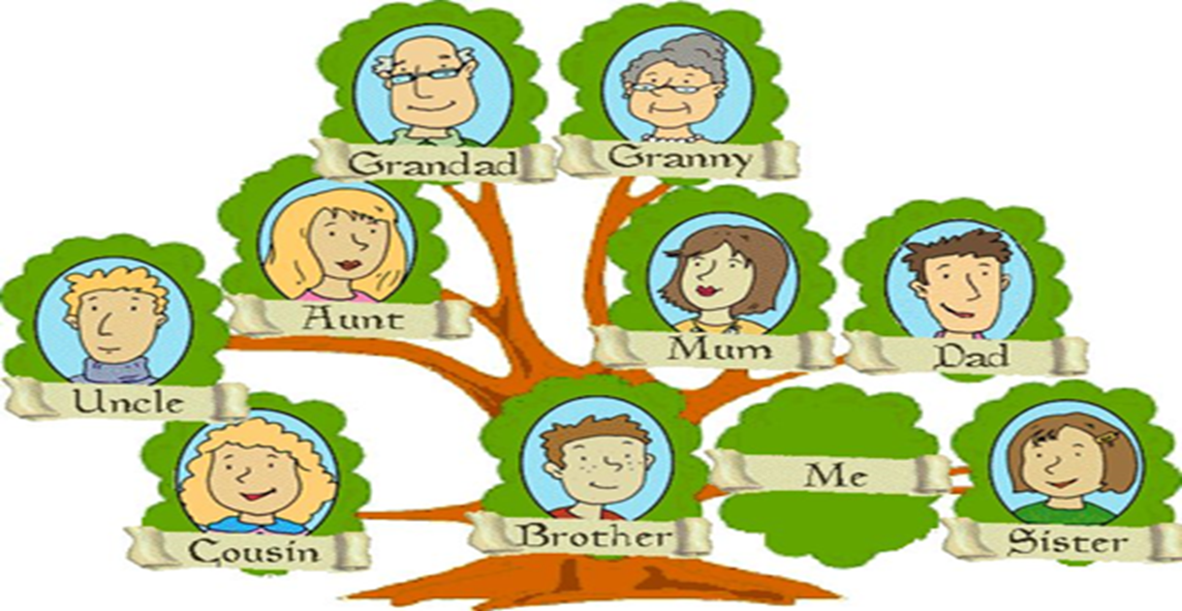

**<Trees every student will draw the faces of their family members….>**

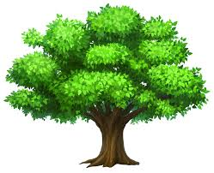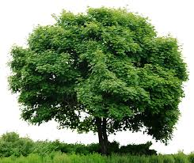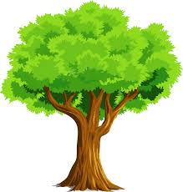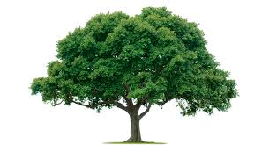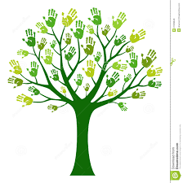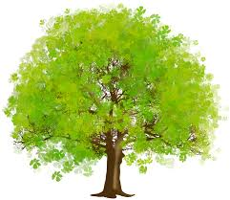

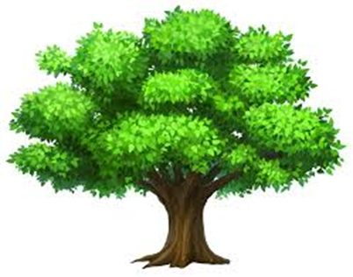

**<A work sheet when a pair work>**

**Let’s know about my friend’s family.**

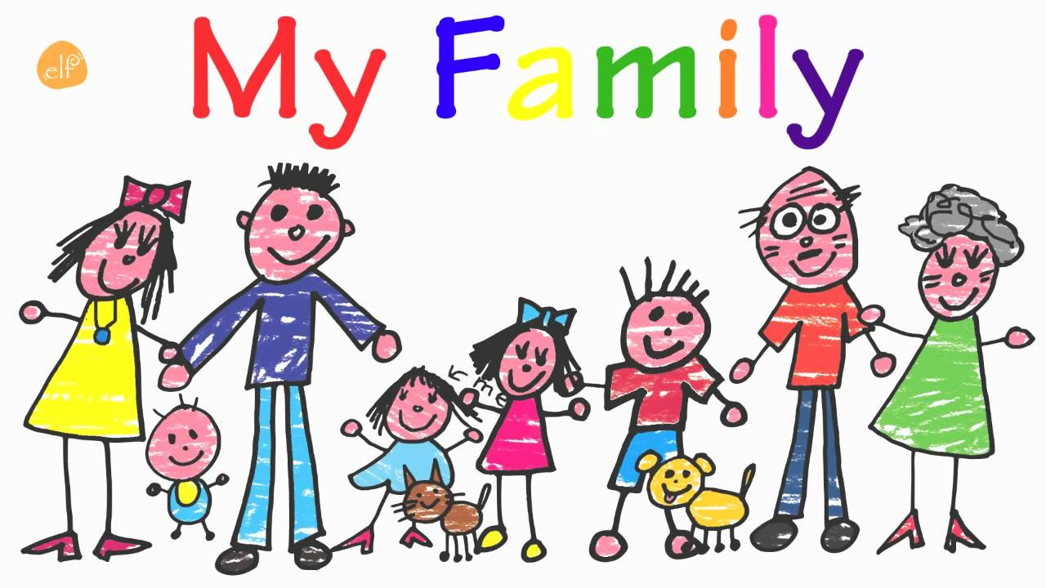

|  |
| --- |
| Father, mother, brother, sister,  uncle, nephew, grandfather, grand mother |

There are ______members in her family.

He(she) has _________, _______________, _____________, _________________.

He(she) doesn’t have _________, _______________, _____________, _________________.

He(she) loves her family.