☐ Listening ☐ Speaking ☐ Reading ☐ Grammar ☐ Writing

Topic: Keeping Health

Instructor:  MONICA KIM | Level:  Upper Intermediate | Students:  14 | Length:  - min

Materials:
- A whiteboard and markers
- 14 copies of Worksheet _Vocabulary and Collocations
(See attachment #1)
- 7 copies of the text “Some of the things they said were good for us...”
(See attachment #2_Reading#1)
- 7 copies of the text “…and some things we were advised to avoid”
(See attachment #2_Reading#2)
- PPT slides ( See attachment_#3 )

Aims:
- SS will be familiar with key vocabulary through T’s explanation and CCQ
- SS will be able to get the main idea by skimming the reading text given.
- SS will improve scanning skill by explaining to each other what they have read.
- Ss will improve speaking and listening ability by sharing ideas in a pair and in a whole class.

Language Skills:
- Reading : reading the texts of “ some of the things they said were food for us...” and “…and some things we were advised to avoid”/ Worksheet
- Writing : taking notes during pair discussion
- Speaking : Sharing ideas with whole classmates and talking to each other in a pair
- Listening : Listening to T’s presentation, instruction/ classmates’ ideas

Language Systems:
- Lexis: latter, stroke, impede, lab, plunge, fatal, battering, opt for, booze, prolong life, ward off, retail therapy, sedentary jobs, taste buds, dust mites
- Phonology: Correct pronunciation of vocabulary words
- Function: understand the context, practice dialogue
- Grammar: past and present tenses
- Discourse: explaining what they’ve read to each other in a pair

Assumptions:
- Most SS are interested in things that are good or bad for our health.
- SS will enjoy knowing the results of recent studies
- SS have their own private ways to keep them stay healthy
- SS are used to working in a pair.
- SS know how to skim and scan

Anticipated Errors and Solutions:
- SS may not know the key words.
- Have SS take a guess through worksheet exercises.
- SS may not understand some words and concepts.
- Show them the PPT slides with pictures.
- There may not be enough time to complete the text reading.
- Assign the post activity writing text as homework.

References:
- http://www.englishisapieceofcake.com/index.html
- TESOL Binder
- THE WEEK, pg 18~19, 24 December 2011, ISSUE 849

Lead-In
Materials:

Time | Set Up | Student Activity | Teacher Talk
1~2  min | Whole Class | Listen to Teacher | Hello, everyone? How are you feeling today? All of you look great and healthy. Are there any particular ways on your own or some secrets to be stay healthy, Angela?  (Angela says about some things.)  That’s great. I think that’s really effective for health.  About me, I take a vitamin pill every day, I try to eat different kinds of vegetables and I try to use steps instead of using elevator when I need to go upstairs in a building.  Today, we’ll going to learn some good and bad things about our health through reading exercises. Okay? Let’s start.

Pre-Activity
Materials: A whiteboard and markers, Computer liked with projector, PPT slide(Attachment #3)

Time | Set Up | Student Activity | Teacher Talk
3~4  min  4 min | Whole  Class | Watch some PPT slides.  Try to understand whole words.  Try to understand all of the words.  Answer the question  Listen to Teacher’s explanation  Do with the worksheet individually | Before we get into that, I’ll show you some pictures related to our health.  (Turn on the projectors and show PPT slides to SS.)  As you can see here, there are several things that are considered to be good or bad for human’s health. There have been a lot of researches mainly done by scientists and some of them are controversial until now in terms of the effectiveness toward health.  So, let’s quickly review these items.  - Elicit:  (Let SS know the words they’ll encounter in the text reading later.)  1)Placebos 2)Milk 3) An apple a day  4) Sleeplessness 5) Coffee  6)Red and processed meats 7)Desk jobs  8)Tangerines 9) Shopping  10) Vitamin pills 11) Washing dishes  12) Sugary drinks 13) Olive oil 14) Swearing  15) Your pillow 16) Salt 17) Green tea  18) Alcohol  Is there anyone who knows the first word “placebo”?  What can you guess from this image of placebo? Any idea?  (If there’s no answer from SS, explain that.)  A placebo is a pill with no effect. Sometimes a doctor gives it to a patient instead of a real drug.  This word is especially used for so-called “Placebo effect”. Have you guys heard about that? No?  Okay, Let’s assume some patient receive sugar pills by a doctor instead of real medicine. They don’t know they have taken fake pills. But as time goes by, they could get healthier. This is called “placebo effect”. That means expecting to get better has a powerful effect. Fake drug often becomes to work even though they are not effective enough.  - CCQ:  Is placebo a real drug?  (NO!)  Okay, Is there any word you don’t know among these words? No? That’s great.  Let’s move on.  I’ll give you a worksheet. There are some vocabularies and collocations that you have to match. Try to take a guess even though you don’t know the meaning. Okay?  I’ll give you 2 min and work on your own.  (Hand out Worksheet to SS.)  (After two minutes)  Did you find it easy or difficult? Okay. Let’s quickly review your answers.  (Review the answers one by one.)  Well done. In fact, these are the words that you’ll see in your reading session. So try to remember those words.

Main Activity
Materials: 14 copies of the reading text (Attachment #2),

Time | Set Up | Student Activity | Teacher Talk
1~2  min  15min | Whole Class  In pairs | Listen to Teachers’ instruction.  Read text given/ explain what they’ve read to each other in a pair. | - Instructions:  You are all 14, so I’ll split you into 7 pairs like this. Please seat with your partner. (Let SS seat in pairs.)  I’ll give you one article excerpt from the magazine “THE WEEK”. There’re two kinds of articles; the first one is about some good things for our health and the other one is about some bad things. Please, discuss with your partner which person choose which article.  Then, both of them in a pair have to read the text given. (simultaneously). After you read, pick one or two items and then explain to each other what they have read.  There are 9 items for each of you. I’ll give you 15mins. You don’t need to cover all of the items if you don’t have enough time. Try to explain to each other as much as possible.  When you see some words you don’t understand, just try to guess the meaning. I’ll be around here, so ask to me some of them if you’re really in need.  -CCQ:  Do you work alone?  What time do you have?  Is it possible to ask me if you have trouble?  Okay, Let’s start!  (Teacher monitor discreetly. Answer the SS’s questions when they have some difficulties in understanding the contents. Check if there are something or some words that have to share with whole class.)

Post Activity
Materials: A whiteboard, markers

Time | Set Up | Student Activity | Teacher Talk
3~4  min | Whole  Class | Answer the teacher’s questions./Share their ideas | Good. During your conversations, I’ve noticed  that some important words and collocations  you don’t really understand. So, I’ll explain  them once more.  (Explain the words)  Have you guys fun of reading this text?  Is there anything that you find interesting?  (Answer from SS)  Was there any information that particularly  surprised you?  (Answer from SS)  Okay, great! Well done everybody!  Please try to review the words you’ve learned  today after class.  There’s no assignment as usual.  Today’s class is done, See you next time.

Attachment #1

Worksheet #1. Vocabularies and collocations

- Match the word on the left with the definition on the right (Vocabulary):

- Latter a. causing or capable of causing death
- Stroke b. to hinder, to obstruct
- Impede c. the last item on a given list
- Lab d. to hit heavily and repeatedly
- Plunge e. death of brain cells due to lack of oxygen
- Fatal f. to choose
- Battering g. alcohol
- Opt for h. laboratory
- Booze i. to thrust or throw forcefully into a substance

- Match the collocations(collocations) :

Prolong jobs
Ward buds
Retail life
Sedentary mites
Taste therapy
Dust off

Attachment #2
Reading# 1. Good or Bad?

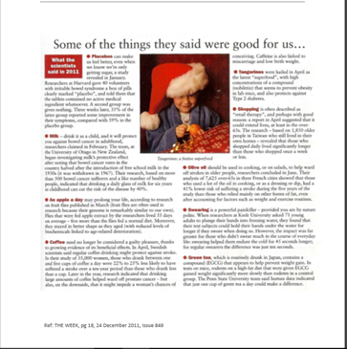

Attachment #2
Reading# 2. Good or bad?
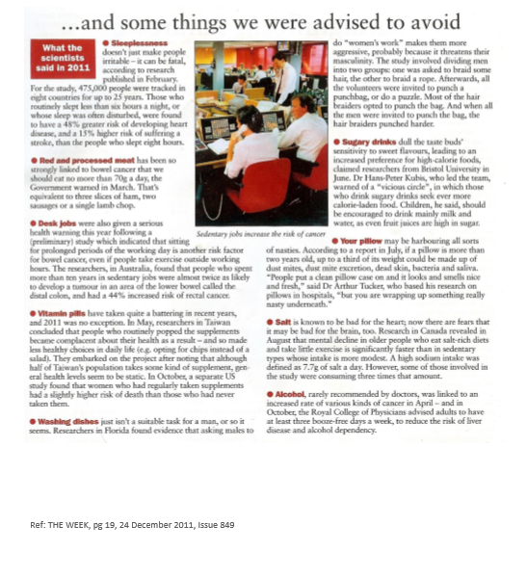
Attachment #3

