For Reading - Chess
Vocabulary preview
1. competitive 2. Alternate 3. Restrict
4. object 5. Opponent 6. Stipulate
7. precisely 8. Conjecture 9. Exist
10. invasion 11. Represent 12. Conquer

ⓐ to limit or control the size, amount or range of something ( )
ⓑ to happen or be present in a particular situation or place ( )
ⓒ competing very hard to be more successful than other people or businesses ( )
ⓓ the purpose of a plan, action or activity ( )
ⓔ exactly and correctly ( )
ⓕ someone who you try to defeat in a competition, game, fight or argument ( )
ⓖ to take control of another country by force ( )
ⓗ to switch from one to the other in a repeated pattern ( )
ⓘ to make an agreement, law, or rule about something that must be done ( )
ⓙ having ideas or opinions with little information ( )
ⓚ to symbolize or express something ( )
ⓛ the act of entering and attacking another country by force ( )

For Reading - Chess
Main text
hess is a competitive and recreational game played between two players on a checkered board with 64 squares, alternately black and white. Both players start the game with 16 black or white pieces; each piece can be moved only according to its own particular restrictions.
The object of the game is to force your opponent into such a position that he or she is unable to move without the loss of their “king” piece. This position is called “checkmate”. Games may also be drawn if a “stalemate” is reached, where no one can move to any effect. In serious competition chess, moves may be “timed out” if a player takes longer to make a move than stipulated time limit.
Chess is an ancient game. How ancient or precisely where it originated is a matter of conjecture. It is believed to have come originally from India, but it is known that it was also played in China and Arabia. One clue is that an Indian game similar to chess exists called “chaturanga”, which appears to resemble closely a game recorded from Persia in the 6th century as “shatranj.” Another theory is that the game originated in China.
The Arabs acquired the game during their invasions of Persia, and then brought it to Europe when they conquered Spain in the 10th century. The chess pieces used in the “modern” game date from the Middle Ages, and so represent figures familiar at that time – bishops, castles (otherwise known as rooks), knights, pawns (representing serfs), a king and a queen.
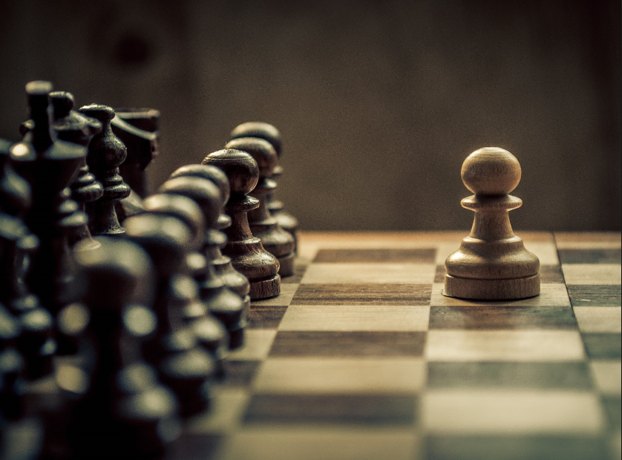
<Questions>
- What does mainly discuss about in this text?
- In “stalemate” position, what happened? Please describe this situation.
- The writer said, “The origin of chess is just a matter of conjecture.”, why did the writer say so? Do you agree with this?
For Reading - Chess
Work sheet #1
A. Choose the word that best completes each sentence. (Change the form, if necessary)
Alternate restrict opponent stipulate represent

1. The regulations ____________ that everything has to comply with the relevant safety standards.
2. Periods of depression ____________ with excited behavior.
3. When Tom was younger, he hated the school and everything it ____________.
4. The new laws ____________ the sale of handguns.
5. During the primary elections, Hillary was Trump’s leading ____________.

B. Please rearrange the words below to make complete sentences.
Please do NOT look at our main text, below sentences are on main text originally, just organize by yourself.

1. where / how / ancient / a matter of conjecture / or precisely / it originated / is

2. acquired / during / their invasions of Persia / the game / the Arabs

3. that / the game / originated in China / is / another theory

For Reading - Chess
Work sheet #2
A.
1. The following explanations correspond with a chess game EXCEPT
(a) The game is played alternately black and white.
(b) A time limit exists.
(c) Games are not likely to end in draw.
(d) The chess pieces used in the modern game are related to the Middle Ages.

2. The following are used as chess pieces EXCEPT
(a) bishop (b) king (c) elf (d) knight

3. Which of the followings is NOT considered the place chess originated?
(a) China (b) India (c) Arabia (d) Europe

4. According to the text, what happened in 10th century?

B. Choose the closest meaning to the following words.
1. conjecture
a. favor b. donate c. guess d. conviction
2. invasion
a. intrusion b. admission c. abolition d. registration
3. object
a. supreme b. obligation c. inject d. aim
4. restrict
a. limit b. bless c. drain d. blaze
For Reading - Chess
Work sheet #2
A.
1. The following explanations correspond with a chess game EXCEPT
(a) The game is played alternately black and white.
(b) A time limit exists.
(c) Games are not likely to end in draw.
(d) The chess pieces used in the modern game are related to the Middle Ages.

2. The following are used as chess pieces EXCEPT
(a) bishop (b) king (c) elf (d) knight

3. Which of the followings is NOT considered the place chess originated?
(a) China (b) India (c) Arabia (d) Europe

4. According to the text, what happened in 10th century?

