Listening ☐ Speaking ☐ Reading ☐ Grammar ☐ Writing

Topic: People in my town

Instructor:  Clarius | Level:  Pre-intermediate  (Age under 12) | Students:  10 | Length:  50minutes

Materials:
- Computer
- Speaker , Screen
- Projector
- White board, board markers
- Handouts #1, #2, #3, #4

Aims:

- To learn vocabulary and idioms related to jobs
- To be able to match the vocabularies and idioms with the right description
- To be able to write the proper words in accordance with the context
- To practice listening skills by listening to an English song

Language Skills:

- Reading: Lyrics of the song
- Listening: English song about jobs
- Speaking: Singing song him/herself, Discussing in pairs
- Writing: Filling blanks

Language Systems:

- Phonology: Learning the pronunciation by singing an English song
- Lexis: Vocabulary and idioms related to job
- Function: note-taking skills, Matching the words with the right pictures
- Discourse: Pair discussion, Group discussion

Assumptions:

- Students are aware of various jobs
- Students are curious about different types of jobs
- Students understand the function of each job
- Students are able to listen to a song and sing along willingly

Anticipated Errors and Solutions:

- Students may have difficulty in understanding the jobs’ description
- Have the students discuss about the job in group / Teacher provide some explanation about the jobs

- Students may not be able to understand the song at first time
- The activities will be provided step by step and the song will be played for four times.
- When needed, playing the song one or two more times

- Students are too shy to sing along
- Teacher sings and encourages the students to sing together
- Increase the volume of the song to cheer up the students

References:
YouTube
https://youtu.be/JBXaupIJHr8?list=PLNzoOuFP8wo5Wp1dGXz8TsIPm4pWVKPsf

Lead-In
Materials: Board, Board markers, Post-it
Time | Set Up | Student Activity | Teacher Talk
5min | Whole class  Group  Whole  class | Answer the questions  Write dream job on a post-it  Answer the question | Hello, everyone. How was your weekend?  I saw a movie last Saturday with my wife and it was about a boy who achieved his dream as an astronaut. What is your dream job? Talk within groups for few minutes and write your dream job on the post-it.  (Teacher distributes post-it to students)  /Students talk in group about their dream jobs)  Okay. Sam, what is the dream job of your partner? Olivia, what is your dream job?  (Teacher asks few students)  Thank you for sharing your dreams with us. Today we will learn some words and idioms about various jobs by listening to a song.

Pre-Activity
Materials: Computer, Speaker, Worksheet #1
Time | Set Up | Student Activity | Teacher Talk
5min  3min | Whole class  Whole  class | Listen to the song and order the picture according to the song.  Complete worksheet #1 | Instruction  Now, I am going to play a song. Listen carefully to the song and write the number below the picture according to the order.  (Distribute worksheet #1)  Let’s do the first verse as an example.  CCQ  What should you write under the first picture?  Now, let’s listen to the whole song, and place the rest of the picture in order.  (Play the song)  Monitor discreetly whether the students understand the song.  (Check the answers)  Ok, let’s check together. What is number 1? And what comes next?  Great job! Now, let’s move on the next activity.

Main Activity
Materials: Computer, Speaker, Worksheet #2,#3
Time | Set Up | Student Activity | Teacher Talk
10min  2min  15min  5min | Whole class  In pairs  Whole  class  Group  Whole  class | Listen to the song and match the pictures to the description  Share and compare ideas about the answers  Answer the question  Discuss the answer in team  Verifying the answers | - Listening and matching the words with its description  Instructions  Listen to the song one more time. This time, try to match each picture with its description in the box.  (Distribute worksheet #2)  CCQ  What are you supposed to do?  (Play the song)  Do you need more time to finish?  - Yes → Give a couple more minutes  - No → Ok, compare your answer with your partners.  (After 1 minutes)  Ok, let’s see the answer together. Sam, which description matches with picture B?  Olivia, which matches with picture C?  - Filling blanks  Instructions  Now close your books and do not look at the handouts. Now, remember what you listened, and fill in the blanks. Discuss in team.  (Distribute worksheet #3)  Ok, Let’s listen to the song and see you have the right answers.

Post Activity
Materials: Computer, Speaker, Worksheet #4
Time | Set Up | Student Activity | Teacher Talk
5min | Whole class | Sing the song together | Instructions  Now, at last, let’s sing the song all together.  (Students sing the song)  Great job. Today you have learned various vocabularies and idioms about jobs through a song. Before you go, please put the post-it, on which you have written down your dream jobs, on the classroom wall.  Please reviews today’s learning and see you next time.

Worksheet #1
Direction: Listen to the song and write the number below the picture according to the order. When you are done, compare your answer with your partner.

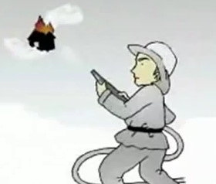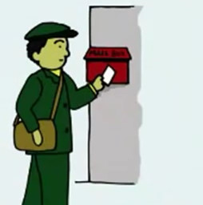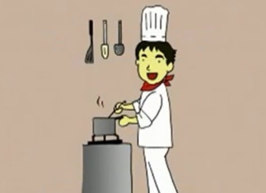
1

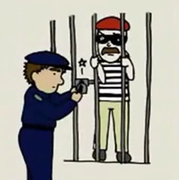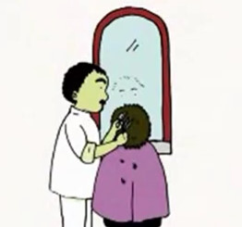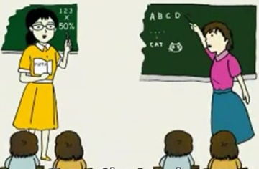

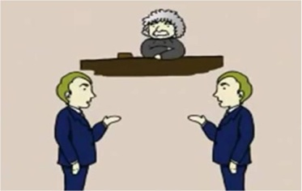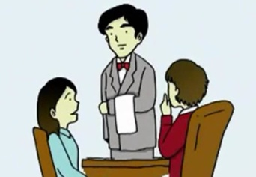

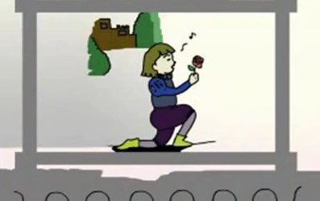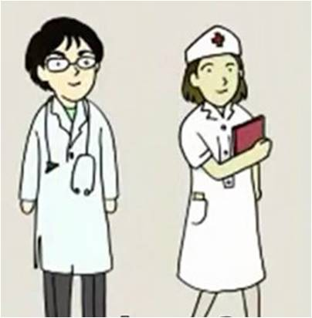

Worksheet #2
Direction: Listen to the song one more time, and match the pictures to the description.

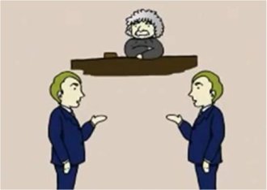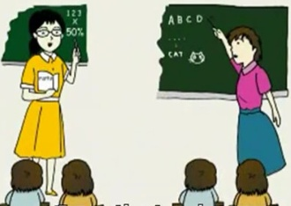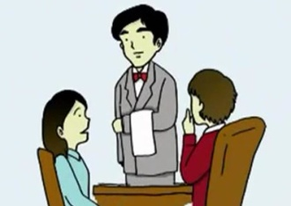
D
C
B
A
H
G
F
E
O
N
M
L
K
J
I

- fighting fires | ( A ) |  |  | - in the local schools | ( )
- changing tires | ( ) |  |  | - acting on the stage | ( )
- flying through the air | ( ) |  |  | - writing on the page | ( )
- cutting peoples hair | ( ) |  |  | - working in a restaurant | ( )
- with the mail | ( ) |  |  | - asking what you want | ( )
- putting folk in jail | ( ) |  |  | - in the courts | ( )
- at the swimming pool | ( )

Worksheet #3
Direction: Listen to the song and fill in the blanks.

I see s fire fighter (fighting fires)
I see a (car mechanic) changing tires
I see a pilot (flying through the air)
I see a (barber) (cutting people hair)
I see the people in my town and I say “Hey brother! What’s going down?”
I see a (postman) with the mail
I see the police (putting folk in jail)
I see a (lifeguard) at the swimming pool
I see the teachers (in the local schools)
I see the people in my town and I say “Hey brother! What’s going down?”
Doctors, nurses, (astronauts), judges, lawyers (in the courts)
I see an actor (acting on the stage)
I see a (writer) writing on a page
I see a (chef) working in a restaurant and a waiter (asking what you want)
I see the people in my town and I say “Hey brother! What’s going down?”
Doctors, nurses, astronauts, (judges), (lawyers) in the courts
I see the people in my town and I say “Hey brother! What’s going down?”
I say “Hey brother! (What’s going down?”) ♬♪♩

Worksheet #4
Direction: Now, let’s sing together!

I see s fire fighter fighting fires
I see a car mechanic changing tires
I see a pilot flying through the air
I see a barber cutting people hair
I see the people in my town and I say “Hey brother! What’s going down?”
I see a postman with the mail
I see the police putting folk in jail
I see a lifeguard at the swimming pool
I see the teachers in the local schools
I see the people in my town and I say “Hey brother! What’s going down?”
Doctors, nurses, astronauts, judges, lawyers in the courts
I see an actor acting on the stage
I see a writer writing on a page
I see a chef working in a restaurant and a waiter asking what you want
I see the people in my town and I say “Hey brother! What’s going down?”
Doctors, nurses, astronauts, judges, lawyers in the courts
I see the people in my town and I say “Hey brother! What’s going down?”
I say “Hey brother! What’s going down?” ♬♪♩

