☐ Listening ☐ Speaking ☐ Reading ☐ Grammar ☐ Writing

Topic: Describing cooking recipe

Instructor:  MIN(Ji Eun Kim)  157WD | Level:  Intermediate | Students:  14 | Length:  50min

Materials:
-Recipe Vocabulary sheet 1 2 3
-Worksheet: Complete the blank
-Wall charts sample : Making a wall charts / posters, Markers, Tape
-Video clip : You tube
-Computer, Projector devices

Aims:
To recognize various verbs that describe cooking by brainstorming
To identify cooking recipe vocabulary from video
To comprehend the details cooking recipe and verbs
making the wall charts.
To practice describing how to cook food/meal/dish by making
their own sentences with verbs and words.

Language Skills:
Listening: SS listen to cooking recipe video.
Speaking: SS share their own recipe with others.
Writing: SS will create their own recipe,
SS will write how to cook my dish/food/meal.
Reading: SS will watch the You tube video with subtitle.

Language Systems:
Lexis: Learn new vocabulary from the Vocabulary sheet and work sheet
(cooking recipe words)
Function: Describing cooking recipe that SS know how to cook.
Discourse: Discuss ideas involving cooking

Assumptions:
SS have Intermediate level and can create their own sentences.
SS communicate using the language appropriately in everyday and specialized language situations
SS have experience making breakfast.

Anticipated Errors and Solutions:

Students may not know vocabulary words in the vocabulary sheets.
Encourage students to guess and identify words from context and explaining.
The video may be too fast for students: replay few times or read it loud.
Monitor activities of students and support them
when they ask of they are confused.

References:

www.google.com - Recipe Vocabulary sheet 1 2 3

You tube : mmmEnglish 01 Cooking Verbs & How to Poach an Egg!

You tube URL : https://youtu.be/bOnmVFww6gc

Lead-In
Materials:
Time | Set Up | Student Activity | Teacher Talk
3min | Whole  class | Warm up | Greet students and ask about breakfast.  Hi guys  It is time to start listening.  How is it going?  What did you do?  What did you have for breakfast ?  I had a great toast for breakfast !  Everyone loves toast.  I learned how to make a poached eggs on toast easy at home!  Can you introduce us how to make  a poached eggs on toast?  Expected answers are:  Boiling water…  Pour the egg…  Ok, We will listen to how to make  a poached eggs on toast easy at home.  First We will learn kitchen verbs that describe how to cook.

Pre-Activity
Materials: board / vocabulary sheet 1 2 3
Time | Set Up | Student Activity | Teacher Talk
15min | pair | Brainstorm  SS think of and describe as many useful cooking verbs as they can.  SS ask questions to Teacher. | Brain storm and describe vocabulary meaning on vocabulary sheet.  Vocabulary  With your partner, think of and list as many words as you can that  describe how to cook  Put the vocabulary sheets 1 2 3 on the board.  Hand vocabulary sheets 1 2 3 out to SS.  Talk with your partner how to describe what words mean.  (SS think of and describe as many useful cooking verbs as they can.)  CCQ  Are you allowed to work with your partner?  How many cooking words do we have to think of and describe?  How do you describe cooking words?  Let’s learn cooking vocabulary meaning.  We will learn kitchen verbs.  Teacher will explain cooking words on vocabulary sheet.  T: “Stir” means ….  “Simmer” means…  This is a list of words that describe cooking.  Some are what we’ve already talked about, and some are not.  If you have any verbs of which you do not know the meanings.  Please ask me.

Main Activity
Materials: Video, Computer, Projector devices

Time | Set Up | Student Activity | Teacher Talk
17min | Whole class  Individually | SS will fill in the blank on worksheet  While listening. | Listening to the video  while watching  Now, Listen to describing how to cook a poached eggs on toast while watching.  The video’s speaker, Emma introduces some simple cooking verbs. She’s making a very simple breakfast dish to demonstrate these verbs.  First, just listen to the video’s speaker  while watching the video.  CCQ  What does she will talk about ?  What toast does she make for breakfast ?  Are you supposed to do something while listening?  (Distribute the Worksheet.)  Please Complete the blank.  Now, you will listen to the video again.  CCQ  What are you supposed to do on Worksheet?  (Play the video)  Do you need to listen again?   Yes Play the video again.   No →Continue.  Teacher will check the answers.

Post Activity
Materials: Charts/Posters sample, Markers, Tape
Time | Set Up | Student Activity | Teacher Talk
15in | Group  Group | Making wall charts/posters  SS work in group.  SS follow the direction.  Students will work in group  Students share their own ideas. | Work in groups to make wall charts / posters  NOW, let’s make wall charts/posters of cooking recipe in group.  (Teacher gives wall charts/posters sample. )  Please Itemize content of recipe.  Teacher will put SS’ wall charts/posters up on the wall.  Free Production  Please, come up how to cook  Food / meal / dish easy at home.  Introduce simple recipe using verbs  at least 3 kitchen verbs.  Share your own recipe with your group.  Please Share your own recipe with your group.  (Teacher will monitor group activity.)  CCQ  What are you supposed to talk with your group?  Which verbs do you use for your own recipe ?  How many verbs does your group use in group activity?(kitchen verbs)  Conclude lesson  See you tomorrow!

SOS Activity
Materials:
Time | Set Up | Student Activity | Teacher Talk
 | Individually |  | Extra vocabulary sheet

Work sheet
Complete blank

- First, light the ( ).

- Put the ( ) on the stove.

- Then, ( ) the water into the frypan.

- Wait until the water is ( ).
So, to show you the difference between ( ) water and ( ) water: The water in this pot is ( ) – it’s very hot and there’s lots of bubbles. And the water in this pan is ( ), so there’s a few small bubbled but it’s not yet as hot as ( ).

- Then, ( ) the vinegar to the water

- ( ) with a spoon.

- ( ) the eggs into the pan, carefully.

- Toast the bread Poached eggs are served on toast. So, toast is just a slice of bread that has been toasted in a ( )!

- ( ) some butter on the toast. OK, it’s time to get our eggs out of our ( ).

- I’m going to use the ( ) to carefully lift the eggs out of the ( ).

- Let the water drain away.

- ( ) the egg on the toast. And repeat!
Wall Chart / Posters Sample
how to make a poached eggs on toast!

(Wall Charts / Posters should consist of 5 articles.
Please Itemize content of recipe)

1.

2.

3.

4.

5.

vocabulary sheet 1
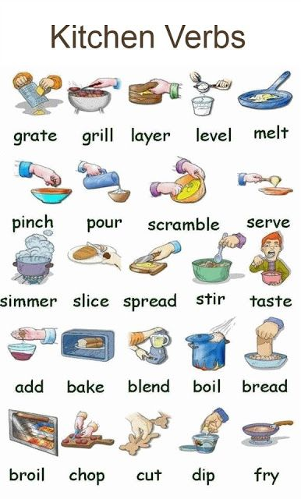

vocabulary sheet 2
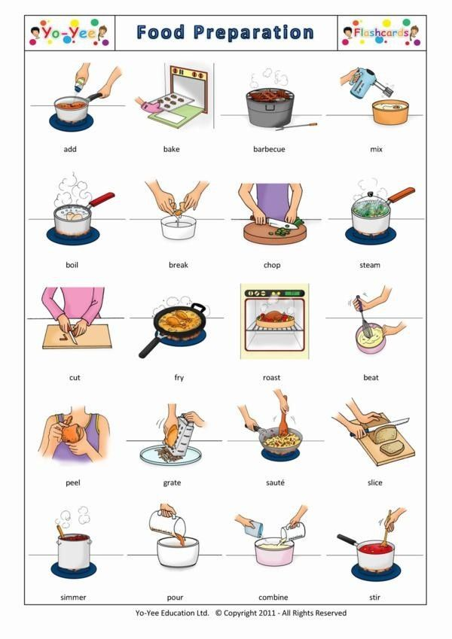
vocabulary sheet 3

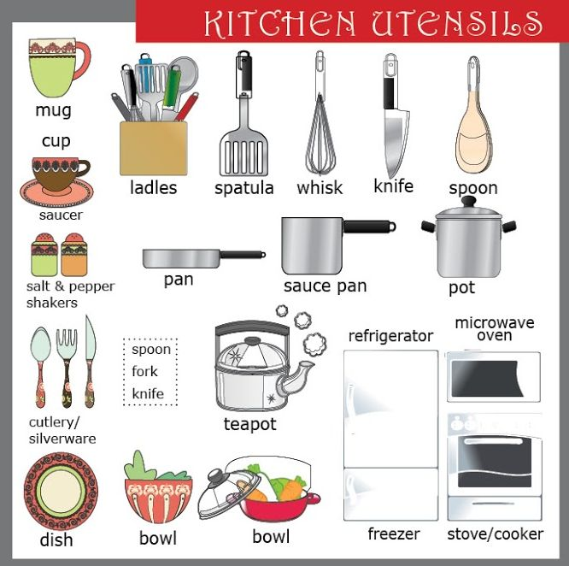

Video Script
Hi everyone! Welcome to the very first video lesson from mmmEnglish.com! I’m so excited you’re here! So excited actually. I’m going to do a dance…
OK! Today’s lesson is going to be about cooking verbs and I’m going to show you these verbs by cooking a very simple breakfast recipe. It’s called ‘poached eggs on toast’.To poach something means, to cook it in liquid. So poached eggs are eggs that are cooked in water.
So, what do we need?
• 2 fresh eggs
• 1 litre of water
• 1 tablespoon (tbsp.) of white vinegar
• A medium-sized frypan
• A spatula
• A stove
And to serve our eggs, we’ll need some toast (not bread), butter, salt and pepper. Ready? Let’s do it!
• First, light the stove.
• Put the frypan on the stove.
• Then, pour the water into the frypan.
• Wait until the water is simmering. So, to show you the difference between boiling water and simmering water: The water in this pot is boiling – it’s very hot and there’s lots of bubbles. And the water in this pan is simmering, so there’s a few small bubbled but it’s not yet as hot as boiling.
• Then, add the vinegar to the water
• Stir with a spoon.
• Crack the eggs into the pan, carefully.
• (Toast the bread) Poached eggs are served on toast. So, toast is just a slice of bread that has been toasted in a toaster!
• Spread some butter on the toast. OK, it’s time to get our eggs out of our frypan.
• I’m going to use the spatula to carefully lift the eggs out of the frypan.
• Let the water drain away.
• Put the egg on the toast. And repeat!
So an egg has two different parts. The white part is called the egg white and the yellow part here is called the egg yolk. Very important when your making poached eggs is that the egg yolk is runny – and not hard! We can test that in a minute but first, let’s add our salt and pepper to out eggs. And, cut our yolk open and see if we have a soft, runny egg yolk. Perfect!
OK, now I’m going to grab a coffee and sit down and have my breakfast! I hope you enjoyed this episode!

