■ Listening ■ Speaking ■ Reading ☐ Grammar ☐ Writing

Topic: Draw My Picture!

Instructor:  SON SEUNGYEON  CHO KYOOTAE | Level:  Beginner | Students:  6 students | Length:  35 minutes

Materials:

6 sheets of shape chart
6 matching worksheets
2 different paintings
6 blank sheets of paper
Pens
Board and markers
Computer and speaker
Audio files

Aims:

- To learn vocabularies by distinguishing different shapes to describe given pictures
- To practice speaking by discussing with classmates
- To practice listening skills through discussion

Language Skills:

Listening: listening partner’s explanation
Speaking: describing some pictures
Reading: completing vocabulary worksheet

Language Systems:

Lexis: students can learn words for describing shapes
Grammar: students can use words for directions such as under, inside and above etc.
Phonology: how various words for shapes are pronounced
Function: when and how to use such words
Discourse: discussions in pairs

Assumptions:

- Students are around 10 years old
- All students are beginners
- Some students make inaccurate pronunciations
- Some students may interpret key vocabularies inaccurately
- Students know they should use only English in the class

Anticipated Errors and Solutions:

- If time is running out, shorten the discussion time. (cut-off plan)
- If there is more time left then expected, give students more time for discussion. (SOS plan)
- If students have trouble understanding key vocabs, let their partners to help them out (do not help them directly).
- If students finish group discussion earlier than expected, give more time for the whole-class discussion and try to ask as many students as possible.

References:

Shapes Worksheet:
http://mahim.info/shapes-worksheets-first-grade/
Picture 1:
https://s-media-cache-ak0.pinimg.com/originals/67/df/ec/67dfec329d2f6c3e7136d39c63e35bc1.jpg
Picture 2:
http://kidzactivities.net/wp-content/uploads/2015/05/Castle-craft-sticks-free-printable.pdf

Lead-In
Materials:
Rectangular shaped book, Square shaped paper
Time | Set Up | Procedure
3 min | Whole class | Hi, everyone. How was your weekend?  Did you guys do anything fun? (ask several students)  Have you ever had a slice of pizza? What does it look like? Can you tell me the shape?  Do you know anything that has the same shape as a pizza slice?  Let students to think for a moment, and let them say “triangle”  Here is a book, and this paper.  Can you tell the difference?  Give students some time, and lead them to say “rectangle” and “square”

Pre-Activity
Materials:
Shape charts, Audio file.
Time | Set Up | Procedure
5 min | Whole class | Before we start a fun activity, we will learn some vocabularies describing shapes.  (Distribute shape charts to students)  Are you familiar with these words?  We are going to learn how to pronounce first.  Please repeat after this.  (Open the audio file so that students repeat each shape with proper pronunciation)

Main Activity
Materials:
Pictures, Blank sheets, Pens
Time | Set Up | Procedure
20 min | Pairs | Okay, now is everyone more comfortable with describing shapes?  Today, we are going to do an activity called “Draw My Picture!”  Has anyone played it before?  Instruction:  First, you will work in pairs with the person next to you.  Then, one person in each group will get a picture, and make sure not to show it to your partner, and the other person will get a blank paper.  The person who has the picture has to describe it verbally, and the other person has to draw according to the direction.  I will give you 5 minutes to run the activity, and when drawing is done, you can compare with the picture and discuss how similar or different it is for another 5 minutes.  And then, we will switch roles and play again for the same amount of time.  Is everyone ready?  Distribute pictures and blank sheets of paper (X2)  Give students some time to check pictures  CCQ’s:  How much time do you have?  Who do you work with?  Teacher monitors students actively and see how each group is working  You have 1 minute left to finish drawing  Okay, time’s up. Now compare your drawings and discuss with your partners.  You have 1 minute left

Post Activity
Materials:
Worksheet
Time | Set Up | Procedure
5 min  2 min | Individual  Whole class | Did you guys have fun?  Was there anything interesting?  Let students to share comments, and if nobody mentions, pick several students  Distribute worksheet  Instruction:  Okay, I am sure you are now more comfortable with shapes.  Now, we will do a matching worksheet. You will have to connect each shape and word that are matching like the example.  I will give you 5 minutes.  CCQ’s:  How much time do we have?  What do you have to do?  You have 1 minute left  Distribute answer sheets  Now, I want you to check the answer.  Answer Check:  What’s the answer for the first shape?  Keep asking until the last shape  Let students to say answers out loud  How was today’s activity? Was it fun?  Well, tomorrow we will learn more words that describe different shapes.  Class is over, have a wonderful day and see you tomorrow.

Shapes Worksheet:
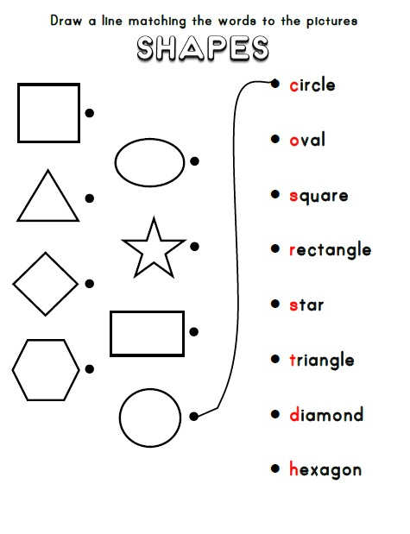

Shape Chart:
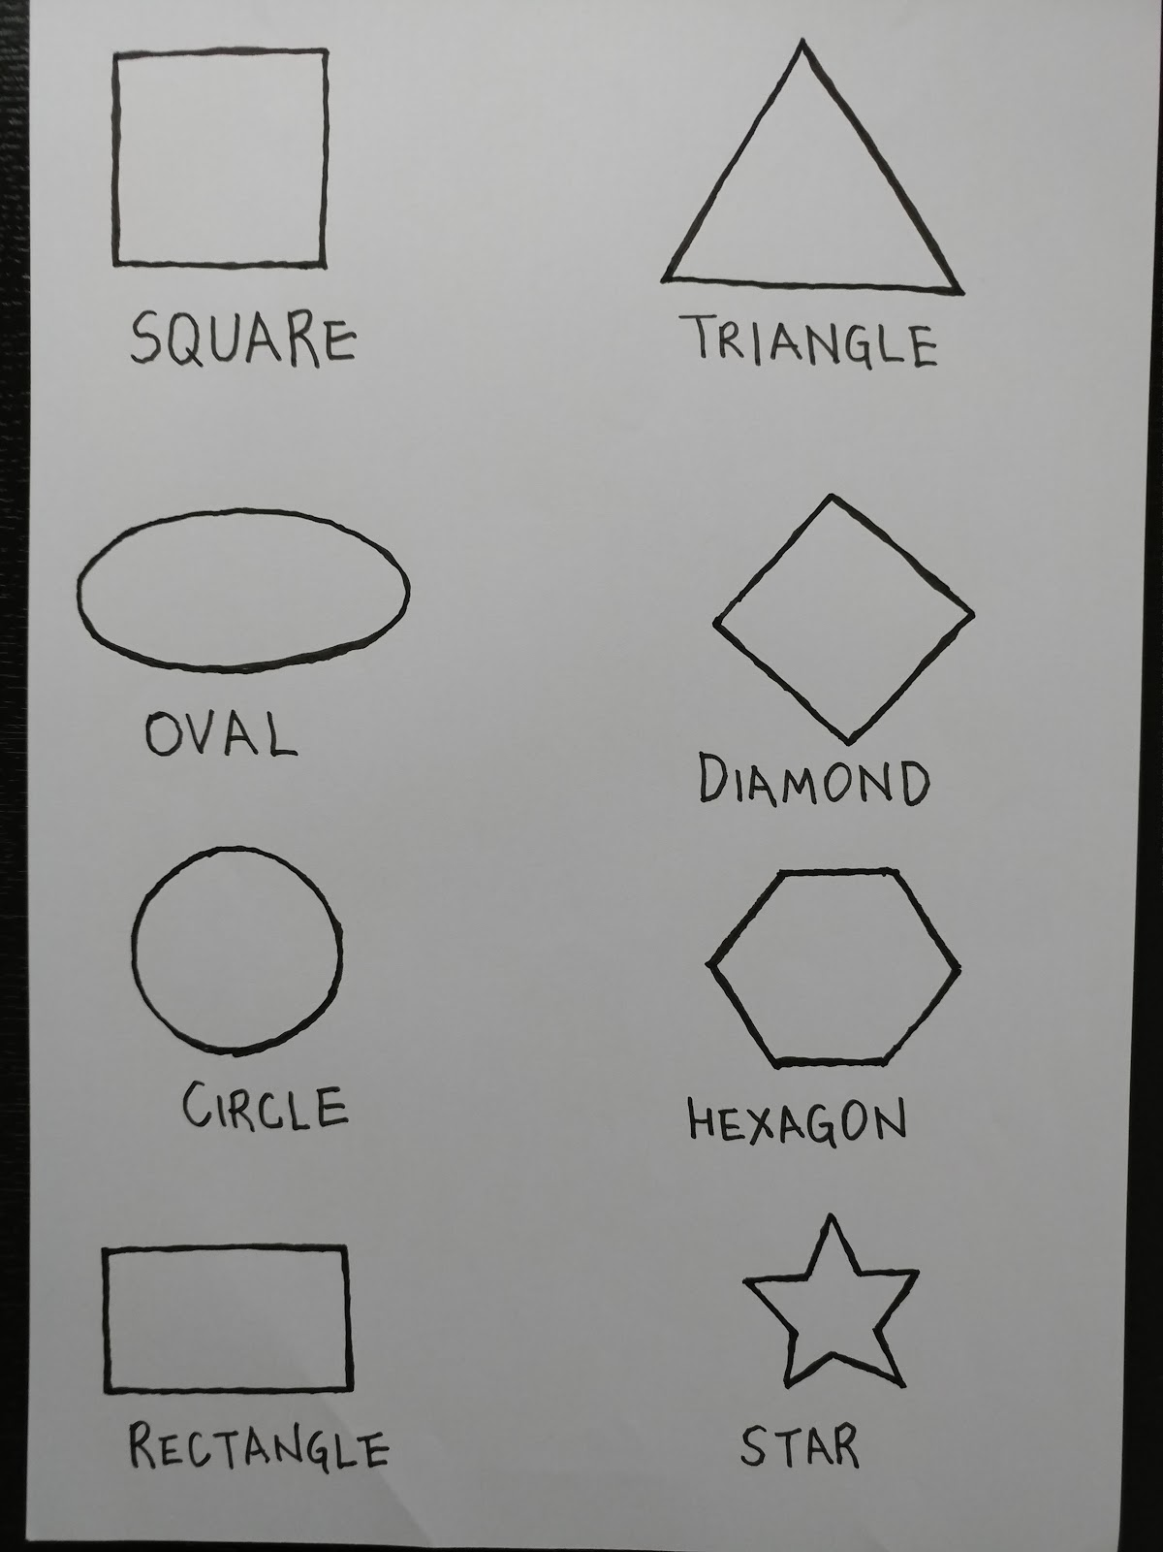
Picture 1:
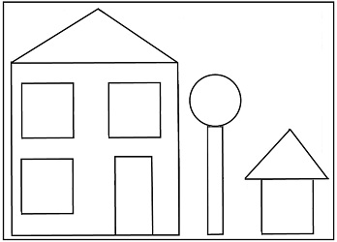
Picture 2:
