☐ Listening ☐ Speaking ☐ Reading ☐ Grammar ☐ Writing

Topic: Adverbs of Sequence

Instructor:  Winona | Level:  Intermediate | Students:  20 | Length:  45 minutes

Materials:
-Blank sheet of A4 paper
-Worksheet
-handouts
-questionnaire
-board
-marker

Aims:
-Students will predict the meaning of the Adverbs of frequency by Listening to the teacher discussion, doing some activities, and making more examples.
-Students will know the form of the Adverbs of frequency by teacher’s explanation and examples.
-Student will practice the second conditional by answering CCQ and answering worksheet.
-Students will practice speaking

Language Skills:

-Speaking: drilling, practice activities and sharing ideas,
-Reading worksheets to answer questions
-Listening: Listening to the discussion and other students shared idea and examples
-Writing: worksheet answer

Language Systems:
-Phonology: drilling
-Grammar: use of Adverb of sequence (First, next, then, after that, finally)

Assumptions:

-Students are able to say or make short sentences.
-Students are willing to share idea and open in communication
-Students can able to understand simple grammar in discussion
-Students are able to comprehend.

Anticipated Errors and Solutions:
-Student may have difficulty in understanding the meaning
*Teacher provides more examples and activities
-Students may have a hard time drilling.
*Teacher gives the students more chance to practice.
-If students need more time to finish their activity (cut-off plan)
*Be flexible with the time as giving students more time to finish their activity and cut off the time of post activity or make an adjustment.
-If students finish their tasks earlier that anticipated (sos plan)
* Give students more time on final activity.

References:
https://www.businessenglish.com/grammar/sequence-adverbs.html?lang=eng (handouts and questionnaire)

Lead-In
Materials:

Time | Set Up | Student Activity | Teacher Talk
5 min | Whole class | Let the student answer or practice their speaking knowledge to say things that they do in the morning | Hello everyone, good afternoon. How are you today?  When you wake up in the morning, what is the first thing did you do?  Teacher, help student to answer and try to Elicit First, next, then, after that, finally in students sentences.  -If there is a student who’s able to say the sentence in a sequence, teacher should praise her/him.  continue now with discussion  T: We will talk about “Adverbs of Sequences”

Pre-Activity
Materials: -Handouts
-board and maker
-questionnaire

Time | Set Up | Student Activity | Teacher Talk
10min  5min  5min | Whole class | Practice reading, listening and speaking  Practice test  Let the student think and brain storm | Procedure:  Teacher Give Hand outs to the students.  teacher make discussion about Adverbs of sequence”  After discussed the topic on hand outs,  (give questionnaire to the student)  Let the students answer the question  T: please try to answer the questions; I will give you 2 minutes to complete the answer.  T: check each question with the whole class.  Teacher makes simple discussion and simplifies the topic.  We used the word First, next, then, finally in adverb of sequence.  Like the examples in your hand out, the instruction or steps of making omelette.  Aside from that, you can also use sequences in giving direction, making something (craft or stuff), telling a short story and plans.  Student centered  CCQ  T: Is anyone wants to try to share another example of “Adverb of Sequences”  Teacher: Okay, let’s do more practice,

Main Activity
Materials: A4 paper

Time | Set Up | Student Activity | Teacher Talk
10min. | Individually | Make a paper fan, following the sequence of instruction  Allow the student to practice speaking ability discussing the sequence of making Paper Fan. | Procedure:  (Give students 1 piece of A4 paper.)  T: we will make a paper fan. Let’s try to follow the instruction.  .  First, fold about 1centimeter of the paper up from the bottom.  Next, flip paper over and fold about 1centimeter of the paper again, making sure that the edge line up at the bottom.  Then, repeat the last 2 steps over and over until there is no more paper to fold  After that, fold again in a half, make a crease and put it together using glue or paste.  Finally, you’re done and you have a fan to use.  CCQ: recall the steps  Are you have fun?  Is eat hard to make?  Is eat cool to use?  Do you like it?  Do you remember the sequences of making fan?  Give every student a chance to say the sequence of paper fan.  T: very good.  Do have any question?

Post Activity
Materials: worksheet

Time | Set Up | Student Activity | Teacher Talk
5min | Individually | Worksheet | Controlled Practice  Procedure: give worksheet to the student  T: I have another activity here, please answer the questions, I will give you 2 minutes to answer the entire question.  CCQ  How much time do you need?  (If they are done, try to exchange the paper worksheet in other students and discuss the answer with the whole class.

SOS Activity
Materials: scratch paper and pen

Time | Set Up | Student Activity | Teacher Talk
5 min | individually | Think about plans and write it down | T: try to make a short plan for tomorrow using Adverb of sequence.  (If there is still time, try to share in the whole about their plans for tomorrow, let’s find out if there are student who has same plan or more interesting plan and talk about their plan. (open conversation)

HANDOUTS

Introduction
We use the sequence adverbs "first", "next", "then" and "finally" to describe the order in which two or more actions happen.
Example:
Making an omelette
"First, I break the eggs. Then, I heat the butter in a pan. Next, I add the eggs. Finally, I
eat the omelette with toast."

Form
We use a comma after "first", "next", "then" and "finally" when they introduce the sentence that describes the action.
- "first": for an action that happens before any others. We can also use "first" at the end of the sentence.
  - "I have a lot of work to do. First, I will make a cup of tea."
  - "I will make a cup of tea first."

- "next" and "then" can both be used for an action that happens after another action but we usually use:

  - "next": for an action that happens immediately after another action, or as soon as possible. We can also use "next" at the end of the sentence.
    - "I went to Bolivia on holiday. "Next", I want to go to Brazil."
    - "I’m eating breakfast now. I will clean the kitchen "next"."

  - "then": for an action that happens after another action if it’s not immediate. We can use "and then" without a comma.
    - "Sarah is doing her degree. Then, she wants to be a lawyer."
Sarah will probably not be a lawyer immediately after she gets her degree.

    - "They went shopping in the morning and then they went to the zoo."
We don’t know if they went to the zoo immediately after they went shopping.

- "Finally": for the action that happens at the end, after any others, or after a long time. We can use "finally" before the verb without a comma.

  - "I worked all evening. Finally, I went to bed at 11pm."
  - "I worked all evening and I finally went to bed at 11pm."
  - "After five years, I finally sold the house."

Complete the sentences with the correct answer from a, b, c or d:
- If you want to pass your exams, you must study very hard ____ .
a.First
b.Next
c. Then
d. Finally
- David woke up late and ____ he was late for work.
  - First
  - Next
  - Then
  - Finally
- Michael ____ finished the project last week.
  - First
  - Next
  - Then
  - Finally
- When you cook vegetables, you should wash them ____ .
  - First
  - Next
  - Then
  - Finally
- James was ill for a week before he ____ went to the doctor.
  - First
  - Next
  - Then
  - Finally
- Tom and Sarah travel a lot. They don't know where to go ____ .
  - First
  - Next
  - Then
  - Finally

First, fold about 1centimeter of the paper, up from the bottom.

Next, flip paper over and fold about 1centimeter of the paper again, making sure that the edge line up at the bottom.

Then, repeat the last 2 steps over and over until there is no more paper to fold

After that, fold again in a half, make a crease and put it together using glue or paste.

Finally, you’re done and you have a fan to use.

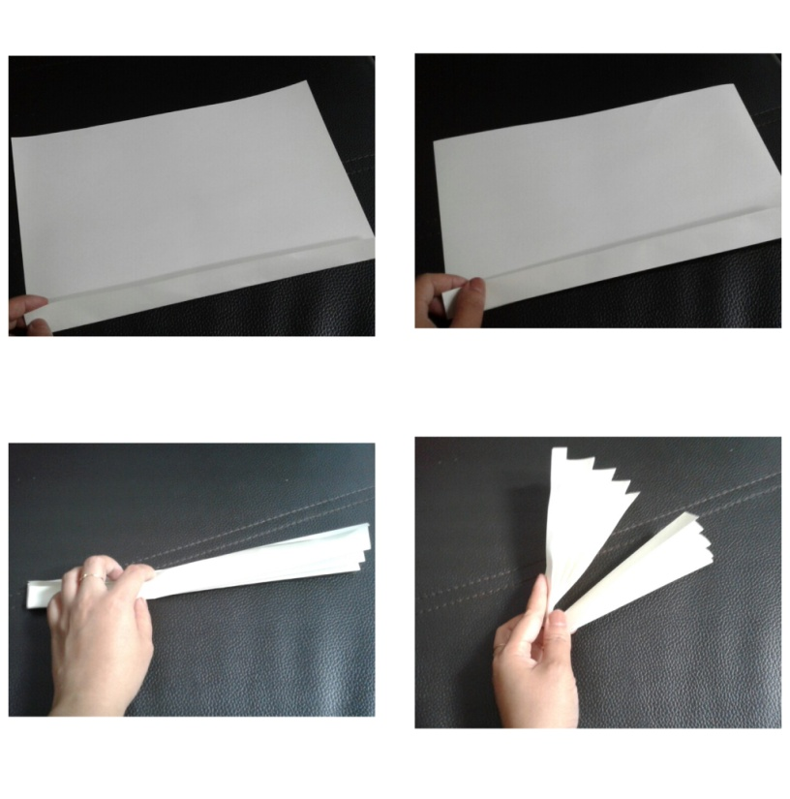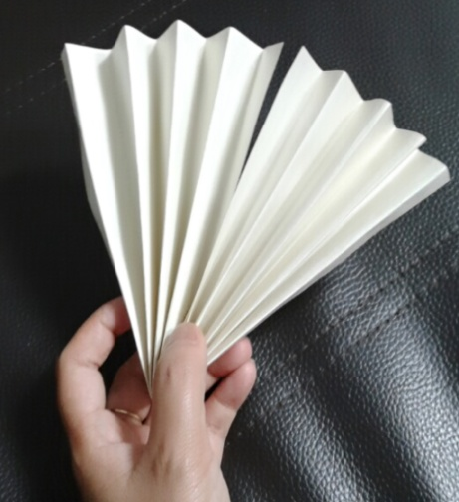

Fill in the box. Use “Adverb of sequence”.
Put the proper word to complete the sequence.

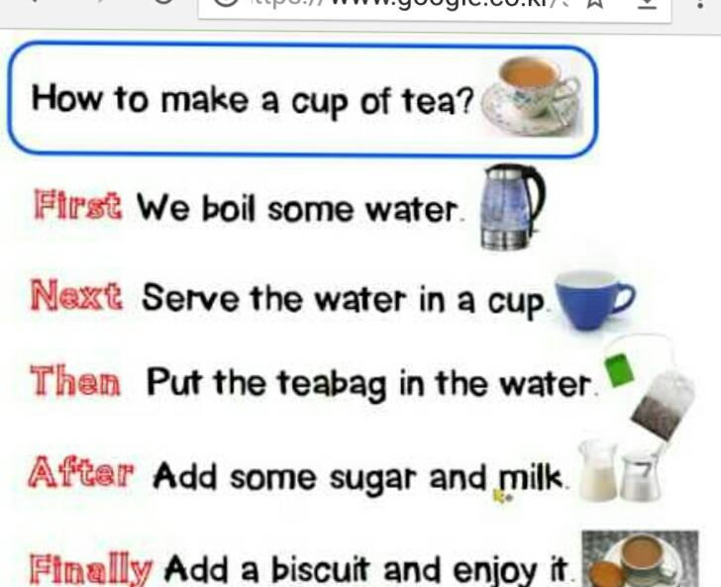
Finally, after that, First, next, then

