☐ Listening ☐ Speaking ☐ Reading Grammar ☐ Writing

Topic: Can you describe a picture?

Instructor:  Lizzy | Level:  Intermediate | Students:  5 | Length:  40 minutes

Materials:
- Board, Board markers
- Handouts (5 copies to each)

Aims:
- Students will predict which preposition will be used to describe a picture.
- Students will know where to put prepositions in a sentence
- Students will know the difference of focus according to the change of the preposition in a sentence
- Students will practice prepositions by describing pictures and completing the worksheets.
- Students will practice speaking and listening ability by sharing ideas in a pair and present each other’s opinion in a class

Language Skills:
- Reading: worksheets to answer questions
- Listening: teacher’s instruction and explanation, classmates’ ideas
- Speaking: practice activities, sharing ideas
- Writing: worksheets answers

Language Systems:
- Lexis & Phonology: people in various action, location
- Grammar: practice present progressive tense from previous class, the use of preposition to describe a picture
- Function: Describing a picture, place

Assumptions:
- Students already have learned present progressive in a previous class.
- Students may know how to describe people in action or statement of things.

Anticipated Errors and Solutions:
- Students may have difficulties understanding the meaning
- Give them further explanations with more examples
- Students may need more time to finish their activity
- Be flexible with the time as giving student more time to finish their activity and cut off the time of post activity

References:
https://en.fotolia.com/
TESOL student binder

Lead-In
Materials:
Board, Board Marker, Picture #1
Time | Set Up | Student Activity | Teacher Talk
6min | Whole Class | Answer questions | Hello, everyone. How are you feeling today?  Do you remember what we had learned previous class? We learned present progressive.  (Hand out Picture #1)  Can anybody give me an example? What are they doing?  (Listen to their response. Hopefully someone will answer. If not, tell them of some example sentences using a picture #1.)  Great. Now, can you tell me which part of the picture these people are located? Where is the man who is walking the dog, Hailey? (she answers) Yes, he’s in the middle of the picture. What about this man, Denise? (she answers) Great job! He’s on the right side of the picture.  What do you use when you describe a location? Do you know what they are called? (If no one answers, write “preposition” on the board)  We’ll learn about preposition today!

Pre-Activity
Materials:
Board, Board Marker, Picture #2
Time | Set Up | Student Activity | Teacher Talk
5min  5min  10min | Whole Class  Pair work  Whole Class | Answer questions  Solve the puzzle  Share answers | What preposition will you use on this part of the picture? What about this part?  (Draw a table on the board and elicit from students. Hand out Picture #2 afterwards.)  Now, how about we practice more by playing ‘Hidden Catch’ game? Ok, let’s play!  Please make a group with the person next to you. I’ll give you 5 minutes to solve the puzzle. When you find differences, try to use prepositions to explain. Do not just point out the spot with fingers. Please work with your partner and feel free to share ideas.  CCQ:  Do you know how to play ‘Hidden Catch’?  What do you do when you describe a picture?  Do you point out the picture with a finger or explain in sentences?  Now, are you ready to share your answers? What differences have you found?  (Write down students’ answers on the board)  Feedback)  Great job guys! Has anyone found the major change/difference on prepositions?  Yes, they are ‘in’ and ‘on’. “In” is used in more broad and vague part than ‘on’.  Let’s read them one by one. We’ll start from Brody.  (students read one by one)

Main Activity
Materials:
Board, Board Markers, Worksheet
Time | Set Up | Student Activity | Teacher Talk
4min  6min | Whole Class  Individually | Listen to the teacher and answer questions  Do the worksheet and share answers afterwards | Now, can we move the prepositions in the sentences? Where else can prepositions be placed? Does it change the meaning of the sentence?  If you change the place of the preposition, you may be emphasizing on different things. Let’s say you want to emphasize the person, not the action. You should say, “Someone [where] is doing something.” But if you want to emphasize the action, you should say “Someone is doing something [where]” or “[where], someone is doing something.”  (Explain more with the sentences students made with previous activity)  CCQ  Where do you put preposition when you want to emphasize the person?  Where do you put preposition when you want to emphasize the action?  Do the worksheet. Choose the correct answer individually. I’ll give you 3 minutes.  CCQ  How much time do you have?  What do you do?  Do you read alone?  Feedback)  Do you need more time?  (Yes – give 30 extra seconds)  (No – check answers together)

Post Activity
Materials:

Time | Set Up | Student Activity | Teacher Talk
4min | Whole class | Answer questions | Can anybody describe our classroom using different prepositions? You may be focusing on either an object or action.  Demonstration)  For example, “There are some posters on either side of the classroom”  (Go through everyone)  Wrap-up)  Did you have fun today?  I hope you all enjoyed today’s lesson. We will work on more prepositions next class. See you next time.

Picture #1

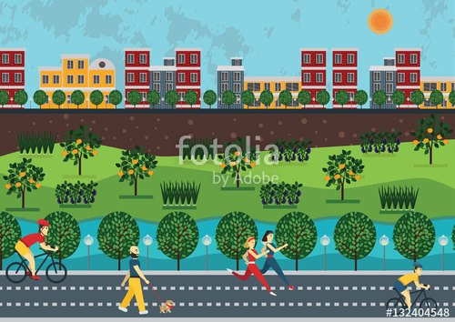
Table #1

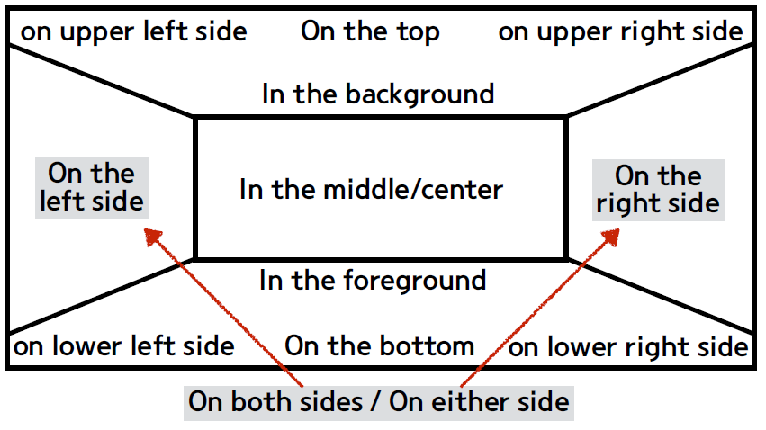

Picture #2

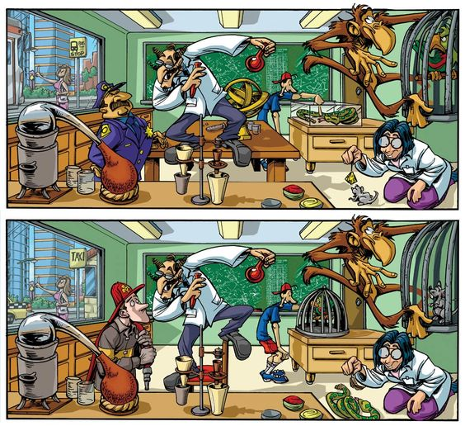

Worksheet #1
Preposition
Find the answer according to the highlighted sentence.

- There is a woman. She is reading a book. She is on the right side of the picture.
- The woman on the right side of the picture is reading a book. ☐
- The woman is reading a book on the right side of the picture. ☐

- There is a boy. He is in the middle of the picture. He is playing with a toy.
- The boy in the middle of the picture is playing with a toy. ☐
- The boy is playing with a toy in the middle of the picture. ☐

- I see a lady. She is on the bottom of the picture. She is knitting.
- The lady on the bottom of the picture is knitting. ☐
- The lady is knitting on the bottom of the picture. ☐

- The man is on the left side of the picture. He is wearing a uniform.
- The man on the left side of the picture is wearing a uniform. ☐
- The man is wearing a uniform on the left side of the picture. ☐

- There are a couple of birds. They are flying. They are in the background of the picture.
- The birds in the background of the picture are flying. ☐
- The birds are flying in the background of the picture. ☐

- The buildings are on both sides of the picture. They are standing in a row.
- The buildings on both sides of the picture are standing in a row. ☐
- The buildings are standing in a row on both sides of the picture. ☐

