■ Listening ■ Speaking ■ Reading ■ Grammar ☐ Writing

Topic: Prepositions!

Instructor:  Paul Kim  David Choi  KyooTae Cho | Level:  Basic | Students:  6 | Length:  53 min

Materials:
- Box
- Cell phone
- Picture
- 6 worksheet #1
- 6 worksheet #2
- Projector
- Computer
- Board & Markers

Aims:
- To learn when and how to use various spatial prepositions through a discussion in pairs, completing two worksheets.
- Students can develop speaking and listening skills by group discussions.
- Students can learn vocabularies for various objects by completing worksheets.

Language Skills:
- Listening: listening to partner’s picture description
- Speaking: describing pictures
- Writing & Reading: worksheet exercises

Language Systems:
- Lexis: Students can learn spatial prepositions and vocabularies for various objects through worksheets.
- Phonology: Students can improve listening skills by discussing with classmates.
- Grammar: Students can learn where to put prepositions within a sentence.
- Function: When and how to use spatial prepositions.
- Discourse: Discussion in pairs

Assumptions:
- Students are beginners
- Students are not fully comfortable with using spatial prepositions
- Some students make inaccurate pronunciations
- Students know they must use only English in class

Anticipated Errors and Solutions:
- If time is running out, shorten the discussion time. (cut-off plan)
- If there is more time left then expected, give students more time for discussion. (SOS plan)
- If students have trouble understanding key vocabs, let their partners to help them out (do not help them directly).
- If students finish group discussion earlier than expected, give more time for the whole-class discussion and try to ask as many students as possible.

References:

Definition :
http://dictionary.cambridge.org/dictionary/english-korean/in?q=In

Worksheet #1:
https://en.islcollective.com/resources/printables/worksheets_doc_docx/prepositions_of_place/prepositions-of-place/87746

Worksheet #2:
https://en.islcollective.com/resources/printables/worksheets_doc_docx/prepositions_of_place_2/prepositions-elementary-a1/58688

Picture :
https://www.google.co.kr/search?q=%EB%B0%A9%EA%B7%B8%EB%A6%BC&tbm=isch&imgil=2esWZQ0JhGJH5M%253A%253B3f11ypYK7W_SUM%253Bhttp%25253A%25252F%25252Fmegatvstory.tistory.com%25252F149&source=iu&pf=m&fir=2esWZQ0JhGJH5M%253A%252C3f11ypYK7W_SUM%252C_&usg=__ip_yr3WZ1tzZ2Ueeki9I3525sTc%3D&biw=1366&bih=672&ved=0ahUKEwi0oNmioMTVAhVGpZQKHQdrAasQyjcIPg&ei=CeiHWfT3C8bK0gSH1oXYCg#imgrc=2esWZQ0JhGJH5M:

Lead-In
Materials: board.
Time | Set Up | Student Activity | Teacher Talk
3 min | Whole class. |  | Greeting  Hello everyone. How is going? I am happy to hear that you are good. So are you ready for studying English?  (eliciting)  When you study English what is the most difficult part?  (if they say unexpected answer, you can tell them correct answer)  Yes, you are right. Preposition is really difficult.  Introduction of Task  Today we will be learning some prepositions and how to connect prepositions to different sentence and situation.

Pre-Activity
Materials: Table. Pen. White board

Time | Set Up | Student Activity | Teacher Talk
10min | Whole class | Look at the teacher  Listen and Repeat  Explain about preposition  Looking and answer the Question | T : To day we are going to learn about  preposition. Specially kind of these -  ‘write on the board a preposition which is under, on, behind, in, next to, above, In front of’  I think perhaps everyone has heard of  these. But I want to teach these  more.  Instruction  T: Firstly I am going to read these and  please you guys repeat again.  Under  On  Behind  In  Next to  Above  In Front of  Near  Between  T: Ok! Good Job  <CCQ>  Why don’t one of you guys please explain about that preposition?  <Listening what they say>  Thank you! Excellent  I will tell you definition of these.  Under  below something  On  on a surface of something  Behind  at or to the back of someone or something  In  inside a container or place  Next to  very close to something or someone, with nothing in between  Above  in a higher position than something else  In front of  close to the front part of something  Near  not far away in distance  Between  in the space that separates two places, people, or things.  Ok. I will check how much you understand.  Let’s try using this box

Main Activity
Materials: Box, Objects, picture, beam projector, board.
Time | Set Up | Student Activity | Teacher Talk
7min  3 min  5 min  4 min | Whole class  Whole class  Pairs  Whole class | Looking and answer the question  Explain picture to partner. | - Realia Exercise  <Using box, Cell phone>  T : As you can see, here is a box and a cell phone. I will place this cell phone like this ‘place the cell phone on the box’  And then I will ask to you where pencil is.  You should answer my question.  Are you ready?  Ok. starts  <Demonstration>  <CCQ>  Where is it?  - Place the cellphone on the box.  - Place the cellphone in the box.  - Etc  Ok. Good job. Let’s move on the next step.  - Explaining Pictures  instruction  From now on, you need to make a group in pairs. Then I will hand out a picture.  (hands out picture)  If you get that picture, you need to explain this picture to your partner sitting next to you. But using Korean is not allowed.  All you need to do is explain your picture by using target language.  You have 5 minute.  CCQ  How much time do you have?  Using Korean is allowed?  What should you do with picture?  Are you working individually?  (Discreetly monitors the students).  (if time is up, you can project picture on the board)  Time is up. How was it? Was it difficult to you? If you were, what was the most difficult?  Feedback  (After listening to their views of the picture, teacher can explain picture )  What are the most proper preposition in this situation?  (Ask them and say correct answer)

Post Activity
Materials: Worksheet #1, Worksheet #2
Time | Set Up | Student Activity | Teacher Talk
5 min  3 min  10 min  3min | Individual  Whole Class  Individual  Whole Class | Work on worksheet #1  Answer out loud as going through each question  Work on worksheet #2  Answer out loud as going through each question | Okay, now is everyone more familiar with different prepositions?  Now, just to review what you have learned today, you will do a couple of worksheets.  Are you guys ready?  Distribute worksheet #1  Instruction:  As you can see, it’s a simple fill in the blank exercise. Choose proper prepositions for each picture. You have 5 minutes. Then, we will go over with the whole class together. Please work individually.  CCQ’s:  What do you have to do?  How much time do you have?  Discreetly monitor students  You have 3 minutes left.  Is everyone ready to go over?  Where is the hamster in the first picture?  How about the second one?  (Keep asking)  Instruction:  Okay, good job everyone.  Now, I will give you another fill in the blank worksheet, and it might be a bit more complicated than the first one, but the instruction is the same.  (Distribute worksheet #2)  I will give you 10 minutes to finish. If you have any question, feel free to ask. Please work individually. After 10 minutes, we’ll go over together for about 3 minutes.  (Discreetly monitor students)  CCQ’s:  How much time do you have?  Who do you work with?  You have 3 minutes left to finish.  Okay, is everyone done? Does anyone need more time? → If yes, give about 30 more seconds  It seems like everyone is ready.  Let’s go over together.  What is the answer for number one?  Keep asking  Good job everyone.  I hope you enjoyed today’s class.  How was it? Was it fun? Great!  Well, class is over. Have a wonderful day, and see you tomorrow.

Picture
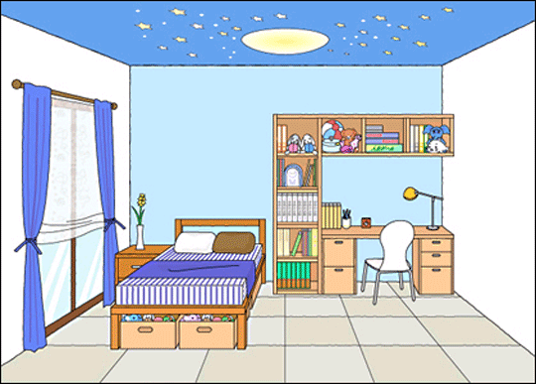

Worksheet #1:
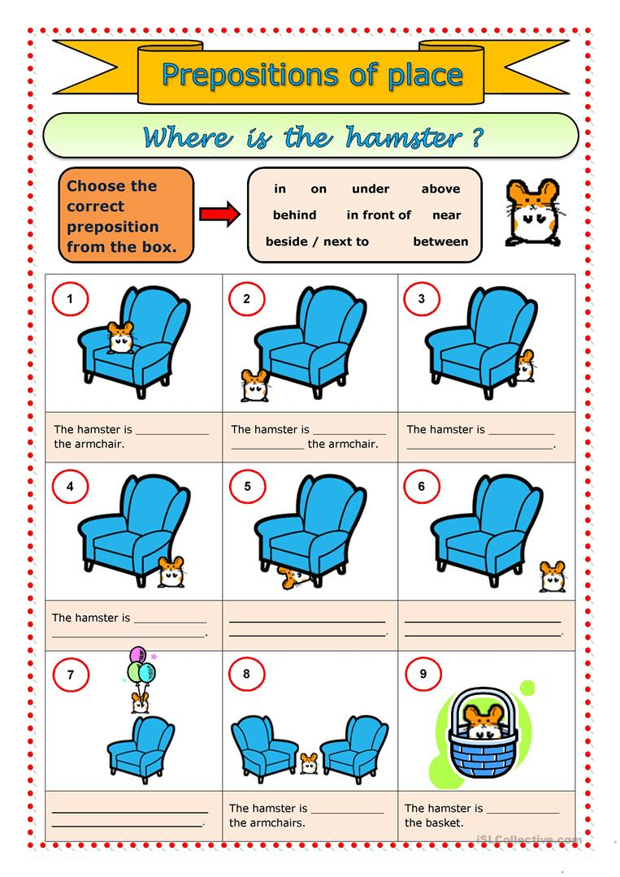

Worksheet #2:
