**Worksheet**

Write a correct answer. In some questions, there many not be an correct answer.

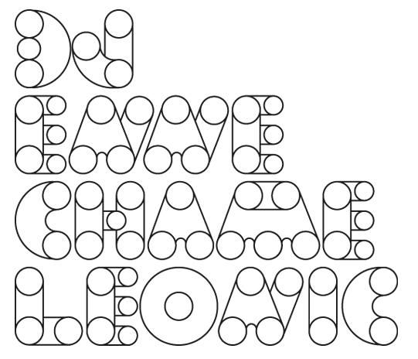

1. How many circles are there?
2. Is there an oval?
3. Is there a triangle?

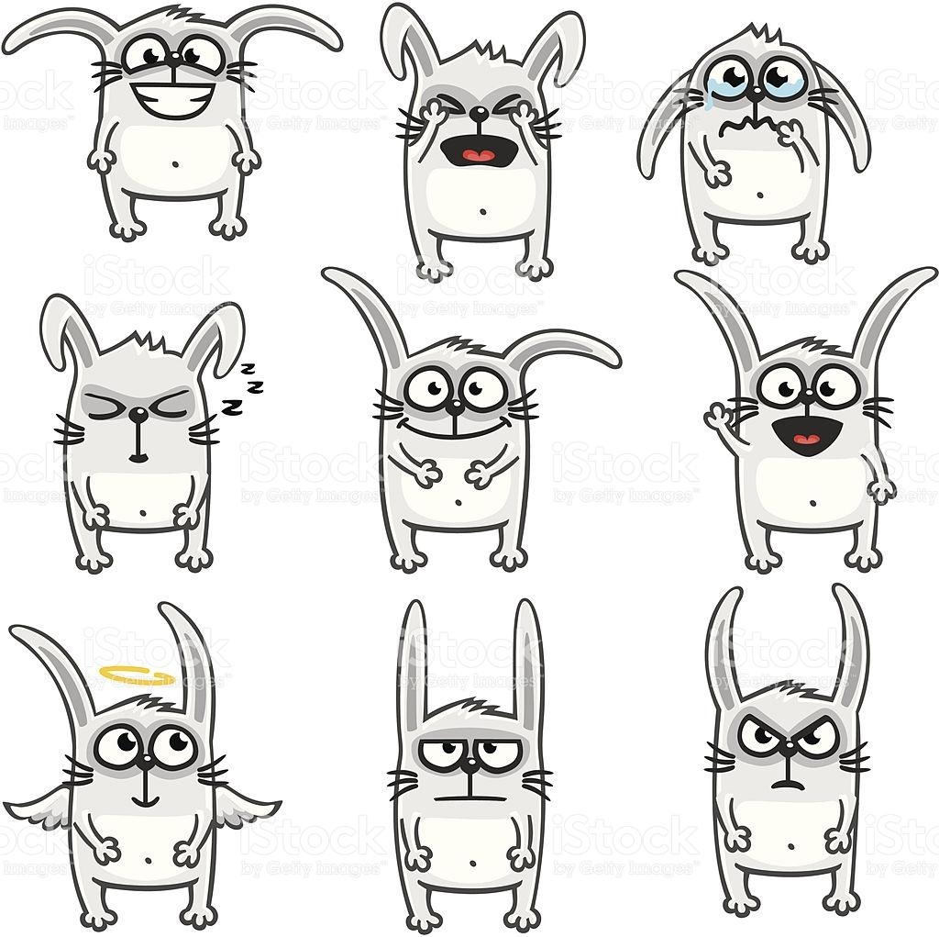

1. How many rabbits are there?
2. Is there an angel? If yes, Who is an angel?
3. How many rabbits who are angry? If there are, Who are angry?
4. How many rabbits who are happy? If there are, Who are happy?



1. How many people are there?
2. How many girls are there?
3. How many kids are there?
4. How many people who are happy?

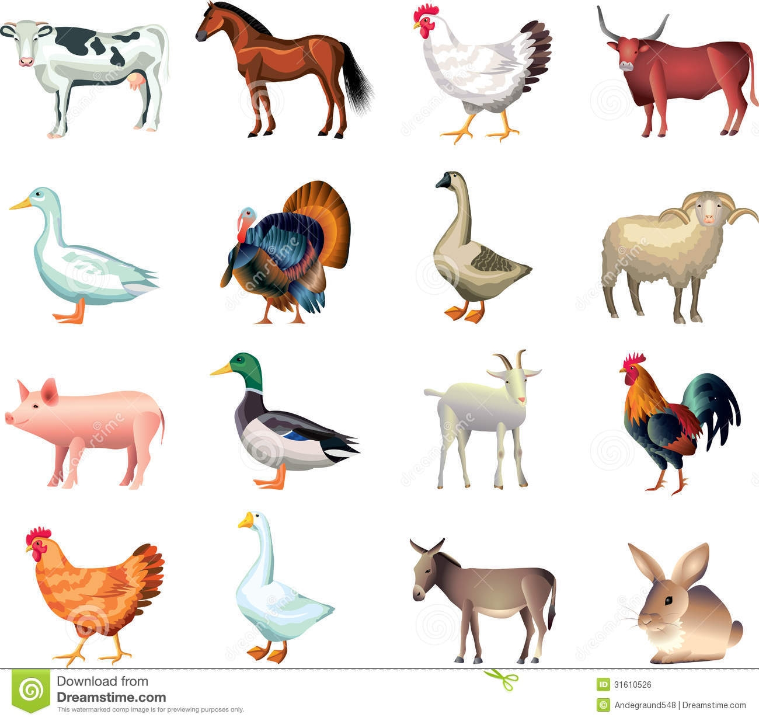

1. How many birds are there?
2. Is there a horse?
3. How many mammals are there?

PPT

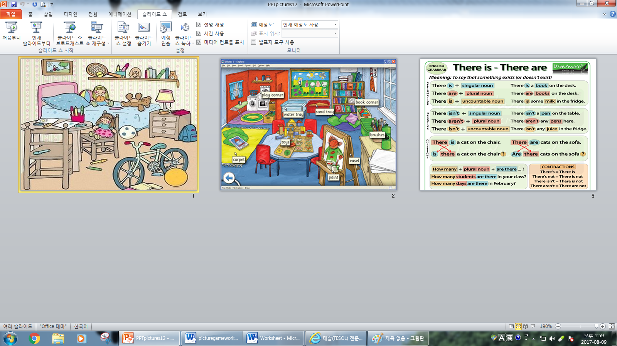

**(Worksheet 1)**

|  |  |  |  |  |
| --- | --- | --- | --- | --- |
|  |  |  |  |  |
|  |  |  |  |  |
|  |  |  |  |  |
|  |  |  |  |  |
|  |  |  |  |  |

You can choose items to decorate your room or you can draw items what you think.

**(Worksheet 2)**