Worksheet 2-1
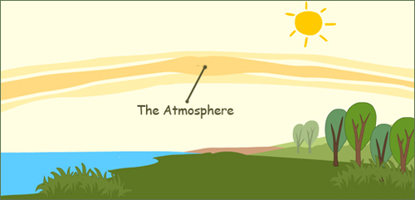
STEP1
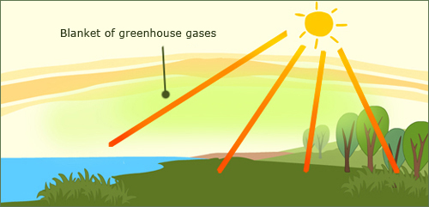
STEP2
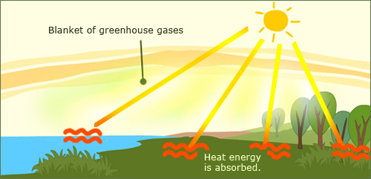
STEP3
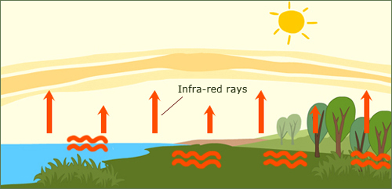
STEP4
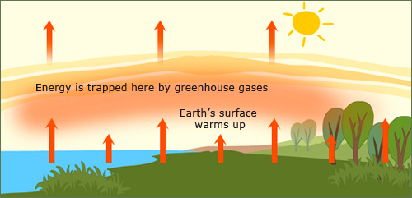
STEP5

Worksheet 2-2
- As it reaches the earth’s surface, the land
and water absorbs the sunlight’s energy.
- Some of the energy passes back into space, but much of it remains trapped in the atmosphere by the greenhouse gases, causing our globe (earth) to warm up.
- The earth’s atmosphere is all around us.
It is the air that we breathe.
- Once absorbed, the energy is sent back into the
atmosphere in the form of infra-red rays.
- Sunlight enters the Earth’s atmosphere,
passing through the blanket of greenhouse gase
WORKSHEET 4
Things you can do about global warming.

It is our turn to do our bit!

Worksheet 1
Put a word in the blank
Greenhouse / Climate / greenhouse gases / Weather

1.__________ describes the total of all weather occurring over a period of years in a given place. _________is the average weather condition of that place. tells us what it’s usually like in the place where you live.

For example, some countries like Cameroon, Ghana and Liberia are all in the tropical wet region of Africa. They have a very sunny, hot and wet__________ all year round. However, there may be very different day-to-day weather conditions in each village or town in these countries. (Climate)

2 ________ is all around us. _________ may be one of the first things you notice when you wake up._________ describes whatever is happening outdoors in a given place at a given time.__________ can change a lot within a very short time. For example, It can be windy at night, rainy in the morning, hot and sunny at noontime, and even back to windy before sunset.________ includes daily changes in rainfall, temperature and wind in a given location. (Weather)

3 ________ is also another word you should know about. Have you ever seen a __________? In some countries, people build a small glass house to plant crops in it. It is built to keep the sun’s heat from escaping from the glasshouses.

In a way, the earth is like a glasshouse. The earth has some very important gasses in the atmosphere that keeps us warm. (Greenhouse)

4. _________are water vapour, carbon dioxide and methane.
When the sun heats the earth, _______ keep the heat on the earth’s surface. Without _______, heat would escape back into space and Earth’s average temperature would be colder. (Greenhouse effect)
Worksheet 3
- Who have warned that the world’s climate has changed
a lot, and has affected many living and non-living things?
(Scientists)

- What are massive amounts of snow that have stayed long enough to harden into blocks of ice?
(Glaciers)

- Since when have humans excessively produced and released massive carbon dioxide and other greenhouse gases into the atmosphere?
(Industrial Revolution)

- Where have rainfall amounts also risen near the mid-latitudes since the beginning of the 20th century?
(The northern hemisphere)

- After I read the passage “What brings about more Greenhouse gases?”, I realize that if the greenhouse effect becomes stronger, it could make the earth warmer than usual. The green house effect is causing global warming. As a result of global warming, people are seeing climate change like heat waves, storms and floods in all over the world. (TRUE )
Pictures
