☐ Listening ☐ Speaking ☐ Reading ☐ Grammar ☐ Writing

Topic: I Love My Home

Instructor:  Sarah | Level:  intermediate | Students:  6 | Length:  30 Minutes

Materials: Room pictures
work sheet
Cards
Crayons
White board and marker
Matching activity
SOS work sheet
pencil

Aims:
-Main aim: Ss will learn a stuff location by listening to teacher's explanation and reading "I love my home" book.
-Second aim: Ss talk about their room stuff and location.
-Personal aim: I want student to improve their reading and listening skill.

Language Skills:
- Reading: Ss will be reading book.
- Listening: Ss will be listening to teacher's explanation.
- Speaking: Ss will be speaking discussion other students.
- Writing: Ss will be writing their opinion.

Language Systems:

-Lexis: Stuff in the home
-Grammar: Where, in
-Function: Describe home materials.
-Discourse- Ss are talking other Ss opinion( Activity)

Assumptions:

Ss know how to use where, in.
Ss know house and location.
Ss will have lots of questions to make their activity.

Anticipated Errors and Solutions:

Ss can’t understand words.
- Give some hints or explain words.
Ss have difficulty matching picture and location
- First show how to do it.
Ss have drawn picture.
- I can explain and give direction.

References:
Image taking for Google
www.google.com ( images)
I love my home – language world

Lead-In
Materials:

Time | Set Up | Student Activity | Teacher Talk
3min | individual | They are Listening for teacher’s question and answer. | Good Afternoon everyone? How are you today?  Did you wash your hand?  Did you brush your teeth?  Did you wash your face?  - Where did you brush your teeth, face and hand?  I brush my teeth for three minutes.  How about you?

Pre-Activity
Materials:
Picture of the rooms. Paper, crayons
Time | Set Up | Student Activity | Teacher Talk
7min | Whole  individual | Sharing answers together.  Listen for teacher’s instruction.  They are draw their room and explain and sharing their drawing. | I will show two pictures of bathroom and bedroom.  Activity 1  I will show my room and explain location and I will give paper.  This is my living room. I take a rest on the sofa in the living room.  Sometimes I was watching TV.  I will give 5 minutes. You draw their room.

Main Activity
Materials: I love my home book, card,

Time | Set Up | Student Activity | Teacher Talk
10  min | Group  Activity  Pair activity | They talk about their opinion.  They are read a text book  Quiz  They can think answer.  Sharing answers together | Reading I love my home book  Let’s read together.  I will question about book.  I will use 7 minutes read a book.  I will ask question about text book.  What did I say?  How many times did I say?

Post Activity
Materials: Work Sheet ( match the word)

Time | Set Up | Student Activity | Teacher Talk
7min | Pair activity | Make a group.  They should discuss their thinking of the work sheet.  They match the word.  Sharing answers together. | I will explain how to do it.  I will give 4 minutes  What did I say?  How many times did I say?  .

SOS Activity
Materials: work sheet, pencil

Time | Set Up | Student Activity | Teacher Talk
3min | individual | Make a sentence and draw map.  They talk about their home.  Sharing answers together. | Make 7 sentences.  I will 3minutes.  Show first,  - I has two toothbrushes in my home

Work Sheet
Match the word
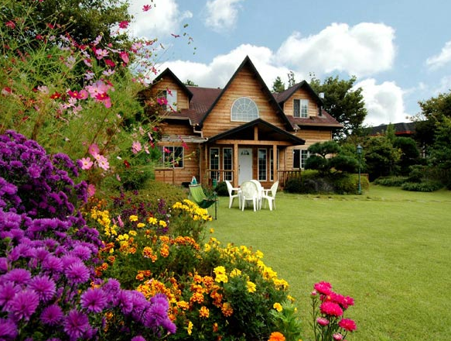
Kitchen
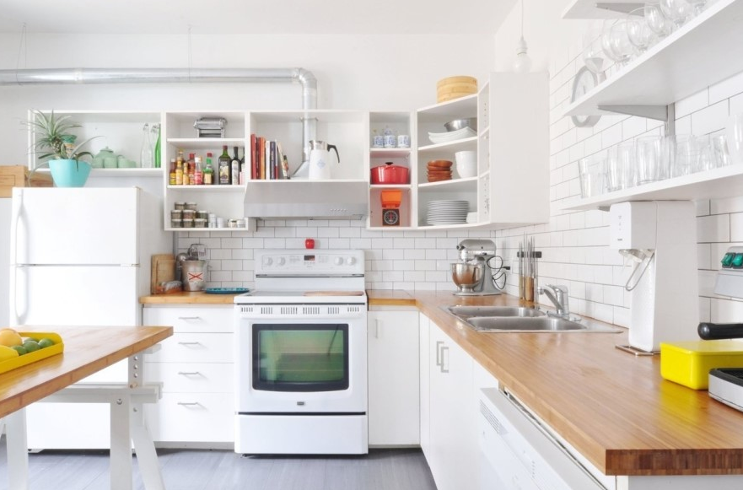
Toothpaste
Garden
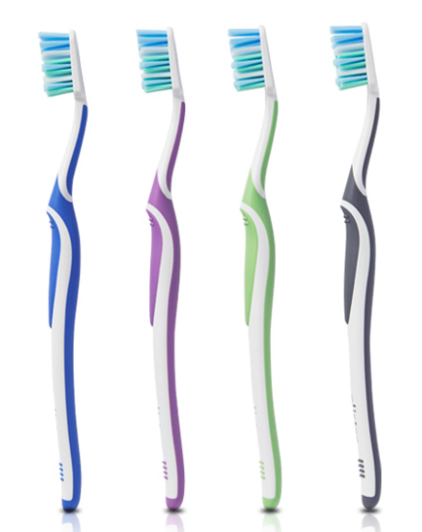
Living room
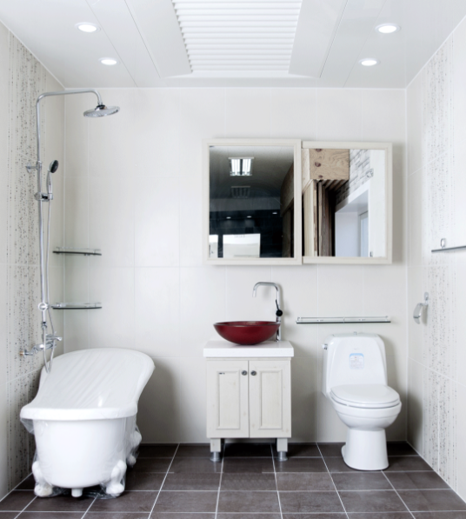
Bedroom
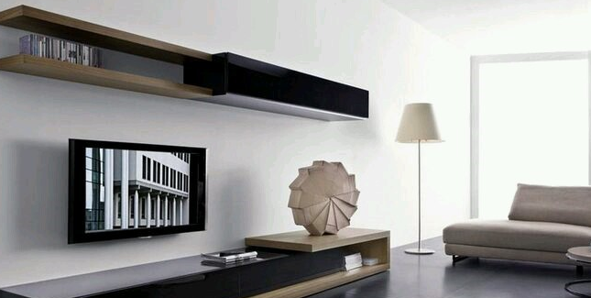
Toothbrush
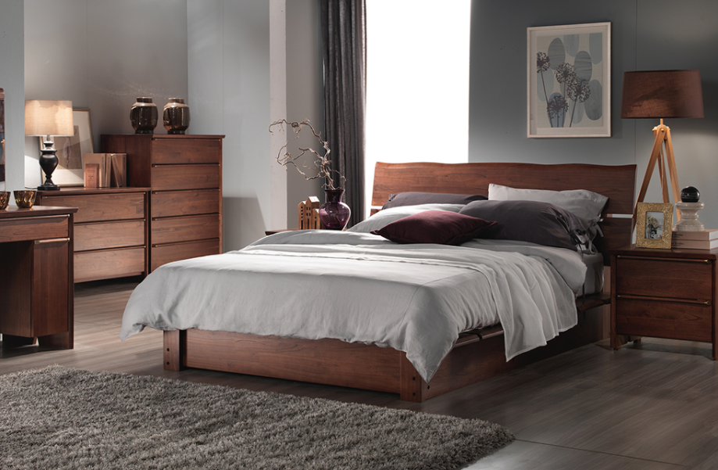
Bathroom
