Flash Cards
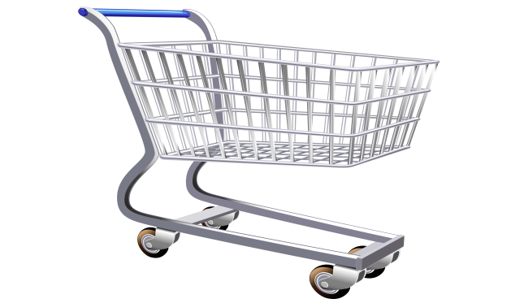  Shopping cart | 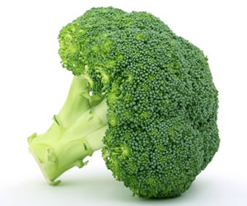Broccoli
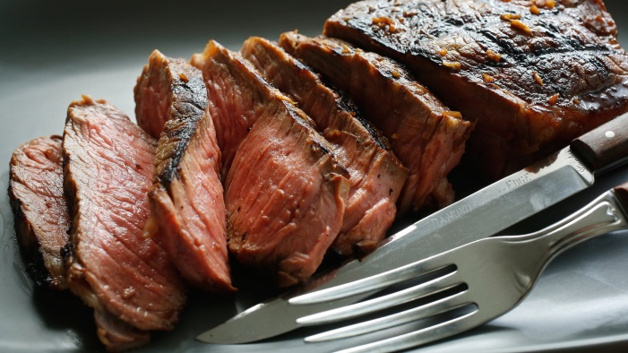 Steak | 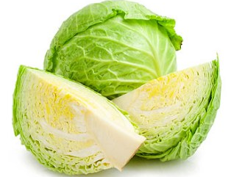 Cabbage
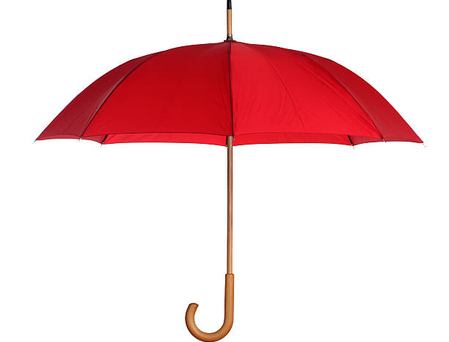 Umbrella | 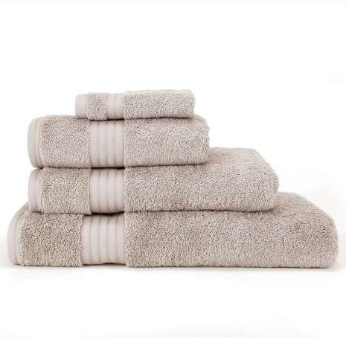  Towel
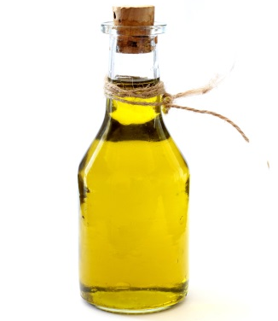  Oil | 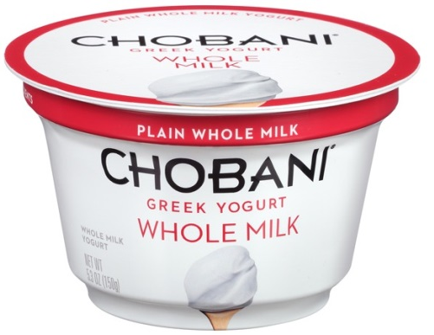  Yogurt
Sorting worksheet
Sort the materials in the box to Felix’s basket or to Alice’s basket.
Towel, Milk, Cabbage, Steak, Oil, Yogurt,
Broccoli, Umbrella, Jacket, Fruit
Felix’s basket

Alice’s basket

Idioms Worksheet
Match the words on the left with the definitions on the right by drawing line.
- a thick, black liquid that comes from the ground and that is used in making various products
- a leafy vegetable that has several forms, one that grows in a tight round shape
- a common vegetable that has green branches and many small green or purple flowers
- a food that is made when bacteria are added to milk and that is often flavored and chilled
- a piece of cloth used for drying things

- Broccoli
- Cabbage
- Yogurt
- Towel
- Oil

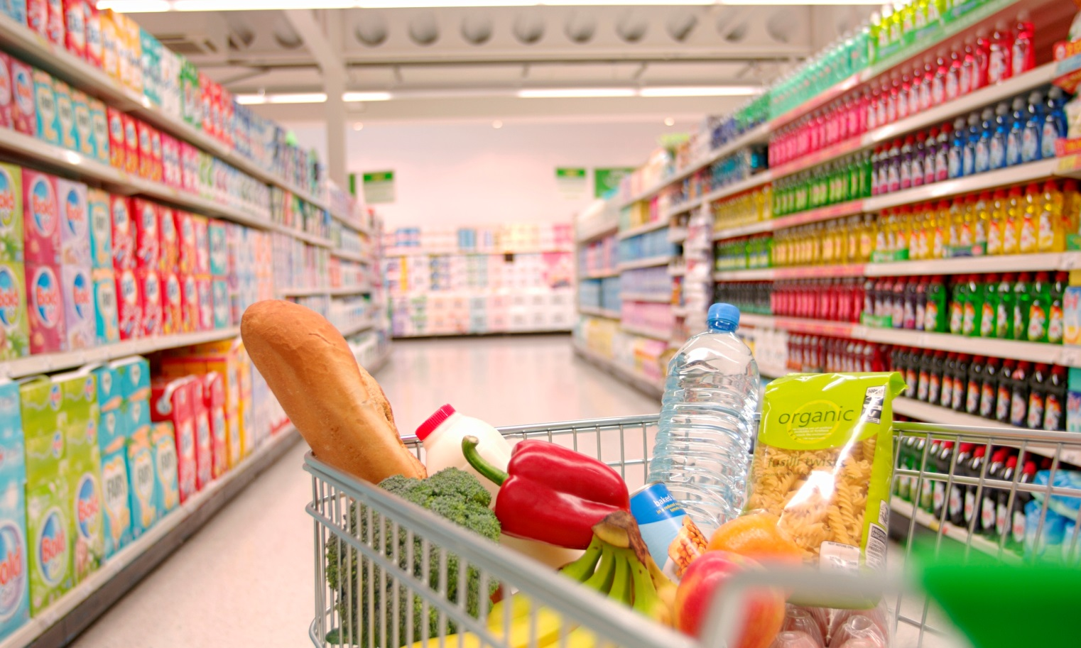
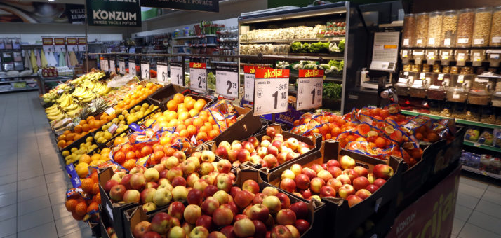
Image of Supermarket

Writing worksheet
Write these sentences.

1. Look at Alice’s shopping cart!
2. There are a lot of things.
3. Look at my basket.
4. I have an umbrella.

