Handout Sheet
Nicole(Won Kyung)Kim

Petunia Dursley (Aunt Petunia)

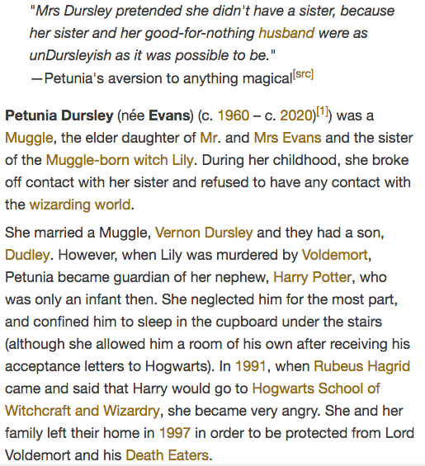

http://harrypotter.wikia.com/wiki/Petunia_Dursley

Listening Worksheet
Nicole (Won Kyung) Kim

- Who is Aunt Petunia?

- Harry’s mom and Aunt Petunia ever close?

- Do you think her parents mistreated Aunt Petunia? Why and why not?

- After watching clips what was your first thoughts? Why and why not?

- Have you had any experienced where the results were different than what you intended to?

