Phrase flash cards

I’ll have
I’d like to

Drawing lots
Waiter | Customer
Waiter | Customer
Waiter | Customer

Ordering Food in a Restaurant

Waiter: Hello, Can I help you?
Kitty: Yes. I’d like to have lunch.
Waiter: Would you like to have a starter?
Kitty: Yes, I’d like to have a bowl of chicken soup, please.
Waiter: And what would you like to have for the main course?
Kitty: I’ll have cheese burger.
Waiter: Would you like anything to drink?
Kitty: Yes, I’d like to have a glass of Coke.
Waiter (After Kitty having her lunch): Can I bring you anything else?
Kitty: No thank you. Could you bring me the bill, please.
Waiter: Certainly.
(After a moment)
Waiter: That’s $34.
Kitty: Here you are. Thank you very much.
Waiter: You’re welcome. Have a nice day.
Kitty: Thank you, same to you.

Restaurant picture 1

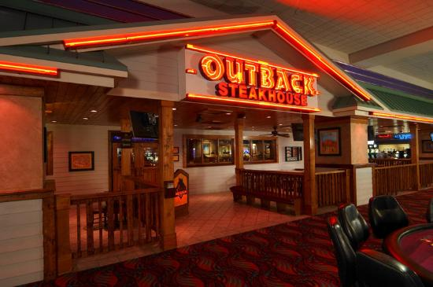

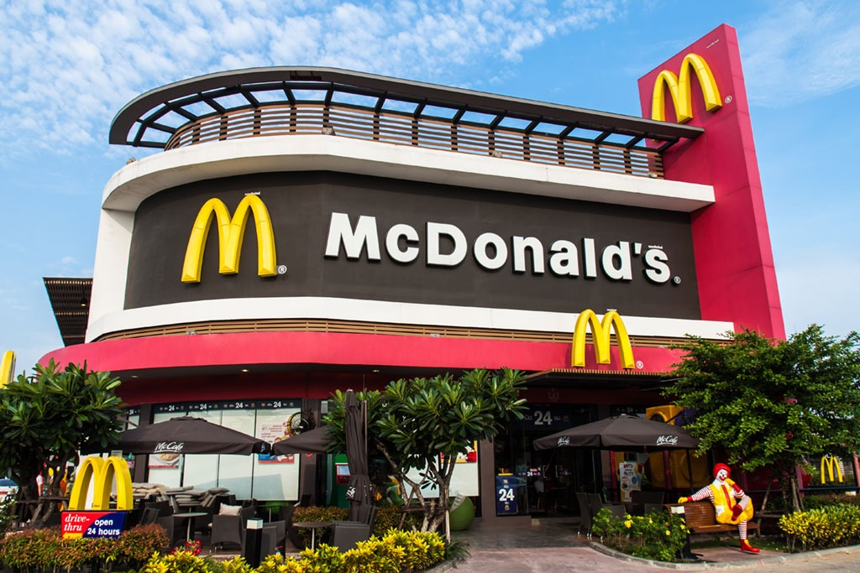
Restaurant picture 2

Filling the blanks
Ordering Food in a Restaurant

Waiter: Hello, Can I help you?
Kitty: Yes. ______________ have lunch.
Waiter: Would you like to have a _________?
Kitty: Yes, _____________ have a bowl of chicken soup, please.
Waiter: And what would you like to have for the ______________?
Kitty: ____________ cheese burger.
Waiter: Would you like anything to ________?
Kitty: Yes, _______________ have a glass of Coke.
Waiter (After Kitty having her lunch): Can I bring you anything else?
Kitty: No thank you. Could you give me the bill, please?
Waiter: Certainly.
(After a moment)
Waiter: That’s $34.
Kitty: Here you are. Thank you very much.
Waiter: You’re welcome. Have a nice day.
Kitty: Thank you, same to you.

