Dish Soap for Dinner

Joe came home from work and opened his mailbox.
In his mailbox, he found a yellow bottle of soap - soap for washing dishes. The dish soap was a free sample from a soap company. The company mailed small bottles of soap to millions of people. It was a new soap with a little lemon juice in it. The company wanted people to try it.

Joe looked at his free bottle of soap. There was a picture of two lemons on the label.
Over the lemons were the words "with Real Lemon Juice."
"Good!" Joe thought. "A free sample of lemon juice! " I'm going to have a salad for dinner. This lemon juice will taste good on my salad." Joe put the soap on his salad and ate it.
After Joe ate the salad, he felt sick. Joe wasn't the only person who got sick. A lot of people thought the soap was lemon juice.

They put the soap on fish, on salads and in tea. Later they felt sick, too. Some people felt really sick and went to the hospital. Luckily, no one died from eating the soap.

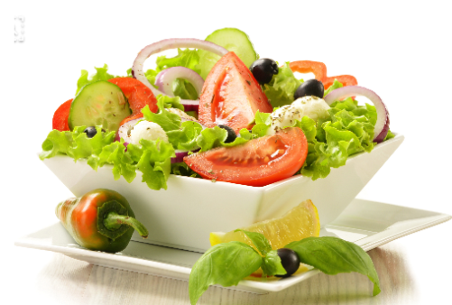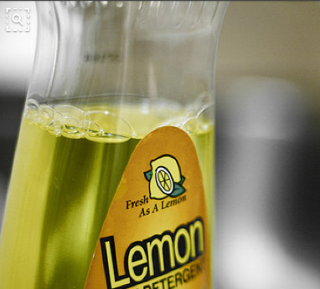

Check Questions

a. what is he's name?
b. Do you know Free samples?
c. How did he get to Free sample?
d. Why did they mail to people to free samples?
e. Have you ever used a Free sample?
f. What is label?
h. Do you believe that "Dish soap will taste good on my dinner"?
i. What has got him after eat to dish soap?
j. Can you guess taste of dish soap?
k. what would you do if you get same Free sample?
L. How did this story make you feel?
m. What can we learn from Joe's story?
n. Do you have a story about a mistake you made?

Role play
Dish soap for dinner

Doctor: How may I help you?
Joe: I have a stomachache.
Doctor: What were you ate last night?
Joe: I ate a vegetable salad of Lemon dressing. But, it was tastes strange so, I brought a dressing bottle.
Doctor: Show me the bottle. How did you get it?
Joe: I got a free sample from shopping mall.
Doctor: (Read the label of bottle) Oh My God! It's dish soap.
Joe: Really? (Read the label of bottle) Oh My God! I just saw at picture on the label "Real two Lemons".
Doctor: You ate dish soap. That's why you felt sick.
Joe: I didn't know. (Throw his dinner up)
Doctor: I'll give you to medicine. Don't eat dish soap, and Read carefully to label!
Joe: Thank you. I will be more careful in future.

vocabulary

-free sample
A free sample or "freebie" is a portion of food or other product (for example, beauty products) given to consumers in shopping malls,
supermarkets, retail stores, or other venues
ex)- This is a freebie

-try
- A try is a way of scoring points in rugby league and rugby union Try may also refer to: Conversion (gridiron football), a way of scoring points.

- You want to do it, and you take action which you hope will help you to do it.
[NOUN] In the game of rugby, a try is the action of scoring by putting the ball down behind the goal line of the opposing team.

-label
- A label is a piece of paper or plastic that is attached to an object in order to give information about it. - handing With care, directions for the use ... etc.-et cetera)

-carefully
- Have a nice time, dear, and drive carefully
ex) - read carefully
- listen carefully
- Do you listen carefully to what I say?

Worksheet

※ One word in each sentence is not correct. Find the word and cross it out. Write the correct word.
yellow
Ex) In his mailbot, Joe found a green bottle of soap.

1. The dish soap was a free ticket from a soap company.

2. It was a new soap with a little orange juice in it.

3. The company wanted people to eat it.

4. There was a picture of two bananas on the label.

5. Joe put the soap on his dishes.

6. After he ate the salad, Joe felt fine.

7. A lot of people thought the soup was lemon juice.

8. They put the soap on fish, on salads, and in coffee.

