☐ Listening ☐ Speaking ■ Reading ☐ Grammar ☐ Writing

Topic: It was cold, dark night….

Instructor:  Miji(Summer) Lee | Level:  Pre-intermediate | Students:  6 | Length:  35 Minutes

Materials:
3 copies of reading passage (Group A)
3 copies of reading passage (Group B)
6 copies of worksheet
White board and markers

Aims:
Students will learn new vocabulary by reading handout.
Students can develop their reading skills by guessing from the pictures, scanning for information and reading for detailed information.
Students will be able to speak with their partner by sharing the information.
Students will be able to get creative thinking by anticipating the end of story in reading handout.

Language Skills:
Reading: Reading handout (It was cold, dark night..)
Speaking: sharing the information with their partner, talk about what they read in the handout.
Listening: teacher’s elicitation, other students’ thought and guessing.
Writing: taking notes of partner’s answers.

Language Systems:
Discourse: extend the story, information gap activity
Lexis: new vocabulary in the story,
Function: asking and answering questions, guessing the order of story

Assumptions:
- Students can guess the main story through the pictures.
- Some students have difficulty in understanding new vocabulary.
- Students enjoy the information gap activity.
- Students may work well with their partner to know the full story.

Anticipated Errors and Solutions:
Students may not understand words in reading handout.
-Explain by giving definitions and examples.
If students finish their activity early. (SOS plan)
-Tell students to think how you act if you are in the situation like Vanessa.
There may not be enough time to complete the lesson. (cur-off plan)
-extending the story would be a writing homework.
Some students have difficulty in answering the comprehension questions.
-help them to remind the story, and check the answer with partner.

References:
New English File Teacher’s book(Pre-intermediate, Oxford University Press 2005)
http://www.englishlessonplanner.com

Lead-In
Materials: none

Time | Set Up | Teacher Talk | Student Activity
2mins | Whole class | Hello everyone, How are you today?  Did you have a good lunch time?  What did you eat?  Do you like a creepy story?  Do you enjoy watching a crime movie?  Why do you like it or dislike it? | Answer the question  (Yes, I like it! Or I don’t like it)

Pre-Activity
Materials: Worksheet 1, PPT files

Time | Set Up | Teacher Talk | Student Activity
8  mins | Whole class  Pair  Whole class | Here is Vanessa’s story. She faced with dangerous situation.  (Distribute worksheets)  There are 4 pictures in the worksheet.  Please guess what story is, and put the pictures in the order you think what happened to Vanessa with your partner.  I will give 3 mins.  Monitor discreetly.  What do you think happened to Vanessa?  Could you tell me the order of the story you think?  Before we read the reading passage, we are going to learn key vocabulary.  (Show the pictures in PPT files)  What do you think when you see this picture?  (elicit the meaning from students) | Guess what happened to Vanessa and the order of the story.  Answer the question.

Main Activity
Materials: reading handout A, B, worksheet 2

Time | Set Up | Teacher Talk | Student Activity
10  mins  6mins | Whole class  Individually  +pair  Pair  Whole class | - Information gap activity  Instruction  I am going to give the reading passage of Vanessa’s story. These handouts are a little bit different from your partner’s, there are some missing parts.  Please read first individually, and meet your partner, asking the question to find it out!  Also make the full story with your partner.  (Distribute the handout)  I will give 8 mins.  CCQ  How much time do you have?  Are you working alone?  What do you find out?  Monitor discreetly.  Give time warning: 1 min left. I can give 1 min more if you need it.  - Answer comprehension questions  Instruction  If you find out the full story, Please answer the questions in this worksheet with your partner.  (Distribute the worksheet 2)  You have 3mins.  CCQ  How much time do you have?  Are you working with your partner?  Alright! Let’s do together.  Joy, Could you do #1?  (Check the answers together) | Read the passage first and ask the question each other to find the missing parts.  Answer the questions with partner.

Post Activity
Materials: none

Time | Set Up | Teacher Talk | Student Activity
9  mins | Whole class  Pair  Whole class | - Free production  Instruction  At the end of the story, What do you think happened to the murderer?  Please talk about an interesting end with your partner. You have 5mins to talk.  Monitor actively.  Give time warning: 1 min left. I can give 1 min more if you need it.  2. Feedback  Do you think your partner’s ending is interesting?  Please tell me the ending of yours or partner’s, anything is okay.  Did you enjoy activity today? | Talk about own end of the story in pair.  Speak the ending of the story.

SOS Activity
Materials: none

Time | Set Up | Teacher Talk | Student Activity
5mins | Pair | Instruction  If you face with this situation, what would you do? Talk with your partner for 3 mins. | Talk about what would I do in pair.

- Put the pictures in the order you think the story happened.

It was a cold, dark night

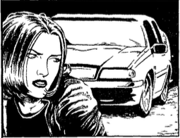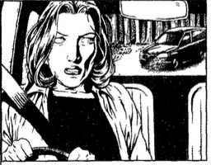

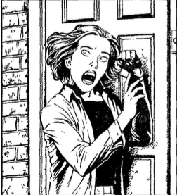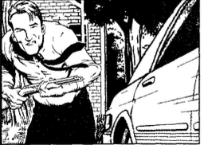

- After reading the statements, Write True (T), False (F) or Not mentioned (NM)

1. There was a red car behind Vanessa.

2. The car was following Vanessa.

3. When the doorbell rang, Martin was in the study room.

4. The tall guy recognized the man from TV.

5. Martin called the police, when they found the murderer.

- Answer the following questions.

6. What was the news about on the radio?

…………………………………………………………………..

7. Why was the man following Vanessa?

……………………………………………………………………

8. Why did the murderer get in Vanessa’s car?

……………………………………………………………………

