Speaking Lesson Plan
Title: Favorite places and trip plan for your vacation.

Instructor:  Eric | Level:  Pre-intermediate | Students:  5 ~10 | Length:  30 minutes

Materials:
- Pictures (about the countries), Map
- Work sheet 1,2
- White board, marker

Aims:
-Students can practice skills by sharing his memories & plan with others.
-Students can listen to other Ss speaking skills and other opinions.
-Teacher can minimize talking time and enable the Ss to discuss their
opinions each other.

Language Skills:
-Listening: teacher’s instructions and questions. Ss travel experience.
-Reading: Steps for planning travel
-Speaking: Share the ideas with classmates. Teacher’s CCQ’S
- Writing: Write about where Ss want to go for their vacation

Language Systems:
-Function: Expression.
-Discourse: Talking to partner.

Assumptions:
-Students have previous experience of traveling.
-Students have previous experience of pair work and group work.
-Students are interested in planning their own vacation plan.

Possible Problems and Solutions:
-Ss may not come up with answers. : Suggest prepared information.
-Ss may not know about geographical knowledge: Explain
-Ss may finish the activities earlier than expected. : giving presentation
time for real-play
-Ss may take the activities too long : Shortening remaining activities and
giving warning

References:
http://www.wikihow.com/Plan-a-Vacation
mobile app: Skyscanner, Google map,

Lead-In
Materials: Map
Time | Set Up | Description of activities
1 min | Whole Class | Procedure  <Greeting>  T: Good Morning everyone?! How are you today?  S: I’m good (or so so , bad)  T: Do you have something special last week?  S: Yes or no!  T: Where did you do?  (Teacher says his own story. “For the last week, I did my vacation plan. I am going to travel Jeju-Island for 5 days with my wife this year. Planning my trip is always makes me happy. And I want to go around the whole world someday)

Pre-activity
Materials: White board, markers, Pictures
Time | Set Up | Description of activities
3 min | Whole Class | Procedure  <Elicitation>  T: Have you ever been abroad? Where have you been? Which country is most impressive and the memorable for you?  Choose 1~2 Ss and ask them.  All of you guys have a variety of experiences.  T shows a country name card to Ss  T: Now, let me show you some pictures. Which  country comes up in your mind when you see  this picture ? Could you tell me about that ?  Ss answer.  T: Ok, in this world, there are 215 countries.  today’s lesson title “Where is your favorite places for your vacation?”  Among the world, choose places you want to go.  T write on the board about topic  T: Well, we will talk about your own travel plan.

Main-activity
Materials: Hand out – worksheet 1
Time | Set Up
5 min  2 min  5 min | Whole Class  Whole Class  Whole Class | Procedure  <Reading activity>  T: Before making your own travel plan, I’ll give this instruction sheet.  T hands out worksheet A to Ss.  T: Now, read the worksheet. And think about how to plan your own vacation. I’ll give you 5 minutes.  <CCQ’s>  - What are you doing to do?  - Are you reading for 5 minutes?  After 5 minutes  T: Ok. You all understand these instructions ?  You agree with all ?  Discuss in group about these steps. I’ll give you 2 minutes.  After 2 minutes  T: It’s time. Please tell us about your partners opinion  Ss present opinions.  <Discussion and making their plan>  T: Now. Each group, try to decide where to go and  what to do. And write in this paper  T hands out worksheet B to Ss.  I’ll give you 5 minutes  <CCQ’s>  - What are you doing to do ?  - Are you working alone ?  After 5 minutes  T: Ok. Come all members of each group out and write on the board for your travel period and places. And then, tell us about your plan.  All team members will have to take turns to say.  Ss present their plan  Good job everyone!

Post-activity
Materials: n/a
Time | Set Up | Description of activities
10 min  2 min  2 min | Whole Class  Whole Class  Whole Class | Procedure  <Real activity>  Instruction  One talks with travel agent about his summer vacation according to the plan you wrote, you proceed your conversation. Demonstration is just example. You can make your own conversation  - Demonstration  A : Good evening sir, May I help you?  B : I'd like to go somewhere during my summer  vacation.  A: Where do you think in your mind?  Is there anything that interests you?  B: I’m just thinking about Jeju Island. But I don’t  know what I could do if I go there.  A : It is small but the most beautiful island  in Korea. It has a lot of beautiful beaches. you  can enjoy sea food, too.  When would you like to leave? How many days  will you stay?  B. May be Next Monday. I will stay for 5days.  Reserve it, please.  A. Sure. You'll take a Jeju Airline.  It cost 300,000won. Flight time is 8 am on  July 26th in Gimpo airport. Your return  flight at 10 PM on July 31th.  B. Good. I ‘ll take it  A. Okay. May I ask your first and last name Sir?  Can you please spell your name in English sir?  B. Eric Jung  A. Thank you sir. I will send your e- ticket by your e-mail tomorrow. Have a nice trip !  <Feedback>  Run the activity and monitor actively. If there is any mistake, correct them later.  <Closing>  T: Good job everyone! Today we talked about your places and trip plan for your vacation. I hope you really enjoy your holidays as you planned. Have a good day ,everyone. See you tomorrow.  End of the lesson.
Total Time: | 30 min

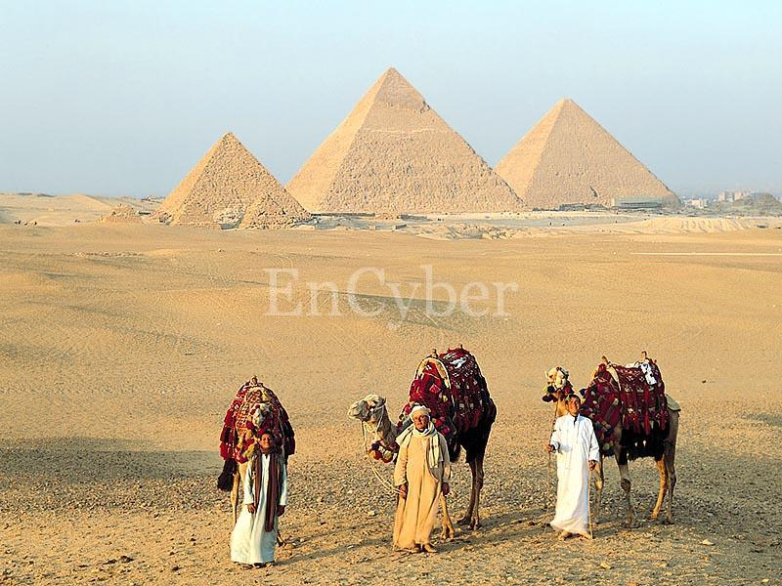
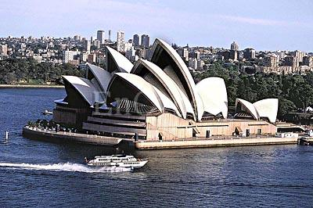

Worksheet #1

How to Plan a Vacation
- Research, research, research. Do it online or with mobile apps. And discuss it with other travelers. For example, go to websites to browse travel photos, journals and videos posted by real people sharing their experiences.
  - Decide what place)s) you have in your memories as best.
  - Decide what place(s) you will be going to.
  - Decide what day/time you will depart and return. Write it down.
  - Calculate how many people are coming along if you're not alone.
- Fill up the suitcases. Pack as many outfits as you will need for the vacation, plus, an extra or two. Don't forget your undergarments, pajamas, shoes, swimsuits/towels if swimming, etc
- Be prepared for certain situations. Planning ahead for things that could possibly happen will make the trip a whole lot smoother. Decide on a schedule for what each person wants to do along the way. Gather together and discuss what you had in mind. Be prepared for arguments. Everyone must be willing to compromise.
- Decide what form of transportation you're taking (plane, vehicle, etc.)
- Estimate the total cost of your vacation. Be sure to include restaurants (food & drink per person each day), gas for the vehicle to get there, back, and to places nearby where you'll be staying, hotel rooms per night, and any other activities that you plan on doing. (Swimming, the zoo, etc.)

Worksheet #2
Period
How many days will you travel?

Place
Where do you want to go? Why? What will you do where you want to go?

Daily Plan

- You can use any kind of travel means (Flight, Train, Ship, walking,….etc.)
- Although you are not rich, don’t limit your travel money.

