⌧ Listening ☐ Speaking ☐ Reading ☐ Grammar ☐ Writing

Pollution is the world’s biggest killer

Instructor:  Jisu Jung (Nikki) | Level:  Pre-intermediate | Students:  10 | Length:  30 Minutes

Materials:

- Audio file: Breaking News English Lesson on Pollution
- 10 copies of the picture: pollution
- 10 copies of worksheet 1: vocaburary
- 10 copies of worksheet 2: listening passage
- 10 copies of worksheet 3: dictation
- 10 copies of worksheet 4: opinion
- 10 copies of worksheet 5: poster making
- 10 drawing papers and crayons: for sos
- Audio script and answer sheet: for the teacher

Aims:

- Students will improve their listening skill by listening to the news

- Students will improve their speaking skill by giving their own opinion on pollution

- Students will recognize the importance of environmental protection by doing all the activities

Language Skills:

- Listening: Listening to breaking news English lesson on pollution
- Speaking: Giving an opinion from the post activity
- Reading: Reading the news after taking the dictation
- Writing: Writing partner’s opinion from the post activity

Language Systems:

- Phonology: Listening to the news, teacher’s talking
- Lexis: Learning new vocabuaries (pollution, disease, low-income, poverty, premature death)
- Function: Giving information about pollution and asking students’ opinion
- Discourse: Discussing about pollution

Assumptions:

- Students already know the meaning of synonym
- Students already know the subject of the news from teacher’s talking before main activity
- Students already understand all kinds of questions from the past class (eg.dictation, opinion)

Anticipated Errors and Solutions:

- Students may not understand new vocabularies easily
→ Drill and give them some explainations
- Students may not be able to answer all questions during listening at once
→ Play news again if possible
- Students may need more time to finish all activities
→ Give them all as an assignment, email them for reference
- Students may understand all clearly, so we may still have enogh time to do something
→ Let students do sos activity

References:

https://breakingnewsenglish.com/

https://goo.gl/SEkUpm

https://goo.gl/CSdifq

Lead-In
Materials: Picture
Time | Set Up | Student Activity | Teacher Talk
2 mins | Whole class | Guess the meaning of pollution | Procedure:  Hello everyone. How are things going?  (Students answer “good”)  Good.  Today, we are going to study listening part about pollution.  Present the picture  What is Pollution?  Elicit from the picture

Pre-Activity
Materials: Worksheet 1
Time | Set Up | Student Activity | Teacher Talk
3 mins  3 mins | Whole class  pairs | Guess the meaning of new vocaburaries  Fill the blanks on worksheet 1 | Procedure:  Before we listen to the news, we are going to look through some new vacabularies.  Distribute the worksheet 1  You can find the synonym on the top of the worksheet. Those words are all about pollution that we are going to learn today.  CCQ  1.Why do we go to the hospital when we get a disease?  2.Are rich people happier than low-income people?  3.Can you buy what you need if you are in proverty?  4.Do you think is it better to live forever than a premature death?  Fill the blanks in the sentences on the worksheet in pairs from the above words.  Check the answer: let students answer in pairs

Main Activity
Materials: Audio file, Worksheet 2, Worksheet 3
Time | Set Up | Student Activity | Teacher Talk
1 min  5 mins  2 mins  3mins  3mins  1 mins | Whole class  Individually  Whole class  Individually  Pairs  Whole class | Listen to News English Lesson on Pollution  Answer questions on worksheet 2  Listen to the news again and take the dictation  Compare the answers in pairs  Read the passage | Procedure:  Distribute the worksheet 2  You are going to listen to the news about pollution.  Listen carefully so that you answer the qustions on the worksheet.  Answer the questions at the same time when you listen to the news if possible.  Play the audio file of the news  (Playing)  Have you answered all the questions?  (- If students say “no” → Do you want to listen again? and replay  - If students say “yes” → go to the next stage)  Check the answer: let them answer at first and elicit  CCQ  1. What does the news mainly discuss?  2. what problem is mentioned in the news?  3. What is suggested about the pollution?  Distribute the worksheet 3  Look at the worksheet.  You are going to take the dictation while you are listening to the news lastly.  Be sure that you write the accurate words.  Replay  (replaying)  Compare the answer in pairs to read all of the passage.  Let’s start reading the news.  Check the answer while students read the passage  Elicit and collect error

Post Activity
Materials: Worksheet 4
Time | Set Up | Student Activity | Teacher Talk
5 mins  2 mins | Whole class  Groups  Whole class | Discuss about protection of the environment and write group member’s opinion on worksheet4  Give some great idea from the activity | Procedure:  We all know about an environmental pollution.  How can we prevent environmental pollution? Do you have any idea to protect our environment?  Distribute worksheet 4  Discuss at least 3 ways to prevent environment pollution in groups. And write your member’s opinion.  Set groups to 3 or 4 students  ICQ  1. What will you discuss about? (protect the environment)  2. Whose opinion should you write on the worksheet? (group member’s)  3. How many idea should you write at least? (3)  Let students give some great idea from the worksheet activity.  Do you have any question?  (if students say ”yes” → eliciting)  You had a great job today and see you in next class!

SOS Activity
Materials: Worksheet 5
Time | Set Up | Student Activity | Teacher Talk
Left time | Groups | Make a poster | Procedure:  Distribute the worksheet 5  We still have few minutes  Choose one subject to make a poster in groups.  Set groups to 3 or 4 students and  let them know time limit.  Attach the posters on the wall

Picture

Pollution

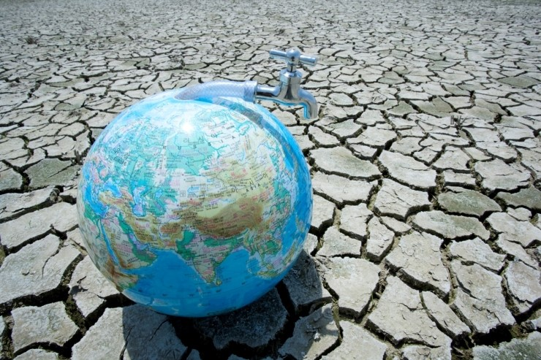
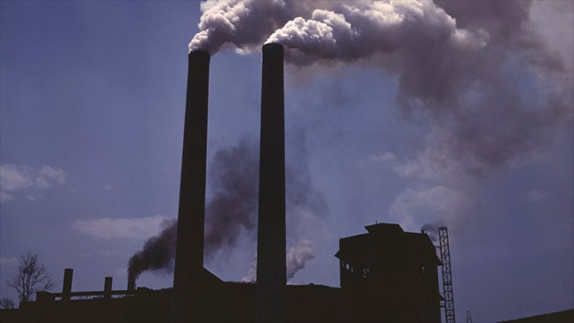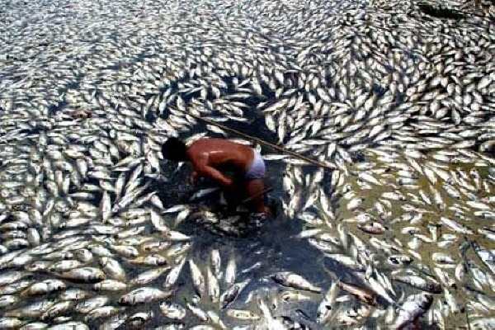

Work sheet 1
Vocabulary

Synonym

disease - illness
low-income - large income
poverty - poor
premature death - early death
pollution - dirtying

Put above words into the blanks in sentences below.

1.Many people caught the _________ from the patient.

2.A death prior to 65 is considered to be a _________.

3.I am on a _________ and cannot save.

4.Lots of African children labor under _________.

Audio Script

Pollution is the world’s biggest killer

A new study has found that pollution is now the world's biggest killer. One in six deaths worldwide is because of pollution. This is 16 per cent of all global deaths. Most of these deaths were from non-infectious diseases caused by pollution. These include heart disease, lung cancer and stroke. The study was published in the medical journal 'The Lancet'. Researchers said most pollution-related deaths occurred in poorer countries. About 92 per cent of these deaths were in low-income nations, especially countries where there is a lot of economic development, such as India and China. Bangladesh and Somalia were the worst affected countries. Brunei and Sweden had the lowest numbers of pollution-related deaths.
Study co-author Karti Sandilya said: "Pollution, poverty, poor health, and social injustice are deeply intertwined." He added: "Pollution threatens fundamental human rights, such as the right to life, health, wellbeing, and safe work." He said air pollution was the biggest killer. Air pollution led to 6.5 million premature deaths. The second biggest killer was water pollution, which caused 1.8 million deaths. The next largest killer was pollution in the workplace, which was linked to 800,000 worldwide deaths. Scientist Dr Penny Woods said: "Air pollution is reaching crisis point." She said the people who pollution hit the hardest are those with breathing and lung problems, children and the elderly.

Worksheet 2

Listening Passage

1. Which contries are not really affected by pollution? (One more answer is possible)

- India
- Bangladesh
- Brunei
- Somalia
- Sweden

2. What is the biggest killer of environmetal pollution?

- Water pollution
- Air pollution
- Light pollution
- Pollution in the workplace
- Noise pollution

3. TRUE/FALSE: Circle T or F properly for each sentence.

- One in six deaths is because of air pollution. T / F
- Most of these deaths were from non-infectious diseases caused by pollution. T / F
- Most pollution related deaths occurred in poorer countries. T / F
- The second beggest killer was pollution in the workplace. T / F

Worksheet 3

Dictation

A new study has found that pollution is now the world's biggest killer. One in six deaths worldwide is because of pollution. This is 16 per cent of all global A._________. Most of these deaths were from non-infectious diseases caused by pollution. These include heart disease, lung cancer and stroke. The study was published in the medical journal 'The Lancet'. Researchers said most pollution-related deaths occurred in B._________ countries. About 92 per cent of these deaths were in low-income nations, especially countries where there is a lot of economic development, such as India and China. Bangladesh and Somalia were the worst affected countries. Brunei and Sweden had the lowest numbers of pollution-related deaths.
Study co-author Karti Sandilya said: "Pollution, C._________, poor health, and social injustice are deeply intertwined." He added: "Pollution threatens fundamental D.________ ________, such as the right to life, health, wellbeing, and safe work." He said air pollution was the biggest killer. Air pollution led to 6.5 million premature deaths. The second biggest killer was water pollution, which caused 1.8 million deaths. The next largest killer was pollution in the workplace, which was linked to 800,000 worldwide deaths. Scientist Dr Penny Woods said: "Air pollution is reaching crisis point." She said the people who pollution hit the hardest are those with E._________ and lung problems, children and the elderly.

Worksheet 4

Opinion

How can we prevent environmental pollution? Discuss 3 ways to protect the environment and write your group member’s opinion.

Worksheet 5

Poster making

*Choose one subject to make a poster in groups.

- Air pollution
- Water pollution
- Pollution in workplace

Answer sheet

Worksheet 1
1. disease
2. premature death
3. low-income
4. poverty

Worksheet 2
1. C.Brunei E.Sweden
2. B.Air pollution
3. A.F B.T C.T D.F
short explanation
A.One in six deaths is because of pollution
D.The second beggest killer was water pollution.
pollution in the workplace is the third biggest killer.

Worksheet 3
A. deaths
B. poorer
C. poverty
D. human rights
E. breathing

