☑Listening ☐ Speaking ☐ Reading ☐ Grammar ☐ Writing

Topic:
Where is the nearest grocery store?

Instructor:  Sophia | Level:  Low- Intermediate | Students:  10 | Length:  30 Minutes

Materials:
- Board & markers
- Vocabulary Picture
- Realia (Volunteer Ss)
- 10 copies of the “Where is the nearest grocery store?” vocabulary worksheets
- CD & CD Player
- 10 copies of the “Where is the nearest grocery store?” main activity worksheets
- 10 copies of the town map worksheets
- 10 copies of the city wordsearch worksheets

Aims:

Main aim- Students will practice the direction by “Where is the nearest grocery store?” vocabulary, main activity and town map worksheets.

Secondary aim- Students will be confident about the direction by “Where is the nearest grocery store?” main activity and town map worksheets.

Personal aim- Teacher wants to follow the Lesson Plan.

Language Skills:

Listening- The teacher’s explanation about new vocabulary and partner disccussion
- “Where is the nearest grocery store?” dialogue & main activity worksheet
Speaking- Asking and answering the direction
Reading- Matching vocabulary & making the sentences
- Main activity worksheet & Role playing
- Find the correct building on town map
Writing- Writing the direction

Language Systems:

Phonology- Contractions (eg. I’m / You’re / Tiffany’s …)
Lexis- Direction words (eg. Across from / the nearest / go left…)
Grammar- Preposition (eg. Across from / next to…)
Function- Asking (eg. Where is the nerest grocery store?)
Discourse- Dialogue between the neighbors
- Write the direction.

Assumptions:

1. Ss know the teacher’s style of teaching.
2. Ss know they should speak only English in the class.
3. Ss are confident with pair and group work.

Anticipated Errors and Solutions:

- If Ss need more time to finish their main activity (cut-off plan)
> Cut the switch role playing

- If Ss finish thir activity early (SOS plan)
> Give Ss the city wordsearches worksheets

- If one of the Ss is absent
> Have 3 members on one team in pair work

References:

https://goo.gl/d25EkK
https://goo.gl/x1cLJk
https://goo.gl/3TCQ6R
https://goo.gl/z2Uaux
http://bogglesworldesl.com/wordsearches.htm
Listen and Listen 2-2, Unit2 “Neighbors” Dialogue

Lead-In
Materials:
- Board
Time | Set Up | Student Activity | Teacher Talk
2min | Whole  Class | 1. Greeting | Hello everyone. How are you today?  When do you ask the directions?  (Let Ss talk about their experience and write the answers on the board)  OK, Let’s move on to today’s keywords.

Pre-Activity
Materials:
- Vocabulary Picture
- Realia (volunteer Ss)
- “Where is the nearest grocery store?” vocabulary worksheet
Time | Set Up | Student Activity | Teacher Talk
6min | Whole  Class  Pairs  Whole class | Vocabulary | T : Before we listen the dialogue, let’s learn some new vocabulary.  1. Vocabulary  T : Repeat after me.  “across from” and “next to”  Show the picture of the words.  “across from” means…  “next to” means…  I want 2 volunteers who discribe these words.  Who wants to be a volunteers?  Come to the front.  (Ss discribe those words theirselves.)  (T explains the definition of the other 3 words with picture.)  T : Now, we are going to do a matching activity and comlete the sentences.  Instruction  Match the word on the left to the meaning on the right. Draw a line to match. And Complete each sentence using a word from matching words. And then complete the sentences. Work with your partner. You have 3 minutes.  Demonstration  Here is an example. The first word on your worksheet is “across from”. Find the definition of “across from” on the rihgt-hand side. When you find the answer, draw a line.  And look at “B”. Use the words that we leared and complete the senteces.  CCQ  Are you working alone?  How much time do you have?  (Distribute “Where is the nearest grocery store?” vocabulary worksheet and monitor discreetly)  Let’s check the answers together.  What did you get for “across from”?  (Check all the answers orally with the Ss)  T: Okay. What is the title?  Now, let’s star listening the dialogue!

Main Activity
Materials:
- CD & CD Player
- “Where is the nearest grocery store?” main activity worksheet
Time | Set Up | Student Activity | Teacher Talk
14min | Whole class  Individually  Whole class  Group | 1. Listening for the dialogue.  2. Listening for Details  3. Role Playing | 1. Listening for the dialogue.  Instructions  Put your pens down. Listen to the dialogue.  When you listen the dialogue, focus on what the speakers are talking about.  CCQ  Can you take notes?  What are you supposed to think about?  (Play CD)  What are they doing?  Have you ever asked the directions?  2. Listening for Details  Instructions  Now I’ll give you a worksheet. There are 3 questions. Listen to the dialogue. And find the answers to the questions. Work alone.  CCQ  Are you working together?  What are you supposed to do?  (Distribute “Where is the nearest grocery store?” main activity worksheet)  (Play CD)  (Let students write answers as they listen and monitor discreetly)  Do you want to listen again?  - Yes ➜ Have them listen one more time.  - No ➜ Move on the answer check.  Now, let’s check the answers together.  What is the answer for question number 1?  Do you agree with the answer?  (Same for questions 2 to 3)  (If there are any wrong answers, correct them with Ss.)  3. Doing role playing  Instructions  Now turn your worksheet over. Can you see the dialogue? And I’ll divide the class into two gruops. One group takes the role of the man. The other group takes the role of the woman. Have the students in each group read out loud together.  CCQ  How many groups are there?  Do you read out loud?  (Ss do role playing with groups and make them switch roles and do the role playing again.)

Post Activity
Materials:
- Town map worksheet
Time | Set Up | Student Activity | Teacher Talk
8min | Whole class  Pair  Whole class | Speaking  & Writing  About directions | 1. Free production  Instructions  Now I’ll give you town map worksheet. You can see the town map in section A. And fill in the blanks with the correct buildings with your partner.  And then look at section B. Choose a locatin on the town map. Have your partner give directions to get to that place from Johnny’s house. And your artner should write the directions in section B.  You have 5 min.  Demonstration  I choose the department store. From Johnny’s house, go right and go straight. Keep walking. The department store is on your left.  While I give the direction, my partner writes down it in section B.  CCQ  Are you working alone?  How much time do you have?  (Distribute town map worksheet and monitor discreetly)  2. Feedback  T : Did you have fun today?  Did you learn something about directions?  What did you learn?  Good job today! See you tomorrow.

SOS Activity
Materials:
- City wordsearch worksheet
Time | Set Up | Student Activity | Teacher Talk
5min | Individually | City wordsearch | Instructions  Now I’ll give you the city wordsearch worksheet. Find the words in the big box.  CCQ  Are you working together?  What are you supposed to do?  (Distribute town map worksheet and monitor discreetly)  (If Ss don’t finish it, let them do free homework.)

[Vocabulary Materials] 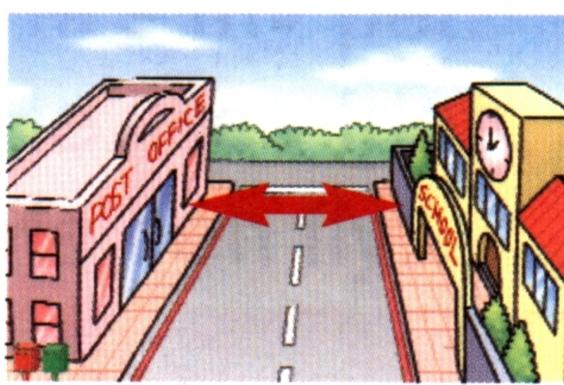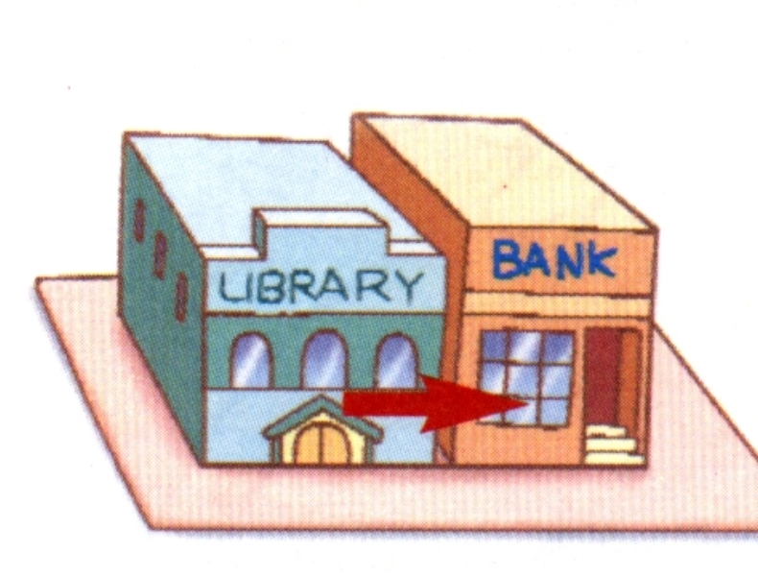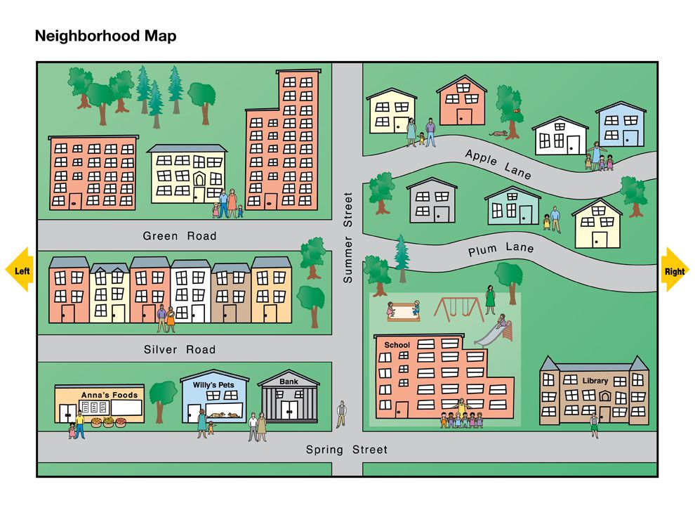
[Realia]
◎ When we do pre-activity about the vocabulary, I’ll invite 2 volunteers for showing “next to” and “across from”

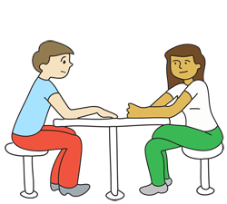
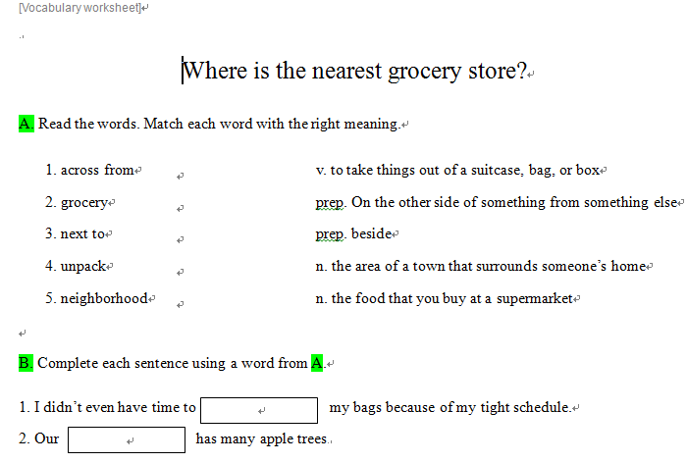

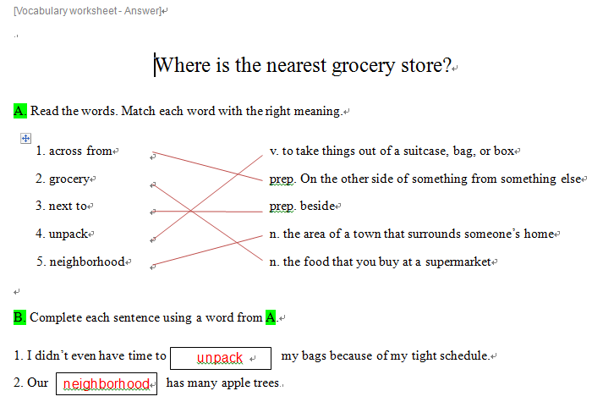
[Main activity]
Where is the nearest grocery store?

1. Where is this dialogue taking place?
ⓐ at the grocery store | ⓑ at the information desk
ⓒ in the neighborhood | ⓓ on Oxford street

2. Choose the right map based on the woman’s directions.
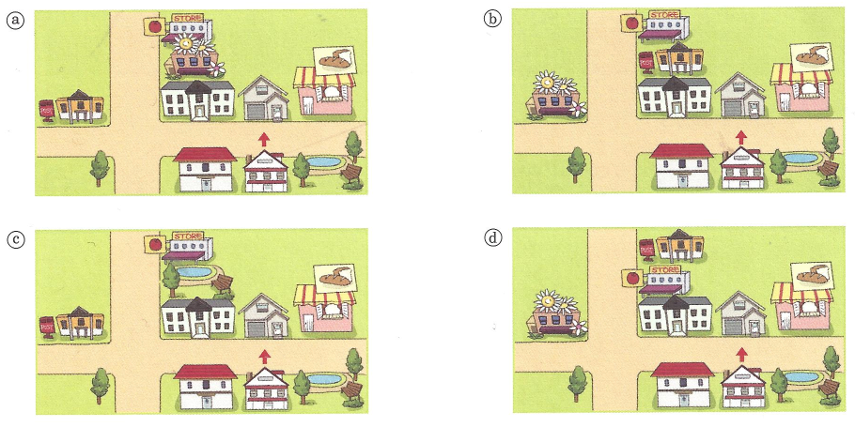

3. Answer T(True) or F(false).
1) Tiffany’s Grocery Store is in front of the post office. | T / F
2) Tiffany’s Grocery Store does not open on Sundays. | T / F
3) Tiffany’s Grocery Store is open from 6 a.m. to 11 p.m. | T / F
4) Tiffany’s Grocery Store offers items at low prices. | T / F
5) Tiffany’s Grocery Store is the nearest grocery store to the man’s house. | T / F

☺ Do role playing

Where is the nearest grocery store?

W: Hi! I'm Elizabeth.
I live right across from your house.
M: Nice to meet you, Elizabeth. I’m Ronald.
W: Likewise.
You're probably busy unpacking your things.
M: Yeah, I’ve been busy for the past few days.
W: Do you need any help?
M: No, but I have some questions about the neighborhood.
W: Go right ahead.
M: Where is the nearest grocery store?
W: Well, that would be Tiffany’s Grocery Store.
From here, go left. Then turn right onto Oxford Street.
Keep walking until you see the post office on the right.
Tiffany’s Grocery Store is right next to the post office.
You can find everything you need at the store.
M: And what are the business hours like?
W: It opens at 6 a.m. and closes at 11 p.m. from Monday through Saturday.
It’s very convenient. But I should warn you. That place is quite expensive!

[Main activity-Answer]
Where is the nearest grocery store?

1. Where is this dialogue taking place? (C)
ⓐ at the grocery store | ⓑ at the information desk
ⓒ in the neighborhood | ⓓ on Oxford street

2. Choose the right map based on the woman’s directions. (B)

3. Answer T(True) or F(false).
1) Tiffany’s Grocery Store is in front of the post office. | T / F
2) Tiffany’s Grocery Store does not open on Sundays. | T / F
3) Tiffany’s Grocery Store is open from 6 a.m. to 11 p.m. | T / F
4) Tiffany’s Grocery Store offers items at low prices. | T / F
5) Tiffany’s Grocery Store is the nearest grocery store to the man’s house. | T / F
[Post activity]
Town map
A. Look at the town map. Fill in the blanks with the correct buildings.
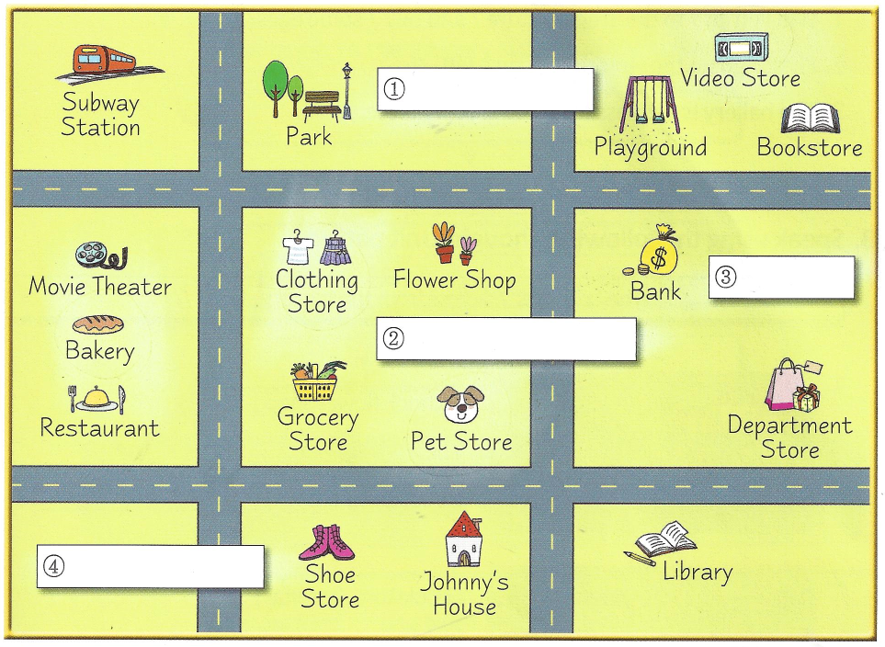
1. The train station is next to the park and across from the flower shop.
2. The post office is across from the restaurant and the shoe store.
3. The coffee shop is between the flower shop and the pet store.
4. The gym is next to the bank and across from the bookstore.
B. Choose a location on the town map. Have your partner give directions to get to that place from Johnny’s house. And write the direction.
[Post activity-Answer]
Town map

A. Look at the town map. Fill in the blanks with the correct buildings.
1. The train station is next to the park and across from the flower shop. (➀)
2. The post office is across from the restaurant and the shoe store. (➃)
3. The coffee shop is between the flower shop and the pet store. (➁)
4. The gym is next to the bank and across from the bookstore.(➂)

B. Choose a location on the town map. Have your partner give directions to get to that place from Johnny’s house. And write the direction.

[SOS-City wordsearch]

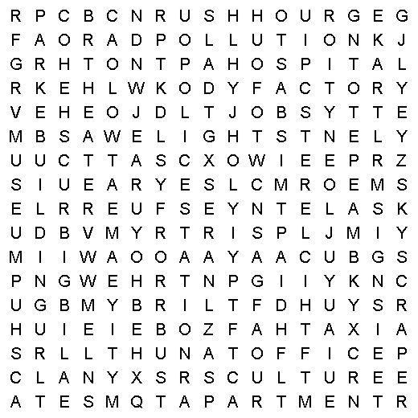 |  |  | 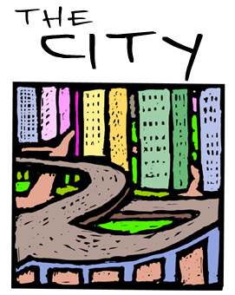  alley  apartment  bank  building  bus  city  crime  crowd  culture  curb  entertainment  factory  freeway
gallery  hospital  hotel  jobs  library  lights  museum  office | park  people  police station  pollution  restaurant  rush hour  signs  skyscraper | stadium  street  subway  taxi  theater  traffic jam  university
 | Look up any city words that you don’t know in the dictionary. Find all of these city words in the grid above.
[Audio Script]
Where is the nearest grocery store?

W: Hi! I'm Elizabeth.
I live right across from your house.
M: Nice to meet you, Elizabeth. I’m Ronald.
W: Likewise.
You're probably busy unpacking your things.
M: Yeah, I’ve been busy for the past few days.
W: Do you need any help?
M: No, but I have some questions about the neighborhood.
W: Go right ahead.
M: Where is the nearest grocery store?
W: Well, that would be Tiffany’s Grocery Store.
From here, go left. Then turn right onto Oxford Street.
Keep walking until you see the post office on the right.
Tiffany’s Grocery Store is right next to the post office.
You can find everything you need at the store.
M: And what are the business hours like?
W: It opens at 6 a.m. and closes at 11 p.m. from Monday through Saturday.
It’s very convenient. But I should warn you. That place is quite expensive!

