⍌ Listening ☐ Speaking ☐ Reading ☐ Grammar ☐ Writing

Topic: You have to let your failures teach you.

Instructor:  Park Jiweon | Level:  Upper-intermediate | Students:  10 | Length:  30 Minutes

Materials:
-Lead in 1: picture of Obama ‘Who is he?’
-Lead in 2: word card ‘SPEECH’
-Pre-Activity 1: picture of words and word cards (5 pairs)
-Pre-Activity 2: 10 copies of the vocabulary ‘warm-ups’ worksheet
-Pre-Activity 3: 10 copies of the vocabulary ‘synonyms of Vocabulary work’ worksheet
-Main-Activity :Video ‘President Obama’s Message for America’s student’ (1:29)
-Main-Activity 1: 10 copies of listening ‘You have to let your failures teach you’ worksheet
-Post-Activity 1: 10 copies of writing ‘You have to let your failures teach you’ worksheet
-Post-Activity 2: 10 copies of reading ‘You have to let your failures teach you’ Gap fill
-SOS-Activity: 10 copies of bingo sheet

Aims:
Main aim
- To improve Ss listening by watching the Obama’s speech video and doing worksheets for each sections to understand the details.
Secondary aim
- To learn new words about success and failure by pictures, word cards and worksheet
- To read stcrip by doing gap fill
- To share about Ss failure experience
Personal aim
- To encourage failure to overcome success

Language Skills:
Listening- To watch Obama’s speech and to do listening passage worksheet
Reading- To read the script and place the word in the appropriate location
Writing- To write down Ss experience of failure to succeed
Speaking- To make a speech about Ss own experiences

Language Systems:
Phonology- a long vowel for reading sentences
Lexis- To practicing new vocabulary
Grammar- Past passive
Function- Encouraging
Discourse- Obama’s speech

Assumptions:
1. Ss know who Obama is
2. Ss don't have much speech experience
3. Most students gain courage by listening to the experience of turning failure into success.

Anticipated Errors and Solutions:
- Ss may not be able to understand when they do reading worksheet.
> Play the speech video once more.
- Ss may feel difficulty in writing.
> Provide more words related to writing.
- It may take a long time for students to complete the task.
> Complete the tasks by pairing them with each other.

References:
Video- https://goo.gl/Y2VQex
Pictures- successful https://goo.gl/2GU2NB
best effort https://goo.gl/mVjipx
struggling https://goo.gl/5zUqKT
discouraged https://goo.gl/TjA4Yr
failures https://goo.gl/7vedX6
writing worksheet https://goo.gl/LZ7N2X
White house logo- https://goo.gl/uVjTYE

Lead-In
Materials: - picture of Obama ‘Who is he?’
- word card ‘SPEECH’
Time | Set Up | Student Activity | Teacher Talk
2mins | whole class | Listen for teacher’s eliciting question and answer. | T:How are you today?  (Show the picture of Obama.)  Do you know who he is?  Ss: Obama!  T: That's right. Obama, former president in USA. What kind of word came up with him?  Ss: first black president, Friendly, retired, USA, etc.  T: Okay, (Show the word card ‘SPEECH’)  Today we are listening to the former president Obama’s speech. Are you ready?  Well, let's start today's lesson.

Pre-Activity
Materials:- picture of words and word cards (5 pairs)
- 10 copies of the vocabulary ‘warm-ups’ worksheet
- 10 copies of the vocabulary ‘synonyms of Vocabulary work’ worksheet
Time | Set Up | Student Activity | Teacher Talk
5mins  (1mins)  (1mins) | whole class  individually  whole class | Listen for teacher’s explain  Listen for teacher’s instruction and demonstration | Before starting classes, it would be easier to learn and start learning about the important words in your speech.  I. Vocabulary  ( Show the words and pictures and explain the words)  T: Repeat after me. “Successful”  S: “Successful”  T: “Successful”meams …  (same for 5words)  Instruction  Read the sentence and find words similar to the underlined words. I'll give you a minute.  Demonstration  Here is an example on the top.  CCQ  How many minutes do you have to do?  Are you looking for a synonym or antonym?  T: Now let's check out the answer.  What did you get for number 1?  (check all the answers with the Ss)  T: Ok, Let’s start watching Obama’s speech.

Main Activity
Materials: - Video ‘President Obama’s Message for America’s student’ (1:29)
- 10 copies of listening ‘You have to let your failures teach you’ worksheet
Time | Set Up | Student Activity | Teacher Talk
5 mins  (3mins)  10mins  (7mins)  (3mins) | a pair  whole class  a pair | Listen for teacher’s instruction  Do worksheet and discuss  Listen for teacher’s instruction and Watch video  Listen for teacher’s instruction  Do worksheet | T: Before we watching the video. I’ll pass the listening worksheet. let’s do the worksheet as a pair  I. Skimming for the main idea  Instruction  Think about the guiding questions before we watch the video with partner. give you 3mins.  CCQ  What shoud you do?  How much time do you have?  Who do you work with?  (discuss Before part on the ‘listening’ worksheet)  T: ok, then we are gonna move on next one. I am going to play Obama’s speech. listen carefully and answer the literal questions.  II. Listening for the details  Instruction  Watch video and answer the literal questions. play two times. work alone.  CCQ  How many times will I play?  Which question do you answer?  T: Let’s check the answers togther.  What is the answer for qusetion number 1? Ss name?  Do you agree with the answer?  (same for questions 2)  III. Applied the idea  Instruction  Talk about your ideas based on the video with your partner.  CCQ  Who do you work with?  (Distribute the ‘reading’ worksheet)  T: all right. Let’s move on to the next activity

Post Activity
Materials: - 10 copies of writing ‘You have to let your failures teach you’ worksheet
- 10 copies of reading ‘You have to let your failures teach you’ Gap fill
Time | Set Up | Student Activity | Teacher Talk
8 mins  (3mins)  (3mins)  (2mins) | individually | Listen for teacher’s instruction  Write down on worksheet  Listen for teacher’s instruction and demonstration  Fill in the blink | I. Writing on your experience  Instruction  Write down your experience of turning failure into success. You have 3mins. work alone.  CCQ  How much time do you have?  What will you do?  (Distribute the ‘writing’ worksheet)  T: 1min left.  II. Reading: Gap Fill  Instruction  Look at the words on the right side and write down the right word in the blank.  Demonstration  Let me tell you how to do it. Number 1. Read the sentences and guess the correct words for the blank. give you 5mins.  CCQ  Where do you choose to words?  (Distribute the ‘reading’ worksheet)  T: Let’s check the answers togther.  What is the answer for qusetion number 1? Ss name?  Do you agree with the answer?  (same for questions )  III. Feedback  T: Did you get a lot of lessons through class today? Thank you for having fun today.

SOS Activity
Materials: - bingo sheet
Time | Set Up | Student Activity | Teacher Talk
 | a pair |  | Instruction  Fill the bingo sheet useing the words on  the top. Your partner explain about  meaning of the word. If you have the  word, circle the word. When you have 3  lines, shout out ‘‘BINGO’  CCQ  When can you circle the word?  How many lines do you need to shout  bingo?

Script:
You have to let your failures teach you.

…… Some of the most successful people in the world are the ones who`ve had the most failures. J.K.Rowling`s - who wrote Harry Potter - her first Harry Potter book was rejected 12 times before it was finally published. Michael Jordan was cut from his high school basketball team. He lost hundreds of games and missed thousands of shots during his career. But he once said, “I have failed over and over again in my life. And that`s why I succeed.”

These people succeeded because they understood that you can`t let your failures define you - you have to let your failures teach you. You have to let them show you what to do differently the next time.

No one’s born being good at all things. You become good at things through hard work. And even the you're struggling, even when you're discouraged, and you feel like other people have given up on you, don`t ever give up on yourself, because when you give up on yourself, you give up on your country.

I expect you to put your best effort into everything you do. Don't let your family down or your country down. Most of all, don't let yourself down. Make us all proud.

Lead-in 1:
Who is he?

Lead-in 2:

SPEECH

Pre-Activity 1:

Successful

Failure

Struggling

Best Effort

Discouraged

Pre-Activity 2:
Warm-Ups

1. Successful
Something that is successful achieves what it was intended to achieve. Someone who is successful achieves what they intended to achieve.
[a successful actor / It was successful. / whether successful or not]

2. Failure
Failure is a lack of success in doing or achieving something, especially in relation to a particular activity.
[a big failure / I feel like a failure[loser] in life.]

3. Struggling
A struggle is a long and difficult attempt to achieve something such as freedom or political rights.
[struggle to succeed / But studying is always a struggle.]

4. Discouraged
to deprive of courage, hope, or confidence; dishearten; dispirit.
[The news discouraged me.=I was discouraged at the news.]

5. Best effort
Best: Best is the superlative of good.
Effort: If you make an effort to do something, you try very hard to do it.
[I try to give my best effort in everything I do.]

Pre-Activity 3:
Synonyms of
Vocabulary Work
to determine the meaning of a familiar word in a sentence.

ex) I am happy with my life at this moment.
a. good b. sad c. annoying d. bad

- Some of the most successful people in the world are the ones who’ve had the most failures.
a. victorious b. unprofitable c. failed d. unsuccessful

- You have to let your failures teach you.
a. lack of success b.victory c. fortune d. success

- He is struggling for success day and night.
a. lazy b. don’t try c. easy going d. working hard

- He seemed really discouraged when I saw him yesterday.
a. inspire b. encourage c. depress d. cheer up

- I never stopped giving my best effort.
a. bad effort b. struggle c. try not to do d. not stir

Pre-Activity 3: Answer
Synonyms of
Vocabulary Work
to determine the meaning of a familiar word in a sentence.

ex) I am happy with my life at this moment.
a. good b. sad c. annoying d. bad

- Some of the most successful people in the world are the ones who’ve had the most failures.
a. victorious b. unprofitable c. failed d. unsuccessful

- You have to let your failures teach you.
a. lack of success b.victory c. fortune d. success

- He is struggling for success day and night.
a. lazy b. don’t try c. easy going d. working hard

- He seemed really discouraged when I saw him yesterday.
a. inspire b. encourage c. depress d. cheer up

- I never stopped giving my best effort.
a. bad effort b. struggle c. try not to do d. not stir

Main-Activity 1: (Video https://goo.gl/Y2VQex)
Listening passage:
You have to let your failures teach you.
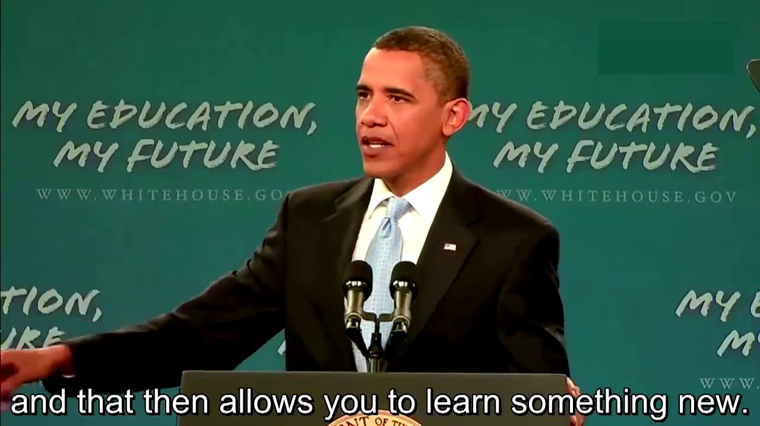
Before - Guiding Questions
- What does the obama do something?
- Have you ever had failures?

Literal
- How many times J.K.Rowling was rejected before
her book was finally published? ________
- Obama recommended to you give up when you’re
discouraged. T / F

Applied
- What would you do if you have failed over and over again in your life? Is it easy to recover?
- What is your best effort you ever had?
Main-Activity 1: Answer
Listening passage:
You have to let your failures teach you.
Before - Guiding Questions
- What does the obama do something?
- Have you ever had failures?

Literal
- How many times J.K.Rowling was rejected before
her book was finally published? 12times
- Obama recommended to you give up when you’re
discouraged. T / F

Applied
- What would you do if you have failed over and over again in your life? Is it easy to recover?
- What is your best effort you ever had?
Post-Activity 1:
Writing:
You have to let your failures teach you.

⠂Write down your experience of turning failure into success.
___________________________________________________
___________________________________________________
___________________________________________________
___________________________________________________
___________________________________________________
___________________________________________________
___________________________________________________
___________________________________________________
___________________________________________________
___________________________________________________
___________________________________________________

Post-Activity 2: GAP FILL
Reading:
You have to let your failures teach you.

…… Some of the most (1)__________ people in the world are the ones who`ve had the most (2)________. J.K.Rowling`s - who wrote Harry Potter - her first Harry Potter book (3)___ ________ 12 times before it (4)___ finally _________. Michael Jordan (5)___ ___ from his high school basketball team. He lost hundreds of games and missed thousands of shots during his (6)______. But he once said, “I have failed over and over again in my life. And that`s why I (7)_______.”

These people (8)_________ because they understood that you can`t let your failures define you - you have to let your failures teach you. You have to let them show you what to do (9)___________ the next time.
No one’s born being good at all things. You become good at things through hard work. And even the you're (10)__________, even when you're (11)___________, and you feel like other people have given up on you, don`t ever (12)____ __ on yourself, because when you give up on yourself, you give up on your country.
I expect you to put your (13)____ ______ into everything you do. Don't let your family down or your country down. Most of all, don't let yourself (14)____. Make us all proud.

successful
was published
succeed
was cut
failures
career
was rejected

discouraged
down
struggling
best effort
give up
differently
succeeded

Post-Activity 2: Answer
Reading:
You have to let your failures teach you.

…… Some of the most (1)successful people in the world are the ones who`ve had the most (2)failures. J.K.Rowling`s - who wrote Harry Potter - her first Harry Potter book (3)was rejected 12 times before it (4)was finally published. Michael Jordan (5)was cut from his high school basketball team. He lost hundreds of games and missed thousands of shots during his (6)career. But he once said, “I have failed over and over again in my life. And that`s why I (7)succeed.”

These people (8)succeeded because they understood that you can`t let your failures define you - you have to let your failures teach you. You have to let them show you what to do (9)differently the next time.
No one’s born being good at all things. You become good at things through hard work. And even the you're (10)struggling, even when you're (11)discouraged, and you feel like other people have given up on you, don`t ever (12)give up on yourself, because when you give up on yourself, you give up on your country.
I expect you to put your (13)best effort into everything you do. Don't let your family down or your country down. Most of all, don't let yourself (14)down. Make us all proud.

successful
was published
succeed
was cut
failures
career
was rejected

discouraged
down
struggling
best effort
give up
differently
succeeded

SOS-Activity: bingo:
You have to let your failures teach you.

successful succeed failures career discouraged
struggling best effort give up differently

