☐ Listening ☐ Speaking ☐ Reading ☐ Grammar ☐ Writing

Topic: Relationship

Instructor:  Jennifer  Karen | Level:  Upper Intermediate | Students:  8 | Length:  30 Minutes

Materials:

- Board & Marker

(Vocabulary)
- Odd : picture 1
- Odd : picture2
- Passionate: picture 3
- Supporting: picture 4
- Dependability : picture 5

(Worksheets)
- Worksheet 1: The Odd one out game
- Worksheet 2: Making sentence
- Worksheet 3: Cross words : SOS

Aims:

Main aim- students will improve their speaking skills by Worksheet 1: The Odd one out game.

Second aim – students will learn new vocabularies by showing picture and synonym

Personal aim – want students learn describing picture by: Worksheet 2: Making sentence

Language Skills:

Listening - Elicitation by teacher, teacher’s demonstration, listening students’ opinions

Speaking - Talking with friends while looking for something Odd.

Reading - Checking on worksheets

Writing - make complete sentence by Worksheet 2: Making sentence

Language Systems:

Phonology - Speaking and listening from Teacher and students using -ing
(ex: listening, talking, supporting, loving)
Lexis - Vocabulary used in ‘Relationship’.
(ex: Relationship, Supporting, dependability )
Grammar - Making complete sentence using ‘present continuous’
(ex: she is dating with him because….)
Function - Pick out the odd and share idea.
Discourse - Have conversation with a partner about relationship

Assumptions:

1. Students can pick up odd thing by talking.

2. Students know about kinds of Relationship.

3. Some students know how to use ‘present continuous’ for discussing the picture.

Anticipated Errors and Solutions:

-If student don’t know the word on the worksheet 1
>Explain the meaning of a word with elicit.

-If the times is not enough to write the sentences
> the sentences that is incomplete can be said to be just plain speaking

-If students can’t use ‘present continuous’
> give examples

References:
Worksheet 3(Crosswords) : www.bogglesworldesl.com

Lead-In
Materials: n/a

Time | Set Up | Student Activity | Teacher Talk
1min | Whole class | 1. Greeting& understanding topic | Good afternoon!  How was your week?  How do you feel when you are in relationship?  Today we will talk about ‘relationship’.

Presentation
Materials:
- Board & marker
- Odd : picture 1
- Odd : picture2
- Passionate: picture 3
- Supporting: picture 4
- Dependability : picture 5
Time | Set Up | Student Activity | Teacher Talk
7mins | Whole class | 1. Vocabulary  a. Relationship  b. Odd  (student look for difference)  c. Passionate  d. Supporting  e. Dependability | Before we start, let’s learn some vocabularies.  (Draw man and woman)  What these couple doing?  (relationship)  (miming holding hand together)  CCQs  When you are in relationship, what do you do with your partner?  Look at this picture  What do think about it?  Did you find anything strange?  (The yellow duck is odd.)  CCQs  (show the picture)  What is odd?  (red apple)  (show the picture)  This people are huge fan of rock music.  They are passionate on rock.  CCQs  Now what are we in passionate?  (TESOL)  What they are doing  They are supporting each other  How do you support someone who in trouble?  CCQs  Who support our class?  (captain)  What does she think about him?  She is lying down with dependability.  Synonym is trust  CCQs  Who is your dependability when you were a baby?  (parents)

Practice
Materials:

- Worksheet 1: the one out game

Time | Set Up | Student Activity | Teacher Talk
15mins | Whole class  Pairs  Whole class | 1. Make seating as pair  2. Worksheet 1: the one out game  3. Share students ideas  (Share their more reasons) | (Make seating as pairs)  Instruction  Let’s find the odd together with you partner and talk about reason why you chose those words.  I will give you one point who gives the most unique reason.  I will give you 7minutes.  ICQs  1. What do you look for among the words?  (odd)  2. How many minutes are you given?  (7minutes)  3. When do you get one point?  (who have the most unique reason)  Let’s share your ideas.  What do you think about question 1?  (Eliciting student’s idea)  ICQs  Are we sharing our ideas all together?  (yes)  Okay, that’s enough.  I like your ideas. Good job!

Production
Materials:
- Worksheet 2 : Making Sentence

Time | Set Up | Student Activity | Teacher Talk
 | Whole class  Individual  whole class | 1.Making Sentence Writing worksheet2  (distribute the worksheet)  (share students ideas)  2. Conclude lesson | Instruction  Now, look at this image and write sentences as much as you can use present continuous.  Ok, let’s share your ideas.  How did you describe?  (Elicit How did Students describe the picture)  ICQs  1. What do you use to make a sentence?  (present continues)  Great job today!  Hope you enjoyed it  Have a nice weekend!

SOS Activity
Materials:
- worksheet 3 : Cross words

Time | Set Up | Student Activity | Teacher Talk
4mins | Whole class | (answer the worksheet 3)  (Compare their worksheet with whole class) | Instructions  Answer the cross words on Worksheet  3.  (Let students check the answer with their students.)

Odd: Picture 1
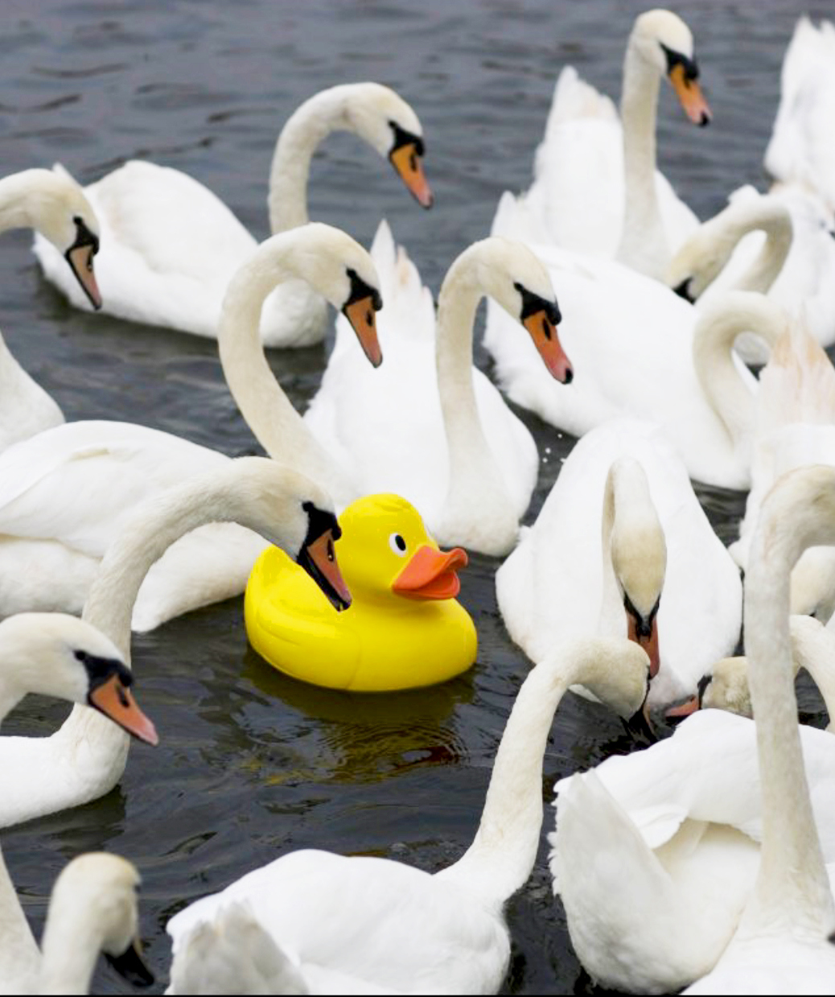

Odd: Picture 2

Passionate: Picture 3

re

Supporting: Picture 4

Dependability: Picture 5

