163th WK TESOL
Mimi & Annie
Hiking mountains
Speaking Lesson Plan

☐ Listening ▇ Speaking ☐ Reading ☐ Grammar ☐ Writing

Topic: Hiking mountains

Instructor: Mimi  Annie | Level:  Intermediate | Students:  8 | Length:  30 Minutes

Materials : Hiking mountains worksheet 1-A,1-B,2,3 (8 copies)
Seven word cards
Pictures of words
Markers and the white board
Scotch tape

Aims
Main aim
- Students will be able to talk more fluently about hiking by practicing speaking about their hiking experiences
Secondary aim
- Students will become familiar with some words related to mountains and hiking while doing work sheet 1,2, and 3
Personal aim
Teachers will be able to monitor students’ dialogues and give students corrections of mistakes at the end of the class

Language Skills:

Listening- Listening to teachers instructions
- Listening to a partner or group members
Speaking- Giving information about the mountains to the partner during “Let’s get to
the top” worksheet1
- Creating dialogue during “Let’s get to the top” worksheet2
- Discuss to plan hiking
Reading – Reading the information about mountains on “Let’s get to the top” worksheet 1
- Reading the instructions on “Let’s
get to the top” worksheet 1,2, and 3
Writing- writing about mountains on “Let’s get to the top” worksheet 1
- Writing hiking plan on “Let’s get to the top” worksheet 3

Language Systems:

Phonology- Ridge, [I:] Steep, Peak
Lexis- Mountains (Peak, Ridge, Steep, Stream, Slope, Hiking, Climbing)
Grammar- future tense/planning (be+ing or will)
Function- Asking, Suggesting, Giving information
Discourse- Dialogue creation about hiking

Assumptions:

- Students have experiences on hiking.
- Students know most of words on worksheet 1 and 2
- Students can speak about their hiking experiences with some errors.

Anticipated Errors and Solutions:

Students may not fill up the all the blank in time during let’s get to the top work sheet1
> Stop students if they have spoken enough.

If students have difficulties to create dialogues when they do worksheet 2
> Give students some examples of words so that students can make a sentence

Students may not be interested in hiking, so they don’t participate actively
> Encourage to think about some positive hiking experiences from the past

References:
1.Hiking work sheet
https://goo.gl/YBKd9j

2.Pictures
https://goo.gl/EL1U3a
https://goo.gl/mF1Wjv
https://goo.gl/jKRyHP
https://goo.gl/8Do5Kt
https://goo.gl/QkXwrM
https://goo.gl/Xx2rzo
https://goo.gl/n624yR
https://goo.gl/fsQyK7

3.mountains information
https://goo.gl/gkVusT
https://goo.gl/gf4Psh
https://goo.gl/ewUEeK
https://goo.gl/DZpcAo
https://goo.gl/z4UY2r
https://goo.gl/DgvEj9
https://goo.gl/3o8Ypk

4.SOS Plan
https://goo.gl/ckuBYv
https://goo.gl/LFKsja

Lead-In
Materials: -
Time | Set Up | Student Activity | Teacher Talk
2mins | Whole class | Greeting and short answers  Answers Y/N | - Greeting  Good morning.  How are you?  How was your week? Any exciting activities? Like riding a bicycle, going on a picnic, hiking a mountain to see colorful trees. They are so beautiful these days, aren’t they?  - Introduce the topic  So, what we are talking about today is hiking a mountain.  Do you like hiking a mountain?  Yes? No?  I do. I go to a mountain 2 or 3times a week with my second daughter. It’s more like walking but becoming hiking little by little.

Presentation
Materials: Five word cards
Pictures of words
Scotch tape
Time | Set Up | Student Activity | Teacher Talk
6mins | Whole class | Speak about the word  Answer to the question  Speak about the word  Speak about the word  Answer to the question  Speak about the word  Answer to the question  Speak about the word  Speak about the word  Answer to the question. | I. Vocabulary  So, what we are going to do today is talking about hiking.  Before we start the speaking about hiking, let’s look through some vocabulary first.  Presentation  Peak  First word is peak.  (show the word card and attach it to the board)  Does anyone have an idea of this word?  Yes. Right. I think most of you know about peak.  CCQ  - What do you do when you reach the peak of a mountain?  Shouting “Yaho,” Taking pictures like this  (show the picture of peak)  Ridge  Second word is ridge.  (show the word card and attach it to the board)  Does anyone have an idea of this word?  Ridge is this  (Show the picture of ridge)  These people are walking on the ridge  Steep  Third word is steep.  (show the word card and attach it to the board)  Does anyone have an idea of this word?  Look at this picture.  This man is standing on a steep hill.  Do you see the angle of the surface? It’s closed to vertical.  Do you know the opposite word for steep? That’s gentle.  (show the word card and attach it next to steep)  It’s closed to horizontal.  CCQ  Is a steep hill easier or harder to go up than gentle hill? harder  Stream  Fourth word is stream.  (show the word card and attach it to the board)  Does anyone have an idea of this word?  Look at the picture of stream.  (Show the picture of stream)  CCQ  When you put your feet into steam in summer how do you feel? cool  Slope  Fifth word is slope.  (show the word card and attach it to the board)  Does anyone have an idea of this word?  Look at the pictures here.  What can you see?  Sheep on a slope/ flowers on a slope  I think you are familiar with this word as ski slope  Hiking and Climbing  Finally I would like you to think about the difference between hiking and climbing.  Does anyone have an idea?  Look at the pictures.  (Show the pictures of hiking and climbing covered the letters)  Which one do you think is hiking?  Which one is climbing?  Can you find the differences?  Yes.  Climbing is more technical and needs some equipment.  And some times more dangerous.  Well done everyone.  We are done with words, so it’s time to speak.

Practice
Materials:
“Let’s get to the top” work sheet1-A and 1-B (Gap fills)
“Let’s get to the top” work sheet2 (Dialogue creation)

Time | Set Up | Student Activity | Teacher Talk
6mins  6mins | pairs  Pairs | Students repeat the dialogue after teacher.  Students answer  Students answer  Work in a pair and create dialogue  Answer teacher’s questions  Students freely share their experience | - Information Gap (Controlled practice)  These days, colorful leaves covered all over mountains. So we easily see many people get together for hiking mountains. As you know, there are many famous mountains around Korea. Shall we find out some interesting information about these famous mountains?  (Distribute “Let’s get to the top!” work sheet 1-A,B )  Instructions  - Make a pair (one student is A, the other student is B) and ask each other about the information you need.  - Fill the gap as you find out  - Don’t look at your partners paper  (Demonstrate the dialogue)  Look at the box on your worksheet.  There is a conversation between two women. Annie and I will be them. I have the information about mountain Sokri and Annie doesn’t. Annie will ask me questions and write the information.  Repeat after me and Annie.  ICQs  - What are you asking about? Information missing  - Can you find information you need to look at your partners’ paper? no  (Monitor students.)  Has everyone filled the gap with information?  Which mountain is the highest?  Which mountain is the high season now?  Which mountain is the free entrance fee?  Has anyone been on one of these mountains?  - Dialogue creation (Less Controlled Practice)  Now, what we are going to do is to practice speaking more related to you.  (Distribute “Let’s get to the top!” hiking work sheet 2)  Instructions  - Make pairs and ask each other about the questions given  - Don’t write down the answers and create a dialogue using presented vocabularies.  ICQs  - How many questions do you ask each other?  - Do you have to write down the answer?  (Monitor students discreetly)  Ok, everyone how did you go??  Enjoyed having a dialogue with your partner?  (Eliciting Students’ experiences)  How many of you like hiking mountains? Has anyone recently been on hiking??

Production
Materials: “Let’s get to the top” work sheet 3

Time | Set Up | Student Activity | Teacher Talk
6mins  4mins | Groups | Read the instruction on the let’s get to the top work sheet.  Answering to the ICQ questions  Speaking about hiking plan with group | - Free production  Instruction  Now, I like to give you some time to talk about hiking that you want to go.  Plan your hiking for the next weekend with your group.  (making groups of 4 people)  (Distribute the Let’s get to the top work sheet 3)  Read the text on the work sheet and write important information about your hiking.  You have 4minutes.  ICQs  - Who are you working with? The group  - Do you write sentences or only important information? Important information.  (Monitoring)  Alright. Time’s up. Even if you are not finished your plan yet, it’s ok. All you had chances to talk about your hiking plans.  - Post activity  Error correction  So, I’d like you to correct yourself if you recognize your mistakes.  (Error correction from Annie)  (Error correction from Mimi)  Feed back  Do you have any questions?  Did you have fun talking about hiking today?  Is there anything you can remember about hiking?  Good. We are done.  Have a nice day.

SOS Activity
Materials: Unforgettable Hiking Work Sheet

Time | Set Up | Student Activity | Teacher Talk
7mins | Groups | Discussing with the groups  Numbering on the items on memorable hiking work sheet.  A group says three items and the reasons.  B group says three items and the reasons  C group says three items and the reasons. | Since we have little more time,  I want you to do this interesting activity with your group.  (Making groups/ 3-3-2)  Instructions  Read the text on the work sheet. You were hiking a mountain by yourself and got lost. There are some items you might need, put numbers in parenthesis in the order of priority.  ICQs  - Where do you put the numbers?  - If you think water is the most important, what number will you put?  Alright, you have 3minutes.  You seems almost done.  Group A, what are your top three priority and why?  Group B, what are your top three priority and why?  Group C, what are your top three priority and why?  Hmm… little different / almost same.  Interesting.  Okay, I think we are done today.  Feedback  Do you have any questions?  Is there anything you can remember about hiking?  Good. I hope you remember that for a long time. We are done. Have a nice day.

Peak

Ridge

Steep

Gentle

Slope

Stream

Hiking vs Climbing

These are streams

They are walking on the Ridge.

A man is on a steep hill.

Sheep are on a mountain slope Flowering on a slope

When you reach the PEAK you do this!
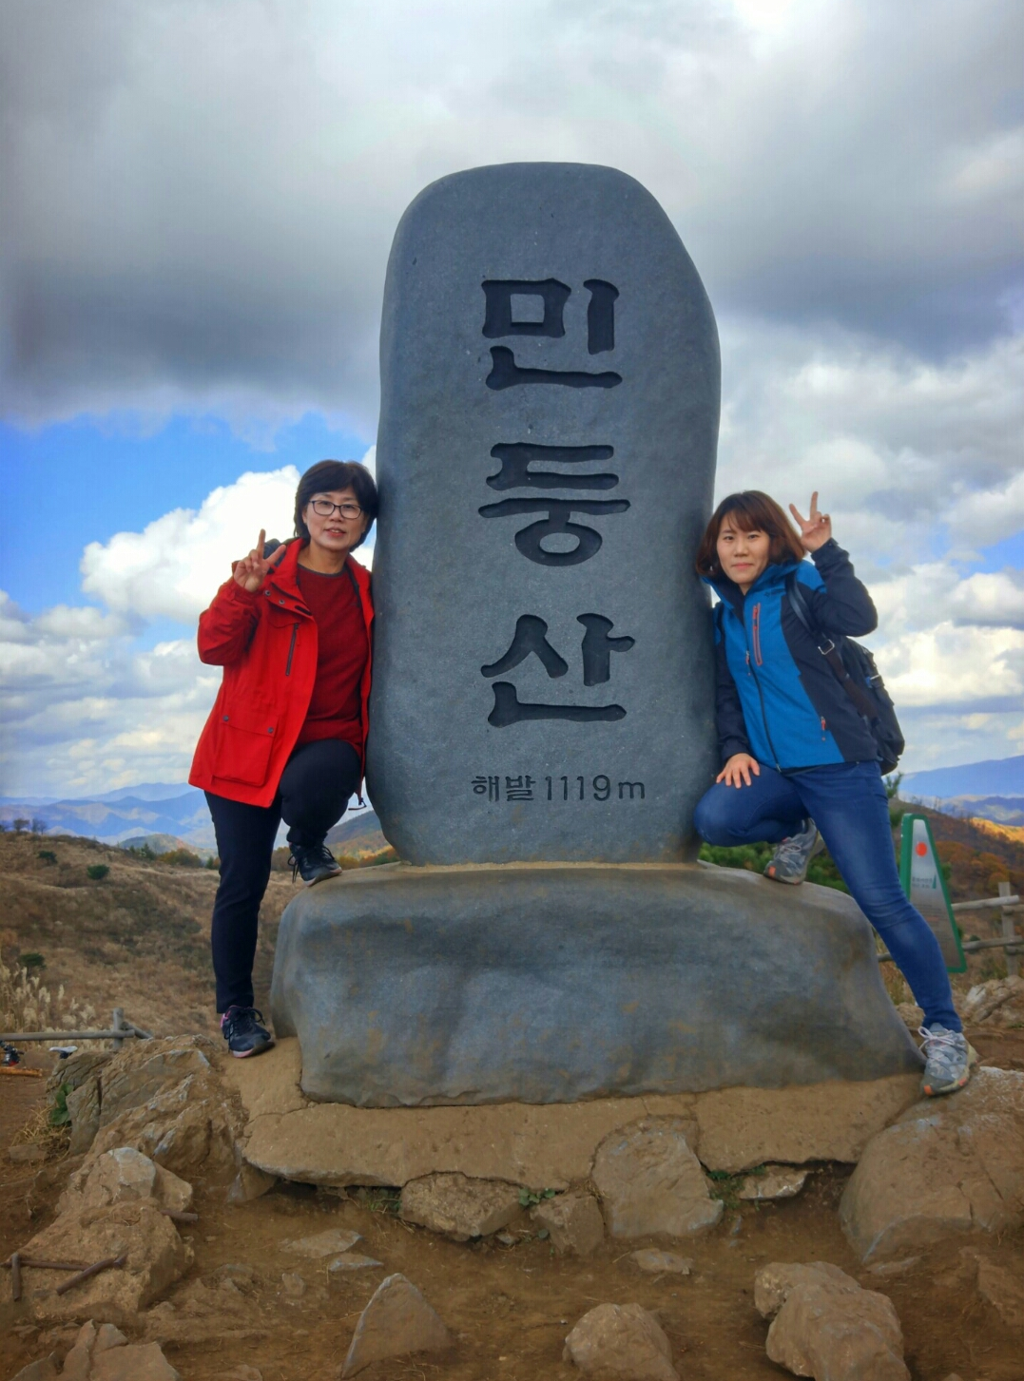

Hiking

Climbing

Let’s get to the top! Work sheet1-A
Sounds good. Let’s go together.
Is it the high season now?
Where is located? Is it high?
Yes. Which mountain are you planning to go?
Do you want to go mountain hiking next weekend with me ?
I am planning to go to mountain Sokri.
It’s located in Boeun-gun, Chungbuk.
The height is about 1000m.

Yes, its high season is Oct. and Nov.
And we need to pay for the entrance. It’s 4000won.

Songri mountain

Location:Boeun-gun, Chunbuk
Height: about 1000m
High season: Oct.,Nov.
Entrance fee: 4000won
Bukhan Mountain

Find the information missing about mountains by asking your partner.

Seorak mountain
Location:
Height:
High Season:
Entrance Fee:
Location: Seoul
Height: about 850m
High Season: Sep.,Oct.
Entrance Fee: Free

NaeJang mountain
Taebaek mountain
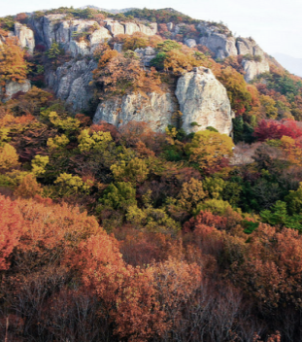
Location: Junbuk
Height:765m
High Season: Oct.,Nov.
Entrance Fee:5000won
Location:
Height:
High Season:
Entrance Fee:

Hanlla mountain
Jiri mountain
Location: Jeju Island
Height: 1950m
High Season: Jul., Aug.
Entrance Fee: Free
Location:
Height:
High Season:.
Entrance Fee:

Let’s get to the top! Work sheet1-B
Sounds good. Let’s go together
Yes. Which mountain are you planning to go?
Where is located? Is it high?
Is it the high season now?
Songri mountain

Location: Boeun-gun, Chunbuk
Height: about 1000m
High season: Oct.,Nov.
Entrance fee: 4000won
Do you want to go mountain hiking next weekend with me ?
I am planning to go to mountain Sokri.
It’s located in Boeun-gun, Chungbuk.
The height is about 1000m.

Yes, its high season is Oct. and Nov.
And we need to pay for the entrance. It’s 4000won.

Bukhan Mountain

Find the information missing about mountains by asking your partner.

Seorak mountain

Location:
Height:
High Season:
Entrance Fee:
Location: Inje, Gangwon
Height:1700m
High Season: Feb~May
Entrance Fee:3500won

NaeJang mountain
Taebaek mountain

Location:
Height:
High Season:
Entrance Fee:
Location: Taebaek
Height:1500m
High Season: Jan.,Feb.
Entrance Fee:2000won

Jiri mountain
Hanlla mountain
Location:
Height:
High Season:
Entrance Fee:
Location:Gyongnam
Height:1915m
High Season:Sep.,Oct.
Entrance Fee: Free

Let’s get to the top work sheet 2
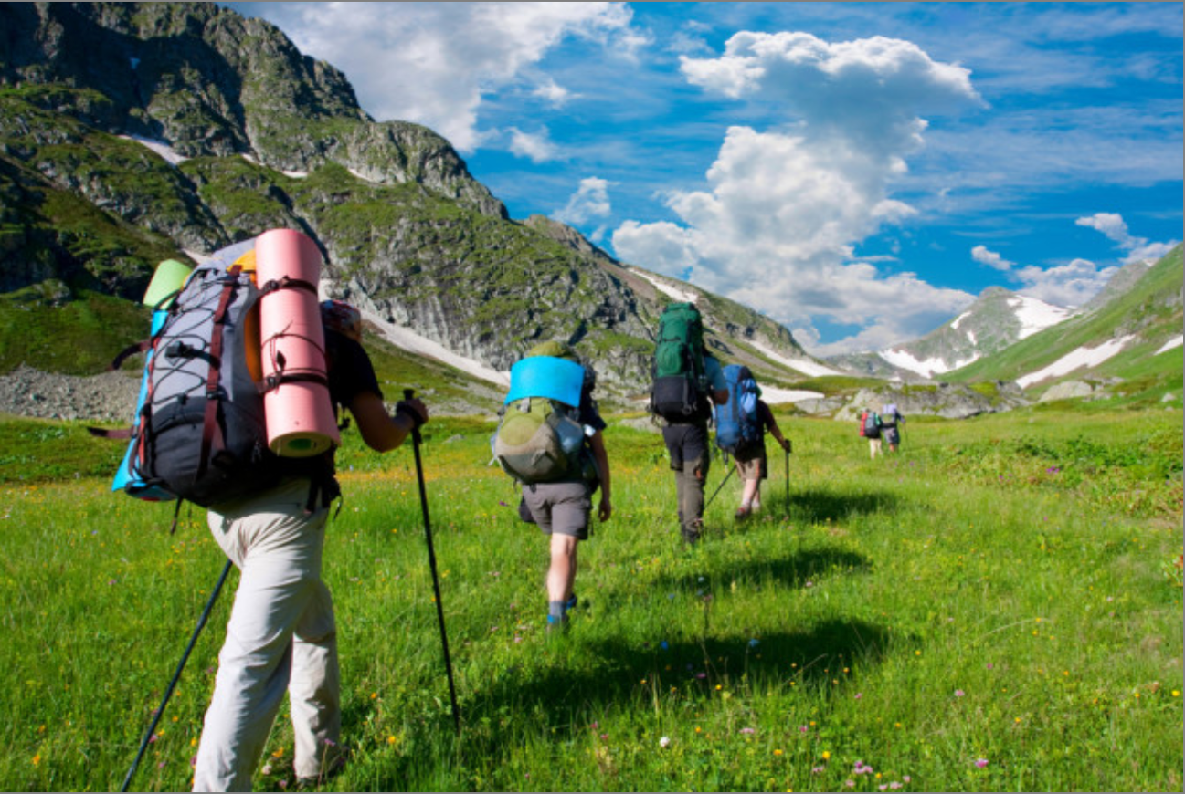

Look at the picture and talk about the questions with your partner.
(Use words we
You don’t need to write the answers)

- What are they carrying on their backs?

- How high up do you think they will hike?

- Do you like holidays in mountains?

- What kind of hiking do you like?
(eg. being relaxed walking, enjoying going up to the top, enjoying scenery, views of nature)

- What things can you do on top of a mountain?

Let’s get to the top work sheet 3
You are a member of a mountain-hiking club and you are planning to hike a mountain next weekend.
Talk with your group and write important information that you should announced.
(Don’t write sentences, but information such as where, when, how, what)
You have 4 minutes.

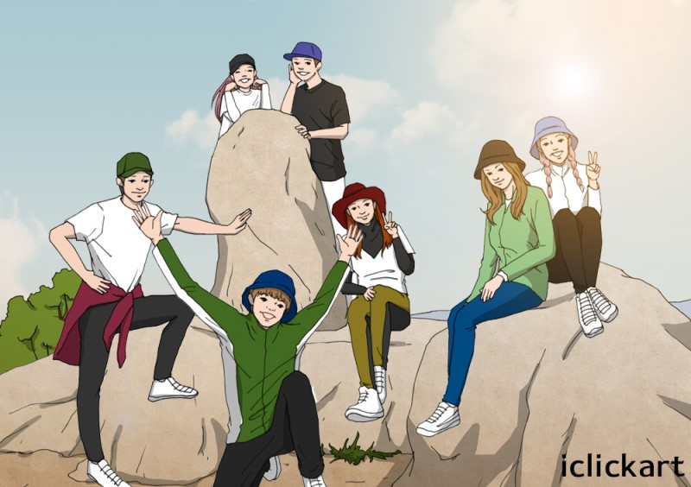

Unforgettable hiking!

Everything was going fine.
You were out hiking by yourself, the sun was shining, the scenery was gorgeous. The trail wound through the hills before you and life was good…
But then you lot lost.
The trail disappeared, and with it, your sense of direction. Were you heading South? No… it was West. Right? You can’t remember.
You shout for help, but your voice is lost in the wind. No one will hear you.

Which items are most essential to survive and return home? Put them in the order of priority!

( ) Extra hiking boots
( ) Map and compass
( ) 15m of nylon rope
( ) Extra batteries
( ) 2 bottles of water
( ) 1 roll of Kimbab and two chocolate bars
( ) Binoculars
( ) A hat
( ) A flashlight
( ) A lighter
( ) A whistle
( ) First-aid kit
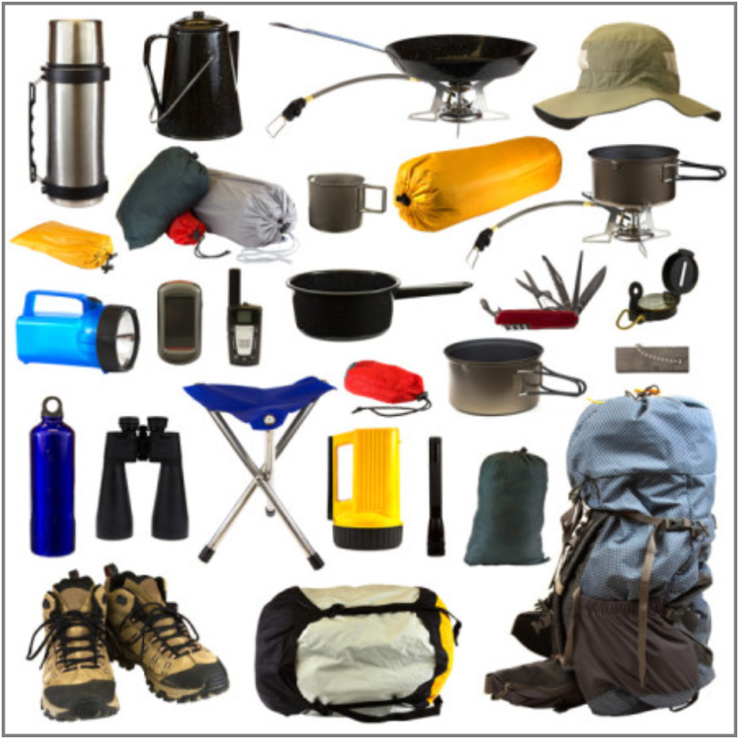
( ) A multi-purpose tool
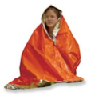
( ) Sun glasses
( ) Emergency blanket
( ) Signal flares

