☐ Listening ⌧ Speaking ☐ Reading ☐ Grammar ☐ Writing

Have you experienced…?

Instructor:  Jisu Jung,  Jiwon Park | Level:  intermediate | Students:  8 | Length:  30 Minutes

Materials:

- PPT: example of language in use and vocabulary
- 8 copies of worksheet 1: board game (have you experienced?)
- 8 copies of worksheet 2: interview
- 8 copies of worksheet 3: for SOS (have you experienced?)

Aims:

1. Main aim: Students will improve their speaking skill by having an interview

2. Secondary aim: Students will learn how to use present perfect tense when speaking

3. Personal aim: Students will be fully interested in speaking by playing board game

Language Skills:

- Listening: Listening to classmate’s speaking
- Speaking: Having an interview about their experiences and speaking during board game
- Reading: Reading questions on worksheets
- Writing: Taking a note from the lesson

Language Systems:

- Phonology: Using contractions (I’ve been, I’ve never been…)
- Lexis: Learning new vocabuaries (adventurous, argue, celeb, escape, witness)
- Grammar: Being familiar with present perfect tense
- Function: Having an interview and playing a board game
- Discourse: Speaking about their experience

Assumptions:

- Students already learned present perfect tense in grammar class
- Students feel a lot of interest in speaking about their experience
- Students already understand all kinds of questions from the past class

Anticipated Errors and Solutions:

- Students may not understand new vocabularies easily
→ Give them some explanations
- Students may not understand how to play a board game
→ Give a demonstration
- Students may understand all clearly, so we may still have enough time to do something
→ Let students do sos activity

References:

- adventurous word: https://goo.gl/4SVpHc
- argue word: https://goo.gl/CAzEee
- SOS: https://goo.gl/eeTjLD

Lead-In
Materials: N/A
Time | Set Up | Student Activity | Teacher Talk
1 mins | Whole class | Exchange greetings | Procedure:  T: Hello everyone. How are you?  Ss: “good.”  T: Today, we are going to talk about experiences. Before we start the lesson, we are going to look through some vocabularies.

Presentation
Materials: PPT
Time | Set Up | Student Activity | Teacher Talk
7 mins | Whole class | Guess the meaning of vocaburaries | Procedure:  Present the vocabularies from the PPT  Elicit from all vocaburaries  T: Take note of vocaburaries if you need  ⅠVocaburary  1. Escape  (Show the picture)  2. Celeb  (Show the picture)  3. Adventurous  (Show the video)  4. Argue  (Show the video)  5. Witness  (Show the synonym)  CCQ  1. Do you want to escape from the city and go for a holiday?  2. Have ever met celeb directly, not on the screen?  3. Do adventurous people like to live in jungle?  4. Did your parents argue with each other?  5. Does a lawyer ask the fact to a witness?.  Present the conversation from the PPT  T: You are going to practice speaking tasks by talking about your experience.  ⅡConversation  Nikki: Have you ever been to New York?  Jiweon: No, I haven’t. I’ve never been to New york.  Nikki: Have you ever been to LA?  Jiweon: Yes, I have. I’ve been to LA.  T: Be sure of the contractions “I’ve and I haven’t”

Practice
Materials: Worksheet 1
Time | Set Up | Student Activity | Teacher Talk
11 min | pairs | Play the board game on the worksheet 1 | Procedure:  Distribute worksheet 1  T: We are going to play a board game. We will make a sentence using present perfect tense such as have been, haven’t been. I’ll give you 11 minutes. Let’s start now.  Instruction  1.Ss get into a pair. Prepare a game board and dice.  2. Take turn to roll the dice and move along the board according to the number on the dice.  3. Make a sentence based on the words which you land on a square on the game board and ask your partner questions.  4. Follow the instructions on the square and go forward or go back.  5. Continues until one of the student get into Finished square.  ICQ  1. How do you start playing the board game? (by throwing dice)  2. What should you do after throwing dice?(go to the question from the number of dice and answer the question)  T: Have you done? Who finished first?

Production
Materials: Worksheet 2
Time | Set Up | Student Activity | Teacher Talk
11 mins | pairs | Interview each other from the worksheet 2 | Procedure:  Distribute worksheet 2  T: Interview your partner about 3 topics below. Be specific answering all wh questions. Feel free to talk so that we focus on speaking by interview.  ICQ  1. How many topics do you have to interview? (3)  2. What should you do if you finish being an interviewer? (Be an interviewee)  Let them know time limit  T: Ok, time is over. Did you have fun today?  Ss: “Yes”  T: Do you have any questions?  Elicit from the questions if there is  Give them feedback

SOS Activity
Materials: Worksheet 3
Time | Set Up | Student Activity | Teacher Talk
Left time | Individually | Match the occupation  on SOS | Procedure:  Distribute the worksheet 6  T: Read the each sentence below and complete the wordcross.

PPT
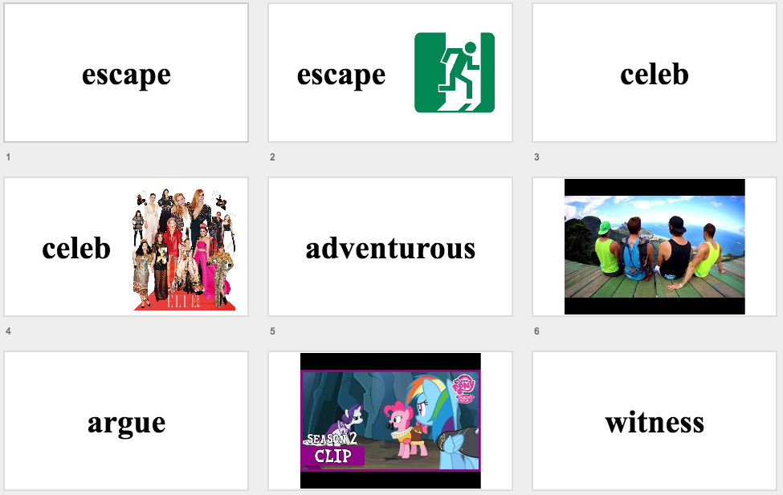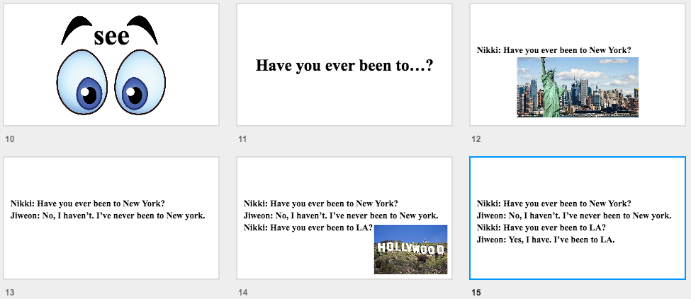

Worksheet 2: interview
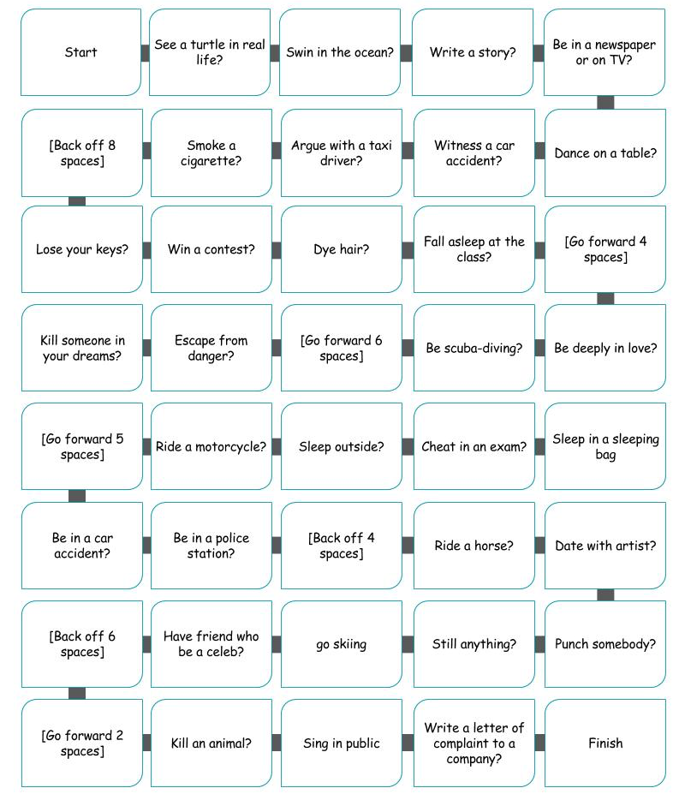
Interview
Worksheet 2: interview
Interview
Interview your partner about following topics.
TOPICS.
Have you done something adventurous in my life.
Have you bought something valuable in my life.
Have you eaten something unusual thing in my life.

WHEN

__________________________________________________________

WHERE

__________________________________________________________

WHAT

__________________________________________________________

HOW

__________________________________________________________

WHY

__________________________________________________________
SOS
Have you experienced…?
Across
2. happens when a vehicle hits a person, an object, or another vehicle, causing injury or damage.
5. the same as a celebrity.
8. is willing to take risks and to try new methods. Something that is adventurous involves new things or ideas.
9. from a place, you succeed in getting away from it.
Down
1. a vehicle with two wheels and an engine.
3. something such as hair or cloth, you change its colour by soaking it in a special liquid.
4. someone who appears in a court of law to say what they know about a crime or other event.
6. they do not obey a set of rules which they should be obeying, for example in a game or exam.
7. someone or something, you hit them hard with your fist.
SOS-Answer
Have you experienced…?

Across
2. Accident
5. Celeb
8. Adventurous
9. escape

Down
1. Motorcycle
3. dye
4. witness
6.Cheat
7.Punch

