|  |
| --- |
| ☐ Listening ☐ Speaking ☐ Reading **☐ Grammar** ☐ Writing |
| **Topic: If I had a million dollars…** |

|  |  |  |  |
| --- | --- | --- | --- |
| Instructor:  **Kim Hayoung (Karen)** | Level:  **Upper-Intermediate** | Students:  **9** | Length:  **30 Minutes** |

|  |
| --- |
| Materials:   * Music clip: “If I had a million dollars” * Handout : Second conditional * Worksheet1: Gap fill exercises * Worksheet2: Chain conditions * Worksheet3: Word search puzzle * Board game & Instruction paper * Two Dices (Numbers and positive negative) * Three Pieces * Chips * Cards |

|  |
| --- |
| Aims:  Main aim: Students will learn the second conditional by answering Worksheet 2: Gap fill exercises.  Second aim: students will improve in speaking about hypothetical / imaginary situation worksheet 3  Personal aim: student will be confident to participate in speaking second conditional by and playing board game |

|  |
| --- |
| Language Skills:  Reading: Reading worksheet before answering questions  Listening: music, classmate ideas, teacher’s instruction  Speaking: playing board game, answering worksheet 2: Gap fill exercise.  Writing: Brainstorming on Workshee1: Mind map |

|  |
| --- |
| Language Systems:  Phonology: Pronunciation of “would” /wʊd/, “I'd (←I would) [aɪd]”  Lexis: If I (verb), I would  Grammar: Second conditional  Function: Giving information of how and when to use “If I (past simple) + I would (verb) ”  Describing and imagining unreal situation.  Discourse: Playing Board game. |

|  |
| --- |
| Assumptions:   * Students already learned the second conditional. * Students already have known how to play board game. * Students already know the past modals. |

|  |
| --- |
| Anticipated Errors and Solutions:   * Students may have difficulty to answer worksheet   < Give them hint or keywords   * Students may not understand have to use second conditional   < provide more examples   * Students didn’t finish the activity yet. * < Give more time to finish their activities. |

|  |
| --- |
| References:  - (Video clip) <https://youtu.be/tajhs_FdT98>  - (Chant lyrics) goo.gl/XSLt21  - (Worksheet 3) goo.gl/dumuUD |

|  |  |  |  |
| --- | --- | --- | --- |
| **Lead-In** | | | |
| Materials: n/a | | | |
| Time | Set Up | Student Activity | Teacher Talk |
| 2mins | Whole class | Greeting | **Procedure:**  Hello, everyone!  How was your week?  (Wait for Ss response)  That’s good to hear.  Is there anyone who had a million dollars before?  (Hoping Ss would response “No”)  Aw… too bad for you…  Let’s imagine that you had a million dollars!  If you had a million dollars, what would you do?  (Ss response)  That’s good idea!  **Contextualization**  Okay, does anyone heard music  “If I had a million dollars?”  (Ss response “No…”)  We will start our class by listening the music |

|  |  |  |  |
| --- | --- | --- | --- |
| **Presentation** | | | |
| Materials:   * Board & Marker * Projector * Video clip : “If I had a million dollars” * Handout | | | |
| Time | Set Up | Student Activity | Teacher Talk |
| 10mins | Whole class | Listen to the video and write down sentences  (Listening to music)  (Receive handout) | **Procedure**  **1. Recall**  I’m going to play the music.  You can write down some lyrics you have heard.  CCQs  Can you take down note while you listening to the music?  (Ss response “yes”)  (play music start from (0:20) to (2:02))  Do you want to listen again?  (if Ss say yes, play music again  If Ss say no, proceed to next step)  Alright!  Can you tell me what you heard about?  (Ss response “If I won a million dollars,”, “I would buy…” or “I could have…”)  What kind of grammatical structure?  Can you guess?  (Ss response “Second conditional”)  Yes!  This grammatical structure is called  “Second conditional.”  (write ‘Second conditional’ on the board)  **2. Reflect**  Let me give you handout before I explain about second conditional.  (distribute the handouts to Ss)  (write on the board  If I had a million dollars, I would buy a house.”)  ‘The Second conditional’ is like the first conditional. We are still thinking about the future and the result of this condition. But there is not a real possibility that it will happen.  For example, you do not have a million dollars. Is it possible that you have a million dollars?  (Ss response No.)  No! But maybe you will have million dollars in the future. So you can think about having a million dollar in the future, like a dream.  Can you read the sentence on the board? (point at the board)  (Ss read “if I had a million dollars, I would buy a house”)  What is clause in this sentence?  (Ss response “If I had a million dollars,”)  (T underline the sentence)  And what is main clause?  (Ss response “I would buy a house.”)  (T underline the sentence)  Yes! How do we make this into negative?  (If I had a million dollars, I wouldn’t buy a house.)  **3. Drill**  How about this?  “If I had a million dollars, I would spend all of my money.”  (Ss “if I had a million dollars, I wouldn’t spend all of my money.”)  Please make this sentence into positive.  “if I had a million dollars, I wouldn’t buy a house for Karen”  (“if I had a million dollars, I would buy a house for Karen”)  I love you everyone~ |

|  |  |  |  |
| --- | --- | --- | --- |
| **Practice** | | | |
| Materials:   * Worksheet1: Gap fill exercises * Worksheet2: Chain conditions | | | |
| Time | Set Up | Student Activity | Teacher Talk |
| 8mins | Whole class  Pair | Make and speak Ss’s own creative sentence.  Ss have their partner | **Instruction**  **1. Controlled Practice**  Now we are going to do an activity.  Please get one and pass  (Give worksheet 2)  Please complete the sentences using second conditional form of the verb.  You have 2mins  CCQs  - How many minutes do you have?  (Ss response “2mins”)  - How do you complete the sentences?  (Ss response “using second conditional form”)  (If Ss are done answering worksheet, proceed to next step.)  Now, please tell me the answer.  What’s the answer number 1?  (Ss response the answer)  Very good everyone!  **2. Less-Controlled Practice**  Let’s do another activity.  Please get one and pass.  (distribute the worksheet 2)  This time we will do as a pairs.  (T makes Ss 2 members as a group )  The first speaker begin with a sentence using “Second conditional”  The next speaker uses the end of the previous sentence. Then the first speaker continues the story.  **Demonstration**  For example…  “If I won a million dollars, I would buy a Ferrari”  ________, can you make sentence using the end of the previous sentence?  (Ss response like “If I bought a Ferrari, I would drive to France.”)  (T says, “If I drove to France, I would eat a lot of pasta”)  This is how you do an activity  Please do not write anything on your worksheet.  You have 2mins  CCQs  Do you write on your worksheet?  (Ss response “No”) |

|  |  |  |  |
| --- | --- | --- | --- |
| **Production** | | | |
| Materials:   * Board & marker * Board game * Tokens * Dices * Cards | | | |
| Time | Set Up | Student Activity | Teacher Talk |
| 10mins | Whole class | Make 3 members per group  And make the desk and chairs in to 3 groups  Read the instruction  (clean up and fix their seating arrangement) | **Instruction**  **1. Free Practice**  This time, we will play a board game.  Please make 3 members per group.  I will give you board game for each group.  Now, Let’s read the instruction before we play board game  Instruction number 1?  (Ss read the instruction).  (1. Get one piece for each player  2. Roll two dice(first dice is the number of steps, and second dice is positive and negative)  3. make second conditional with the words given(be aware of +&-)  4. when you are on black spot, get one card and follow the rule  5. When you get one each shapes, then say loudly "Millionaire".)  Also please get chip after you answer complete sentence.  You have 8mins  ICQs  When do you get chips?  (after answering )  When do you say “millionaire”?  (when we get one each shape of chips)  You may start now.  **Monitoring**  (Check how Ss are doing. Help Ss only when they ask for it. Give them some ideas, if Ss look lost.)  **2. Conclusion**  Ok! Everyone time’s up!  Let’s fix our chair and desk  (Ss fix their chair and desk)  Did you enjoy playing board game?  Hope you all enjoyed today.  Good bye. |

|  |  |  |  |
| --- | --- | --- | --- |
| **SOS Activity** | | | |
| Materials:   * Worksheet 4: word search puzzle. | | | |
| Time | Set Up | Student Activity | Teacher Talk |
| 5mins | Whole class | Listening teacher’s talk and answering the question. | **Instruction**  Here is a search word puzzle. You can highlight or draw circle with given words.  Work with group. I will give you 4 minutes.”  ICQs  “How much time do you have?  “Are you answering it as a group?”  **Monitoring**  Assist students if they need any help. Give a time warning “1 minute left” |

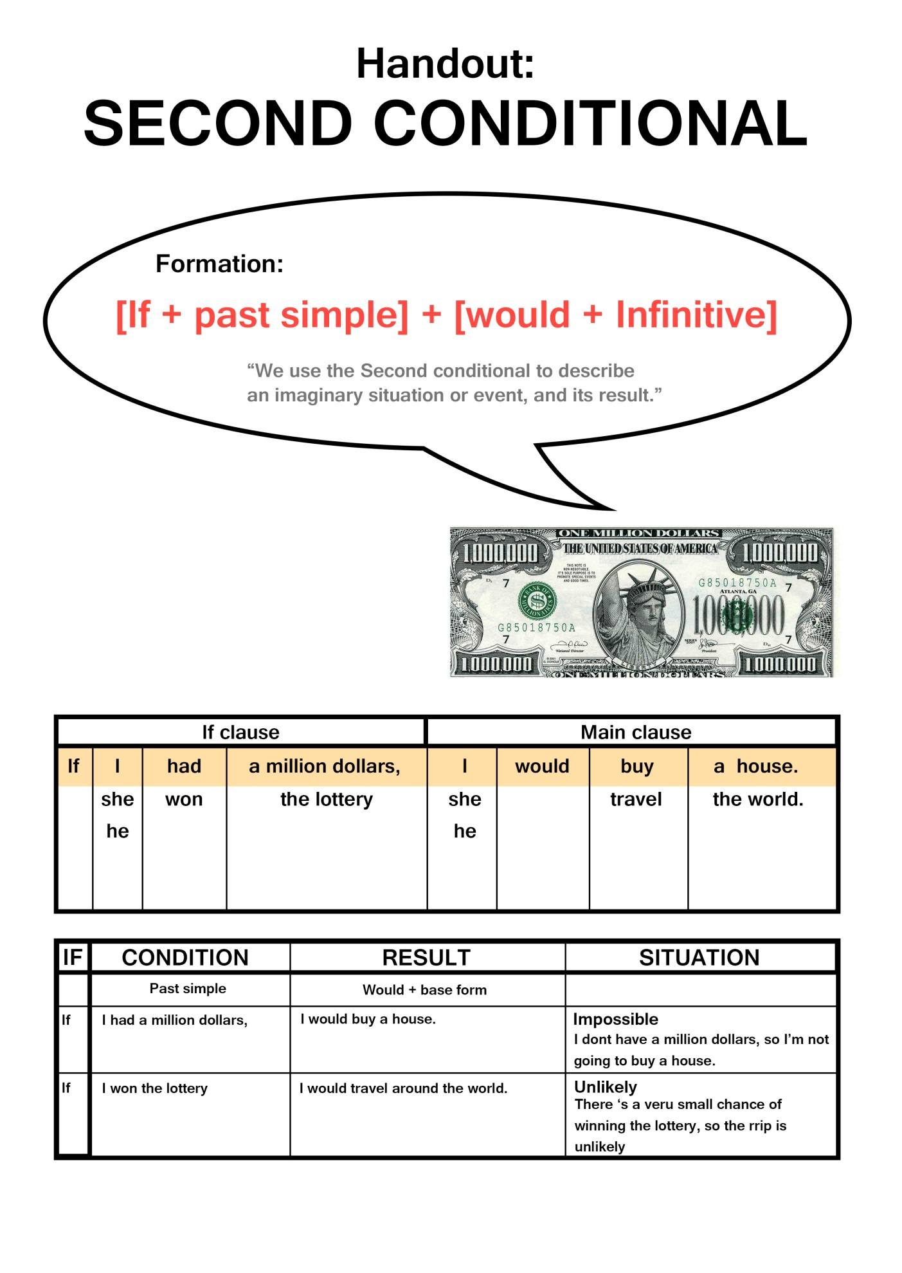

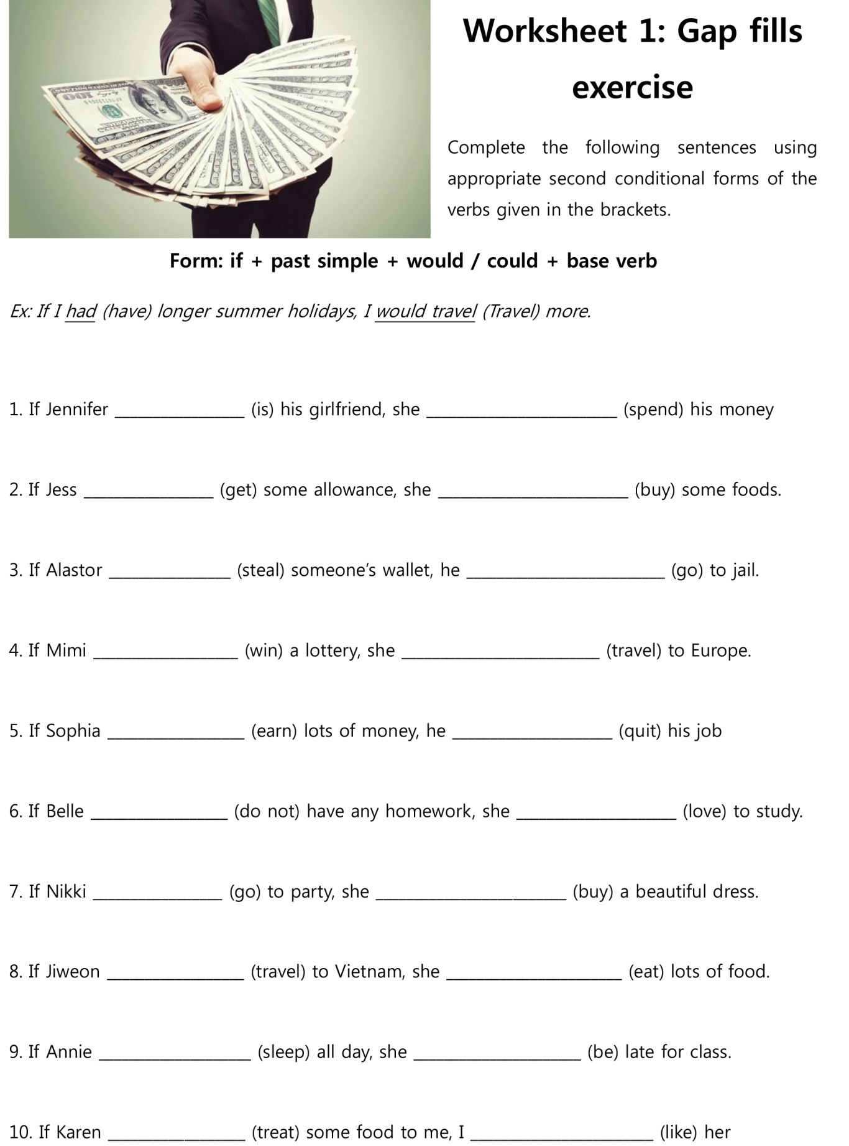

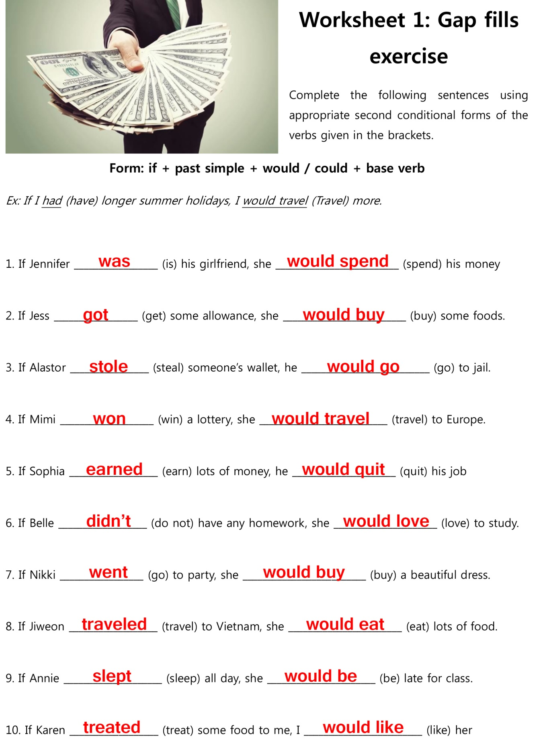

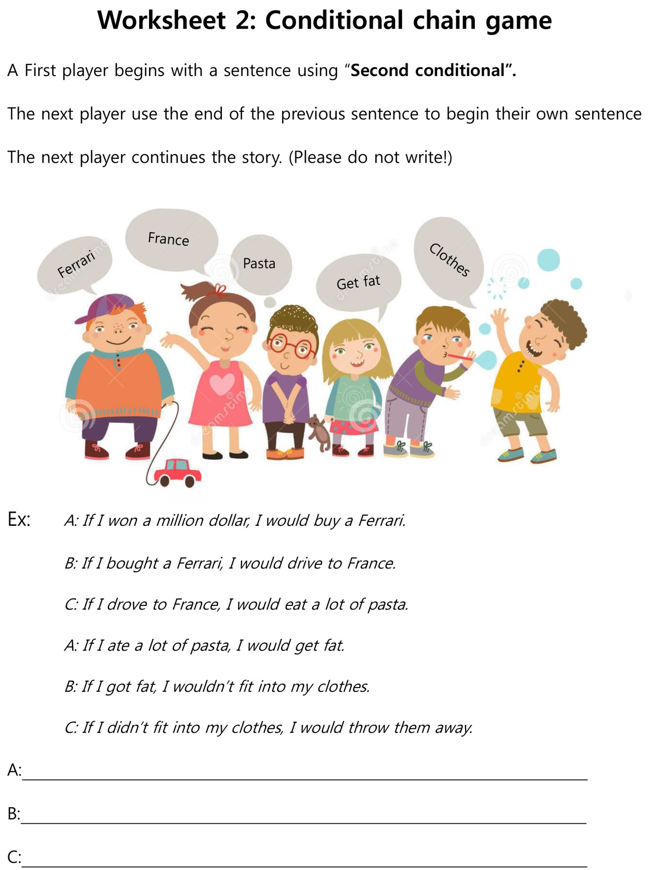

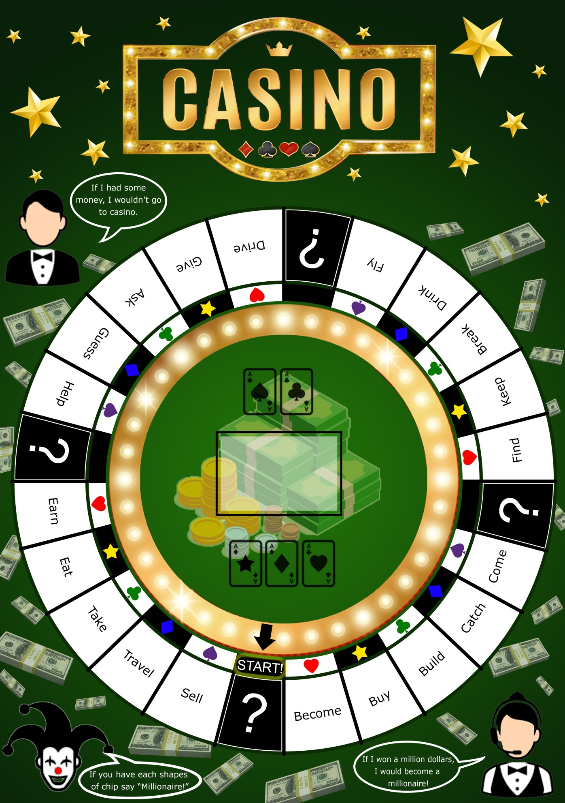

BOARD GAME

GAME CHIPS

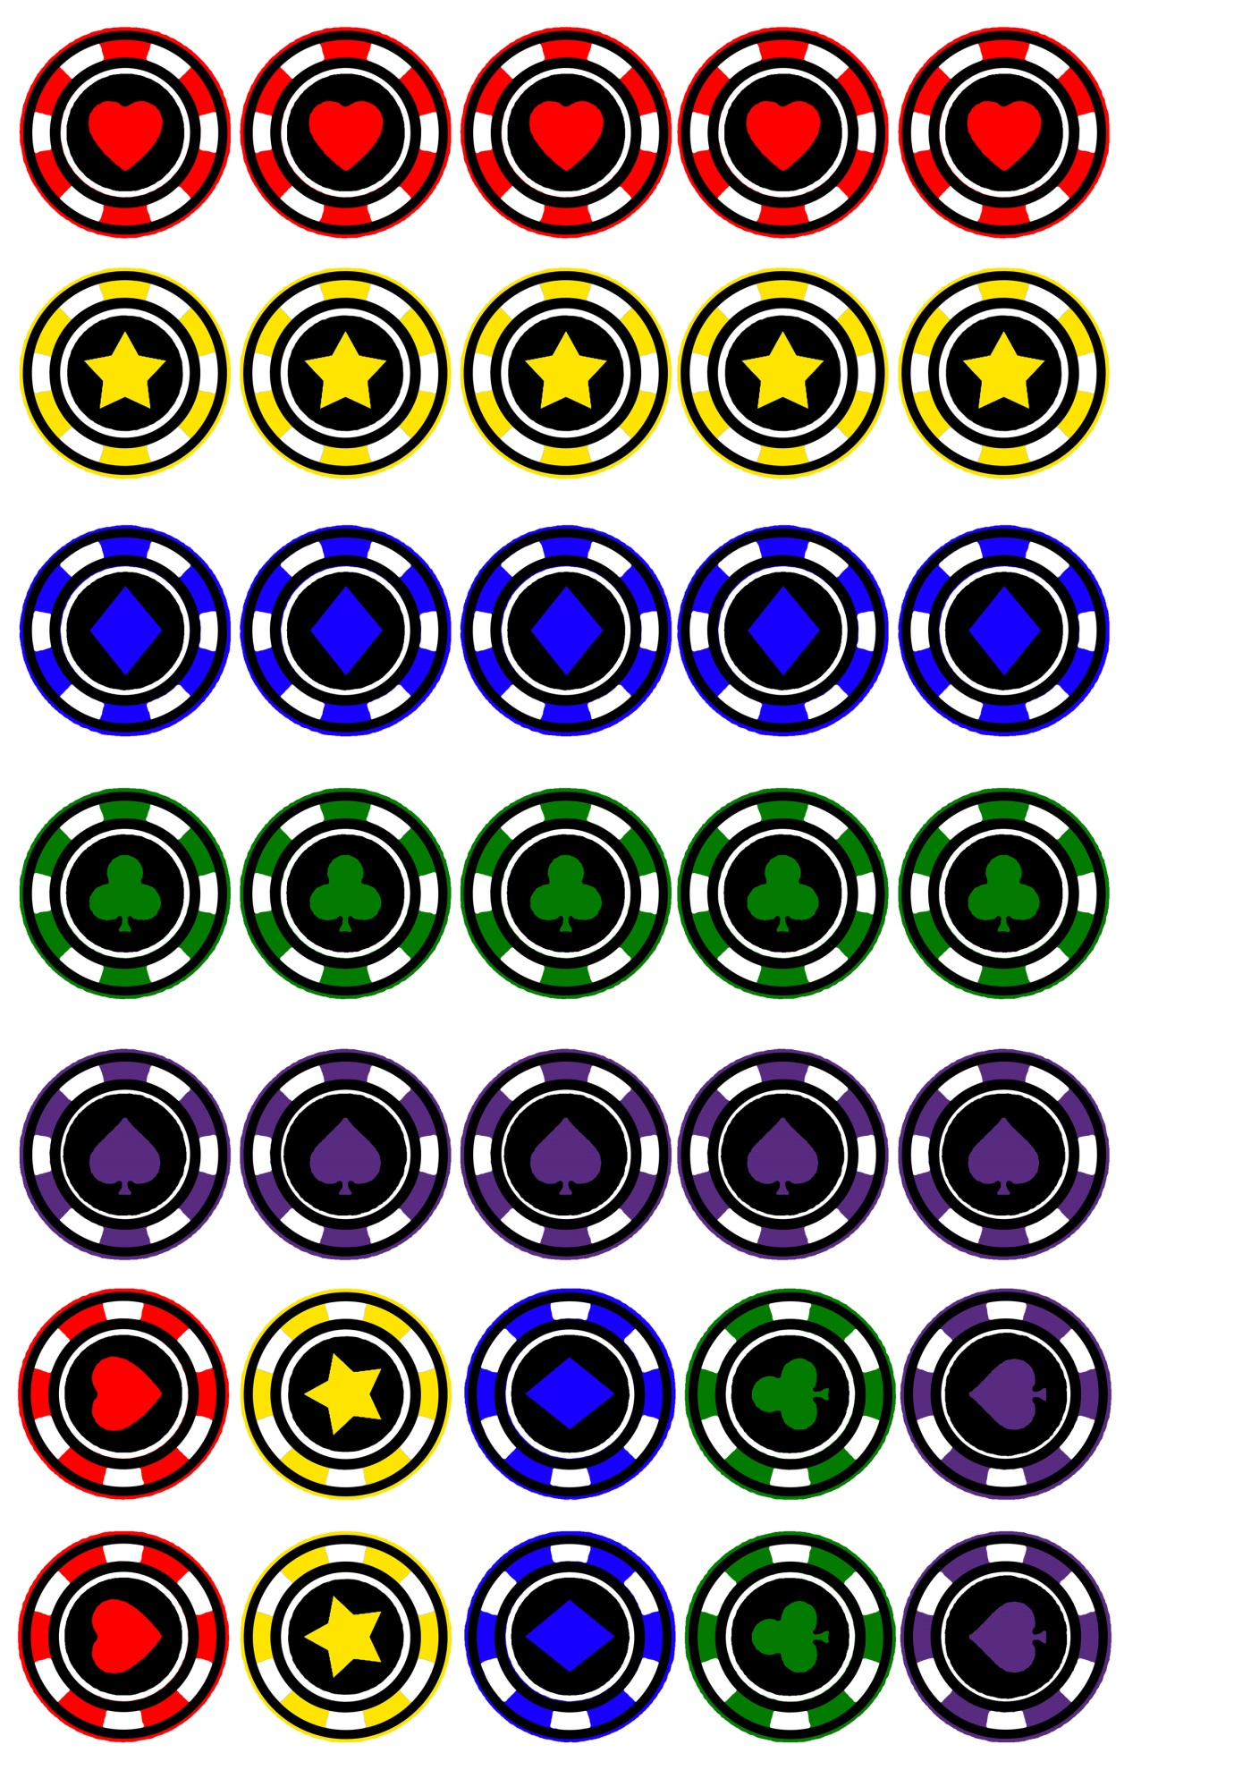

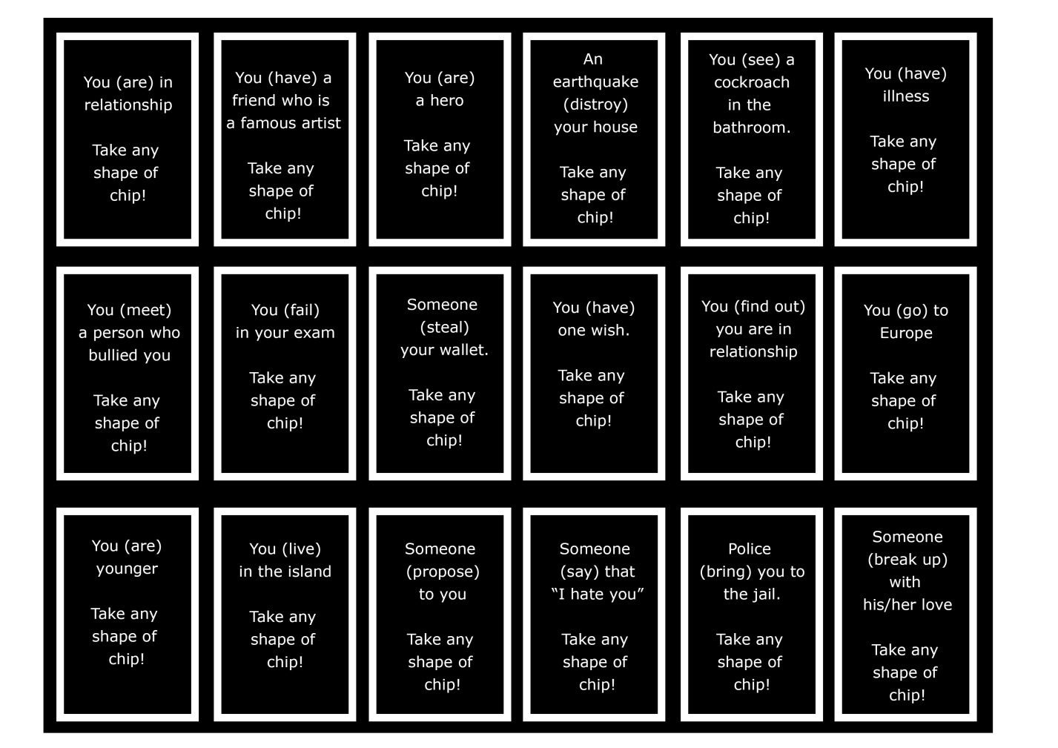 

CARDSS

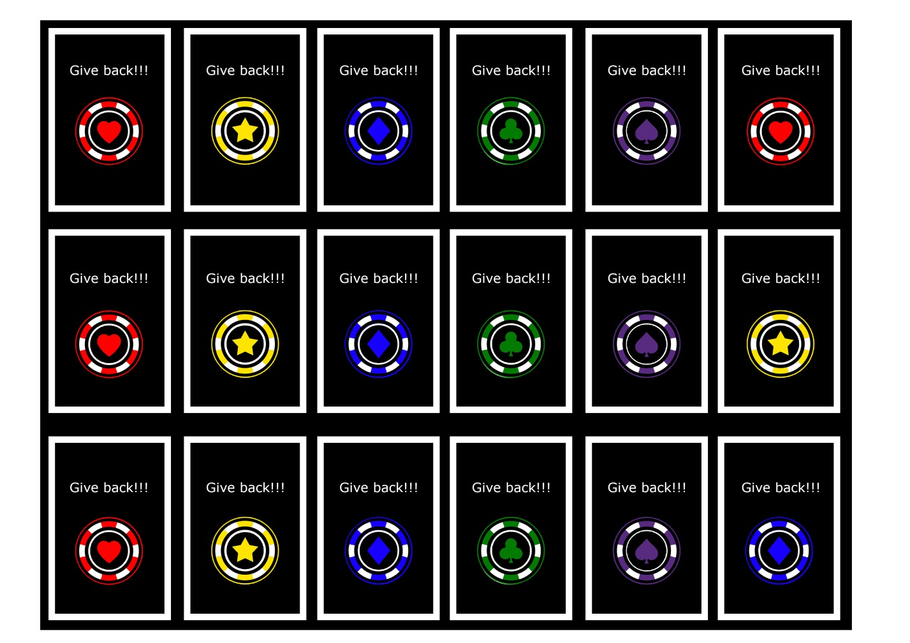

CARDSS

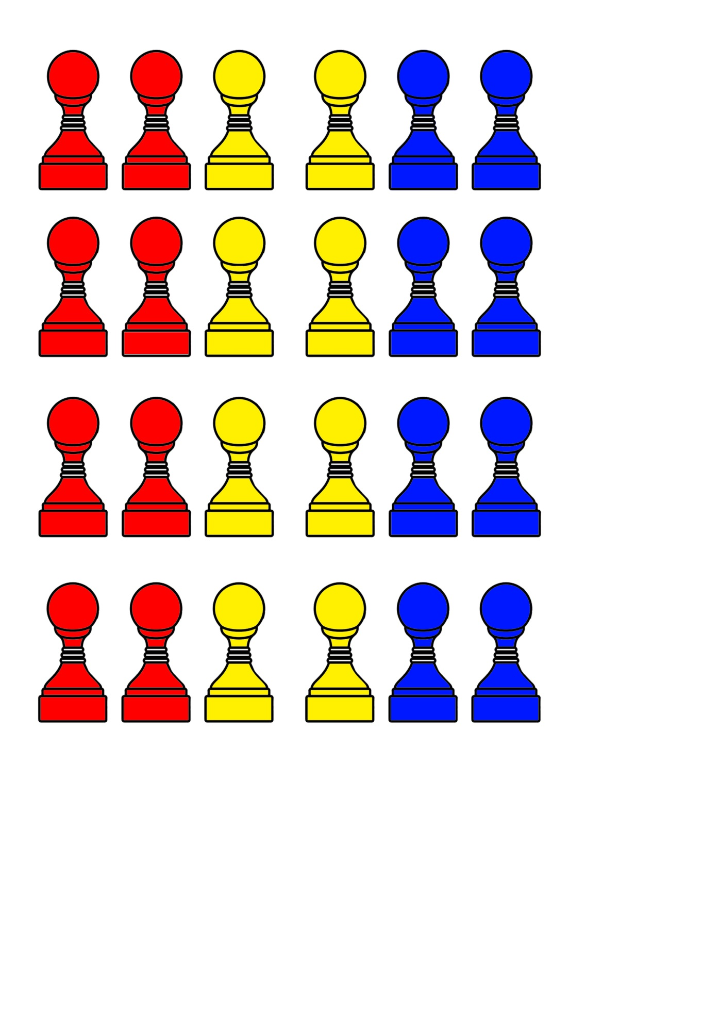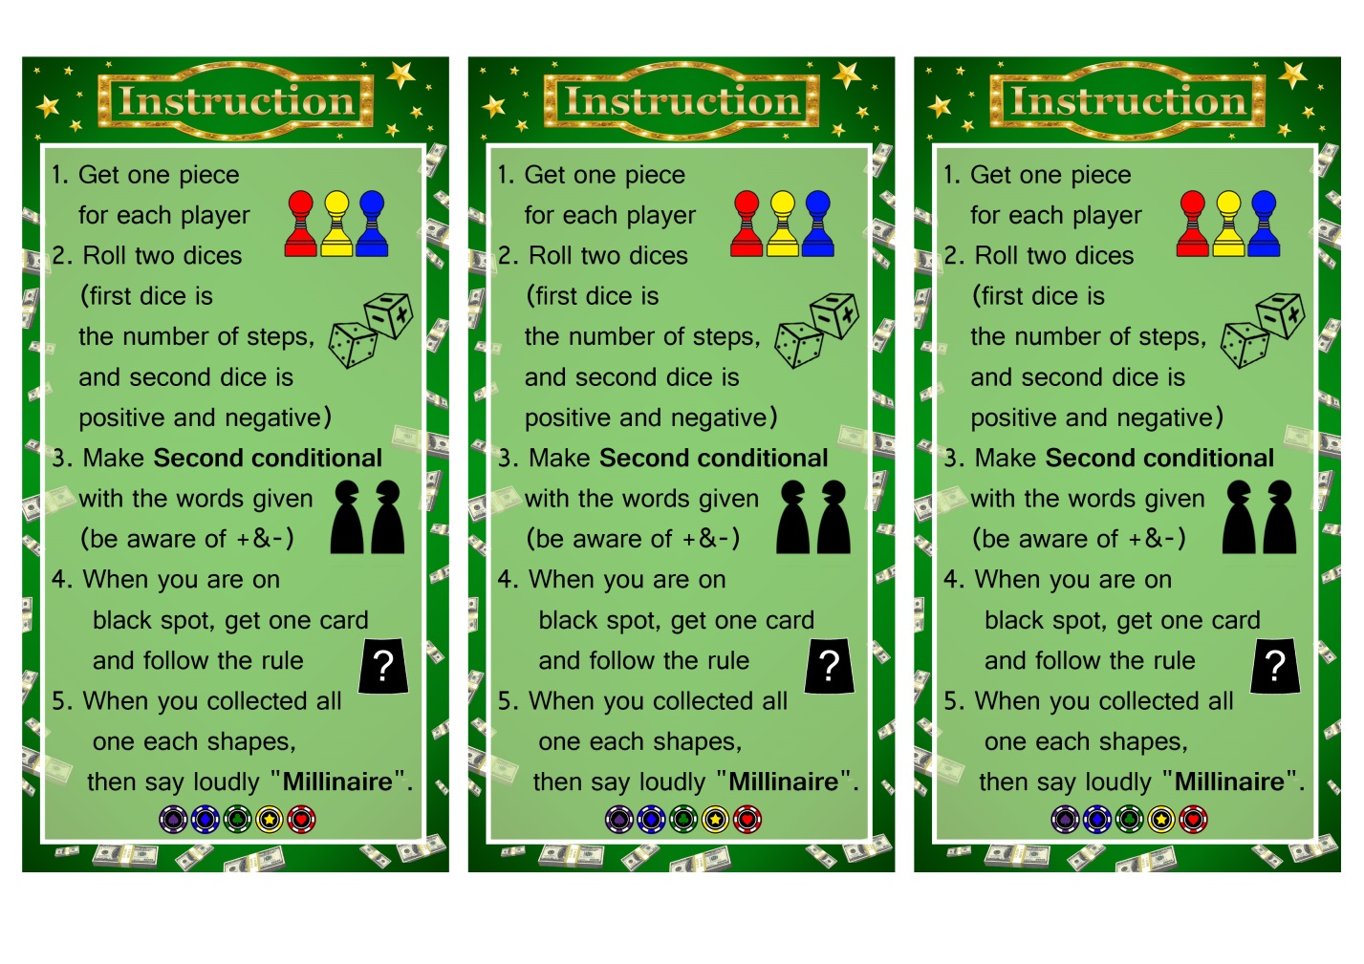

GAME PIECE& INSTRUCTIONS

DICE TEMPLATES

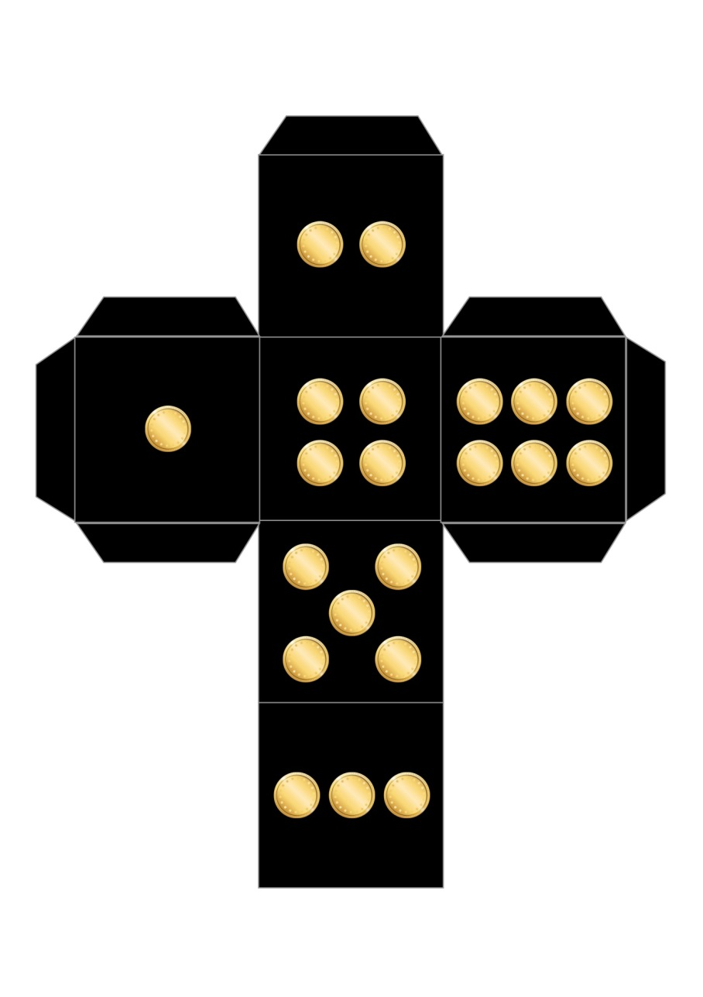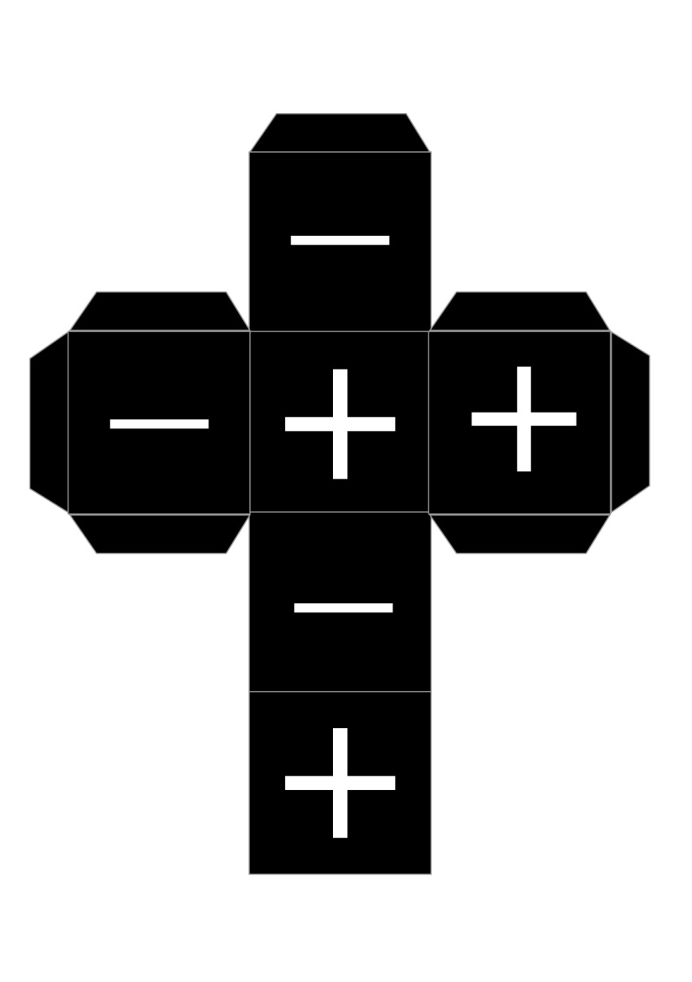

DICE TEMPLATES

