|  |
| --- |
| ☐ Listening☐ Speaking ☐ Reading **⌧Grammar** ☐ Writing |
| **Relative pronouns: who, which, that** |

|  |  |  |  |
| --- | --- | --- | --- |
| Instructor:  **Jisu Jung,** | Level:  **intermediate** | Students:  **8** | Length:  **30 Minutes** |

|  |
| --- |
| Materials:  - PPT: relative pronouns  - 8 copies of worksheet 1: exercise  - 8 copies of worksheet 2: picture description  - 8 copies of worksheet 3: crossword for sos  - Answer sheets: for teachers |

|  |
| --- |
| Aims:  1. Main aim: Students will learn how to use relative pronouns in sentences by doing  exercise  2. Secondary aim: Students will recognize the usage of relative pronouns by doing all activities  3. Personal aim: Students will improve their grammar skills by learning relative pronouns |

|  |
| --- |
| Language Skills:  - Listening: Listening to classmate’s speaking  - Speaking: Describing pictures using who, which, that from worksheet 2  - Reading: Reading questions on worksheets  - Writing: Answering the questions on worksheet1 |

|  |
| --- |
| Language Systems:  - Phonology: Using contractions when the teacher is speaking(ex. didn’t from the PPT)  - Lexis: Learning a new vocabuary “sword”  - Grammar: Being familiar with relative pronouns “who, which and that”  - Function: Describing pictures and answering the questions using relative pronouns  - Discourse: Learning the usage of relative pronouns |

|  |
| --- |
| Assumptions:  - Students already know the meaning of relative pronouns  - Students feel a lot of interest in grammar by learning relative pronouns  - Students already understand all kinds of questions from the past class |

|  |
| --- |
| Anticipated Errors and Solutions:  - Students may not understand the usage of relative pronouns  → Drill again, give them some more examples  - Students may not understand the questions on worksheets  → Explain clearly  - Students may understand all quickly, so we may still have enough time to do something  → Let students do sos activity |

|  |
| --- |
| References:  - picture1 in ppt: <https://goo.gl/4xi54G>  - picture2 in ppt: <https://goo.gl/caHeA4>  - picture3 in ppt: <https://goo.gl/bqXQvG>  - pictures on worksheets: <https://goo.gl/XwfRFZ>  - SOS on worksheet3: <http://bogglesworldesl.com/crosswords.htm> |

|  |  |  |  |
| --- | --- | --- | --- |
| **Lead-In** | | | |
| Materials: N/A | | | |
| Time | Set Up | Student Activity | Teacher Talk |
| 1 mins | Whole class | Exchange greetings | **Procedure:**  **Order sequence on the board**  -Relative Pronouns  1. What’s relative pronouns?  (who, which, that)  2.Exercise  3.Picture description  T: Hello everyone. How are you?  Ss: “good.”  T: Today, we are going to study the usage of relative pronouns. You are going to learn who, which and that among relative pronouns today.  **Prepare to present the PPT** |

|  |  |  |  |
| --- | --- | --- | --- |
| **Presentation** | | | |
| Materials: PPT | | | |
| Time | Set Up | Student Activity | Teacher Talk |
| 8 mins | Whole class | Learn the usage of relative pronouns | **Procedure:**  **Present the PPT from page1 to 2**  **Elicit from all**  T: We use relative pronouns who, which and that to describe nouns.  We use “who” for people and “which” for things. You can use that for both.  **Present the PPT page3 and explain all**  T: a theif is a person who steals things. ~Nikki lives in a house that is too expensive.~I ate an apple which is delicious.  **CCQ**  1. Does a theif steals things?  2. Does Nikki live an expensive house?  3. Did I eat an delicious apple?  **Present the PPT from page4 to 7**  **Read sentences from the first box and Let Ss guess the answers**  **-**  **Present the PPT from page 8 to 13**  **Drill**  **CCQ**  1. Do I like the smart man?  2. Do I love the expensive bag?  3. Did I eat the delicious steak? |

|  |  |  |  |
| --- | --- | --- | --- |
| **Practice** | | | |
| Materials: Worksheet 1 | | | |
| Time | Set Up | Student Activity | Teacher Talk |
| 8 mins  2 min | individually  pairs | Answer the questions on worksheet 1 | **Procedure:**  **Distribute the worksheet 1**  T: We are going to do some exercise on worksheet 1. Answer the questions and compare with your partner when you finish all.  **Write on the board**  “That X , preposition”  T: You can not use that with prepositions and comma.  **Let them know time limit**  T: Have you done? Who finished?  **Compare the answers together and elicit**  T: Do you have any question? |

|  |  |  |  |
| --- | --- | --- | --- |
| **Production** | | | |
| Materials: Worksheet 2 | | | |
| Time | Set Up | Student Activity | Teacher Talk |
| 9 mins  2 mins | pairs | Describe the pictures on worksheet 2 | **Procedure:**  **Distribute the worksheet 2**  T: Describe 4 pictures by using relative  pronouns that we just learned with  your partner. Make at least 3  sentences for each and you make a  story using relative clause if needed.  **ICQ**  1. How many sentences should you make at least? (3)  2. Do you have to describe only visible  things from the pictures? (No, you can  make a story)  **Let students know time limit**  T: Ok, time is over.  **Write on the board**  “sword”  T: Do you know the meaning of  sword? You can use sword to describe  a big knife.  Did you have fun today?  Ss: “Yes”  T: Do you have any question?  **Give students feedback: Eliciting**  **and collecting errors** |

|  |  |  |  |
| --- | --- | --- | --- |
| **SOS Activity** | | | |
| Materials: Worksheet 3 | | | |
| Time | Set Up | Student Activity | Teacher Talk |
| Left time | Individually | Play the crossword game | **Procedure:**  **Distribute the worksheet 3**  T: Read the each sentence below and complete the crossword. |

PPT

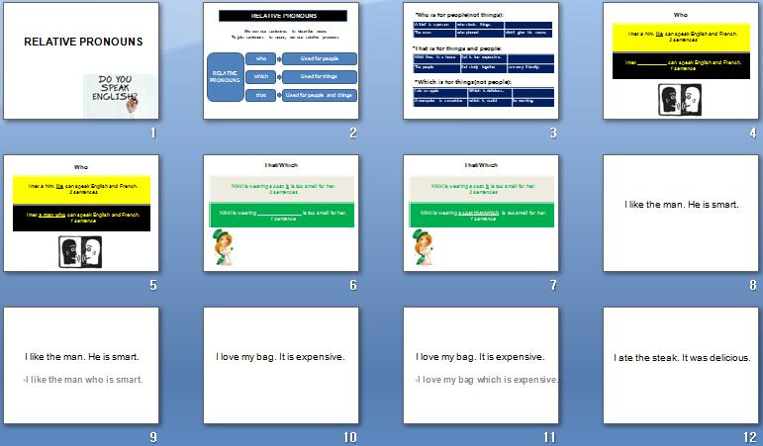

Worksheet 1: Exercise

Exercises (Relative clauses: who/that/which)

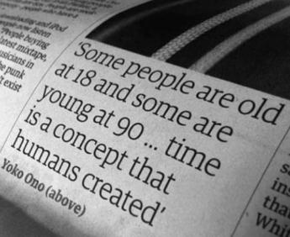

**1.Write who or which.**

*Ex) I know the man who always gets angry.*

A. I met a man _____ can speak chinese very well.

B. Where is the clock _____ was hanging on the wall?

C. Why does she always wear a coat _____ is too big for her?

D. What’s the name of the man _____ is always late in your office?

E. I think everybody _____ attended the English class was satisfied.

**2. Are these sentences right or wrong? Correct the mistakes.**

*Ex) My friend bought a coat who is 1,000,000 won.*

*→ Wrong/ …a coat which is…*

1. This is the book which/that is about gardening.

→

1. I phoned the man which has been to Canada.

→

1. I always go to the roof who I’m working on.

→

1. I met the woman who/that taught me English.

→

1. Where is the cheese who/which was on the table?

**3. Explain what some words mean. Choose the right meaning from the box, and then write a sentence with who.**

*Ex) An architect is someone who designs buildings.*

|  |  |
| --- | --- |
| she/he | -breaks into a house to steal things  -doesn’t believe in God  -buys something from a store  -is ill in hospital  -pays rent to live in a room |

1. A customer someone who ________________________________
2. A thief someone ________________________________________
3. A patient ______________________________________________
4. A tenant ______________________________________________
5. An atheist _____________________________________________

**4. Make one sentence from tow. Use who/that/which.**

*Ex) The man open the door. He was wearing glasses.*

*→The man who opened door was wearing glasses.*

1. Some students took the exam. Most of them passed.

→

1. A policeman stopped our car. He wasn’t very friendly.

→

1. A waiteress served us. She was impolite.

→

1. A building was destroyed in the fire. It has now been rebuilt.

→

1. A bus goes to the airport. It runs every half hour.

Worksheet 2: Picture description

**Picture description**

**\*Describe the pictures using who/which/that. Make 3 sentences for each pictures with your partners.**

|  |
| --- |
| *Ex) The man who is bring a sword is cutting a gourd in two.*  **externalFile.jpg** |

**A. B.**

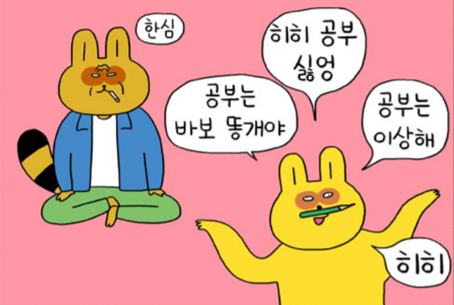****

**C. D. **

Worksheet3: crossword for SOS

|  |  |  |  |
| --- | --- | --- | --- |
| Jobs Crossword:  **Across**  **1.** Somebody who plays an instrument.  **3.** Someone who grows crops.  **7.** Somebody who fixes teeth.  **8.** A person who serves food.  **9.** Someone who fixes cars.  **13.** Somebody who catches criminals.  **16.** A person who plays sports.  **17.** Someone who stars in a movie.  **19.** A person who sings songs.  **20.** Somebody who helps sick people.  **21.** Somebody who flies airplanes.  **22.** A person who does experiments. |  | | |
| **23.** Somebody who teaches. | | **Down**  **2.** A person who helps a doctor.  **4.** Someone who delivers mail.  **5.** Somebody who helps sick animals.  **6.** Somebody who puts out fires.  **9.** Someone who digs for metal ore in the ground.  **10.** Someone who cooks food.  **11.** A person who paints | picture.  **12.** A person who protects a country.  **14.** Someone who cleans buildings.  **15.** A person who makes computer games.  **16.** A person who goes to outer space.  **18.** A person who tells us the news. |
| astronaut7.jpg | |

Answer sheet: Worksheet 1

1.

A. who

B. which

C. which

D. who

E. who

2.

A. right

B. wrong, who

C. wrong, which, that

D. right

E. wrong, which, that

3.

A. buys something from a store

B. breaks into a house to steal things

C. is ill in hospital

D. pays rent to live in a room

E. doesn't believe in God

4.

A. Some students who/that took the exam were passed.

B. A policeman who/that stopped our car wasn't very friendly

C. A waiteress who/that served us was impolite

D. A building which/that destroyed in the fire has been rebuilt

E. A bus which/that goes to the airport runs every half hour

Answer sheet: Worksheet 3

