☐ Listening ☐ Speaking ☐ Reading ☐ Grammar ☐ Writing

Topic: They said that they are doing the best.

Instructor:  Mimi | Level:  Intemediate | Students:  9 | Length:  30 Minutes

Materials:
10 flash cards
Reported speech work sheet 1(9 copies)
Reported speech worksheet 2-A(5 copies) & 2-B(5 copies)
Reported worksheet 3(2copies)
SOS Activity worksheet (9 copies)
White board and marker
Scotch tape, PPT slides on computer

Aims:
Main aim
>Student will understand the form of the reported speech by teacher’s explanation and substitution table.
Secondary aim
>Student will practice both how and when to use reported speech by doing reported speech work sheets
Personal aim
>Teacher will be able to keep students’ interesting for the grammar throughout the different activities

Language Skills:
Reading: reading worksheets1&2 to answer questions
Listening: teacher’s explanations and instructions.
reported speech work 2&3 sheet to listen the questions from the pair
Speaking: drilling, reported speech work sheet 2 &3 activity
Writing: Reported work sheet1 to answer questions

Language Systems:

Phonology: drilling
Grammar: meaning of reported speech
Function: reporting, relaying message, repeating

Assumptions:
Ss already know the direct speech
Ss already know verb changes

Anticipated Errors and Solutions:
Ss may have difficulty to change direct speech to reported speech
- Teacher explains more about the form of grammar.
Ss may have a hard time drilling
- Teacher gives the Ss more chances to practice
If the Ss need more time to finish their activity
- Give more time to finish their activity
If the class finish earlier than expected (SOS Plan)
- Run the final activity

References:
- Work sheets and sos plan
English grammar in use, Raymond Murphy
goo.gl/3GKTeS
goo.gl/7cRJXB

- PPT Slides
goo.gl/aLfqdh

Lead-In
Materials:
white board and marker

Time | Set Up | Student Activity | Teacher Talk
1min | Whole  class | Answer questions.  Ss answer we are doing our best. | Greeting  Hi! Everyone. How’re you doing today?  Today is so cold. Isn’t it? The weather caster said it’s minus 4degree this morning.  No matter how cold it is, we are doing our best for the class. Right?  What are you gonna do?  You said that you’re going do your best for the day. Let’s start the class then

Presentation
Materials:5 flash cards in direct speech, 5 flash cards in reported speech
White board and marker, computer

Time | Set Up | Student Activity | Teacher Talk
4min  6min | Whole class | Ss answer  The ss come up and find the matching card. And put their card next to the direct speech card.  Ss answer  Ss tell one by one about the question given  Ss look at the PPT slides  Ss answer  Ss answer  Ss answer  Ss repeat after T | Guided warmer activity  I’m giving out the flash card to each of you. (Distrbute flash cards to ss)  Read it out loud one by one to the class mates.  CCQ  What are you going to do when you have the flash card? ( read it out loud to the classmates)  Procedure:  Ⅰ. Recall  You’ve heard all statements written on the cards. As you learnt about the direct speech last week, who has got the card written in direct speech?  ( collect the direct speech cards from ss and put them on the board)  Now, the rest of ss, can you come up with your card and find out the card which is related to your card statement?  Ⅱ. Reflect  Well done, everyone!  Let’s see what we have on the board.  Can anyone tell what’s the difference between two statements?  (try eliciting more questions from ss, verb changes…..reporting someone’s saying…)  Now, let’s talk about your story then.  (go around Ss and ask a question and then make the other one report what the student has just said)  What do you usually have for your breakfast?  (Ask the other s to make the reported speech)  What are you going to have for your lunch today?  What did you do last weekend?  Where have you been last holiday?  Now, What do you see in the form of these sentences?  (Let Ss tell you the form of structure)  Ⅲ. Conclude  Form  The reported speech form is involving the verb tense changes.  (Show Ss PPT of verb changes)  We have more tenses than what the slide is showing , but, today we will concentrate only these 4 tenses.  Drilling  Situational drilll  ( Show ss example slides)  Now, let’s look at the some situations On the slide and let’s try to change the statement to reported speech  CCQ  What do you do? ( Change the direct speech to reported speech by looking at the picture  (Explain about the picture)  How is she going to report it to mother?  (ask Ss)  Now , you can try the second picture.  (Show Ss substitution table)  He said the teacher was giving everyone an A  gave  had given  Ok Now listen and repeat.  CCQ  What do you? ( listen and repeat)  Show the substitution table ask student to repeat.

Practice
Materials: Reported speech worksheet 1(9copies)
Reported speech work sheet 2 A( 5copies) &B(5copies)

Time | Set Up | Student Activity | Teacher Talk
6min  7min | Individually  Whole class  Pairs & one group of 3 | Ss answer  Ss give answers.  Ss answer | Ⅰ.Controlled practice  Now, we’re going to do the worksheet.  (Ditribute worksheets)  Instructions  There are 5 questions. You need to change the direct speech into the reported speech  ICQs  How many questions? 5 questions  What do you do? Change it to the reported speech  Has everyone done?  Feedback  Shall we find out the answer together?  (go around Ss to ask answer )  Error correction( if there is)  Ⅱ.Less-controlled practice  We are going to practice more of reported speech.  Here is another worksheets for you all.  (distribute worksheets)  Instructions  1.Read through what Sarah says first  2.One of you’ll be sarah and the other one is her friend.(2-A : A is Sarah, 2-B: B is Sarah)  3. As a Sarah’s friend, you make reported speech according to what sarah has just said  4. Swap the role after you make 4 reported speech.  5.You don’t need to write down  6.give you 5 min  ICQs  What do we do first? (Read what Sarah says)  What do you do as a Sarah’s friend?  ( Make 4 reported speech)  Do you swap the role? (Yes)  Do you need to write down? (No)  How many minutes? ( 5 minutes)  (Monitor ss discreetly)  I

Production
Materials: Reported speech worksheet 3: Korean whispers(2 copies)

Time | Set Up | Student Activity | Teacher Talk
6min | Groups | Group work  Ss read instructions with team members.  Ss tell instructions | Ⅰ.Free practice  We’re going to have little fun before we wrap up the class.  Instructions  1.Let’s make into 2 groups.  2.Read through the instructions.  ICQs  Can you tell me what it says?  Who wants to be the first teller?  The first one come up to the front.  (Ask the s to write down the sentence in direct speech)  Now, go and whisper it to one next in your team.  The last one come up to the front and write down the sentence in direct speech.  Ⅱ.Wrap up  How was it everyone? Had a fun?  I hope you’ve enjoyed today’s class as usual. I’m looking forward to seing you next week

SOS Activity
Materials: Sos activity

Time | Set Up | Student Activity | Teacher Talk
3min | Individually |  | Instructions  1.There are 6 statements.  2.Change the direct speech into the reported speech  3.Change the reported speechinto the direct speech.  ICQs  How many statements?  What do you do?

Reported speech Work sheet 1
- You met your friend Pamela yesterday, Here are some of things she said to you.

- You change her direct speech into reported speech.
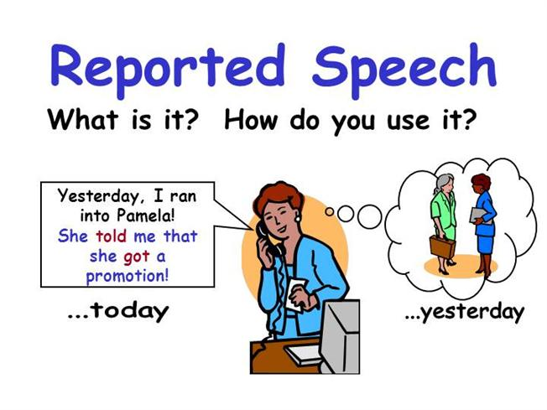

- “ My parents are very well”
She said that her parents were very well

- “I’m going to move my office”
She said that she was going to move her office

- “ I can’t come to the party on Friday”
She said that she couldn’t come to the party on friday

- “ I want to go away for a holiday but, I don’t know where to go”
She said that she wanted to go away but, she didn’t know where to go

- “ I’m going away for a few days. I’ll call you when I get back”
She said that she was going away for a few days. She would call me when she got back.
Reported Speech Work sheet 2-A

- Here are some things that Sarah said to you:

I’ve never been to the united states.
I can’t drive
Jane has a very well-paid job
I don’t like meat
Jane invited Kevin for her birthday
I don’t have any brothers or sisters
Jane is a friend of mine
Kevin is lazy
I’m working tomorrow evening

- But, later Sarah says something different to you. What do you say?

A: “Kevin works hard” | B: “But you said he was lazy”
A:” Let’s have steak for dinner” | You said you didn’t like meat
A:“Jane is always short of money” | You said Jane had a very well paid jos
A: “ I think New York is a fantastic  place” | You said you had never been to the united states
A: “My sister lives in London” | You said you didn’t have any brothers and sisters

Reported Speech Work sheet 2-B

- Here are some things that Sarah said to you:

I’ve never been to the united states.
I can’t drive
Jane has a very well-paid job
I don’t like meat
Jane invited Kevin for her birthday
I don’t have any brothers or sisters
Jane is a friend of mine
Kevin is lazy
I’m working tomorrow evening

- But, later Sarah says something different to you. What do you say?

B: “Kevin works hard” | A: “But you said he was lazy”
B: “I’m going to buy a car” | You said you couldn’t drive
B: “Let’s go out tomorrow evening” | You said you were working tomorrow evening
B: “I’ve never spoke to Jane” | You said Jane was a friend of yours
B: “Kevin didn’t get an invitation  for Jane’s birthday party” | You said Jane invited Kevin for her birthday party

Reported Speech Work sheet 3

Korean Whispers

- The first student whispers “one sentence” to one sitting next.
- The second member whispers the sentence in reported speech to the next member.
- The whispering continues until it reaches the last student of the group
- The last member must say the original statement in direct speech.

Ex) I love drinking coffee in the morning more than anything else.
- (Name) said that she loved drinking coffee in the morning more than anything else.

SOS Activity

- Change these examples of direct speech into reported speech

- “ How many times does the shuttle bus run to the airport?” the lady asked to the hotel staff.
The lady asked the hotel staff that how many times the shuttle bus ran to the airport

2.The police officer told him “ you have to be pulling your car over”
The police officer told him that he had to be pulling his car over

3.Kathy said “ I have been to New York before and I love to go there again”
Kathy said that she had been to New York before and she loved to go there again

- Change these examples of reported speech into direct speech

1.Tom said that he woke up feeling ill, so he hadn’t gone to work..
Tom said “ I wake up feeling ill, so I didn’t go to work

- She said that she would go to the Eiffel tower while she was staying in Paris.
She said “ I will god to the Eiffel tower while I’m staying in Paris”

- John said that the teacher had graded our grammar exams.
John said “ the teacher has graded our grammar exams”

.
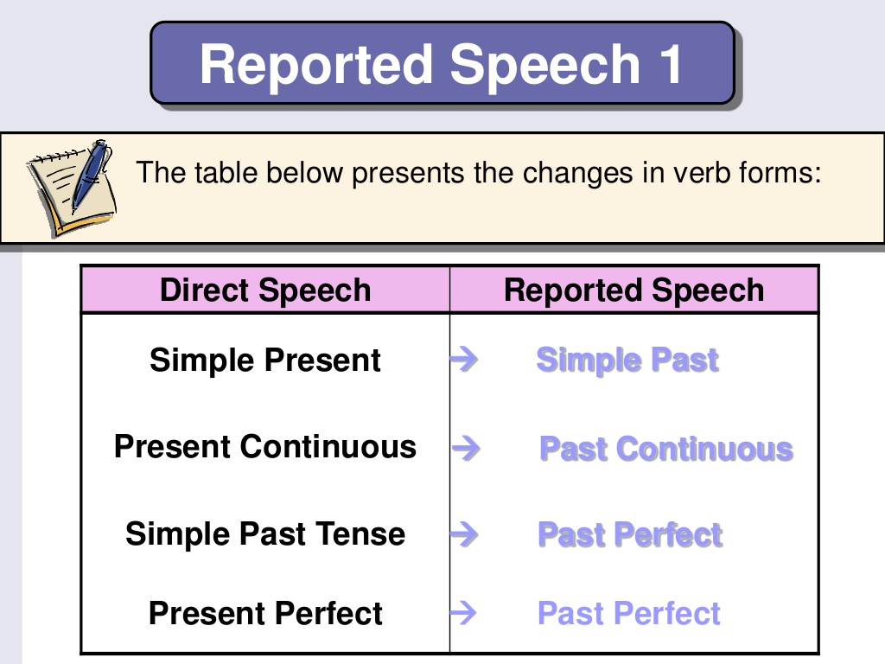

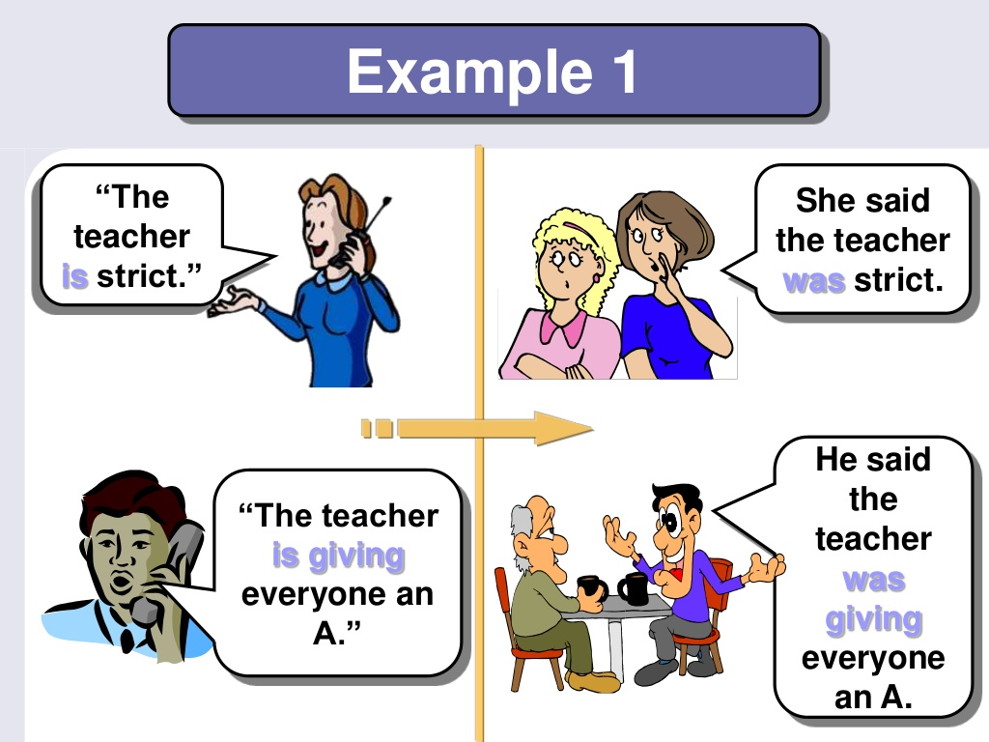

She | said | the  teacher | was | strict
 |  |  | had been

He | said | the  teacher | was giving | everyone  an A
 |  |  | gave
 |  |  | had given

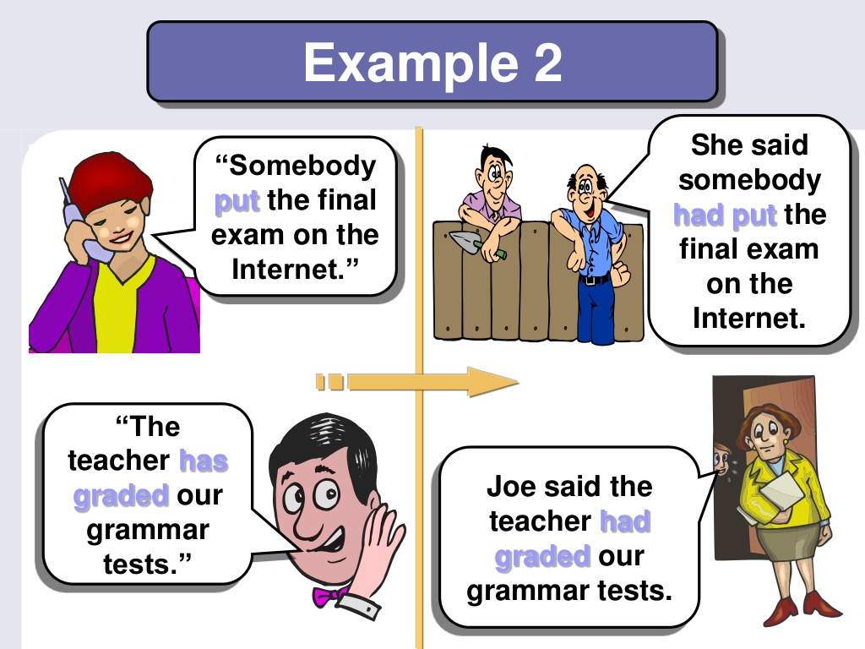

I meet my friends

He said that he met his friends

I play football with friends

He said that he played football with friends

I’m spending my holidays in Jeju island
She said that she was spending her holidays in Jeju island

I’ve been to Paris before

She said that she had been to Paris before

I went shopping for Christmas gift.
He said that he had gone shopping for Christmas gift

