v☐ Listening ☐ Speaking ☐ Reading ☐ Grammar ☐ Writing

Topic: Guideline for safety in earthquake

Instructor:  Sung  (Sung-eui Youn) | Level:  High beginner  (elementary school) | Students:  12 | Length:  50 minutes

Materials:
- White board and board markers
- Listening of youtube clip by using a computer(3 min.)
- Desk, first aid, cellphone, signs for exit and open space for role play(each group)
- Vocabulary worksheet(12 copies)
- Dictation worksheet(12 copies)

Aims:
- To practice listening information about the safety rules for earthquake situation which can happen in many countries
- To practice to understand what is in the video clip
- To predict what students do in the real earthquake situation
- To exercise speaking by discussion of each group members
- To be able to know what the new vocabularies mean in detail in the listening
- To be able to share their own ideas and experiences each other

Language Skills:
- Reading: vocabulary worksheet
- Listening: the video clip
- Speaking: interacting each other with their experiences and comparing answers with groups, discussion in each groups
- Writing: matching exercise, taking dictation

Language Systems:
- Lexis: vocabularies
- Discourse: short script
- Function: preparation in emergent earthquake

Assumptions:
- Students had experiences of earthquake in the last weekend.
- There are 3 students in each group.

Anticipated Errors and Solutions:
- Students cannot listen to the vocabulary easily.
-> First, the teacher do the class work until the students understand the unfamiliar vocabulary and then play the audio of video clip that they couldn’t understand one more time. Then the teacher give an extra assignment to only the students who cannot understand yet about listening to the video clip until they are able to get it.
- A particular group can require the discussion time more.
-> If every student wants to get more time, give 1 more minute and make the role paly time short.
-> If a few of students want to get more time, don’t need to give more time for discussion.
- The class doesn’t have much time for role ply.
-> The teacher can make role play together as a whole class, not groups by teacher’s guideline

References:
- Video clip(Script): https://www.youtube.com/watch?v=1KlLSB4uhzk&t=23s
- Pictures of Worksheet: www.google.com

Lead-In
Materials: Board
Time | Set Up | Student Activity | Teacher Talk
3 min | Whole Class | Response or answer to the teacher’s simple question | Hello. Everyone. How was your weekend? I‘ve heard there were an earthquake in this area. (The teacher show shaking gestures.) Does anybody getting hurts from an earthquake? Are your family members O.K.?  You were very surprised at this event by searching the news involved in earthquake. To prepare the situation like this in the future, we’ll listen to the basic guideline of the safety of earthquake.  First of all, we need to do worksheet of vocabularies that the speaker used.

Pre-Activity
Materials: Idioms/vocabulary worksheet, pictures involved in earthquake
Time | Set Up | Student Activity | Teacher Talk
10 min  2 min | Whole Class  Individually  Whole Class  Individually  Whole Class  Whole  Class | Listen and follow teacher’s direction  Take worksheet of vocabularies  Answer to CCQ  Take worksheet continually  Speak and listen  Listen | 1. Vocabularies  - Instruction  You need to do matching exercise for knowing vocabularies by yourself. Also, you get the chance to learn about new vocabularies and a few of familiar vocabulary before listening script by seeing the pictures. You get 5 minutes.  (Distribute the worksheet of vocabularies)  - Demonstration  Match the picture and meaning to the right vocabularies.  - CCQ  Are you working in group?  What do you learn through matching exercise?  How much time do you have?  Let the students know about time left until finishing, and ask to them about giving 1 minute more if they want.  Check whether students write down the right answers on their worksheet by using the white board.  - Encourage to draw students experiences for answers although they are simple sentences.  - Look through all vocabularies in detail to show right answer to students  2. Prediction  - Instructions  If you are in the class in an earthquake,  what are you going to do? You can  imagine everything around you is very  shaking now.  Write down what students would do in that  situation.

Main Activity
Materials: Computer, Speaker, Pictures, White board
Time | Set Up | Student Activity | Teacher Talk
6 min  12 min  11 min | Whole  Class  Whole  Class  Whole  Class  Whole  Class  Whole class &Individually  Groups  Individually  Groups | Listen to the video clip  Answer to CCQ  Listen  Answer to CCQ  Listen to the video clip 2 times more  and take worksheet of dictation  Share and check the answers  Get the right answers  Role play following the guideline for the safety in earthquake situation  Interact each other | 1. Listening for the subject  - Instructions  Now, I’ll play the audio of video clip. You need to concentrate on listening what the speaker says. You should listen to script thinking the earthquake situation. You can take a note.  -CCQ  What should you imagine during listening time?  Are you allowed to use taking a note?  2. Listening for Details  -Instructions  You already listen to the speaker with taking notes. You can listen to the speakers 2 more times. By doing this, you can fill in the blanks in your worksheet for dictation.  -CCQ  How many times are you going to listen to speaker more?  What are you going to do?  (Distribute the worksheet for dictation)  Play the video clip(only playing audio)  Students write down answers listening to a speaker.  As I mentioned before, I’ll let you listen one more time. You can fill in the blanks.  (Play one more cycle)  You need to compare your answers with your group members.  (If there is the answer that nobody knows, the teacher can give the answer on the white board.)  Next, we’re going to do role play. Referring to your completed worksheet of dictation, you can do role play with your group members. Two players are supposed to be 2 students in the class in earthquake situation. The last player can read each step for other 2 players in order that they can listen and follow the steps. You can use your desk and cell phone, also I’ll offer first aid kits and signs of exit and the open space to each group for role play.  If you finish role play, groups can change their roles and do role play again.  Students can check whether they followed the guideline each other.

Post Activity
Materials: N/A
Time | Set Up | Student Activity | Teacher Talk
6min | Whole  Class  Whole  Class  Groups  Whole  Class | Discuss with group members  Answer to CCQ  Discussion with group members  Share opinions together  Listen to teacher’s talk | 1. Free Production  -Instructions  Do you think the guideline for the safety in  earthquake situation is easy to follow?  Can you follow the guideline in actual  situation? Have you ever heard the  earthquakes occurred in other areas and  do you know other safety rules?  Discuss about this with your group  members. You have 4 minutes.  -CCQ  How many people do you discuss with?  How much time do you have?  Participate within each group discuss  together  Share student’s opinions.  Take 2 volunteers if time runs out.  2. Conclude lesson  Elicit today’s main idea and vocabularies  for students.  -Give homework  Assignment is listening to the video clip 5 times and memorizing about the vocabularies we learned today.  Good job today. Please don’t panic in earthquake situation following the guideline. See you in the next class!

<Worksheet for Vocabularies>
*Match words and pictures.
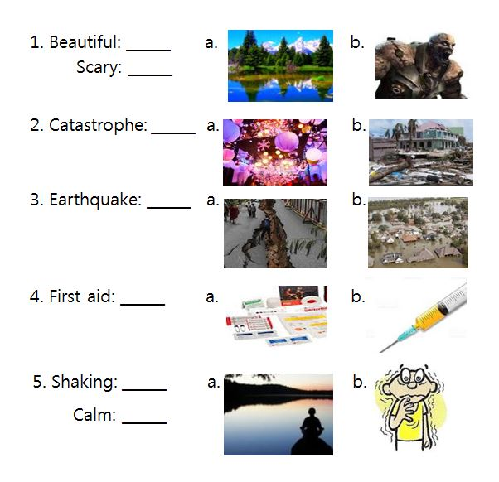
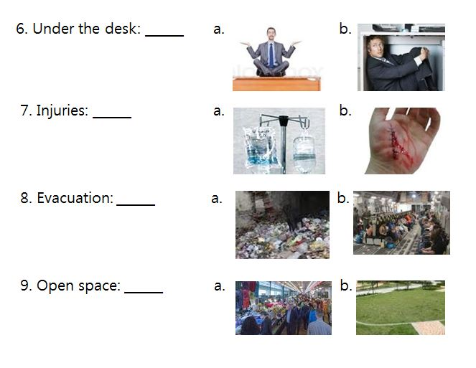
*Write down the vocabularies matching meaning.
1. The shaking of the surface of the Earth: __________________________
2. The urgent escape of people away from an area: _____________________
3. The assistance given to any person suffering a sudden injury
: _____________________
<Worksheet for Dictation>
*Fill in the blank in order for the guideline for the safety in earthquake situation listening to a speaker.
1. Earthquake starts.
2. Stay ___A___. Don’t panic.
3. Drop and cover. Go ___B___ the desk.
4. Remain ___B____ the desk until ___C___ stops.
5. ___C___ stops.
6. Check everybody is O.K.
7. If somebody got ___D___ and have a phone, call emergency service.
(It’s good if somebody has first aid)
8. When you are making on your exit, be sure head to the department evacuation assembly point or head to the open space.)

(**The first letters of dictation vocabularies were written below)
A:__c_________
B:__u_________
C:__s_________
D:__f_________

