S

what will you have for dinner?
Reading Lesson Plan

163th WK TESOL
ANNIE(Seonju oh), NIKKI (Jisu Jung)

☐ Listening ☐ Speaking ◙ Reading ☐ Grammar ☐ Writing

Topic: What will you have for dinner?

Instructor:Nikki  Annie | Level:  Upper intermediate | Students:  9 | Length:  30 Minutes

Materials:
“What will you have for dinner?” PPT
Included “What will you have for dinner?” video clip, and
Pictures of grated cheese, ground beef
“What will you have for dinner ?” work sheet 1,2-1,2-2,3.
ANIKI’S FRENCH MENU
Realia: Bread, wheat flour
The white board, markers

Aims
Main aim- Students will improve their reading comprehension by reading ANIKI’S
FRENCH MENU and answering the following questions.

Secondary aim-Students will speak more confidentely about food by dicussing about the menu.

Personal aim- Students will be fully interested in french food by doing all activities.
Teachers will lead the reading class more confidently by following the lesson plan

Language Skills:

Listening - Listening while wathching the video clip
Listenig vocabulary presentation.
Listening teacher’s instruction about “what will you have for dinner?” work sheet1,2,3

Speaking - Speaking about food while doing the“what will you have for dinner?”work sheet1
Sharing the answers on “what will you have for dinner?” work sheet 2
Discussion during “what will you have for dinner?” work sheet 3.

Reading - Read the ANIKI restaurant’s menu
Read the questions in “what will you have for dinner?” work sheet1,2,3

Writing - Answering the questions on “what will you have for dinner?”work sheet 2.

Language Systems:

Phonology- -ed Purged[d], Grated[it]
Silence pronounciation Crumb[-]
Hymonym Grate & Great/ Flour & Flower

Lexis- Food and ingridients (beef, onion, egg yolk…)

Grammar- be made from/ with/ of

Function- Suggesting (during post acticity;deciding the menu with group members)

Discourse-Menu in a restaurant,

Assumptions:

1.Students have already experienced French food.
2. Students feel much interested in talking about the menu with their preference.
3. Students already undertstand all kinds of questions from the past class.

Anticipated Errors and Solutions:

- Some students don’t finish skimming the ANIKI restaurant’s menu in time
> give them one more minutes and say get only gist of each food.
- Students may not understand new vocabularies easily
> Let other students explain and give them definition.
- Students may understand all clearly and fast, so we still have some time left.
> Let students do SOS acticity

References:

Video
https://goo.gl/ohU1HH

vocabulary
www.dictionary.com
www.thesaurus.com

Pictures
https://goo.gl/vmZgGY
https://goo.gl/66X6HF
https://goo.gl/WA289R
https://goo.gl/6ZAZQy
https://goo.gl/PhtUyR

About food
https://goo.gl/1anie1
Steak tartar: https://goo.gl/mwHnkr
Bouillabaisse: https://goo.gl/spnmMd
Omelet: https://goo.gl/gid2Cg
Escargot: https://goo.gl/ZJtqaj
Gratin: https://goo.gl/bkEt8S
Crepe: https://goo.gl/PBW5fU

Lead-In
Materials: the white board, makers
Time | Set Up | Student Activity | Teacher Talk
1min | Whole class | Greeting back  Talking about food students like | (Write sequence on the board using color makers)  (show “what will you have for dinner” ppt on the screen )  Greeting  Good afternoon.  How are you today?  What did you eat for lunch/dinner today?  Was it delicious?  What was in it?  Introduce the topic  I’m asking these because we are going to talk about food.  What kind of food do you like?  Do you like Korean food? Chanese? Japanese? French? Italian?

Pre-Activity
Materials:
“What will you have for dinner?” PPT
Included “What will you have for dinner?” video clip, and
Vocabulary
Pictures of grated cheese, ground beef

Realia: Bread, wheat flour
The white board, markers
Time | Set Up | Student Activity | Teacher Talk
8mins | Whole class | Watching video  Answering the questions | Alright. Before we begin, I want you to see this first.  (Show “what will you have for dinner today?” video clip)  (Run time: 1’31’’)  How was it?  Can you guess what country and what food did you watch?  Yes, that was France and Crepe.  Before we do today’s lesson. Let’s look through some vocabulary first.  - Purge  (Show the word on the screen)  Do you have any idea of this word?  (pause a little)  The synonyms are cleanse, remove, clear and eject  Example sentence is as you can see  The new state governor has promised to purge the police force of corruption.  CCQs  -If I say “Purge the clam shells before you cook” what are you going to do?  Get rid of the shells  - Culinary,  (show the word on the screen)  Do you have any idea of this word?  (pause a little)  Here’s an example  There are a wide variety of culinary purpose oils such as olive oil, palm oil, soybean oil, canola oil, etc.  Can you guess the meaning of this word?  It is “realated to or used in kichen or in cookery”  CCQs  -If I say “culinary art” what’s in your mind?  Drawing on dishes.  Beuatiful food.  - Grated/ground  How about these words?  Grated and ground.  The original word form of grated is grate, and ground is grind.  Do you have any ideas about these?  They have similar meanings.  (Pause a little)  Look at these pictures  (Show pictures on the screen)  This is grated cheese, and this is ground beef.  CCQs  What Korean food do you make with ground beef?  Deemsum(Mandu)  Meat jeon  - Crumb/Crust  Next words are crumb and crust.  (Show the words on the screen)  Do you have any idea of these?  (Pause a little)  I brought bread for these words.  Any ideas?  (Point the bread crust)  This part is crust and  (Point the soft part of the bread)  This is crumb and  (Crush the bread and point the small piece fallen)  These are crumbs  CCQs  -Does everyone know Hansel and Gretel, a famous fairy tale?  Do you remember what the birds ate all, so Hansel and Gretel couldn’t find the way back home? Crumbs  - Wheat flour  (Show the word on the screen)  last word is wheat flour.  Some of you might know this word. Can you tell me what it is?  It’s power made from wheat.  CCQs  Do you know what this bread made from?  Wheat flour

Main Activity
Materials:
“What will you have for dinner ?” work sheet 1,2-1,2-2
ANIKI’S FRENCH MENU
Time | Set Up | Student Activity | Teacher Talk
13  mins | Pairs  Individuals  Individuals  Whole class | Answering the questions  Discuss about food with “What will you have for dinner?” work sheet 1  Reading the text and answering the questions.  Sharing students’ answers | Before we read, I want you to one more thing to wamp up your brain.  (Distribute work sheet1)  What do you see in the pictures at the bottom?  Do you like steak?  Alright.  Instruction  Read the questions at the top of the paper and as pairs talk about them.  Alright. I think it was enough time.  Now, we are ready for the reading aren’t we?  (Distribute ANIKI’S FRENCH MENU )  Let me give you this pretty “ANIKI FRENCH MENU” that NIKKI made.  (Show the reading instruction on the screen)  Instruction 1  First, I want you to skim the ANIKI’S FRENCH MENU.  What kind of foods are serving and what ingredients are in there.  You have 3minutes  CCQs  -What are you doing?  Skimming the menu.  -What kind of information you will find?  Kinds of food and ingredients  Time’s up.  Instruction 2  Now read the menu details and answer the questions in the “What will you have for dinner?” work sheet 2  You have 6minuets.  CCQs  -What are you going to do? Read the menu and answer to the questions  -How long do you have for that? 6minutes.  Most of you seem to finish.  Then, let’s find out what you have all together.  Number 1, Sophia, what did you choose?  Can you read the full sentence?  Number 2, Jennifer, what do you have?  Can you tell me one more time with full sentences?  Number 3, Belle, what’s your answer?  (if she’s right) Good.  (if she’s wrong) anyone has different answer?  Number 4.Mimi.  Great.  Number 5.Alaster.  Good.  Number 6.Who wants to show your drink menu? Jiweon? Can you explain yours?  Great.

Post Activity
Materials: “What will you have for dinner ?” work sheet 3
Time | Set Up | Student Activity | Teacher Talk
8mins | Groups | Talking about the menu and deciding the foods.  Sharing what the groups decide and why  Giving feedback | Now we are going to talk about the menu as groups. (three of you three of you and three of you)  Instruction  With your group, decide what you are going to have for lunch and dinner tomorrow and why you choose the food.  (you need to consider what your teammates like or don't eat)  (Distribute work sheet 3)  you have about 4 minutes.  CCQs  -what are you deciding?  what's for lunch and dinner tomorrow.  -What do you need to consider to decide the food? Teammates’ preference.  (after 4minutes)  Alright. time's up.  instruction (continued)  we are going to share what are for your lunch and dinner. from this group.  (point the very right side group)  Next, this group  (point the second group)  and the last  (point the last group)  Great. you sound all lovely and I am getting hungry.  Feedback  Did you have fun today?  What did you read about?  Do you remember any word from today's lesson?  Good. then we are done.  Have a nice day.

SOS Activity
Materials: ANIKI’s cross puzzle
Time | Set Up | Student Activity | Teacher Talk
6mins | pairs | Do the ANIKI’s cross puzzle. | Since we have a littl time left, let’s do this croword puzzle.  You can work with your partner as pairs.  (make pairs)  The words are all in your ANIKI’S FRENCH MENU.  You have about 5minutes.  Ok. Time’s up.  We are done today, have a nice day.

What will you have for dinner? - Work sheet 1

Discuss the following questions with your partner.
1. Have you ever had French food? How was it?
2. Do you like French food or Korean food? Why or why not?

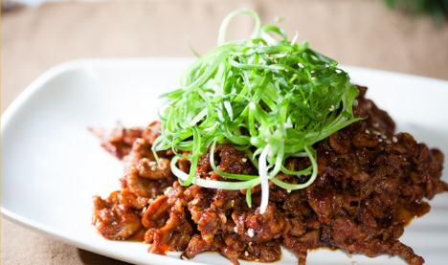

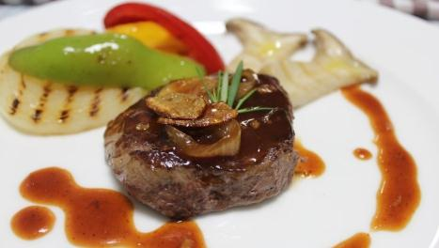

What will you have for dinner? - Work sheet 2-1
Answer the questions refer to the menu.
1. What is not mentioned in the menu?
(A) Steak tartar is made from raw meat.
(B) Bouillabaisse made with fish, shellfish and vegetables.
(C) Omelet is folded around ingredient such as ham, cheese and vegetables.
(D) Gratin is cooked under overhead grill to form crumbs on top.
(E) Type of syrup is added in Crepe.

2. In what order is escargot cooked? Correct the order.

(A)Put snails to their shells.
(B)Add the butter and sauce.
(C)Crush the snails from their shells.
(D)Cook with seasoning.

Reorder: ( )→( )→( )→( )

3. Which menu doesn’t need a heat for cooking? One more answer is possible.

What will you have for dinner? - Work sheet 2-2

4. Who may be given an extra charge? Why?
(ex. People who order… because…)

5. If you were in ANIKI’S French restaurant, what would you order? Why?

6. Create a drink menu for the restaurant. You should be drawing, naming and explaining it as much as you can.
What will you have for dinner? - Work sheet 3

Decide what you will have for lunch and dinner tomorrow from the menu and why you choose the menu with your group. (Consider your group member’s preference)

Food | Reason
Lunch

Dinner
Food | Reason

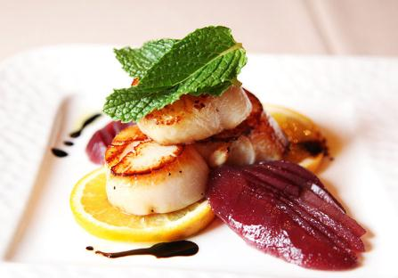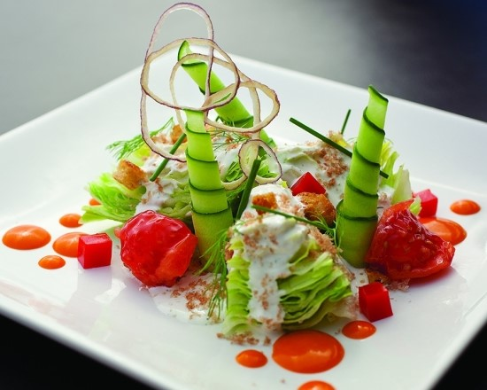

Answer sheet

Work sheet 2-1
- D, Gratin is cooked under overhead grill to form a crust on top. Not crumbs.
- C→D→A→B
- Steak tartar and crepe

Work sheet 2-2
- Example answer: People who order escargot because the explanation of escargot in the menu. People who order additional ingredients normally pay for extra charge in restaurants.

ANIKI’s Crossword Puzzle
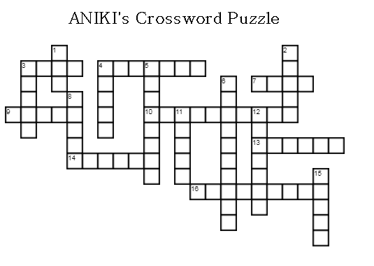
 | ACROSS
 | 3 | the flesh of animals as used for food
 | 4 | a thin, flat cake of batter fried on both sides on a griddle or in a frying pan
 | 7 | a liquid food made by boiling or simmering meat, fish, or vegetables
 | 9 | the finely ground and bolted meal of wheat, as that used in baking
 | 10 | something that enters as an element into a mixture
 | 13 | to rub harshly or gratingly
 | 14 | the fatty portion of milk, separating as a soft whitish or yellowish solid
 | 16 | an aquatic animal having a shell, as the oyster and other mollusks and other crustaceans.
 | DOWN
 | 1 | uncooked, as articles of food
 | 2 | the brown, hard outer portion or surface of a loaf or slice of bread
 | 3 | A tree species of which are grown as shade or ornamental trees, for timber, or for sap.
 | 4 | Cleanse, remove, eject clam so that I cook for you.
 | 5 | related to or used in kichen or in cookery
 | 6 | spread over or open, or occupying a wide space.
 | 8 | a small particle of bread, cake, etc.that has broken off
 | 11 | to scrape or rub with rough or noisy friction, as on thing on or against another
 | 12 | the yellow and principal substance of an egg, as distinguished from the shite
 | 15 | a small bulbous plant, Allium schoenoprasum, related to the leek and onion, having long, slender leaves that are used as a seasoning.

ANIKI’s Crossword Puzzle-Answers

