☐ Listening ☐ Speaking ☐ Reading ☐ Grammar ☐ Writing

Instructor:  Belle, Mimi | Level:  Intermediate | Students:  8 | Length:  30 Minutes

Materials:

- 8 copies of mail text
- 8 copies of worksheet1 (Reading comprehension test )
- 8 copies of worksheet2 (Writing an email)
- Slides for vocabulary presentation on computer
- realia(picture for megazine, and a lemon)

Aims:
Main aim : Ss will improve reading comprehension ability
through their activities of reading the text
Secondary aim : Ss will also improve their writing skill by writing an e-mail
Personal aim : Teacher will be able to keep Ss’ interest throughout the class
by selecting the routine topic for the material.

Language Skills:

Reading: reading e-mail between co worker
Writing: writing an e mail for post activity
Listening: listening to teacher’s presentation, instruction
Speaking : while sharing their ideas and thoughts

Language Systems:

Phonology : 'next to', 'last week', 'next quarter' contraction
Grammar : finished, requested, mentioned, conducted (simple past)
Lexis : quarter, critic, acidity, export, dull, facilitate, procure
Function : understand emailing, writing an email
Discourse : communication, express ideas and thoughts through activities,

Assumptions:

Ss knows how to E- mail in casual way
Ss know about the coffee taste and acidity
Ss are used to working individually , in pairs and in groups

Anticipated Errors and Solutions:

Ss might not be familiar with the formal way of E-mailing
: give them information about the formal form of e-mail
Ss might have difficulties while their reading
: encourage and help them to do their work
Ss might not have enough time to finish their work
: give them time to finish their work or give as homework
Ss might not understand the instruction
: give them explanation clearly

References: Text for Hackers TOEIC reading
Sos activity for https://goo.gl/Tvyuoc

Lead-In
Materials: white board, marker
Time | Set Up | Student Activity | Teacher Talk
2 min | whole  class |  | Greeting  Hello, everyone  How are you today? (Ss answer)  Eliciting  Have you ever seen a business email?  (Ss answer)  How do you think about email?  (Ss answer)

Pre-Activity
Materials: White board, marker, computer(ppt)
Time | Set Up | Student Activity | Teacher Talk
7  min | Whole class | Listen the explanation  Look some pictures for the Vocabulary  &  Answer the questions  Listen the explanation  Look some pictures for the Vocabulary  &  Answer the questions | Procedure  Before we start,  We’re going to study about the vocabulary of the text today  Vocabulary presentation  quarter  (draw a picture and ask ss)  Can you guess what this means?  (It means that one of four equal parts of something.)  CCQ)  You have an apple, you cut it 4 pieces,  Can you tell one of them a quarter?(yes)  How can you say that 3 month in a year? (quarter a year)  critic  (showing ss about the movie critics of food critics)  Can you guess what this means?  (It means that someone who writes reviews and express opinions about books, films, music and art.)  CCQ)  Where else can you see the critics easily these days? (On TV , singing contest , superstar K, Phantom singer…etc)  acidity  (give them definition from the dictionary)  Acid- an acid is a liquid with a PH value of less than 7.  Acidity is a noun  Can you guess what this means?  CCQ)  Lemons, limes like citrus fruits have sour taste. Are these acidic? (yes)  Do these have acidity? (yes)  export  (draw picture of a port with big ship and write down export and import )  Can you guess what this means?  CCQ)  Does samsung export Mobile phones or import mobile phones? Samsung exports mobile phones.  dull  (Showing images of dull on slides)  Let’s look at the different of images that showing the meaning of dull.  The word “dull” is used in many ways to express for someone and something.  It means something or someone that is dull is not interesting in any way and a dull color or light is not bright. Specially, in wine, uninteresting, boring and flat wine is said dull as well as the color of wine is unclear and not bright. When coffee has no characteristic of taste and aroma, it’s said dull coffee.  We can also say that ‘it’s dull’ when the scissors are not working well, because it’s not sharp  CCQ)  This coffee doesn’t taste good enough,  How can we say about the taste?  (It tastes dull)  Alastor is a sensitive man  Is he dull?(No)  facilitate  Have anyone heard of this word before?  (Ss answer)  (taking an example sentence)  ;Structured teaching facilitates learning  ;We can call a person or thing that facilitates a facilitator  A facilitator is a person or organization that helps another person or organization to achieve a particular thing  Can you guess the meaning?  (Ss answer)  It means that to make easier or less difficult and to assist the progress  CCQ  Is this class facilitating your learning? (Yes)  How can you call the person who help your progress of learning? facilitator  procure  I’d like to show the picture. It’s quite interesting.(Showing the slide)  Can you guess the meaning of procure by looking at this picture?  (Ss answer)  It’s synonyms are gain and win  Procure means you obtain something as you put a lot of efforts  When something is difficult to get, you can say procure.  CCQ)  Will you manage to procure the certificate of TESOL? (yes)

Main Activity
Materials:
8 copies of worksheet1 (email text and comprehension question)
Time |  | Set Up |  | Student Activity |  |  | Teacher Talk
11  min |  | whole  class  individually  Whole class |  | Ss answer  Ss read the text  answer the questions |  |  | Procedure  Guiding Question  How many of you are confident to write an e-mail at work?  Have you ever write formal way of e- mail to your co-workers or business partners?  Today we’ll take a close look at e-mails between coworkers Zelda and Hector.  After you finish your reading,  You’re going to answer the  Reading comprehension test  You can answer the questions  While you are reading  Hand out the text  Run the task  Feedback  Did you finish ?  Let's share your answers  (Ss share their answer one by one)  (checking their answers)
Post Activity
Materials:
8 copies of worksheet2 (writing an email)
Time | Set Up |  | Student Activity |  |  | Teacher Talk
10 min | whole  class  individually |  | writing an  e-mail |  | Procedure  Now it's time to write an email  Instruction  You’re going to be Zelda  You can write an email to Hector for the  Following instructions  You have 8 minutes to write an email  CCQ  What are you going to do? (write an email)  Who are you going to be? (Zelda)  How much time do you have? (8 minutes)  Hand out the worksheet  Run the task  You may begin  Feedback  Did you finish? Now switch it with the  person next to you, read it, and share  something fun (Have Ss to read aloud)  Closing  What have you learned ?  Did you enjoy today ?  Does anyone have any questions?  Have a nice day.

Read these emails between Zelda and Hector

To: | Hector Quiintero <quintetero@isiscoffeecompany.com>
From: | Zelda Corbin <corbin@isiscoffeecompany.com>
Date: | August 15
Subject: | Kenya Fresh Blend

Hector,

I was reading some food magazines this morning, and there were negative of one of our new coffee blends set to launch next quarter. According to a critic who was present during our coffee tasting last week, the acidity level in Kenyan Fresh Blend was too weak. You might want to check out Subway Magazine and The Prime food Journal to see the comments he and other critics have made.

Taking this into consideration, I’d be really grateful if your research team could look into this matter more closely. As you know, we’re hoping that the Kenyan Fresh Blend will become one of our main export products, so if the acidity level is not high enough, as the critics say, then it would be best to address this problem before we go into mass production. I’m having a meeting with my other product development team members next week, so please send me a report as soon as you finish your research. Thanks in advance.

Zelda
To: | Zelda Corbin <corbin@isiscoffeecompany.com>
From: | Hector Quiintero <quintetero@isiscoffeecompany.com>
Date: | August 22
Subject: | Re: Kenyan Fresh Blend
Attachment: | Two documents

Zelda,

My staff and I just finished the research you requested and our findings confirm what you mentioned in your last e-mail. As it turns out, the lab test conducted on the blend indicates that its acidity level is 5.0, which lacks that sharp, clean taste that coffee lovers look for. A report submitted by the staff who conducted the coffee tasting stated that most of the participants said the coffee was dull.

I have attached a copy of the lab test as well as the report on the coffee tasting held last week. Our research team recommends changing the blend. it is ready to produce several samples for your consideration, but will wait for your instructions. Please, let me know if there is anything else you would like me to do facilitate the development of this coffee as an export product.

I will be out of the office today to procure some coffee bean samples from a new supplier, so please call my mobile phone if there is anything you would like to discuss.

Hector
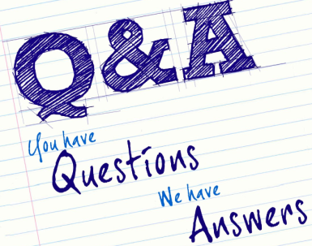
Reading comprehension test

- According to the passage, what is the name of the coffee were they going to launch?

- What did Zelda want Hector to do?

- What was the level of the acidity?

- How did Zelda become to know about the level of acidity in their product is weak?

- Why does Zelda want to have a research report back as soon as possible?

- Why did Hector say to Zelda that he would wait for her instructions?

- If you were the Zelda, how would you feel after reading the negative review of your coffee product?

- If you were Corbin, how would you feel when Zelda ask you to check out the magazines to read the critics’ comment?

- If you were the consumer, what types of coffee would you buy? Why?

Reading comprehension test Answer sheet

LITERAL

- According to the passage, what is the name of the coffee were they going to launch? (Keyan Fresh Blend)
- What did Zelda want Hector to do? (To send her a research report)
- What was the level of the acidity? (5.0)

INTERPRETIVE (answers may vary)

- How did Zelda become to know about the level of
acidity in their product is weak?
She red reviews of the product from the magazines.
The critics commented that in the Subway magazine and the primefood journal.

- Why does Zelda want to have a research report back as soon as possible?
She likes to address the problem before going into the mass production on next meeting with other product development team members

- Why did Hector say to Zelda that he would wait for her instructions?
To facilitate the development of the coffee

APPLIED (answers may vary)

- If you were the Zelda, how would you feel after reading the negative review of your coffee product?

- If you were Corbin, how would you feel when Zelda ask you to check out the magazines to read the critics’ comment?

- If you were the consumer, what types of coffee would you buy? Why?

Worksheet2 Writing an email
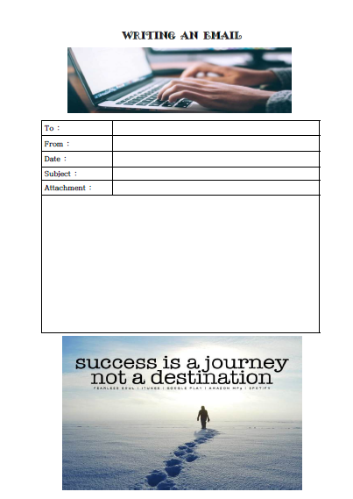

For vocabulary presentation

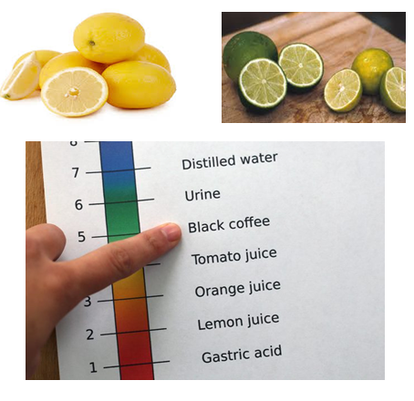
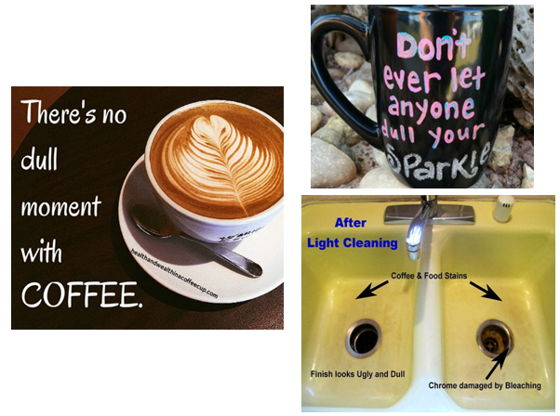

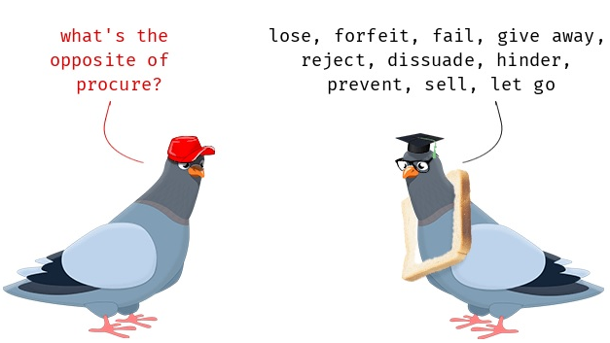

Pictures for realia

SOS work Sheet: Keyan Fresh Bean

There are 11 words from the text . Circle the words when you find.
Write the down the words you have circled below the box.

E | A | S | W | R | T | G | O | H | A
C | T | C | C | O | N | D | U | C | T
G | I | A | I | I | A | F | J | R | C
P | U | T | T | D | I | Q | O | A | O
C | L | S | I | I | I | R | T | E | F
V | A | Q | E | R | L | T | X | S | F
T | K | Z | H | L | C | I | Y | E | E
H | C | N | U | A | L | N | C | R | E
R | E | V | I | E | W | U | Y | A | K
C | D | N | E | L | B | D | D | K | F

SOS work Sheet : Keyan Fresh Bean

There are 11 words from the text . Circle the words when you find.
Write the down the words you have circled below the box.

E | A | S | W | R | T | G | O | H | A
C | T | C | C | O | N | D | U | C | T
G | I | A | I | I | A | F | J | R | C
P | U | T | T | D | I | Q | O | A | O
C | L | S | I | I | I | R | T | E | F
V | A | Q | E | R | L | T | X | S | F
T | K | Z | H | L | C | I | Y | E | E
H | C | N | U | A | L | N | C | R | E
R | E | V | I | E | W | U | Y | A | K
C | D | N | E | L | B | D | D | K | F

ACIDITY
CONDUCT
FACILITATE
REVIEW
BLEND
CRITIC
LAUNCH
TASTING
COFFEE
DULL
RESEARCH

