☐ Listening ☐ Speaking ☐ Reading ☐ Grammar ☐ Writing

Topic:
Christmas and Holiday cards

Instructor:  Jennifer, Sophia | Level:  Intermediate | Students:  8 | Length:  30 Minutes

Materials:
- Vocabulary picture
- Realia : Starbucks cup, Invitation card, Foil, Foil pressed card, Scissors, glues,
- Stickers, Foil pressed color paper, Paper
- 2 Videos
- 8 copies of the worksheet 1 “Christmas and Holiday Cards”
- 8 copies of the worksheet 2 “Read and check comprehension”
- 8 copies of the worksheet 3 “Make Christmas cards”
- 8 copies of the worksheet 4 “Christmas word search”(SOS)

Aims:
● Main aim- Students will improve their reading skill by “Christmas and Holiday Cards”
worksheet 1, “Read and check comprehension” worksheet 2

● Secondary aim- Students will be fun with making the cards.

● Personal aim- Teacher wants to follow the Lesson Plan

Language Skills:

Speaking- Doing “Read and check comprehension” worksheet 2
- Sharing their answers by “Christmas and Holiday Cards” worksheet 1 and
“Read and check comprehension” worksheet 2

Listening- While Ss share their story, they can listen each other carefully.

Reading- When Ss read the worksheet 1,2,3

Writing- Write the “Read and check comprehension” worksheet 2 and “Make
Christmas cards” worksheet 3

Language Systems:

Phonology – Correcting the pronunciation during the class
Lexis- Christmas and Holiday (eg. traditional, sentiment, precede…)
Grammar- Imperative sentence
Function- Giving information
Discourse- Making the Christmas card

Assumptions:

1. Ss know the teacher’s style of teaching.

2. Ss know they should speak only English in the class.

3. Ss are confident with pair and group work.

Anticipated Errors and Solutions:
- l If Ss speak their L1
– Encourage them to speak English

- l If Ss need more time to finish their activity (Cut-off plan)
– Give them 30 seconds more and then stop the activity.

- l If Ss finish their activity earlier than anticipated (SOS plan)
– Give Ss Christmas word search worksheet

References:

- Introduce the topic-Video (Card): https://goo.gl/W8Z1NW
- Introduce the topic-Video (Christmas): https://goo.gl/9YNpwk
- Christmas word search (SOS): https://goo.gl/216kCX

Lead-In
Materials:
Time | Set Up | Student Activity | Teacher Talk
1min | Whole Class | Greeting | 1. Greeting  Hello everyone, how are you today?  (Ss greet back)

Presentation
Materials:
- Vocabulary picture
- Realia : Starbucks cup, Invitation card, Foil, Foil pressed card
- 2 Videos
Time | Set Up | Student Activity | Teacher Talk
5min  2min | Whole Class  Pair | Vocabulary  Watch the video | T : Before we read, let’s learn some new vocabulary.  ● vocabulary  1) traditional (picture)  (Show Hanbok picture)  This is the Korean traditional clothes.  (Show Hanok picture)  This is the Korean traditional house.  CCQ  1.What is our traditional food?  (Kimchi, Bulgogi…)  2) sentiment (synonym)  Its synonym is ‘feeling’.  When you feel happy or sad, That is all kinds of sentiment.  CCQ  1. When you got ‘A’, which sentiment do you have?  (Happy, Exciting...)  3) precede (Picture)  This person is the most preceding person in this line.  It means same as before.  CCQ  1. What day is the preceding Christmas?  4) personalized (Realia & Picture)  (Show a starbucks cup.)  What’s this? (Ss : Starbucks cup)  Yes, This is a Starbucks cup.  When we go to Starbucks, we can make a personalized menu.  (Show the picture)  For example, if you prefer soy milk, you can change it rather than milk.  CCQ  1. Have you ever made your personalized menu in Starbucks? (Yes or No)  5) invitation (Realia & Action)  T1: Could you come to my birthday party?  (Giving the invitation to T2)  T2: (Looking through the invitation)  Oh, thank you inviting me. I’ll be there.  T1: Okay. See you then.  (Show the invitation card)  When you want to invite someone, you can write it and give it to them  CCQ  1. Have you ever given the invitation card? (Yes)  2. When do you give the invitation card?  (Wedding day, Mother’s day, My birthday…)  6) ornate (Picture)  (Show a picture)  Look at this picture. This is an ornate alphabet.  Ornate is decorated with a very small or complex design.  CCQ  1. Is the palace of Versailles ornate? (Yes)  7) foil pressed card (Realia)  (Show the foil)  This is the foil.  (Show the foil pressed card)  This is the foil pressed card.  ● Introduce the topic  These videos relate today’s topic.  Can you guess what it’s about?  (Try eliciting more today’s topic from Ss.)  (Christmas, card…..)

Practice
Materials:
- Worksheet 1: Christmas and Holiday Cards
- Worksheet 2: Read and check comprehension
Time | Set Up | Student Activity | Teacher Talk
6min  7min | Whole Class  Individually  Whole  Class  Pair  Whole Class | Worksheet 1  (Christmas and Holiday Cards)  Worksheet 2  (Read and check comprehension) | ● Skimming  Instruction  Read the dialogue quickly and do the worksheet 1 (Christmas and Holiday Cards) alone.  You have 5 minutes.  CCQ  How much time do you have? (5)  Do you do alone? (Yes)  (Distribute the “Christmas and Holiday Cards” worksheet.)  (monitor discreetly)  Feedback  Do you need more time to do?  (If yes – give 30 seconds extra time  If no – check answers together)  Let’s check the answers.  1. True of False  Mimi, can you read the number 1? …  2. Check the box  What boxes did you check?  ● Read and check comprehension  Instruction  Do the worksheet 2 (Read and check comprehension) with your partner. Write your partner’s answer.  You have 5 minutes.  CCQ  1. How much time do you have? (5)  2. What are you supposed to write?  (Partner’s answer)  (Distribute the “Read and check comprehension” worksheet.)  (monitor discreetly)  Let’s share the answers.  (Ss share their answers.)

Production
Materials:
- Worksheet 3: Make Christmas cards
- Scissors, Glues, Stickers, Foil pressed color paper, Paper
Time | Set Up | Student Activity | Teacher Talk
8min  1min | Whole Class  Individually  Whole Class | Make Christmas cards | ● Make Christmas cards  Instruction  Now, let’s make your own Christmas cards.  You have 6 minutes.  After 6 minutes, we’ll share our Christmas cards.  CCQ  1. What are you supposed to do? (Making a Christmas cards)  2. How much time do you have? (6min)  (Distribute the “Make Christmas cards” worksheet and materials)  (monitor discreetly)  Feedback  Have you all finished?  (If no – give 30 seconds extra time)  Let’s share our Christmas cards  (Ss share them each other.)  2. Wrap-up  Did you have fun today?  I hope you enjoyed today’s lesson.  See you tomorrow.

SOS Activity
Materials:
- Christmas word search worksheet 4
Time | Set Up | Student Activity | Teacher Talk
5min | Pair | Christmas  word search  worksheet | Instructions  Now I’ll give you the Christmas word search  worksheet. Find the words in the big box with your partner.  CCQ  1.Are you working alone? (No)  2.What are you supposed to do?  (Do Christmas word search)  (Distribute Christmas word search worksheet and  monitor discreetly)  (If Ss don’t finish it, let them do free homework.)

Vocabulary - Traditional (Hanbok)
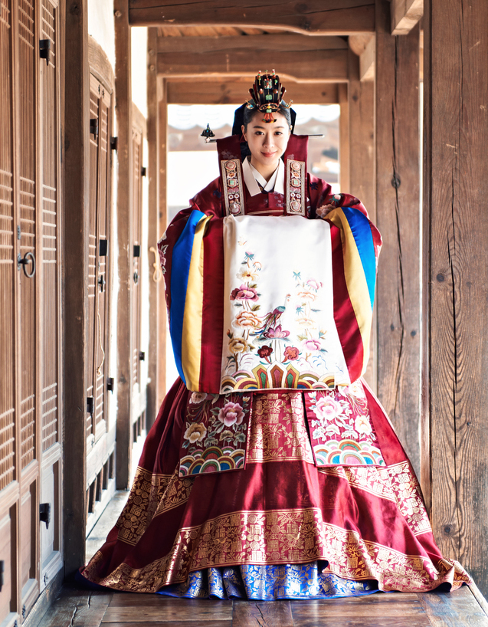
Vocabulary - Traditional (Hanok)
Vocabulary - Precede
Vocabulary - personalize
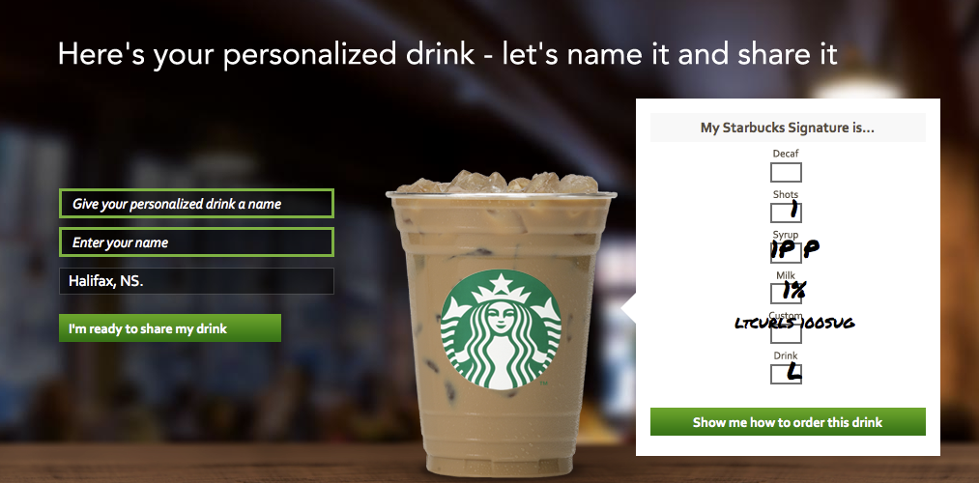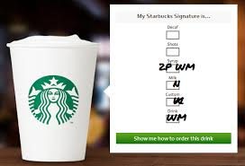
Vocabulary - ornate
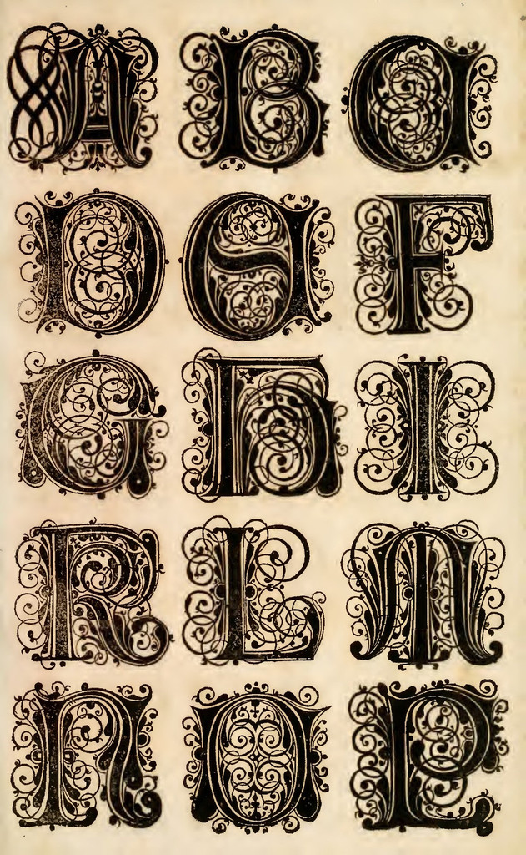

Christmas and Holiday Cards [Reading Text]
Christmas cards
A Christmas card is a greeting card sent as part of the traditional celebration of Christmas in order to convey between people a range of sentiments related to the Christmas and holiday season. Christmas cards are usually exchanged during the weeks preceding Christmas Day by many people (including non-Christians) in Western society and in Asia. The traditional greeting reads "wishing you a Merry Christmas and a Happy New Year".

Holiday Greeting Cards
Celebrate the Christmas season & send holiday cheer to family and friends with our new collection of Christmas & Holiday Cards.
Create a personalized holiday greeting that stands out with your favorite photo memories. From Christmas and Holiday Cards to New Year's and Holiday Party Invitations, you can add one or more of your favorite photos with our improved ordering and card selection. Shop by color, style - from Modern Christmas to Traditional Holidays - or browse until you find the perfect card for your loved ones. Discover new card trim options with a selection of square cards, ornate cards, circle cards, and square cards, or try one of our new Foil Pressed Cards to create a holiday greeting that shines bright. Say Merry Christmas, Happy Holidays, and Happy New Year with the perfect card that matches your family's unique style.
Christmas and Holiday Cards [Worksheet 1]

1.True or False?
Read each sentences carefully. Circle true or false.

1. Christmas cards are parts of the traditional celebration of Christmas. True / False
2. Christmas cards are usually traded on the Christmas day. True / False
3. Exchange Christmas cards is only in the Western. True / False
4. In advertising, You can add one or more of your photos on the cards. True / False
5. In advertising, There are square, ornate and triangle trim options. True / False

2.Check the box
Check all types of cards below which the customer wants.

Well, I want my card to be a folding and foil pressed card. I don’t want to be complicated, so I prefer a simple style. Please make a square of the card. Ah, and write “Merry Christmas” on the front of the card! Thank you a lot :) Merry Christmas and Happy New Year!
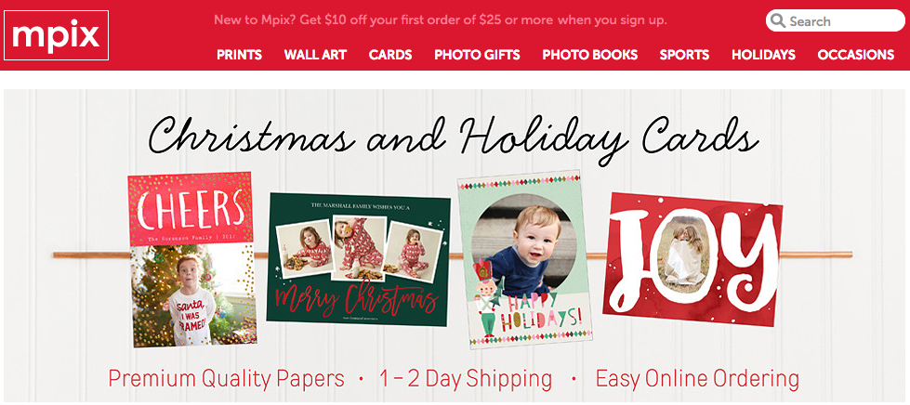

Format Sentiment Design style Trim option
Flat cards Christmas Modern Square
Foil pressed cards Holiday Traditional Ornate
Folded cards Party Invitation Simple Circle
Modern Pop cards New year Colorful Rectangle
Photo cards Hand lettered

Christmas and Holiday Cards [Worksheet 1 - Answer]

1.True or False?
Read each sentences carefully. Circle true or false.

1. Christmas cards are parts of the traditional celebration of Christmas. True / False
2. Christmas cards are usually traded on the Christmas day. True / False
3. Exchange Christmas cards is only in the Western. True / False
4. In advertising, You can add one or more of your photos on the cards. True / False
5. In advertising, There are square, ornate and triangle trim options. True / False

2.Check the box
Check all types of cards below which the customer wants.

Well, I want my card to be a folding and foil pressed card. I don’t want to be complicated, so I prefer a simple style. Please make a square of the card. Ah, and write “Merry Christmas” on the front of the card! Thank you a lot :) Merry Christmas and Happy New Year!

Format Sentiment Design style Trim option
Flat cards Christmas Modern Square
Foil pressed cards Holiday Traditional Ornate
Folded cards Party Invitation Simple Circle
Modern Pop cards New year Colorful Rectangle
Photo cards Hand lettered

Read and check comprehension [Worksheet 2]

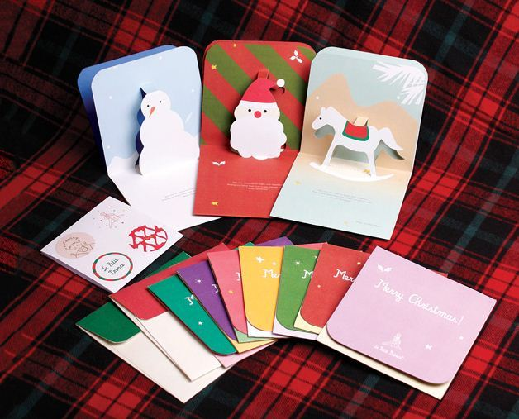
Literal
1. When are the Christmas cards swapped?________________________________
2. Do people who are not Christians also exchange Christmas card?
___________________________________________________________________
3. In the website, Can we create a personalized holiday cards?
___________________________________________________________________
Interpretive
1. Why do people write cards on holidays?
___________________________________________________________________
2. Why do people make their own Holiday cards these days?
___________________________________________________________________
3. Why do people attach the photos on the cards?
___________________________________________________________________
Applied
1. What kind of cards would you like to make?
___________________________________________________________________
2. What is your own Christmas greeting? without the traditional greeting.
___________________________________________________________________
3. How often do you send a card?
___________________________________________________________________
Read and check comprehension [Worksheet 2 - Answer]

Literal
1. When are the Christmas cards swapped? during the weeks preceding Christmas.
2. Do people who are not Christians also exchange Christmas card?
Yes, Even non-Christian people exchange Christmas cards.
3. In the website, Can we create a personalized holiday cards?
Yes, We can add photos and shop by color, style.
Interpretive
1. Why do people write cards on holidays?
2. Why do people make their own Holiday cards these days?
3. Why do people attach the photos on the cards?
Applied
1. What kind of cards would you like to make?
2. What is your own Christmas greeting? without the traditional greeting.
3. How often do you send a card?
Make Christmas cards [Worksheet 3]
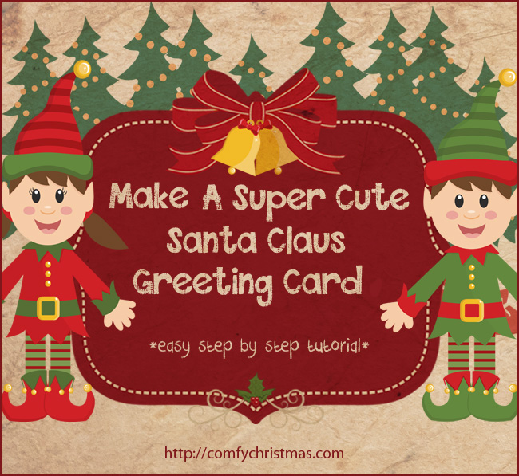
Make your own Christmas card.
You can decorate whatever you want with given materials.
1. First, Fold paper in half  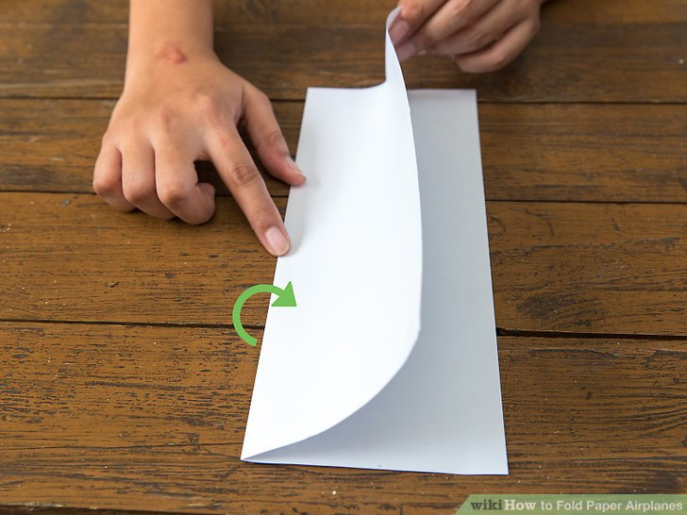 | 2. Decorate whatever you want  with given materials  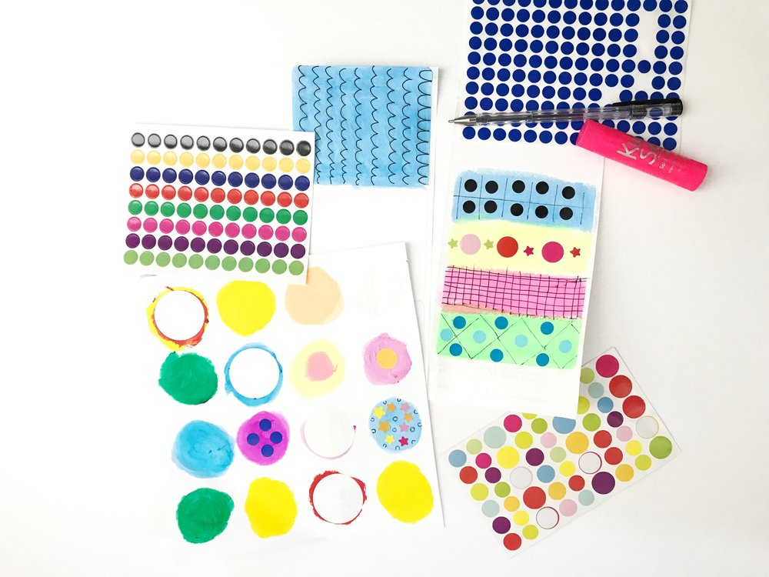
3. Write Christmas greeting on your Christmas card.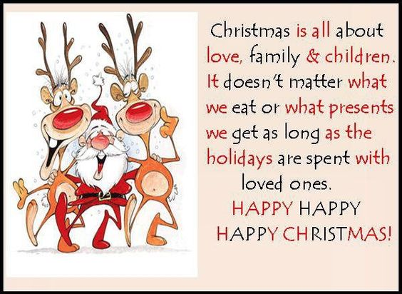
[Realia materials]
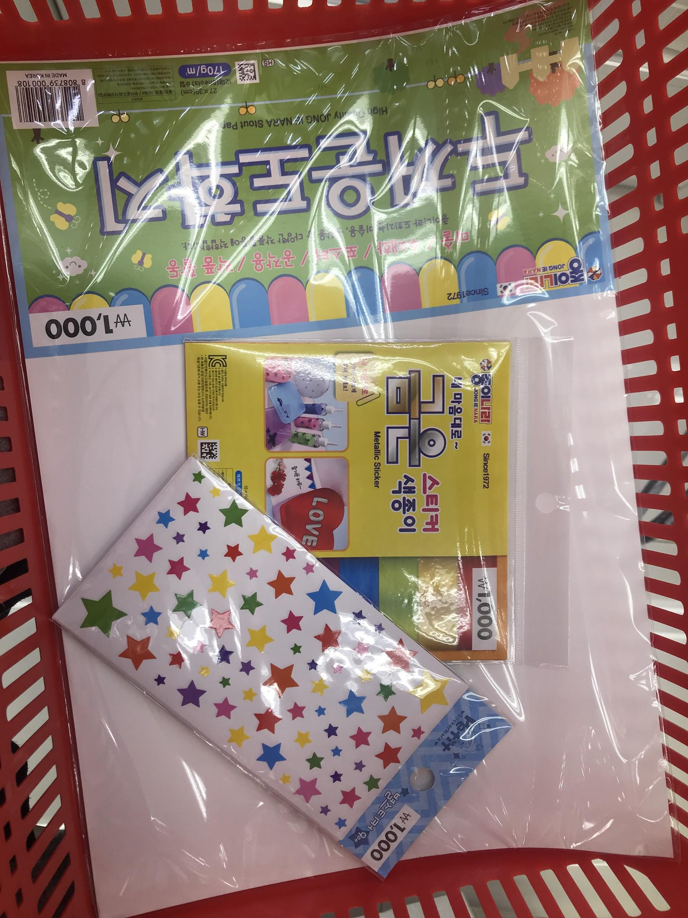
[Christmas word search (SOS) - Worksheet 4]
