Listening Speaking Reading Grammar Writing
Topic: All Of The Weather.

Instructor:  Jeongmin | Students Competency Level and Student ages  Elementary, 6-9 years old | Number of Students:  10 | Lesson Length:  50 min
Materials:(List the Names of all materials used in the lesson. Materials must be shown at the end of this document)
Weather Picture One – Sunny Day
Weather Picture Two – Rainy Day
Weather Picture Three – Windy Day
Weather Picture Four – Snowy Day
Mp3 player or Computer
What’s The Weather Like Today Song
What’s The Weather Like Today Song Lyrics
Flash Cards:
T-Shirt
Shorts
Sun Glasses

Rain Coat
Umbrella
Rain Boots

Jacket
Sweater
Pants

Muffler
Coat
Mitten

Color Pencils
Blank Paper
Paper
Pens
Weather Mask
Sunny
Rainy
Windy
Snowy
Weather and Clothes Paper
Lesson Objectives (What do you want the students to know (new skill or knowledge that you want them to gain)? and What do you want them to be able to do?
Ss will understand and be able to remember the words by some activities. For examples; drawing picture and playing speed quiz game.
Ss will practice to make sentences by talking with classmates and teacher.

Aims:(What students will be able to achieve by participating in the activities of the lesson. (Ss gain or get by doing…)
Ss get comfortable and interested in lesson by listening to T presentation, attitude and singing.
Ss will improve listening, writing, speaking skills by drawing picture, listening music, playing game and responding to teacher.
Ss will learn the words by listening teacher’s explanation.
Ss will learn what they need in this weather by listening teacher’s explanation and talk with classmates.
Ss will learn cooperation by playing game.
Ss will practice to make sentences by talking with classmates and teacher.

Language Skills:(Lists what activities language skills students will be using by participating in the activities of the lesson.)
- Reading: (Where did reading occur in the lesson?)
Weather mask, Flash cards and Pictures of weather.
- Listening:(Where did listening occur in the lesson?)
What’s the weather like today song, Teacher’s explanation and Presentation of other Ss.
- Speaking: (Where did speaking occur in the lesson?)
Sharing the favorite weather, answering, Singing and Talking Each Other.
- Writing: (Where did writing occur in the lesson?)
The work sheets, Drawing picture (T will ask Ss to write down the reason under the paper), Write the words on the paper when Ss play game.

Assumptions:(What students must already be able to do and what concepts must already be mastered before the lesson in order to achieve the aims of the lesson.)
Ss will enjoy and also have fun
Ss will easily learn the words by singing the song and playing game.
Ss have already known about the weather in Korean.
Ss can make the sentence with T assistance as needed.
Ss already have the ability to make simple sentence.
Anticipated Errors and Solutions:(What things might go wrong in the lesson and what the solution will be. An SOS activity should also be included)
The computer doesn’t work, teacher will sing the song by self and help Ss learn the melody or use cell phone.
Activity takes too long; the other activity may be shortened.
Ss have difficulty describing pictures and words, T can give some hints, give some suggestion.
Ss might be shy, T give encouragement.
References: What’s The Weather Like Today -
https://www.youtube.com/watch?v=ocwpEU6RUVI

Lead-In or Pre-Task Part (Warm-Up Part to activate and create interest in the lesson.)
Materials: (List the Names of all materials used in the Lead-In or Pre-Task Part of the lesson. Materials must be shown at the end of this document)
Weather Mask
Sunny
Rainy
Windy
Snowy
Time: | Classroom Set Up: | Student Activity and Goals: | Teacher Procedure &Instructions:
3 min  3 min | Whole class  W | Greet teacher  SS talking with partner by reading their hand out. | Greet student  T asks Ss to talk each other about What’s the weather like today.

Pre-Activity or Task Familiarization Part (Presentation Part for Presenting the language structure to be covered in the lesson. Prepares students for the communication activity.)
Materials: (List the Names of all materials used in the Pre-Activity or Task Familiarization Part of the lesson. Materials must be shown at the end of this document)
Weather Picture One – Sunny Day
Weather Picture Two – Rainy Day
Weather Picture Three – Windy Day
Weather Picture Four – Snowy Day
Mp3 player or Computer
What’s The Weather Like Today Song
What’s The Weather Like Today Song Lyrics
Flash Cards:
T-Shirt
Shorts
Sun Glasses

Rain Coat
Umbrella
Rain Boots

Jacket
Sweater
Pants

Muffler
Coat
Mitten

Color Pencils
Blank Paper
Weather and Clothes Paper

Time: | Classroom Set Up: | Student Activity and Goals: | Teacher Procedure &Instructions:
3 min  2 min  3 min  10min  3 min | Whole class  W  W  W | Ss listen carefully and know about weather.  Ss listen and become familiar with song  Ss listen carefully and know about seasonable clothes.  Ss draw one of the weather with clothes. And write down the words.  Ss describe picture each other. | T explains about the weather  T plays What’s The Weather Like Today Song with dance and asks Ss repeat the song  T explains about the seasonable clothes with shows Weather and Clothes Paper and flash cards.  T asks Ss to draw one of the weather and fill out the blank under the paper.  T asks Ss to describe your picture each other.

Main Activity or Task Realization Part (Practice to Production Part Teacher lead practice of the language presented and move to communication based more student centered activity)
Materials: (List the Names of all materials used in the Main Activity or Task Realization Part of the lesson. Materials must be shown at the end of this document)
Mp3 player or Computer
What’s The Weather Like Today Song
What’s The Weather Like Today Song Lyrics
Pens
Papers
Time: | Classroom Set Up: | Student Activity and Goals: | Teacher Procedure &Instructions:
3 min  2 min  5 min  10min | Whole class  W  W  W | Ss listen to the song again.  Ss know what they will go to do.  Ss work together.  Ss enjoy the game and remember the words. | T plays the Weather song with dance again.  T introduces the Speed quiz game.  T divides teams. And asks each team to write down the 10 words and 5 sentence about weather on the each paper.  T asks Ss to play game.

Post Activity or Post Task Part (Wrap-Up Part to Close the Lesson on a high note to and consolidate language learned in a communication based activity new situation.)
Materials: (List the Names of all materials used in the Post Activity or Post Task Part of the lesson. Materials must be shown at the end of this document)
Weather Picture One – Sunny Day
Weather Picture Two – Rainy Day
Weather Picture Three – Windy Day
Weather Picture Four – Snowy Day
Flash Cards:
T-Shirt
Shorts
Sun Glasses

Rain Coat
Umbrella
Rain Boots

Jacket
Sweater
Pants

Muffler
Coat
Mitten

Time: | Classroom Set Up: | Student Activity and Goals: | Teacher Procedure Instructions:
3 min | Whole class | Ss listen and answers. And say good bye. | T reviews the words and gives Ss to quiz. And say good bye.

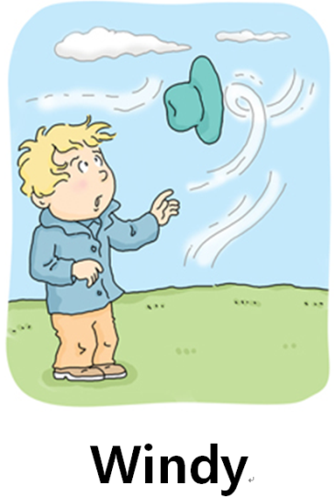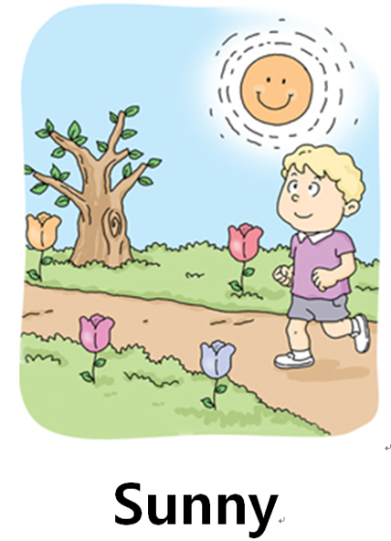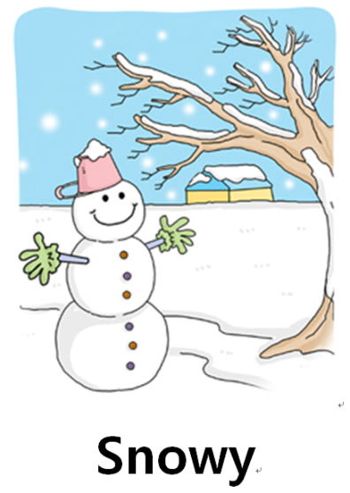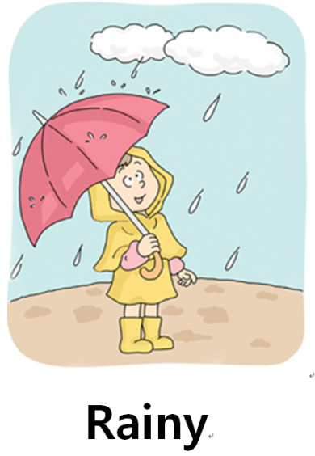
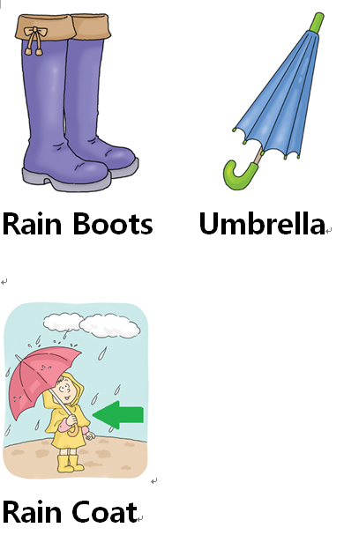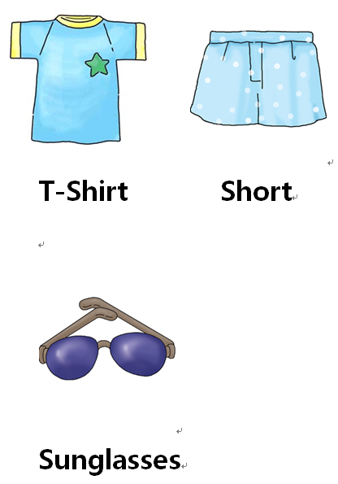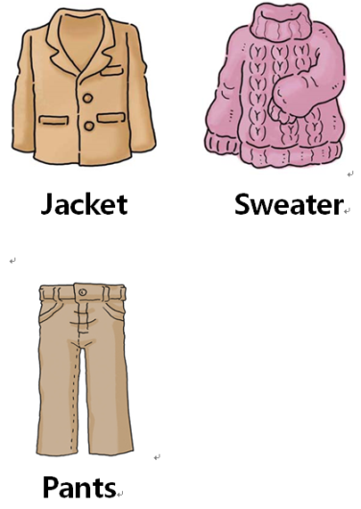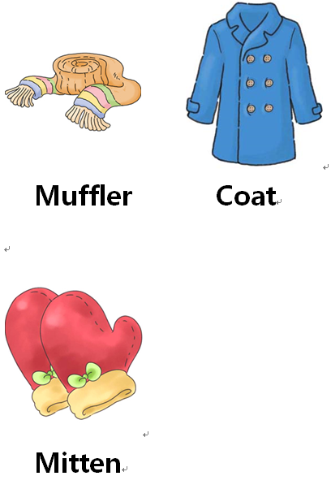

What’s The Weather Like Today Song Lyrics
