Listening Speaking Reading Grammar Writing
Topic: Animal friends
Instructor:  Sally | Students Competency Level : Elementary and Student ages :8-9 years old, | Number of Students:  12 | Lesson Length:  50min
Materials: :(List the Names of all materials used in the lesson. Materials must be shown at the end of this document)
-Animal Flash Cards
Brown Bear Flash Card
Red Bird Flash Card
Yellow Duck Flash Card
Green Frog Flash Card
Purple Cat Flash Card
White Dog Flash Card
Black Sheep Flash Card
Gold fish Flash Card
-Brown Bear, Brown Bear, What Do You See? Story Book
-Animal Puzzle1,Animal Puzzle 2
-Color Clay (Brown, Red, Yellow, Blue, Green, Purple, White, Black)
-Mp3 Player
-Brown Bear Song
-Brown Bear Song Lyrics
-Video Camera

Lesson Objectives : (What do you want the students to know (new skill or knowledge that you want them to gain)? and What do you want them to be able to do?
-Ss will be able to recognize animal’ name and colors by listening to the story and making a clay animals.
-Ss will be able to practice the sentence by playing role-play

Aims : :(What students will be able to achieve by participating in the activities of the lesson. (Ss gain or get by doing…)
-Ss will improve speaking skills by playing role-play.
-Ss will learn patterns by singing a song, and listening a story and playing a role-play
-Ss will learn animal’s name and color by making clay animals

Language Skills:(Lists what activities language skills students will be using by participating in the activities of the lesson.)
- Reading:
Reading a storybook
- Listening:
Listening to the song, to the teacher and to the role-play of other students
- Speaking:
Sharing their favorite animal, doing a role-play
- Writing:
Doing a worksheet
Assumptions: :(What students must already be able to do and what concepts must already be mastered before the lesson in order to achieve the aims of the lesson.)
-Ss will enjoy and have fun.
-Ss will easily learn patterns by doing a role-play.
-Ss will learn animals name and colors by making a clay animals
Anticipated Errors and Solutions: :(What things might go wrong in the lesson and what the solution will be. An SOS activity should also be included)
-If Ss have a difficulty to make clay animals, T can help Ss.
-The video camera doesn’t work, T will use the cell-phone .
-If Ss are ashamed to do a role-play, T ask to them to sing a song.

References:
Brown Bear Song-https://www.youtube.com/watch?v=TA6wi32YpEU

Lead-In or Pre-Task Part (Warm-Up Part to activate and create interest in the lesson.)
Materials: (List the Names of all materials used in the Lead-In or Pre-Task Part of the lesson. Materials must be shown at the end of this document)
-Animal Flash Cards
Brown Bear Flash Card
Red Bird Flash Card
Yellow Duck Flash Card
Green Frog Flash Card
Purple Cat Flash Card
White Dog Flash Card
Black Sheep Flash Card
Gold fish Flash Card
- Brown Bear, Brown Bear, What Do You See? Story Book

Lead-In or Pre-task Part (Warm-Up Part to activate and create interest in the lesson.)
Time: | Classroom Set Up: | Student Activity and Goals: | Teacher Procedure &Instructions:
1min  3min  5min  2min  2min | Whole class  W  W  Pairs  W | Greet teacher  Ss listen to T and guess and become interested  Ss listen to the story  Ss share ideas with partner  Ss song a song with teacher | Greet students  T shows picture of animals and ask to guess what it is  T reads a story about ‘Brown Bear Brown Bear What Do You See?’  T asks Ss to share ‘what’s your favorite animal in this book?’ with their partner on the left.  T shows the motion of song first and sing a long together.

Pre-Activity or Task Familiarization Part (Presentation Part for Presenting the language structure to be covered in the lesson. Prepares students for the communication activity.)
Materials:
-Animal Puzzle 1
Animal Puzzle 2

Time: | Classroom Set Up: | Student Activity and Goals: | Teacher Procedure &Instructions:
2min  6min  3min | Whole class  Two teams  S | Ss listen and become interested  Ss make a puzzle and say the sentence  Ss do a worksheet about animals | T introduces the puzzle game and shows puzzle pictures to Ss and attach to the board.  T divides the Ss into two teams and gives the puzzle each team and ask Ss to put the puzzle together and ask Ss to say “I see a (brown bear) looking at me.”  (Red bird, yellow duck, blue horse, green frog, purple cat, white dog, black sheep)  T hands out the worksheet and asks Ss to solve the problem.

Main Activity or Task Realization Part (Presentation Part for Presenting the language structure to be covered in the lesson. Prepares students for the communication activity.)
Materials: (List the Names of all materials used in the Pre-Activity or Task Familiarization Part of the lesson. Materials must be shown at the end of this document)
-Color Clay (Brown, Red, Yellow, Blue, Green, Purple, White, Black)
-Mp3 Player
-Brown Bear Song
-Brown Bear Song Lyrics
Time: | Classroom Set Up: | Student Activity and Goals: | Teacher Procedure &Instructions:
5min  8min | Whole class  S | Ss listen carefully  Ss make animals with clay  S answers “It is a ( ).  All Ss answer “I see a  ( ) looking at me. | T introduces color clay and shows how to make a animals with clay  -Make a head and body  -Make eyes, ears, nose, mouth, legs and tail  T plays a brown bear song while they are make it and help Ss who need help  T asks one S “What animal is it?”  T asks all Ss “What do you see?”

Post Activity or Post Task Part (Wrap-Up Part to Close the Lesson on a high note to and consolidate language learned in a communication based activity new situation.)
Materials: (List the Names of all materials used in the Post Activity or Post Task Part of the lesson. Materials must be shown at the end of this document)
-Video Camera
Time: | Classroom Set Up: | Student Activity and Goals: | Teacher Procedure Instructions:
5min  4min  3min  1min | team  Team  Whole  whole | Ss do a role play and the other Ss listen to the play  Second teams come up the front and do a role play  Ss watch the video played by Ss  Ss say goodbye | T asks (6 Ss)first team to come up to the front and hold a animal they made and do a role play  T takes a video  Tony, Tony, What do you see?  I see a ( ) looking at me.  Jenny, Jenny What do you see?  I see a ( ) looking at me.  T asks second team to come to the front and do a role play  T shows the video that Ss played  T thanks for participation and ask if Ss enjoyed an activity

Brown Bear Brown Bear What Do You See? Lyrics
Brown bear, brown bear, what do you see?
I see a red bird looking at me.
Red bird, red bird, what do you see?
I see a yellow duck looking at me.
Yellow duck, yellow duck, what do you see?
I see a blue horse looking at me.
Blue horse, blue horse, what do you see?
I see a green frog looking at me.
Green frog, green frog, what do you see?
I see a purple cat looking at me.
Purple cat, purple cat, what do you see?
I see a white dog looking at me.
White dog, white dog, what do you see?
I see a black sheep looking at me.
black sheep, black sheep, what do you see?
I see a goldfish looking at me.
Goldfish, goldfish, what do you see?
I see a teacher looking at me.
Teacher, teacher, what do you see?
I see children looking at me.
Children, children, what do you see?
We see a brown bear, a red bird, a yellow duck, a blue horse, a green frog, a purple cat, a white dog, a black sheep, a goldfish, and a teacher looking at us.
That's what we see.

Flash Cards
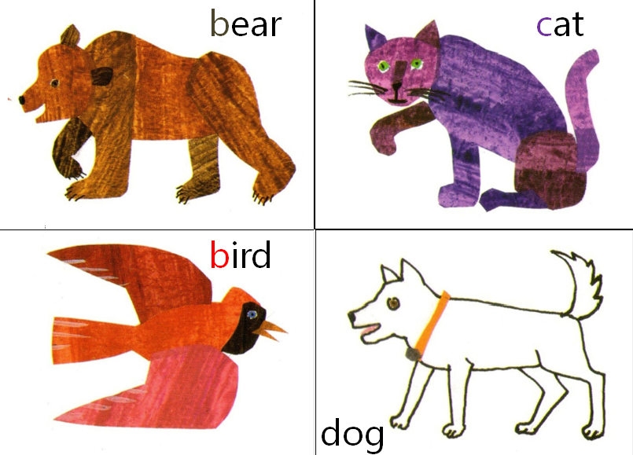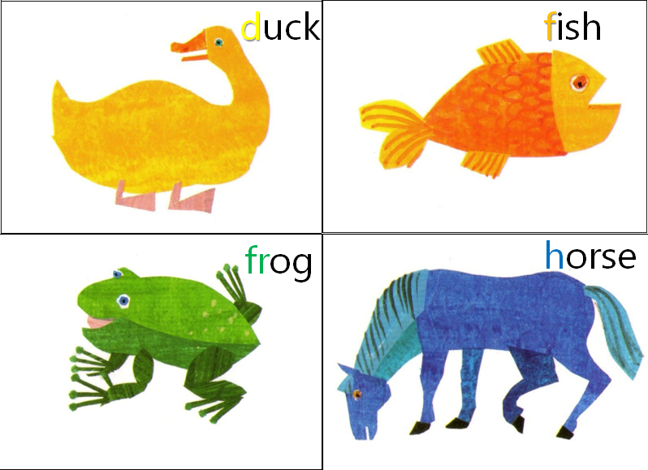
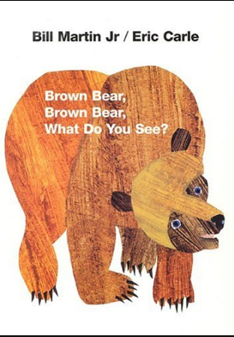
Story Book
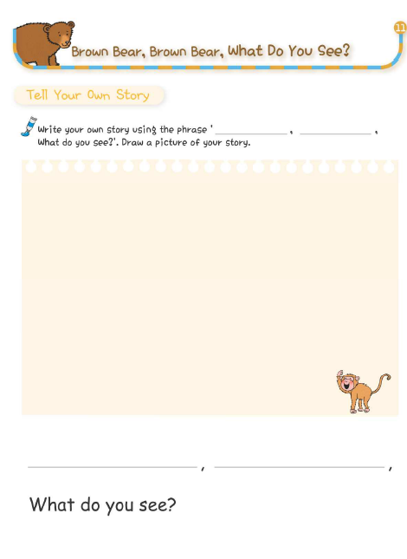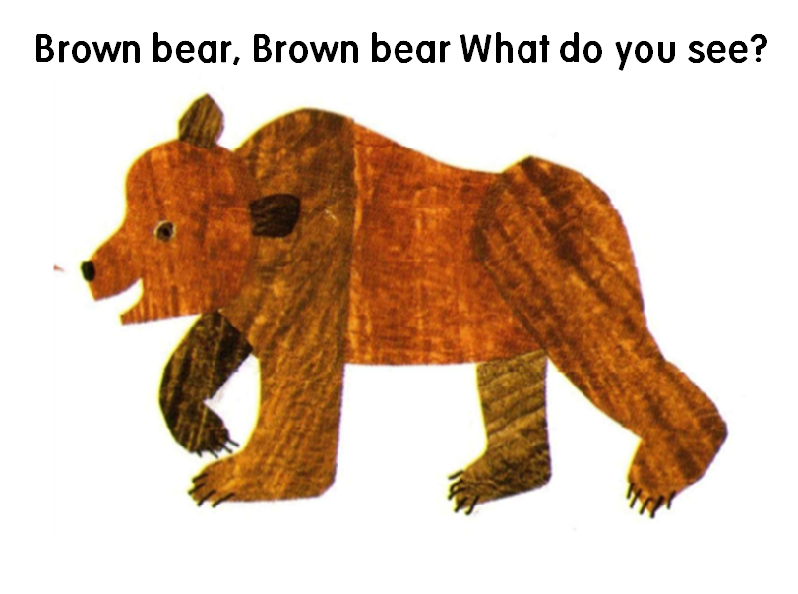 Animal Puzzle1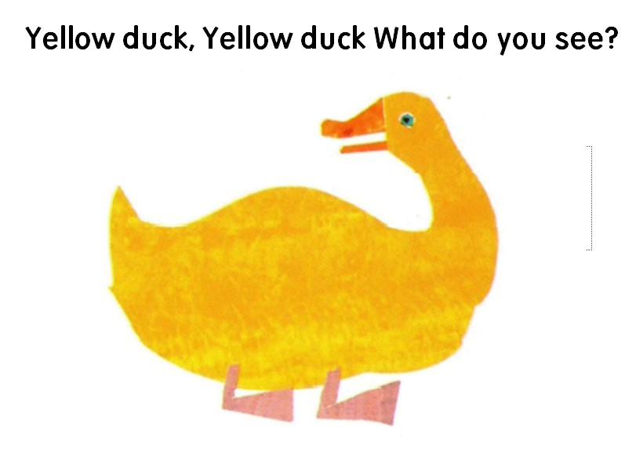 Animal Puzzle2

