☐ Listening ☐ Speaking ☐ Reading ☐ Grammar ☐ Writing
Topic: Getting Around Town.

Instructor:  Lina | Level:  Pre - intermediate | Students:  10 students | Length:  50 minutes

Materials:
 
  Worksheets I – Vocabulary Comprehension Check.
Eliciting (Correct the order of Picture story)
  Worksheet II – Dictation (Fill the blank)
  Worksheet III – Eliciting (Draw picture)
  Using a Board, Marker, Town’s map

Aims:

  To increase listening comprehension in described the situation
  To provide a format for problem solving
  To learn vocabulary and expression for dialog
  To learn information about locations of streets
  To practice listening to speech with various accents
  To be able to pick up on answer from questions and worksheet
● To practice speaking by discussing with group members.

Language Skills:

  Reading: Vocabularies in worksheets, Matching worksheets, Guiding question
  Listening: Teacher’s instruction, Other student’s speeches
  Speaking: Discuss within groups, Role play
  Writing: Answering the questions on of the Worksheets, Map

Language Systems:

  Lexis: Vocabulary and expression for dialog (location, nearby, between, across, next to…)
  Grammar: Present perfect tenses
  Phonology: Understanding the situation
  Function: Giving and receiving opinion, Eliciting, Group work
  Discourse: Worksheets, Group discussion

Assumptions:

Students already have:
  Students know what shop is
  Experienced listening English place and shop
 Student know the teacher’s style of teaching
● Students can speak and write in English but not very accurately
  How the class is set up and run (there will be 2 student groups at each table).

Anticipated Errors and Solutions:

  Students may not be able to follow the passage easily.
→ Let them listen to the tracks again until they get the gist of the content.
  Students may not be able to understand content stream.
→ Give some help. Concentrate on outline work.
  Students may need more time to work on the idioms. (CUT OFF plan)
→ If it takes longer than 5 minutes, cut answer-checking short by verbally sharing the
answers.
  Students finish their activity early. (SOS plan)
→ Give students an extra comprehension question work sheet
→ Give students more time for the discussion

References:

● Express Ways Unit 3 “GETTING AROUND TOWM”
 www. google.co.kr

Lead-In
Materials: Town’s map
Time | Set Up | Teacher Talk
5  minutes | Whole  Class | Procedure:  Hi! Everyone. How are you today? Great~  How was your weekend?  I visited my friend’s house. Have you ever found your way?  Asking a few students their experience.  OK. Today, let’s talk about wayfinding. Look here.  What it is? Yes, it’s a town’s map.  What kind of shop are there?  And check them how to explain the road.  (Elicit from students)  Now, we’re listening to some people conversation.  And we learn some idioms the speakers use.

Pre-Activity
Materials: Town’s map, Board, Marker
Time | Set Up | Teacher Talk
3 minutes  2 minutes  10 minutes | Whole  class  Pairs  Whole  class  Pairs  Individu  ally  Whole class | Procedure  1.idioms  Before we listen the conversation, we’re learning some vocabulary.  Look at this. What is it?  It’s a grocery store, gas station, movie theater, library…  Where is the parking lot? It’s next to the hospital.  Now, we are going to do a matching activity.  Instruction  Make five groups of 2 students.  Let’s have a conversation with your partner.  If you don’t understand some vocabulary, you can ask to your group members.  Demonstration  Today, we’re going to do role play activity.  For example, I need to buy some foods. Where to go?  You’re right. If I want some foods, I have to go to grocery store.  How can I get there?  Excuse me, Is there a grocery store nearby?  Yes, It’s next to the bank. Thank you.  Pretend to be part of a group. Pick up the extra role and pretend to read it silently. Ask a vocabulary question to a group member. Act as though you are memorizing your role.  Discussion and share the answers with your partner  CCQ  Check them how to get to there.  How can I get to the grocery store?  Does anyone know indicating directions?  Monitor discreetly: Answer students if they ask questions.  Give time warning- 1minute left.  Give I more minute if they need it.  Check answers: Let students write the correct idioms on the board.  Go through the idioms one by one.  Elicit the meaning from students.  Explain the meaning if necessary.  2. Prediction  Instruction  Look at these pictures. How do you explain the location?  Elicit vocabulary used to describe the location.  Check your predictions as you listen to the speaks.

Main Activity
Materials: Worksheets 1, Worksheets 2, Worksheets 3
Time | Set Up | Teacher Talk
5 minutes  20  minutes | Whole  class  Pairs  T-S  Individu  al work | Procedure:  - Listening for the main idea.  Instruction  Now, listen to the speakers. Think about the destination of each speaker. Listen for the locations of places.  Do you understand the situation?  Could you find the destination?  Demonstration  For example, I’m asking the questions. Excuse me. Is there a post office nearby?  Tell me who you find the destination?  CCQ  Do you want to listen again?  Show students the picture of the speakers again  Describe the listening text.  - Listening for Details.  Instruction  I’m giving you Worksheet. You see seven pictures?  Discussion and share the answers with your partner.  Decide who will be guide, who will be questioner.  Make sure everyone speaks. You have 10 minutes for discussion.  Demonstration  Now it’s time to do role play to the front of the room.  Which group should do first?  Monitor discreetly: Answer students if they ask questions.  Give time warning- 1minute left.  Give I more minute if they need it.  Good job. I will give you Worksheet II. Fill in the blank.  Discussion and share the answers with your partner.  CCQ  Check up the answers.  Now, let’s check the answers together.  What’s the answer for question number 1?  Do you agree with the answer?  (Same for question 2 to 10)  Error Correction & Feedback  Describe the location. And elicit the next story.  They will present their summary.  Share students’ opinions.

Post Activity
Materials: Board, Marker
Time | Set Up | Teacher Talk
5 minutes | Whole Class | Conclude lesson  Elicit today’s idioms verbally.  Instruction  Review the conversation and vocabularies worksheet what you learned today.  Did you enjoy this activity? Did you have any difficulties?  You did a good job. Have a nice day. See you next class.

SOS Activity
Materials: Extra work sheet
Time | Set Up | Teacher Talk
Change the members in finishing group and share the answers.
Give students one more worksheets.
Work Sheet #01
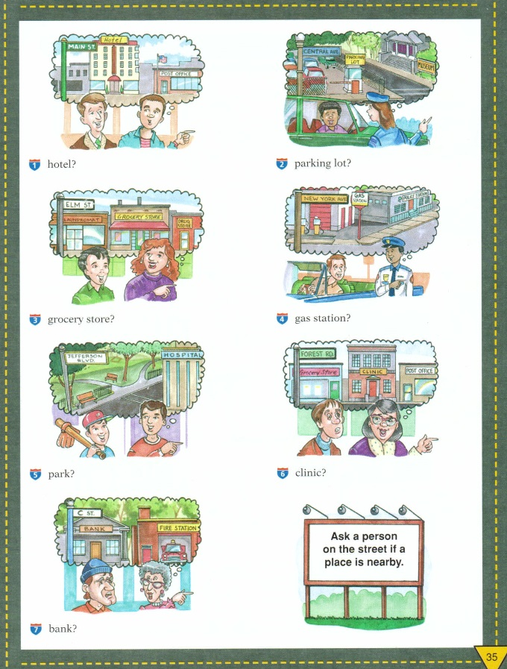

Work Sheet #02
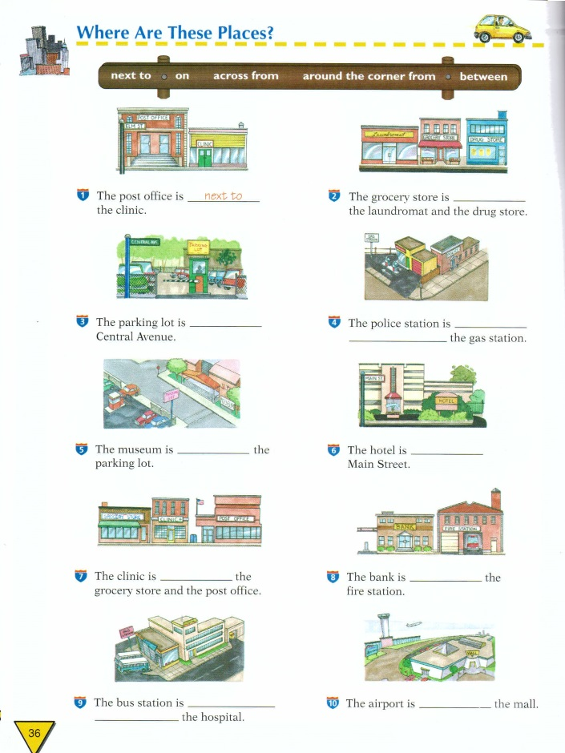
Work Sheet #03
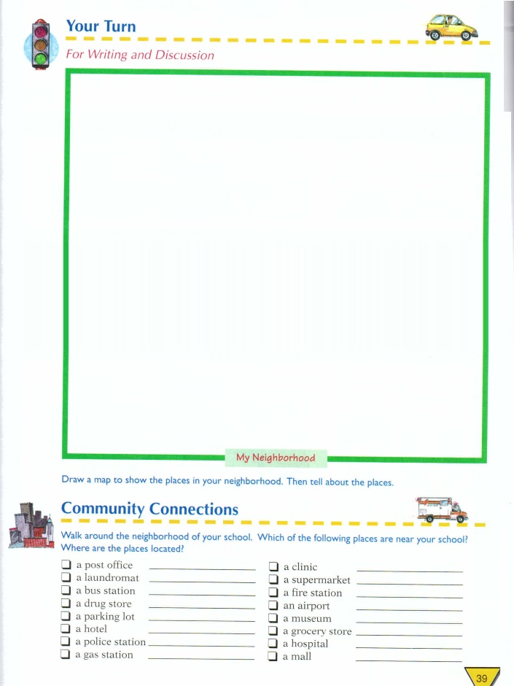
Extra Work Sheet #04
