☐ Listening ☐ Speaking ☐ Reading ☐ Grammar ☐ Writing

Topic: President Trump Thanksgiving Message

Instructor:  Todd | Level:  Advanced | Students:  8 | Length:  50 minutes

Materials:

- Idioms worksheet (8 copies)
- TV & Computer connected to Internet (For watching U-tube)
- Comprehension worksheet 1&2 (8 copies)
- Blown-up pictures about the history of US Thanksgiving day and
Dow Jones index chart
- White board, board markers

Aims:

- To learn words for describing the history of US Thanksgiving day by completing vocabulary matching worksheet
- To think about why Thanksgiving day is important for US citizens
- To practice listening to formal address through US president's speech.
- To be able to know pride and confidence of American people from Donald Trump's speech
- To practice speaking by discussing with group members

Language Skills:

- Reading : vocabulary worksheet
- Listening : US president's speech about the origin of Thanksgiving day and its meaning
- Speaking : prediction, comparing answers within groups
- Writing : comprehension worksheet 1&2

Language Systems:

- Lexis : words used in describing the history of Thanksgiving day
- Function : To know about past and present US situation
- Structure : well-organized public TV messages

Assumptions:

Students already know :

- how the class is set up and run (there will be 4 student groups at each table)
- the teacher's style of teaching and the pace of the course
- all student roughly know information about US President (who Trump is and how old he is, and what he has done)
- most students have already seen his speech at Korean National Assembly when he visited Korea this year.

Anticipated Errors and Solutions:

- Students may not be able to follow the passage easily
→ Follow the task-feedback circle : let them listen to the tracks again until they get the point of the content
- Students may not be able to pick up details from the listening
→ Chunk the listening (Pause-play-pause-play)
- Students may need more time to work on the vocabulary
→ If it takes longer than 5 minutes, cut answer-checking short by verbally sharing the answers
- If time is short
→ Cut post-activity discussion short and only ask 2~3 students to share their opinions about why Trump's address is impressive.
- If students finish their tasks earlier than anticipated,
→ Ask as many students as possible about Korean thanksgiving day called Chu-suk, and differences between US thanksgiving day and Chu-suk

References:

Video clip ;

https://www.youtube.com/watch?v=iPBTCjJBjPI

Lead-In
Materials: Board
Time | Set Up | Student Activity | Teacher Talk
5 min | Groups | Make group of 4, and talk about Trump's previous talk, behavior, thoughts as a US president.  (About both positive and negative aspects) | Hello everyone? Do you know who US president is? Got it! Donald Trump! Recently he has been to Korean. What do you think about him? Many people say that he is a very unique person. Now, before listening materials, let's talk about him briefly.

Pre-Activity
Materials: Vocabulary worksheet, Board, Blown-up Pictures of the Thanksgiving Day (for Prediction)
Time | Set Up | Student Activity | Teacher Talk
5 min  5 min | individually  Whole Class | Solve the word questions  See the pictures and guess what they are. | (distribute words worksheet to each student)  Now, there are 16 words in the paper. you should match each word with its explanation, so write the alphabet that indicates each explanation in the blank.  CCQ)  Who are you working with?  How much time do you have?  What do you write in the blank?  (Monitor discreetly. Answer students if they ask questions. Give time warning: 30 seconds left. Be flexible with time. Give 1 more minute if they need it.)  Let's go through the words one by one.  (Elicit the meaning from students, and explain the meaning if necessary)  Now, look at the pictures. There are pictures about Thanksgiving day, food, and people.  The first one, who are they?  And the second one, what does it look like?  What do you see in the map?  In the fourth one, who do you think he is?  (Show the pictures one by one like this. Elicit vocabulary used to describe Thanksgiving Day.)

Main Activity
Materials: TV, Computer connect to Internet(For watching U-tube), Comprehension sheets 1&2, Pictures related to Thanksgiving day, Picture of US Dow Jones Index, Board
Time | Set Up | Student Activity | Teacher Talk
5 min  10 min  12  min | Whole Class  Whole  Class  individually  Groups | Watch TV and Listen  Note-taking  Write the words in the paper  Write the answers  Tell his opinions about the meaning of Thanksgiving day and American current situations. | 1. Listening for the Main Idea(general understanding)  Let's watch a video clip. Imagine how America was 400 years ago. And also think about various current situations in America.  CCQ)  Can you take notes?  What are you supposed to think about?  (Play U-tube without stopping)  2. Listening for Details  (distribute comprehension sheet 1)  Complete the answers using the words we have just learned.  If you finish it, let's listen one more time!  (distribute comprehension sheet 2)  Write down your answers on the sheet and talk about them in groups.  Let's identify the pictures  (e.g.  Explain some pictures described of the early settlers.  Describe about the first arrival of pilgrims at Plymouth)  Compare with your thoughts from the prediction (if done)  --> Just notice the differences  Think about the meaning of the first thanksgiving day for them.  Discuss about bright sides and dark sides in the US situations.

Post Activity
Materials: n/a
Time | Set Up | Student Activity | Teacher Talk
8 min | Groups | Express opinions based on each student's experiences. | Do you think Trump's speech is impressive? If so, why?  You also have Korean Thanksgiving day - Chusuk. What does Chusuk mean for Korean?  What do you usually eat on Chusuk?  Does anyone have a wonderful experience on Chu-suk?  CCQ) Are you working in groups?  For how long?  Monitor actively and participate within each group.  Let's share your opinions  (Take 2~3 volunteers if running out of time)  Elicit today's words for Ss  (Give homework)  Watch this video at home and dictate the whole sentences.  Good job today, See you guys tomorrow!

(Pictures)
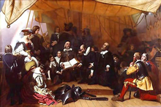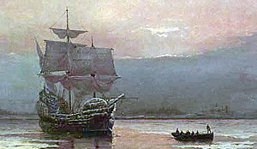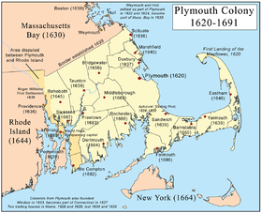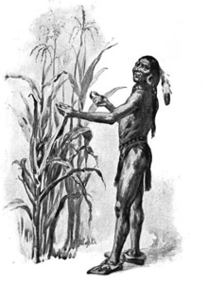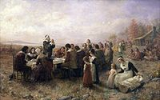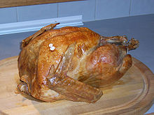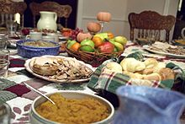
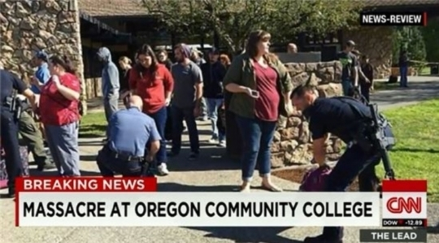

Dow Jones Index Chart (2017)

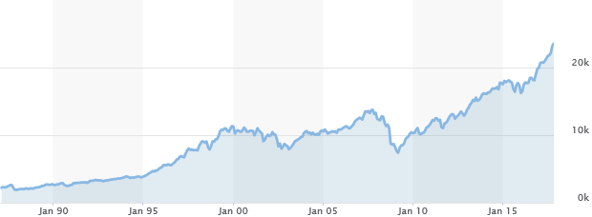

Vocabulary Worksheet
☆ match each word with each explanation below
1. provision ----------------------------------------( g )
2. hardships ---------------------------------------( )
3. the civil war -------------------------------------( )
4. patriots -----------------------------------------( )
5. worship -----------------------------------------( )
6. enthusiasm --------------------------------------( )
7. Plymouth ----------------------------------------( )
8. stock market -------------------------------------( )
9. gracious -----------------------------------------( )
10. pilgrim -----------------------------------------( )
11. sacrifice ----------------------------------------( )
12. paramedics -------------------------------------( )
13. mayflower --------------------------------------( )
14. unemployment ----------------------------------( )
15. treacherous -------------------------------------( )
16. persevere ---------------------------------------( )

a) a person who journeys, especially a long distance, to some sacred place as an act of religious devotion
b) the ship in which the Pilgrims sailed from Southampton to the New World in 1620
c) reverent honor and homage paid to God or a sacred personage, or to any object regarded as sacred.
d) characterized by faithlessness or readiness to betray trust; traitorous
e) a seaport in SW Devonshire, in SW England, on the English Channel: naval base; the departing point of the Mayflower 1620
f) to persist in anything undertaken; maintain a purpose in spite of difficulty, obstacles, or discouragement; continue steadfastly
g) the providing or supplying of something, especially of food or other necessities
h) the war in the U.S. between the North and the South, 1861–65
i) pleasantly kind, benevolent, and courteous
j) a person who loves, supports, and defends his or her country and its interests with devotion
k) the surrender or destruction of something prized or desirable for the sake of something considered as having a higher or more pressing claim
l) a condition that is difficult to endure; suffering; deprivation; oppression
m) a person who is trained to assist a physician or to give first aid or other health care in the absence of a physician, often as part of a police, rescue, or fire fighting squad
n) a particular market where stocks and bonds are traded; stock exchange
o) the state of being unemployed, especially involuntarily
p) absorbing or controlling possession of the mind by any interest or pursuit; lively interest

Comprehension Worksheet 1

☆ We learned 16 key words. After listening, just put one of these in each blank.
1. Nearly 400 years ago, the __________ gathered with native Americans to give thanks to the first harvest.
2. the pilgrims set sail in the ___________ to settle in new land, where they could live and _________ freely.
3. They endured a ___________ voyage across the ocean, and long days inside the ship’s cabin as the storms raged wild.
4. when the pilgrims arrived at _____________, their first act was to pray.
5. they ____________ through the months of bitter winter with the help of Squanto and the Wampanoag tribe, they survived and began to build a new home for their families.
6. On their first thanksgiving they came together to rejoice after their harvest and praise God for his ___________.
7. in the midst of _______________ President Lincoln made the last Thursday of November a national holiday.
8. He called on Americans to come together with one heart and one voice to thank God for his _____________ gifts and to ask him to heal the wounds of the nation and to restore it.
9. we give thanks to all of the pilgrims, the pioneers, and __________, who have gone before us, and for all those warriors who have kept us safe and free.
10. We’re eternally grateful for the courage, heroism, and ___________.
11. This year the face of painful _____________, we have seen the incredible strength of the American spirit.
12. We pray for the victims of the horrible shootings that stole innocent lives, and we thank God for the police, firefighters, ______________, and rescue workers who put themselves in harms way to save others.
13. Our country is doing very well. Our ________________ has hit a new all time high.
14. _______________ is at a 17 year low.
15. The ________________ in this country has never been higher.

Comprehension Worksheet 2.

1. Why do you think Thanksgiving Day is considered one of the most important holidays for American people?

2. Trumps mentioned that American people are suffering from many hardships. What are they? How severe were they?

3. He also said that American made very surprising performances nowadays. What are they?

4. After listening his speech, did you feel President's pride and confidence about America? If so, why?

SCRIPT

“My fellow Americans, Melania and I would like to wish you a blessed and joyful thanksgiving. Nearly 400 years ago, the pilgrims gathered with native Americans to give thanks to the first harvest. Just over a year ago before September of 1620, the pilgrims set sail in the mayflower to settle in new land, where they could live and worship freely.
They came to this continent with few resources, but rich in faith, courage, and dreams. They endured a treacherous voyage across the ocean, and long days inside the ship’s cabin as the storms raged wild. Then when the pilgrims arrived at Plymouth, their first act was to pray. Soon, they persevered through the months of bitter winter with the help of Squanto and the Wampanoag tribe, they survived and began to build a new home for their families.
On their first thanksgiving they came together to rejoice after their harvest and praise God for his provision. Since then, Americans have always remembered the blessings of freedom, and the glory of God. In his first year as President, George Washington proclaimed a day of public thanksgiving and prayer.
He asked all citizens to unite and in serine humble thanks for God’s providence, and the founding of our country, and in the midst of the civil war President Lincoln made the last Thursday of November a national holiday. He called on Americans to come together with one heart and one voice to thank God for his gracious gifts and to ask him to heal the wounds of the nation and to restore it. Today, we give thanks to all of the pilgrims, the pioneers, and patriots, who have gone before us, and for all those warriors who have kept us safe and free.
This week we know that thousands of men and women in uniform won’t be able to come home for thanksgiving. They’re standing watch around the world, facing down our enemies, and defending our great American flag. We’re eternally grateful for the courage, heroism, and sacrifice. We also thank Americans at home who serve their fellow Americans in need of a helping hand. Families who care for the sick, bring food for the hungry, and provide a loving home for children across the country.
This year the face of painful hardships, we have seen the incredible strength of the American spirit. Neighbors helping neighbors, strangers helping strangers, and citizens reaching out for those in need. We pray for the Americans impacted by the devastating storms and wildfires that struck our nation. We pray for the victims of the horrible shootings that stole innocent lives, and we thank God for the police, firefighters, paramedics, and rescue workers who put themselves in harms way to save others.
People of this nation come from all different backgrounds, but we are all one people, and one American family. We all share the same heart, the same home, and the same glorious destiny, and we are all bound together by the common bonds of love, loyalty, and affection that make our country into a wonderful home.
Together, we give thanks to the loved ones who grace our life and for the heroes who protect our nation, and we ask for God’s continued blessing on this magnificent land. Our country is doing very well. Our stock market has hit a new all time high. Unemployment is at a 17 year low. We have created $5.5 Trillion worth of values. We are doing something very special. People are feeling it. The enthusiasm in this country has never been higher. We are very very happy on this thanksgiving day. Thank you, God bless you, and God bless America,”

