☐ Listening ☐ Speaking ☐ Reading ☐ Grammar ☐ Writing

Topic: My Day Yesterday

Instructor:  Lina | Level:  Pre - intermediate | Students:  6 students | Length:  40 minutes

Materials:

○ Worksheet A: Yesterday Question
○ Worksheet B: Past sentence Board game
○ Article : My yesterday items
○ White board, board marker, board eraser, cards. lots of old magazines, catalogues, newspapers, large sheets of paper (for 1 sheet per each pair of students)

Aims:

○ To learn vocabulary and expressions for daily routine
○ To practice pronunciations about past verb.
○ To improve listening skills by listening to his/her partner
○ To practice writing skills by taking notes on a worksheet while listening to his/her partner
○ To practice speaking skills through pair work

Language Skills:

○ Reading: Script, worksheet
○ Listening: Other students’ speeches about their preferences of classrooms and opinions
○ Speaking: Group discussion, comparing answers within groups, role play
○ Writing: Answering questions on vocabulary worksheet, note taking

Language Systems:

○ Phonology: Practice pronunciation through various activities
○ Lexis: Vocabulary and expression about daily routine
○ Function: Listening, pair work, article reading, speaking
○ Discourse: Dialogue, worksheet, interaction between students

Assumptions:

○ Students already know each words
○ Students already know the teacher’s style of teaching and the pace of the course
○ All students have conversation about daily routine
○ Students are actively involved in the class

Anticipated Errors and Solutions:

○ Ss may not understand the vocabulary
Repeat the word until Ss get the sense of the content.
○ Ss may not understand the pair work
Demonstrate how to do the pair work
○ If there is not enough time,
Shorten the post activity and cut off the whole class presentation.
○ If there is too much time,
Give Ss extra time to communicate and share ideas with each other

References:

○ www.eslkidstuff.com
○ www.google.com

Lead-In
Materials: white board, board marker, board eraser, cards
Time | Set Up | Student Activity | Teacher Talk
3mins | Whole Class | Listen to teacher’s instruction | Procedure:  Instruction  Hello everyone, how are you today? What did you do yesterday? Answer the students.  Vocabulary  Today, we’re going to practice saying past tense regular verbs and irregular verbs.  Put the cards on the board. Your students will probably know some of the verbs from previous lessons and other words they can now learn. Start by touching one card and elicit or teach the verb and write the word under the card. Say the word 3 times and then move onto the next card.

Pre-Activity
Materials: pronunciation worksheet A, cards
Time | Set Up | Student Activity | Teacher Talk
3mins  8mins  3mins | Whole Class  Pairs  Groups  Whole Class | Listen to teacher’s instruction  Answer the questions together and share opinions  S mingle around the classroom.  share opinions taking turns with a partner  Listen to teacher’s instruction and speak out loud | Procedure:  Instruction  Now, we’re going to talk about “What did you do yesterday?” First of all, let’s take a look at the worksheet.  Give out the "Yesterday yes or no question" worksheet. (Distribute the worksheet A)  No.1. What did he do yesterday? Did he read a book? No. he didn’t. He watched TV.  Now ask your partner. “Did you watch TV yesterday?  How was it? / What did you do yesterday?  Discuss with your partner about the picture. When you answer it using the past tense.  This sheet will be used in the next stage of the lesson.  CCQ  What did you do yesterday?  How was it?  Demonstration (interview practice)  In pairs, student A asks the question to student B, and student B answers about themselves. After all of the questions have been asked and answered students change partner and practice again. Circulate as everyone is working away, and ask lots of questions.  Student A: Lina, what did you do yesterday?  Student B: Yesterday, I watched TV, played a game.  Monitor discreetly. Answer students if they ask questions.  Give time warning: 1minute left.  Give 1 more minute if they need it.  CCQ  What did you do yesterday?  How was it?  If you don’t understand the past tense?  Feedback  You should now have 11 cards on the board.  As you elicit / teach each verb, stick the card on the board and write the forms under the card.  Say the word 3 times. Say each verb in different voices (low, high, loud, quite, monster voice, singing voice, etc.) and students have to reply in the same voice.  We are going to practice these cards using fun methods.  Start by pointing at a card and saying the past tense form, for example:  Teacher: (pointing to a card) eat.  Students: ate  Teacher: (pointing to another card) read.  Students: read  Continue at a fast pace and get faster and faster, making a game of it.

Main Activity
    - Materials: board with markers, lots of old magazines, catalogues, newspapers, etc
    - - large sheets of paper / card (for 1 sheet per each pair of students)
Time | Set Up | Student Activity | Teacher Talk
4mins  3mins  10mins | Whole Class  Whole Class  Individual  Pairs | Listen to teacher’s instruction and read out loud taking turns with a partner  Listen to teacher’s instruction and read out loud taking turns with a partner  work on the poster  Students share opinion with their partner. | Procedure:  - Dialogue Drilling  Instruction  This is a someone’s daily routines. Look at the text.  (Distribute the article) First just listen. (Teacher reads)  Now, repeat after me. (Teacher reads line by line, Student repeat – drill the text) Practice with a partner. Read together and read line by line,  Read "My Day Yesterday"  I woke up at 7 o’clock.  I ate toast and jam for breakfast.  Then I went to work.  After work I came home.  In the evening I watched TV  and I took a good rest.  For dinner I ate pasta.  and I read a book.  I went to bed and I slept all night.  CCQ  Are there any difficulties on using wh-questions?  When did he get up?  Where did he go?  What did he eat for breakfast.?  What did he eat for dinner.?  Monitor discreetly. Answer students if they ask questions.  Give time warning: 1minute left.  Give 1 more minute if they need it.  - Controll practice  Instruction  Teacher starts by saying the infinitive form of a verb and his/her partner has to say the past form with the phrase "Yesterday, I …", for example:  Teacher: eat toast and jam.  Student: Yesterday, I ate toast and jam  Teacher: go to work  Student: Yesterday, I went to work  Continue through the story, eliciting the key vocab. Get the students really involved in the story by speaking.  - Make a poster picture story  Instruction  let’s have a creative activity!  Make a simple story called "My Day Yesterday" using pictures – and create a poster with it. Students need a large sheet of paper as well as lots of old magazines, catalogues, newspapers. Also need scissors and glue. It is worthwhile making an example before class so you can show students exactly what to do. On the board write "My Day Yesterday" and get everybody to write this at the top of their sheet. Then tell everyone they are going to stick on pictures of things they did yesterday and write sentences. Model this by taking a magazine and finding a picture (e.g. someone riding a bike), then cut it out and glue it to your sheet. Under the picture write "Yesterday, I rode my bike".  Monitor carefully.  CCQ  What do you work?  What activities in common?  If you don’t know some of the vocabulary?  Circulate and help out with vocabulary.  Students to use pictures requiring different verbs from the one learned in the last few lessons (skiing, etc.)  Do you want more time?  Yes→ give them more time.  No→ go over the presentation.  Ok, time’s up! Lets’ share your thoughts!  When everyone has finished, have each person in turn hold up their posters and tell the class what they did yesterday.  At the end of class, their poster pin the posters to the walls – this can be used for a review activity in your next lesson!

Post Activity
Materials: Past sentence Board game, Dice(or coin)
Time | Set Up | Student Activity | Teacher Talk
5mins | Whole Class | Listen to teacher’s instruction  work on the game | Procedure:  Instruction  Did you enjoy this activity? Did you have any difficulties?  Talk about interesting answers  Demonstration (board game)  Look at this worksheet. Now, let’s demonstrate what a question and answer with board game.  Roll the dice and move to spot.  Tell us your yesterday with past tense.  CCQ  What did you do yesterday?  How was it?  closing  It’s time to wrap up! How did you feel about today’s class? Good job today. See you tomorrow!

SOS Activity
Materials: Extra work sheet
Time | Set Up | Student Activity | Teacher Talk
 |  |  | Give students extra time to communicate and share ideas with each other. It’s OK to change the members in finishing group and share the answers.

Article - My Day Yesterday

I woke up at 7 o’clock.
I ate toast and jam for breakfast.
Then I went to work.
After work I came home.
In the evening I watched TV
and I took a good rest.
and I read a book.
For dinner I ate pasta.
I went to bed and I slept all night.

- wake – woke / take – took / read – read / go – went / wash - washed
- eat – ate / come – came / ride – rode / put on – put on / have – had
- sleep – slept / write – wrote / cook – cooked / run – ran / give – gave
- find – found / drink – drank / buy – bought / talk – talked / do – did
Worksheet A
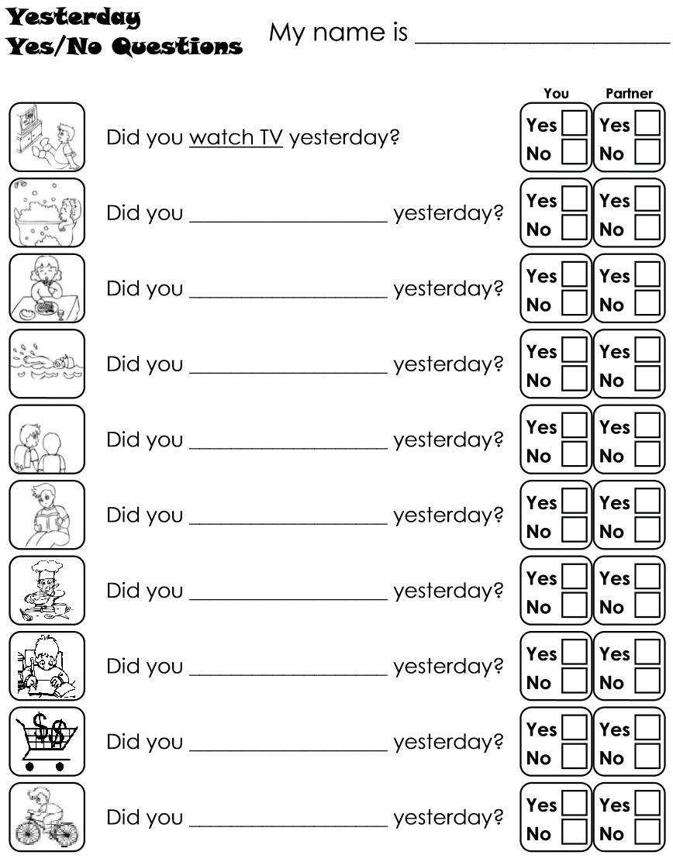
Worksheet B

Past sentence board game

