|  |
| --- |
| ☐ Listening √ Speaking ☐ Reading ☐ Grammar ☐ Writing |
| **Topic: Asking & Giving Directions** |

|  |  |  |  |
| --- | --- | --- | --- |
| Instructor:  YuJin Kwak | Level:  Pre-Intermediate | Students:  4 | Length:  35~40 mins |

|  |
| --- |
| Materials:   * PPT file (Vocabulary, Preposition of directions, Giving & Asking directions) * Worksheet#1, #2 and #3 * Activities’ materials #1 & #2 * Computer & speaker * Whiteboard & marker |

|  |
| --- |
| Aims:   * To learn basic vocabulary, prepositions of directions, conversations and common usages about directions * Speaking, writing and imaging situation by activities * To improve their speaking skills by role play |

|  |
| --- |
| Language Skills:   * Listening: The dialogue about directions * Writing skills as filling in the blank – Worksheet#1, #2 and #3 * Speaking: Discussion, asking and answering questions * Reading: Vocabulary worksheet#1 |

|  |
| --- |
| Language Systems:  - Lexis: Vocabularies, prepositions  - Discourse: Students have conversations through short script  - Function: Ask and imperative sentence by asking and giving directions  (Excuse me, could you ~?. Sure, Go~)  - Grammar: Making sentences with preposition (next to, apposite, etc.) |

|  |
| --- |
| Assumptions:  - Students had experience of directions  - Students may already know basic preposition of directions |

|  |
| --- |
| Anticipated Errors and Solutions:  -A particular group can require discussion time more.  : If every student wants to get more time, teacher gives about 1 or 2 mins more  -The class might finish earlier than expected.  : T will give students SOS activity. |

|  |
| --- |
| References:  - PPT materials: <http://busyteacher.org/23263-directions-asking-and-giving.html>  - Dialogue: <https://www.youtube.com/watch?v=SeIKun0cXQI>  - Crossword: <http://bogglesworldesl.com/crosswords.htm> |

|  |  |  |  |
| --- | --- | --- | --- |
| **Lead-In** | | | |
| Materials: N/A | | | |
| Time | Set Up | Student Activity | Teacher Talk |
| 3min | Whole Class | A couple of students tell their stories about memories or experience of directions. | **Greeting & Introduction**  T: Hello. Everyone. How are you today?  *(wait a moment for students to answer)*  I met a foreigner on the way here, and he asked me for directions.  Have you ever had the same experience as me?    *(Wait a moment for 1 or 2 students to tell their stories, but if no one says, elicit to ask students some questions)*  *For example,*   * *Have you ever been lost when you have traveled abroad?* * *What did you do then?*   T: Ok, Today, we are going to talk about asking and giving directions.  Let’s take a look at a few prepositions of directions and common usage first.  What kinds of prepositions are there? |

|  |  |  |  |
| --- | --- | --- | --- |
| **Pre-Activity** | | | |
| Materials: Whiteboard and marker, Computer and speaker, PPT file,  Worksheet #1 (4 copies each) | | | |
| Time | Set Up | Student Activity | Teacher Talk |
| 12 min | Whole Class &Individually  Whole class  Individually  Whole class | All students watch the PPT file and say prepositions to answer together.  Students say the prepositions in the blanks together.  Student write a worksheet#1 individually.  Students tell and share the full sentence they created. | **Procedure**  *(Teacher draw something on the board to elicit expected answers from students: in, on/under, above/below, next to, behind, on the corner (of), etc. or show them example more with PPT file) – 3mins.*  T: Let’s practice. I will show you a picture. Then, let's practice to fill in the blanks with appropriate prepositions and directions together.  *CCQ*  *What’s the picture?*  *What should you do?*  *T: Say prepositions. The drugstore is ~?”.*  *(Wait a moment until all students answer the question, and elicit answer by gesture or facial expression)*  *Q&A)*   1. *The Drugstore is _between_ the Post Office and the Movie Theater.* 2. *The Police station is _apposite_ the Drugstore.* 3. *The Hospital is _far_ from the Library.* 4. *The Train Station is _across from_ the Bank.* 5. *To go to First Street, _turn right_ from Central Avenue.* 6. *The Bank is ___next to__ the Police Station.* 7. *The Church is _on__ the Second Street.* 8. *The Restaurant is _near__ the School.*   T: I will give you one worksheet#1.  *(Distribute Activity worksheet #1)*  T: I want you to create full sentences by given the places on the worksheet.  CCQ  How much time do you need?  Do you want to work alone?  T: Ok, You have 5 minutes.  (*Monitor activity and give them time notice)*  T: We have 1 minute left.  *(Finish and have them share the sentences what students created to the class)*  T: All right! Let’s check the sentence.  How do you describe “The bank/Flower shop~” is?   1. Bank/Flower shop: 2. Restaurant/Rose a Silva Avenue: 3. Toy Store/Music store/Restaurant: 4. Fast food restaurant/School: 5. Bookstore/Supermarket:   CCQ  How do you describe?  What would you say?    *(Wait a moment until students answer, and teacher may elicit 1 or 2 students)* |

|  |  |  |  |
| --- | --- | --- | --- |
| **Main Activity** | | | |
| Materials: Computer with video clip(Youtube) to play the dialogues  Computer with PPT file  Whiteboard and marker  Worksheet #2 (4 copies each) | | | |
| Time | Set Up | Student Activity | Teacher Talk |
| 17 min | Whole class &  Pair work  Pair work  Pair work | Students will watch the video and work with their partner, and then role play according to the worksheet#2.  Students work with their partner to role play.  The volunteers do first, then they all share together. | **Procedure**  *T:* Great! Now, I will play a video, you can see dialogue how to ask and give directions.  *(Play video clip 1 or 2 times and it takes 5mins.)*  T: Do you want to listen again?  Yes-> Have them listen one more time  No-> Have them do role play.  T: You watched several dialogue how to ask and give directions.  I will give you a worksheet#2. According to this, I want you to create small dialogue and role play. Let’s work in a pair. You will be a person who asks directions or gives.  After you finish, you will role play the dialogue you created to your classmate. OK?  *(Distribute worksheet #2.)*  T: Before we start, let me show you an example.  *A: Excuse me?*  *B: Yes?*  *A: How do I get to the post office?*  *B: Go past the hotel and turn left onto Main street.*  *Go one block and turn right.*  *A: Thank you.*  *(Teacher give them an example or show an example using PPT file.)*  CCQ  What should you do?  How much time do you have?  T: You have 10 mins.  *(Run the task, monitor and help them if necessary)*  T: We have 1 minute left.  *(Finish and have pairs perform their role play in from of the class.)*  T: OK, Are you all finished?  *(Check students’ responses and give 1 min more to finish)*  T: Time is up. Let’s role play. Who wants to do first? Or Any volunteer?  *(Volunteers first and encourage all students to participate)*  *T: Good job everyone and thank you.* |

|  |  |  |  |
| --- | --- | --- | --- |
| **Post Activity** | | | |
| Materials: Whiteboard and marker | | | |
| Time | Set Up | Student Activity | Teacher Talk |
| 3mins | Whole class | Share opinions and ask question about the activity | **Procedure**  1.Feedback  Did you enjoy today’s activity?  Do you have any question on the directions?  2. Error correction  If there was Ss’ error during students spoke, T corrects some errors on board or ask Ss to correct them(self-correction).  T: While you role play, I found something to correct.  CCQ  What’s wrong?  Did you notice that?  *(T will write errors on board, and Ss will answers and do self-correction)*  T: I hope you have enjoyed and learnt from these activities that we have done today.  Good job everyone. Thank you and see you tomorrow. |

|  |  |  |  |
| --- | --- | --- | --- |
| **SOS Activity** | | | |
| Materials: Worksheet#3 : Cross words | | | |
| Time | Set Up | Student Activity | Teacher Talk |
| 3mins | Whole class | Students answer the crossword on worksheet#3 | Instructions  Answer the cross words on Worksheet  #3.  T: Let students check the answer with their students. |

**ASKING & GIVING Directions Scripts**

M1: Excuse me.

Clerk: Yes, May I help you?

M1: I'm looking for the passport office.

Clerk: Passport office? Take the elevator next to the coffee shop.

M1: Oh where's that?

Clerk: Go to that corner, turn left, and go to the next corner and take the elevator to

the second floor

M1: I'm sorry, could you repeat that?

Clerk: Certainly, from here turn around and go to that corner.

M1: Yes.

Clerk: Then turn left and go to the next corner

M1: Okay, I go left and then I go to the next corner. Yes.

Clerk: At that corner, you'll see the elevators. Take the elevator to the second floor

M1: Great, thank you very much.

Clerk: You're very welcome

Clerk: Hello, can I help you?

F1: Please I'm looking for the sky train.

Clerk: The sky train go down these stairs, turn left walk across until you come to the next set of stairs, go down them and turn right.

F1: Pardon me! I didn't quite catch that!

Clerk: Go down these stairs and turn left

F1: Turn left, yes.

Clerk: Then walk straight until you see another set of stairs in front of you.

F1: Oh yes.

Clerk: Go down these stairs and turn right.

F1: I see thank you.

Clerk: You're welcome. Have a good day!

F2: Can you help me?

I'm looking for my friend Renee. She works here.

Clerk: I'm sorry I don't recognize that name.

Does she work in one of the offices upstairs?

F2: Oh no. She works in the stationery store.

Clerk: Oh, the stationery store. The stationery store this next to the post office.

F2: Yes.

Clerk: Go down these stairs, turn left and then turn them.

F2: Down the stairs, turn left and then right.

Thank you very much.

M2: Hi, where's is the Arabica?

Clerk: The café?

M2: Yes, the Arabica coffee shop!

Clerk: Go down these stairs and walk around behind the stairs.

It'll be in front

M2: Great thanks a lot.

**Prepositions of directions**

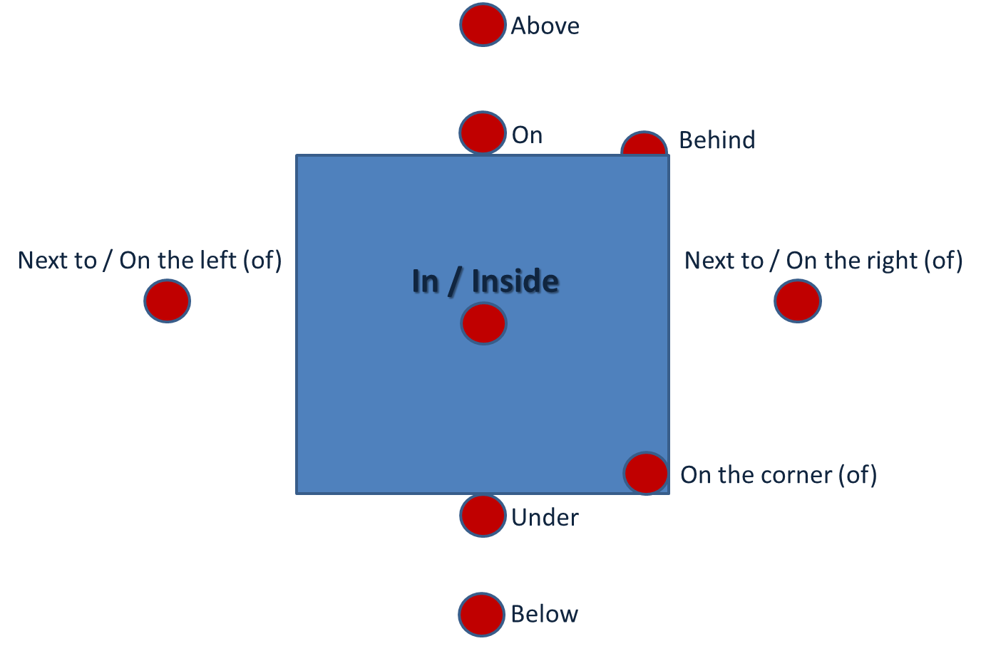

**Giving Directions**

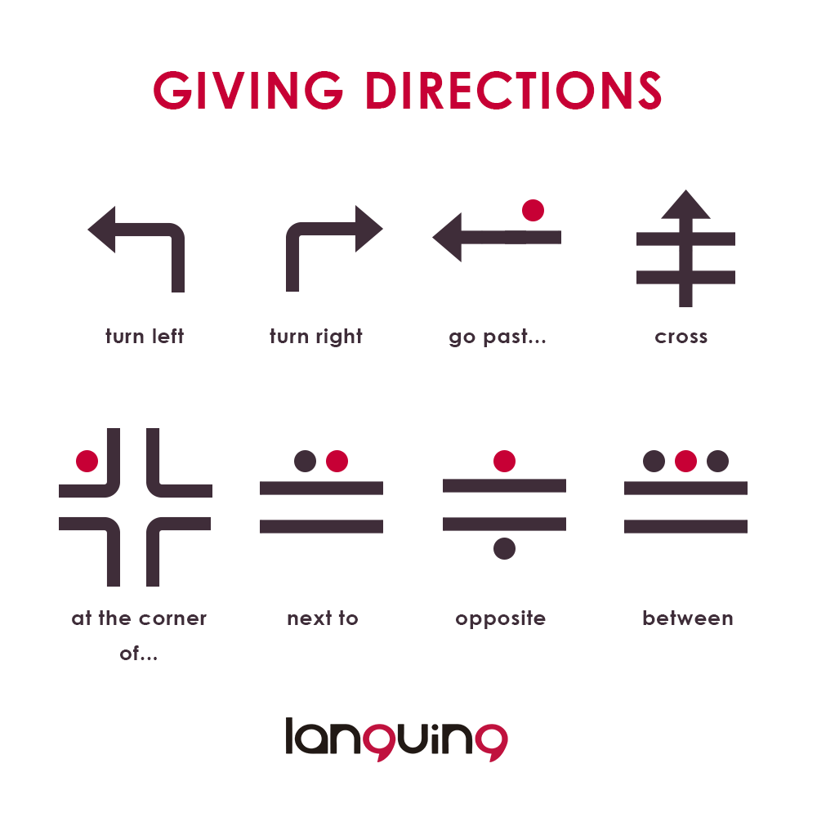

**Say the prepositions (Fill in the blank)**

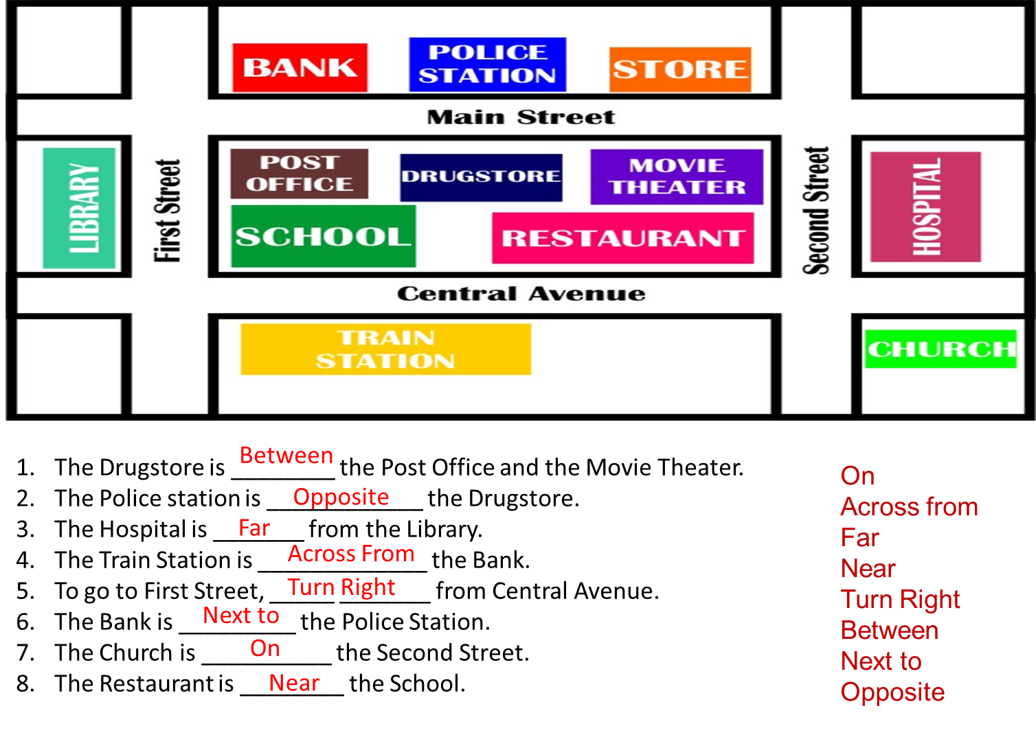

**Activity 1 – Worksheet#1**

* Create full sentences with prepositions using the given hints
* Use a worksheet #1.

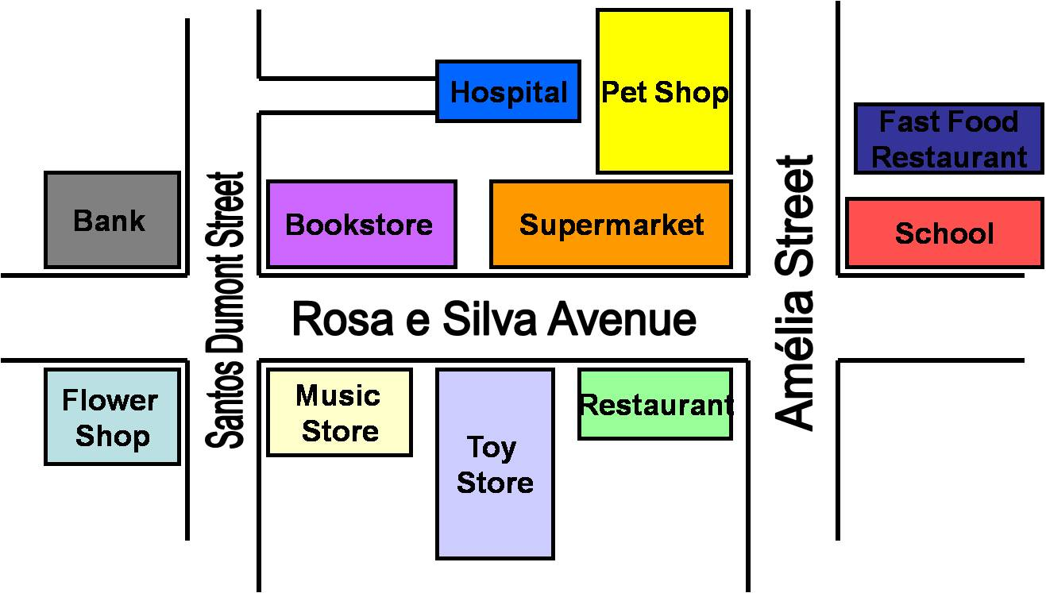

**Create full sentences with prepositions using the given hints:**

**Example:**

**Hospital/Pet Shop**: ....The Hospital is *next to* the Pet Shop....

1. Bank/ Flower Shop: ...................................................................................................

2. Restaurant/Rosa e Silva Avenue: ................................................................................

3. Toy Store/Music Store/Restaurant: ............................................................................

4. Fast Food Restaurant/School: .....................................................................................

5. Bookstore/Supermarket: ............................................................................................

**Activity 2 – Role play Example**

* **For example**

A: Excuse me?

B: Yes?

A: How do I get to the post office?

B: Go past the hotel and turn left onto Main street.

Go one block and turn right.

A: Thank you.

**Activity 2 -Worksheet#2**

**Asking for directions**

 Excuse me, could you tell me the way to ……please? Or Do you know how to get to ….. ?

**Giving directions**

Go straight on, take the first turning on the right, turn right, turn left, and walk down the corridor. Don’t turn left.

* Take a role with your partner
* Create the dialogue in about 4 or 5 sentences
* Explain the directions of the map to your partner

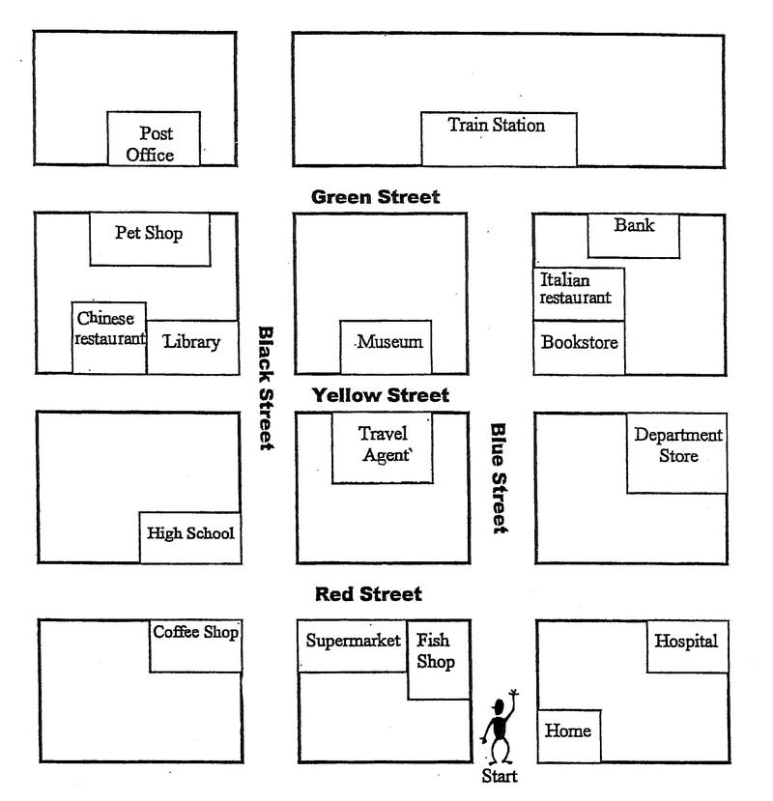

**Asking for directions**

Excuse me, could you tell me the way to ……please?

**Giving directions**

Go straight on, take the first turning on the right, turn right, turn left, walk down the corridor. Don’t turn left.

Worksheet#3

|  |  |  |  |
| --- | --- | --- | --- |
| ttldirectionooposites | | | |
|  | **Across**  **2.** The opposite offar  **5.** The opposite ofcenter  **6.** The opposite ofbackward  **8.** The opposite ofinside  **9.** The opposite ofeast  **12.** The opposite oftop | **Down**  **1.** The opposite ofon  **3.** The opposite ofleft  **4.** The opposite oflow  **5.** The opposite ofbeginning  **6.** The opposite ofmany  **7.** The opposite ofup  **10.** The opposite ofnorth  **11.** The opposite ofbelow  **12.** The opposite offront | |
|  | | | compass |

**☞ Crossword Answer**

|  |  |
| --- | --- |
| **Across**  2. near  5. edge  6. forward  8. outside  9. west  12. bottom | **Down**  1. under  3. right  4. high  5. end  6. few  7. down  10. south  11. above  12. back |