☐ Listening ☐ Speaking √ Reading ☐ Grammar ☐ Writing

Topic: Coffee

Instructor:  YuJin Kwak | Level:  Intermidiate | Students:  4 | Length:  40 mins

Materials:
- Handout, Photo#1~7
- Worksheet#1,2
- Computer & speaker
- Whiteboard & marker
- Colored pencil
- Big paper for drawing

Aims:
- To practice reading comprehension skills including skimming and scanning
- To develop writing and note taking skills by making a poster
- To increase students talking opportunity to present their poster
- To practice reading comprehension by organizing information in a text by the correct order of heading

Language Skills:

- Listening: Asking and answering questions through discussion
- Writing: Practice
- Speaking: Activities and discussion
- Reading: Reading skills including skimming and scanning

Language Systems:

- Lexis: vocabularies
- Discourse: discussion
- Grammar: making own short notes
- Function: guessing the order of text

Assumptions:
- Students know how to skim and scan the article.
- Students may not know some vocabularies in article.

Anticipated Errors and Solutions:

-Students cannot know some vocabularies easily.
: First, encourage Ss to work out meaning through context by themselves.
And teacher can help them understand the meaning through showing some example
such as pictures.
-Student might not know how to read skimming way and scanning
: Teacher remind the last lesson to students
-The class doesn’t have much time for making a poster
: The teacher can be flexible with time

References:
- Handout: http://www.onestopenglish.com/
- images: https://www.google.co.kr/

Lead-in
Materials: Coffee’s bean

Time | Set Up | Student Activity | Teacher Talk
2 min | Whole Class | A couple of students give their opinions to share. | Greeting & introduction  T: Hello. Everyone. How are you feeling today?  Did you have some coffee in this morning?  How much coffee do you drink a day?  (T ask a few questions related to coffee and Ss share their opinions)  T: Today, I’m going to talk about coffee.

Pre reading task
Materials: Whiteboard and marker, Handout, Worksheet#1 (4 copies)

Time | Set Up | Student Activity | Teacher Talk
7mins | Whole Class  Individual  Whole class | A couple of students tell their opinions.  Ss go through the handout.  Ss say answer. | T: I will show you this. This is coffee’s bean.  (Use realia and elicit Ss’ reaction about coffee)  How does it smell?  The smell is good?  Pre-reading Task  Elicit  Have you ever made a cup of coffee?  T: Before we start, I want you to have images, thoughts and ideas in today’s lesson when you smell this.  (Distribute handout and worksheet#1)  T: Now, you are going to read an article about coffee. Look at no.1 question only, and match a heading with a paragraph as soon as you can.  You don’t need to read in details. Just go through it.  I will give you 5 mins to read.  (Encourage Ss skimming reading skill)  T: Are you all finished?  Ok, what’s the correct order of headings?  Could you say the answer?  (According to Ss say, T write the answer on the board in correct order)  C,g,e,d,a,f,b  The correct order of headings:  1 How did it all begin?  2 Who were the first coffee addicts?  3 How did it spread? by smuggling  4 What made Kaldi's goats dance?  5 What is the Bean Belt? the tropics  6 Is it harvested by man or machine?  7 Who ship, roast and retail the coffee?

Main reading task
Materials: whiteboard and marker
worksheet #1 , Photo#1~7
Colored pencil and big paper for drawing

Time | Set Up | Student Activity | Teacher Talk
12mins  14mins | Pair work  Pair work  Whole class  Pair work | Ss work in pairs to discuss.  Ss share their group’s opinion.  Ss get to know the meaning of the word.  Ss can find out information about coffee in more details by making a poster. | T: Now, Look at no.2 questions in the worksheet.  Read the article again in more detail.  (Encourage Ss scanning reading skill)  CCQ  Do you want to work in pair?  How long do you discuss for?  (Monitor actively and help them if necessary)  You have 5 mins.  T: Let’s share your answer.  (Answer can be varied and have all groups answer)  (When Ss say answers, see if Ss know the meaning of words. T write the words on the board in order to Ss can guess the meaning of the words and let them know the meaning with some example to understand easier.)  The answers to the questions;  1 How did it all begin? Kaldi's dancing goats  2 Who were the first coffee addicts? Muslims  3 How did it spread? by smuggling  4 What made Kaldi's goats dance? the caffeine  5 What is the Bean Belt? the tropics  6 Is it harvested Man or machine? usually man  7 Who ship, roast and retail the coffee? developed countries/ the North  Elicit  Can you guess what this means?  - a commodity: an product of trade  - to graze: to feed on growing grass  - a stimulant: something which increases one's power to be active for a long time  - to smuggle: to take something illegally from one country to another  - to stimulate: to cause to become active  - anxiety: an uncomfortable feeling caused by fear or worry  - a dose: a measured amount  T: Now, I want you to make a poster that illustrates coffee story or history in using the information in the article.  When you draw, use arrows & image and also, write short notes on the poster.  If you need further information, you can collect from the internet.  When you are finished drawing, please describe the poster.  CCQ  How much time do you have?  What will you draw?  You have 10 minutes.  T: Have you all finished?  (If no - give 1 or 2 mins extra time,  If yes - discuss the group’s opinions)

Post reading task
Materials: Whiteboard and marker

Time | Set Up | Student Activity | Teacher Talk
5 mins | Pair work | Ss present their poster and opinions. | T: Could you present your poster to the class?  (Have all groups answer)  Conclude lesson  Ss recall the reading or information in the article as making a poster and it helps them understand better.  Teacher listens to the group’s opinions, see if Ss understand the main points in today’s lesson by being asked a few questions by teacher.  For example’ questions;  T: Do you agree how to make a cup of coffee?  What do you think of the story?  Feedback  Did you enjoy today?  Do you have any question on the lesson?  Good job everyone. Thanks.

SOS Activity
Materials: Worksheet#2 – Match the words to their meaning

Time | Set Up | Student Activity | Teacher Talk
5mins | Pair work | Ss answer to the questions about coffee. Then they can practice speaking each other. | Instructions  Do Activity with worksheet  Speaking- in your group answer the following questions on the worksheet.  - Why are coffee houses / cafes so popular around the world?  - Why were the coffee plants guarded so carefully?  - Is coffee harmful?  - Why is coffee harvested by hand?  - Why does the North profit so much from coffee when it is grown in the tropics?  - Why don't the developing countries roast and sell the coffee themselves?  - Can you think of another commodity, which is produced in the tropics, and from which most of the profits go to ‘developed’ countries in the North?

Article Handout
You may know that around the world more people drink coffee than tea. And that, after oil, it is the second biggest traded commodity. You may also know that the drink comes from beans which are first roasted and then ground. But what else do you know about this popular stimulant?
1 __________________________________
It is said that the story of coffee started with an Ethiopian goatherd named Kaldi. One day Kaldi was surprised to see that his goats were behaving very strangely: instead of grazing quietly as normal they were jumping around, almost dancing. He also noticed the red cherries from a plant that the goats were eating. He tried some himself and was surprised by the feeling of extreme happiness and excitement - he felt like dancing too!

2 __________________________________ But it wasn't used as a drink at first, but as a food. The coffee berries, mixed with animal fat, were used by monks to stay awake during long hours of prayer. From Ethiopia coffee was later cultivated in Yemen and the first hot drink was developed there around AD 1000. Three centuries later Muslims were keen coffee drinkers and as Islam spread, so did coffee. Coffee houses appeared in Cairo and Mecca.

3 __________________________________ For hundreds of years the plants were guarded safely. But some beans were smuggled out of Arabia and taken to India. In the 17th century coffee was soon growing in a new continent. From India to Indonesia and then a century later beans were smuggled once again to Brazil-which is now the largest coffee producer in the world.

4 __________________________________ It is the caffeine, an addictive stimulant drug, which made the goats dance and kept the monks awake. Although it is found in other soft drinks, including tea, coffee has the most caffeine. 150 milligrams is the minimum dose needed to stimulate the nervous system and this can be found in a single strong cup of coffee. In the short-term a couple of cups can prevent fatigue and delay sleep. But several cups a day, every day, can cause anxiety and restlessness.

5 __________________________________ This is the band around the middle of the world between the tropics of Capricorn and Cancer. A coffee plant likes lots of rain and shaded sun with rich soil, and the climate in the bean belt is ideal. 70 - 75% of the world production is the milder, higher quality Arabica that originated in Ethiopia. It grows best in higher altitudes where it is not so hot. The remaining 25% is the stronger Robusta which can survive in higher temperatures and lower altitudes.

6 __________________________________ Before becoming beans the fruit of the coffee trees, known as a cherry, is harvested. The most common method is for the cherries to be picked by hand and then dried in the sun on tables or on the ground. Once they are dried all the outer layers are removed. The red cherries have become green beans. Known now as green coffee the beans are put in 60kg bags and shipped abroad.

7 __________________________________ Although the coffee is grown and harvested in the tropics 70% of the total coffee production is imported by countries in the North who control the market. How long the coffee is roasted for depends on the market: only 7 minutes for the North Americans who prefer a light roast, but double that time for espresso coffee favored by the Italians. Nestle and Kraft account for almost 80% of all the instant-coffee sales worldwide.

Activity – Worksheet #1

Now read the article and match a heading with a paragraph.

- These are the headings to the paragraphs. Match a heading with a paragraph.

- What is the Bean Belt?
- Who ship, roast and retail the coffee?
- How did it all begin?
- What made Kaldi's goats dance?
- How did it spread?
- Is it harvested by man or machine?
- Who were the first coffee addicts?

- Read the article again in more detail. What are the answers to the questions above?
- What is the Bean Belt? _______________________________
- Who ship, roast and retail the coffee?______________________________
- How did it all begin? _______________________________
- What made Kaldi's goats dance? _______________________________
- How did it spread? _______________________________
- Is it harvested by man or machine? _______________________________
- Who were the first coffee addicts? _______________________________

SOS Activity – Worksheet#2
Speaking- in your group answer the following questions:

- Why are coffee houses / cafes so popular around the world?
- Why were the coffee plants guarded so carefully?
- Is coffee harmful?
- Why is coffee harvested by hand?
- Why does the North profit so much from coffee when it is grown in the tropics?
- Why don't the developing countries roast and sell the coffee themselves?
- Can you think of another commodity, which is produced in the tropics, and from which most of the profits go to ‘developed’ countries in the North?

Heading with a paragraph

- What is the Bean Belt?
- Who ship, roast and retail the coffee?
- How did it all begin?
- What made Kaldi's goats dance?
- How did it spread?
- Is it harvested by man or machine?
- Who were the first coffee addicts?

Photo 1. Coffee cherry

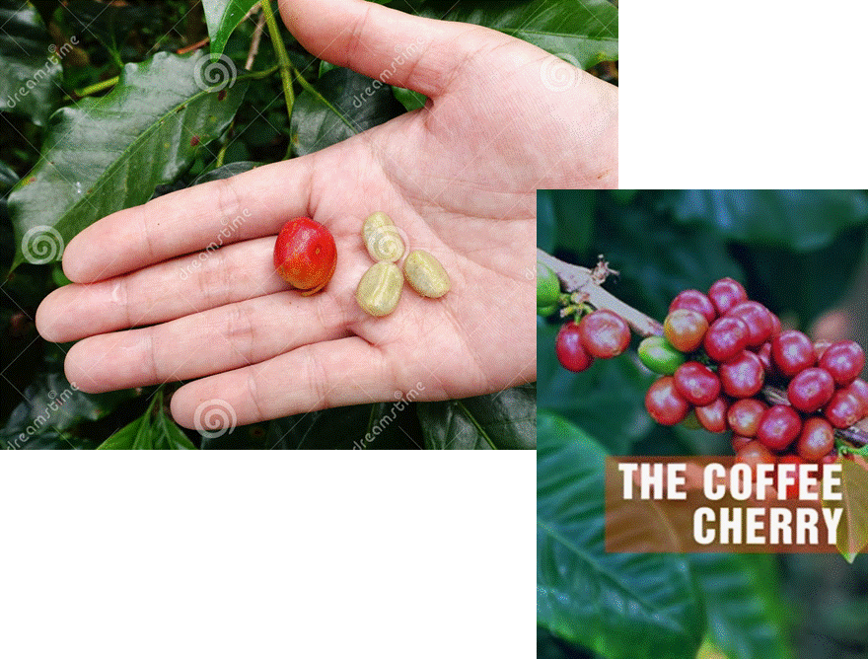

Photo 2. Graze
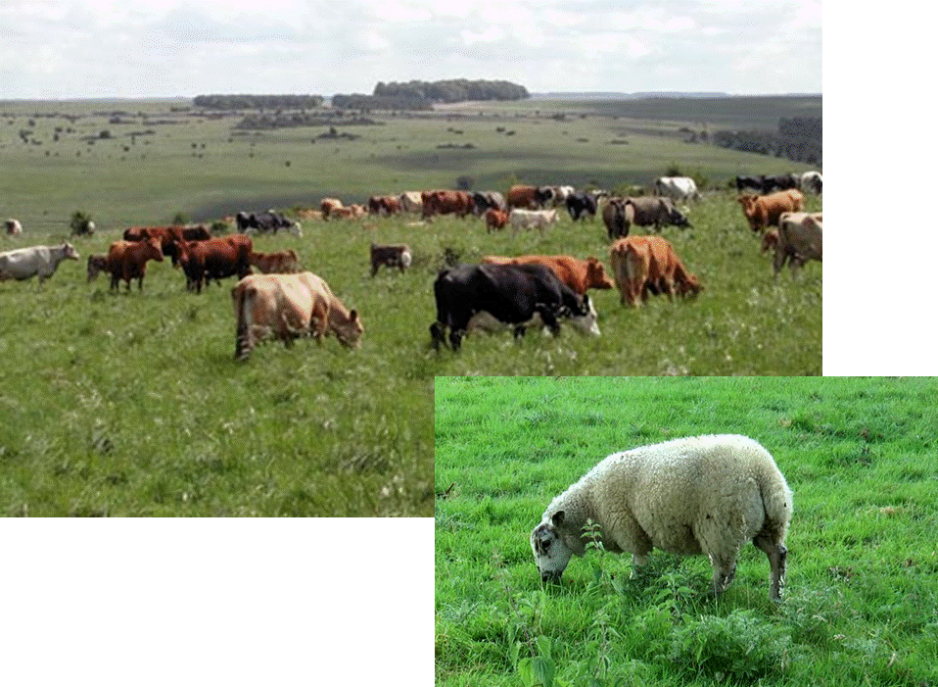
Photo 3. Stimulant
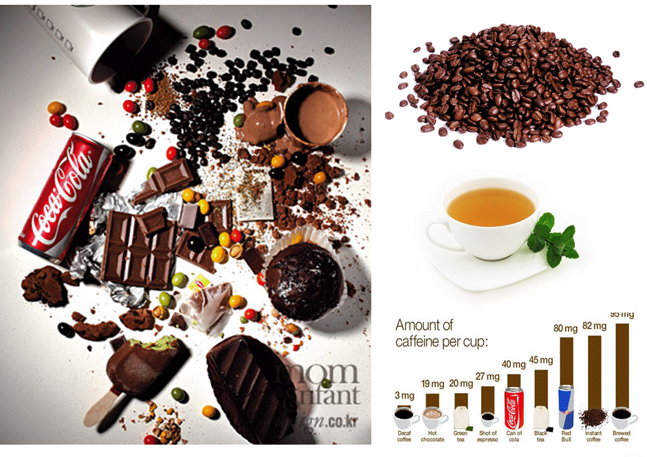
Photo 4. Smuggle
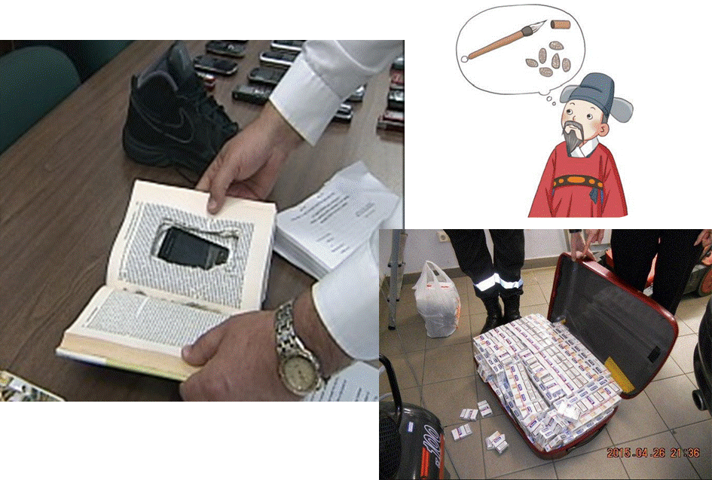

Photo 5. Dose

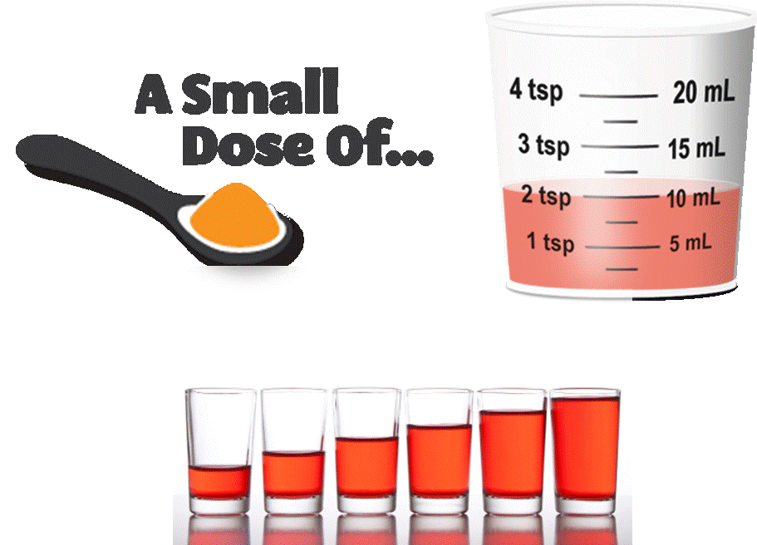

Photo 6. Bean belt / Tropic
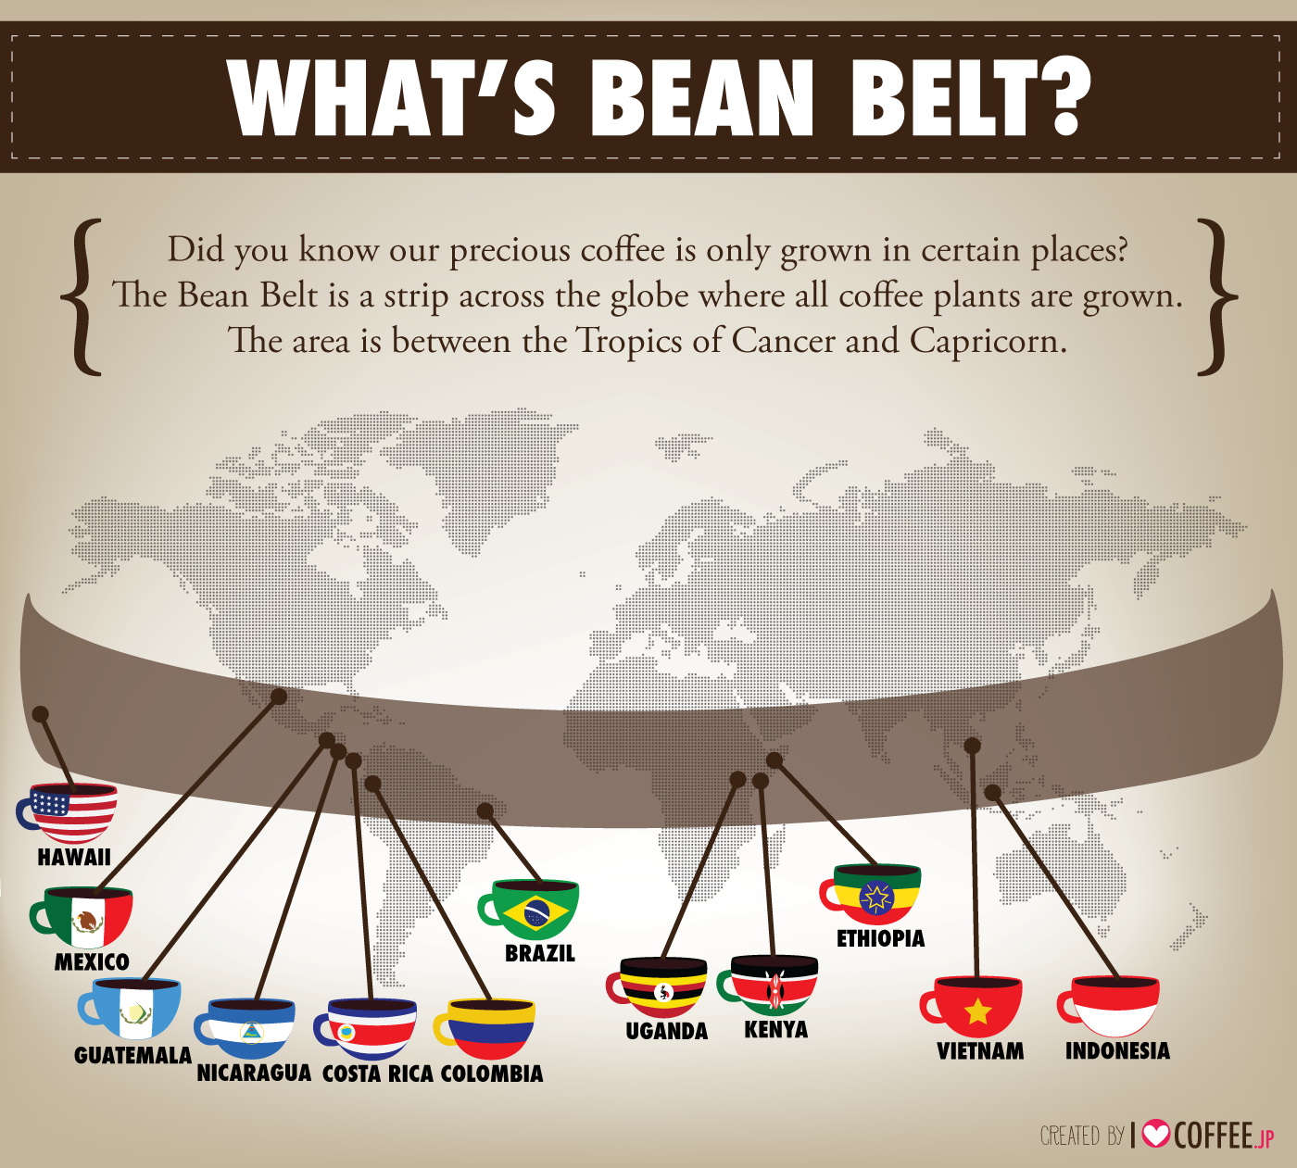

Photo 7. History of coffee
