v☐ Listening ☐ Speaking ☐ Reading ☐ Grammar ☐ Writing

Topic: Making a shopping list

Instructor: Grace | Level: beginner (Elementary) | Students: 10 | Length: 50mins

Materials:
- Dialog worksheet
- Comprehension workseet
- Audio (website link attached)
- Board
- Note book

Aims:
- To be able to understand the simple conversation in the real life by listening to the audio
- To practice listening to real life speech of people before they go to shopping
- To practice speaking of real life speech about making a shopping list by complete their dialog worksheet and practice their dialog
- To learn vocabulary and expressions by reading a dialogue

Language Skills:
- Reading : Read the complete dialog worksheet
- Listening : listen to the dialogue
- Speaking : discussion about shopping list
- Writing : complete for dialogue worksheet

Language Systems:
- Lexis : some words used in dialogue about shopping
- Function: dialogue about shopping
- Grammar : dialogue about shopping

Assumptions:
- Students have experience go to grocery shopping.
- Students may have experience about making shopping list
- Students may know what grocery shopping is.
- How the class is set up and run ( there will be pairs work together and individually )

Anticipated Errors and Solutions:

- Students may not be able to follow the details from listening -> let them listen to the audio again until they fill out the worksheet. Or chunk the listening.
- Student may need more time to work on the dialogue worksheet. -> give students more time, if it takes more than 5 minutes, let them sharing about the answer..
- Students may don’t know some vocabulary -> eliciting or CCQ or picture

References:

- website link : https://www.eslfast.com/robot/topics/shop/2shop06.htm

Lead-In
Materials: n/a

Time | Set Up | Student Activity | Teacher Talk
5 min | Whole class | Eliciting | Hello everyone. How was your weekend? I heard ____ went grocery shopping on Saturday. So here a question for you all.  Have you heard about grocery?  (CCQ)  Do you go to library to buy foods?  Can you buy bread at the café?  Can you buy milk at the school?  Where do you go to buy foods?  Etc.  Students answer  ->market, supermarket  Yes! We go to supermarket to buy foods! We can call it grocery!

Pre-Activity
Materials: board, audio

Time | Set Up | Student Activity | Teacher Talk
6min  2min | Whole class  Individually | Student share their experiences or opinions with teacher and classmates.  Listen to the 2 different dialogue  (Audio 2,3) | Have you ever make list of a shopping?  -yes  -no  What can we buy at the grocery shop?  ->write down on the board about students’ answers  Do you have any experience to go to grocery shopping?  - yes  Ask students about the experience  Instruction -> Listening to the Audio  Ok. Now we are going to listen to two different dialogues about the grocery shopping.  Put your pens down and close your eyes. Let’s listen carefully.

Main Activity
Materials: audio, dialogue worksheet, comprehension worksheet

Time | Set Up | Student Activity | Teacher Talk
6min  6min  8min  5min | Individually  Individually  Whole class  Pairs work | Listen to the dialogue and fill out the blank in the worksheet.  Answer the blanks by reading a complete sentence.  Complete the comprehension questions.  Role play using by complete dialogue worksheet | Instruction ->  I will give you this dialogue worksheet each one.  First, we are going to listen to the dialog again and fill out the blank in your worksheet.  Do you want to listen again?  -yes: have them listen one more time  ->give more time to fill out blanks  -no: have them share the answer ->  Make them to read each sentence.  *ground beef -> what is ground beef?  (eliciting) -> Do you like hamburger?  How does look like a meat in the hamburger?  Show them a picture  Instruction ->  comprehension worksheet with CCQ  Now I want to check whether or not you understand this dialogue by complete this comprehension questions. -> give students 5 min to answer the questions and ask about the answer each question about 3min  Instruction ->  We are going to read out loud this dialogue with your partner. 1 person will be the female and the other person will be the male. Let’s start!

Post Activity
Materials: Writing worksheet

Time | Set Up | Student Activity | Teacher Talk
5min  5min | Pair  Individually | Think about the questions and share the opinion  Write down about another list  On their note book  And share their shopping list. | CCQ again  (Why do we make a list for shopping?)  ->write down on the board about students’ answers if they knows.  Ex)  If we make a list for a shopping->  Do we use a lot of money? no  Do we save money? yes  Do we use a lot of time? no  Do we save the time? Yes  Now we can make another list for different shopping. Right?  Let’s make different shopping list!  And talk about it.  (clothes, bakery, fruit market etc..)

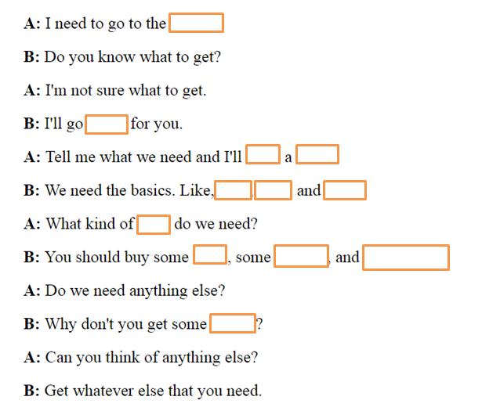
Dialog worksheet 1

Dialog worksheet 2
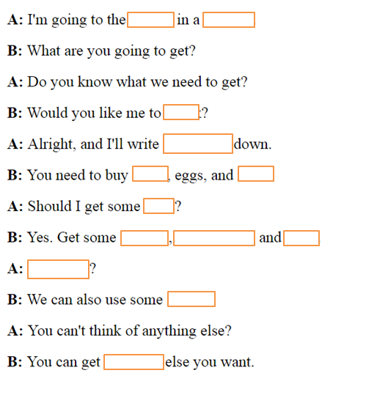

Comprehension workseet.

- Where does she want to go?
- Does she know what to get?
- So what does she do next?
- What are they going to get?
- Are they going to buy meat also?
- What kinds of meat are they going to get?

Picture for ground beef

