☐ Listening ☐ Speaking ☐ Reading ☐ Grammar ☐ Writing

Topic: Thanksgiving

Instructor:  Yejin Choi  (Anna) | Level:  Intermediate | Students:  6 | Length:  50 minutes

Materials: A picture of a turkey for eliciting
A picture of Native Americans for key words learning
Listening streaming URL
Vocabulary sheet (6copies+1)
Listening worksheet(6copies+1)
Extra question worksheet(1)
Script(6copies)
White board and board markers

Aims: To gain knowledge about American Thanksgiving
To practice listening to real-life speech of Americans.
To be able to talk about what they listened from the conversation.
To practice taking notes by listening
To learn new vocabulary
To practice speaking by talking about their own experiences of Thanksgiving

Language Skills:
Listening- the speakers’ conversation about Thanksgiving
Speaking- by answering to the questions & by having a discussion about what they do in Thanksgiving
Reading- their question handouts & script
Writing- by writing down answers to the questions

Language Systems:
Phonology- Pronunciation checking by speaking and listening
Lexis- Learning vocabularies
Grammar- Making their own full sentences to the following questions
Function- Having a discussion & answering to questions
Discourse- Listening to the conversation & reading a script

Assumptions:

Students already know:
- how the class is set up and run (there will be 2 student groups at each table)
- the teacher’s teaching style and the pace of the course
Students are not that familiar with American Thanksgiving
Students are Korean

Anticipated Errors and Solutions:
Students may not be able to pick up details from the listening
-Let them listen to the track again
If some students need more time to write down answers to questions
-give them 1~2 more minute to finish it
There could be students who do not volunteer to answer or talk
-Ask the question to those particular students first
If students finish their tasks earlier than anticipated
-Tell them to think about more possible answers

References:
https://www.podomatic.com/podcasts/info40650/episodes/2013-11-25T08_28_49-08_00
https://people.howstuffworks.com/culture-traditions/holidays-other/thanksgiving.htm

Lead-In
Materials:
A picture of a cooked turkey

Time | Set Up | Student Activity | Teacher Talk
3min | Whole Class | Answer to a question  Look at the picture  Guess and answer to questions | Good afternoon everyone. Did you all eat lunch before this class? Ok then, you might not feel hungry with this picture.  (show a picture of a cooked turkey & elicit)  What do you think this is?  When do you think people it this and where?  (write on the board what Ss say as answers)  Ok, so today, we will listen to a conversation which is about Thanksgiving Day. But before that, we will learn some new words the speakers use.

Pre-Activity
Materials:
A picture of Native Americans
6 copies of vocabulary sheet
Board & markers
Time | Set Up | Student Activity | Teacher Talk
10min | Whole Class | Listen to the teacher’s talk  Understand the key vocabularies | Words  There are 10 key words that we are going to learn. First, to explain the word ‘commemorate’, I will split this word to ‘com’ and ‘memorate’. ‘Com’ means together and ‘memorate’ is similar to the word ‘memory, memorize’.(word-building) So this word means to remember things by means of a special action, ceremony, or specially created object (definition)  <Teach 4 more words ‘pilgrims(definition), Native American(picture), harvest(demonstrate), religious(tell about religion and say it is an adjective form of the word religion)>  I will give you a handout which has the list of words that we just learned now.

Main Activity
Materials: Listening streaming URL
6 pieces of listening worksheet(for Ss)
Board & markers
Time | Set Up | Student Activity | Teacher Talk
8min  8min  8min | Whole Class  Whole Class  Whole Class  Individually  Whole Class | Pay attention to teacher  Answer to CCQs  Listen to the conversation  Answer to questions  Pay attention to teacher  Answer to CCQs  Take notes while listening  Listen carefully to the instruction  Write down the answers below each question  Speak out the answers to the questions | 1. Listening for the Main Idea (general understanding)  Instructions  Put your pens down. Listen to the conversation. Think about what you can realize from the conversation.  CCQ  Can you take notes?  What do you need to think about?  (Play the track)  Do you want to listen again?  (Yes- have them listen again  No- have them share their thoughts)  What did they talk about?  What else did you listen from the conversation about Thanksgiving?  2. Listening for Details  Instructions  Now let’s listen to the conversation again. Also please take notes while listening. Focus on the details and try to catch up all things.  CCQ  What do you need to do while listening?  What are you supposed to focus on?  (play the track)  Do you need to listen again?  (Yes- have them listen again  No- have them share their thoughts)  3. Answering to Questions  Instruction  Now I will give a work sheet which has several questions. There are also questions which have many possible answers so don’t get stressed to be correct. I will give you about 5 minutes.  (Give handouts to Ss)  CCQ  Is there only one correct answer for every question?  How much time are you given?  Now start!  (monitoring-vanish)  (Check whether Ss all finished theirs or not)  Did you all finish?  Ok then let’s check the answers.  No.1  What is American Thanksgiving for?  (ask rest of the questions)  (write down the answers on the board that Ss say)

Post Activity
Materials:
The script(6 copies)
Board & markers
Time | Set Up | Student Activity | Teacher Talk
13min | Pairs  Whole Class | Listen to the instruction  Tell your partner what you do or eat in Thanksgiving | Instruction  Now let’s talk about what you do or eat in Korean Thanksgiving day. For example, I help my mom preparing foods on Thanksgiving day.  Make a pair with a friend next to you  I will give you 5 minutes.  CCQ  For how long do you have a discussion?  What are you supposed to talk about to your partner?  Now let’s start!  (Monitor discreetly)  Ok time is over.  What did your partner say?  (all take turns to talk about what their partners said)  You all did well today. I will give you the script we listened to today. You can go home and read to check if there is something you missed.  (Hand out the script)  Well done! I hope you enjoyed today’s lesson and please feel free to ask if you have any questions. See you tomorrow!

SOS Activity
Materials:
A piece of paper with an extra question(one copy for T)

Time | Set Up | Student Activity | Teacher Talk
Extra time | Individually | Write down the question that teacher tells.  Read the question on the board and think about the answer | Student who already finished the worksheet, try think about the answer to this question.  (write the question on the board)

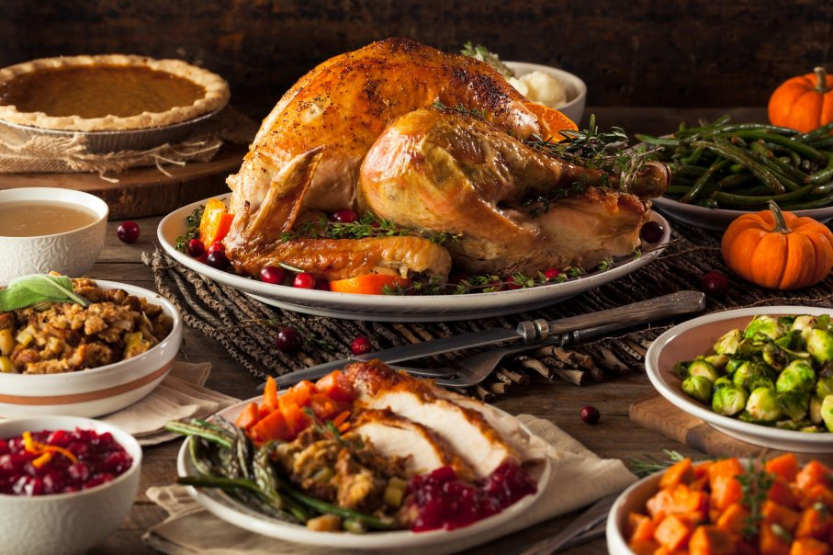

Thanksgiving

Marta: This episode is about THANKSGIVING.
Marta: Hey everybody, I’m so sorry but I have a cold! So, I have no voice- at all today. I think I’d better leave you with Cindy this time, right?
Cindy: Hey everyone! I’m here today with my friend Christine who’s an American artist living & working in Bologna, Italy. Hey Christine, thanks for being with us here today to talk about THANKSGIVING.
Christine: Hi Cindy, thanks for having me.
Cindy: Christine, what is THANKSGIVING?
Christine: American Thanksgiving, it’s a national holiday celebrated in November to commemorate the arrival of the Pilgrims to North America. They celebrated, with the Native Americans, the harvest.
Cindy: And when did it become a national holiday?
Christine: It first became a national holiday under Abraham Lincoln.
Cindy: Ok, let’s get to the good stuff- what was on that first menu?
Christine: That first Thanksgiving was celebrated in Plymouth Colony, which is now Massachusetts, and they had wild turkey, venison…
Cindy: …now, ‘venison’ is deer?
Christine: deer, yes….Indian corn, fowl…
Cindy: …and by ‘fowl’ you mean wild birds?
Christine: Wild birds.
Cindy: So, a pretty simple menu?
Christine: Yes, what they had at the time.
Cindy: Does any of that remain today, on the American menu?
Christine: Well, the most important part of the menu remains the turkey. So today we have the turkey and then the side dishes which are sweet potatoes, cranberry sauce, stuffing, gravy and for dessert: pumpkin pie.
Cindy: Alright, let’s explain ‘stuffing’ a little bit better. What is stuffing?
Christine: Stuffing, it’s seasoned, cubed bread and some people put it in the turkey, others leave it on the side.
Cindy: Is it mixed with any vegetables?
Christine: Yes, carrots, onions, celery.
Cindy: And I know in some parts of America they even put oysters into the stuffing.
Christine: Yes, let’s say depending on your family the recipe changes from family to family.
Cindy: Now, I know that Thanksgiving is very important to you and your family. How did you celebrate Thanksgiving when you were growing up?
Christine: It was very important, and it still is, to my family. But I would say that all Americans celebrate and that’s what makes it important because it’s not religious, it’s centered around food and being thankful. It has a set menu and whether you’re with family or friends- everyone celebrates.
Cindy: It’s not religious. It’s not a religious holiday.
Christine: No.
Cindy: I’ve spent a lot of beautiful Thanksgivings with my neighbors and friends. Now, how will you be celebrating Thanksgiving here in Italy this year?
Christine: This year, I’m going to have Thanksgiving dinner with Italian friends. So now I’m trying to gather all the authentic ingredients so I can make the meal. Cindy: Is it easy? Have you been able to find everything you need?
Christine: Well, in fact, the turkey is a problem because they’re quite large birds and I’m afraid it might not fit in the Italian ovens.
Cindy: You may have to cut it up! (laughs)
Christine: I think so! (laughs)
Cindy: (laughs) That’s good. And what other things will you have besides the turkey?
Christine: Sweet potatoes, I’ve found sweet potatoes. I’m looking now for cranberry sauce but I think I might have to use a substitute.
Cindy: There are some good substitutes out there. And what else? Are…will you have stuffing?
Christine: I’ll have stuffing. That’s easy to make. Also, pumpkin pie. I can find pumpkins here and I’ll roast it and make my own pie.
Cindy: Yum! Will you invite me? (laughs)
Christine: (laughs) Sure! Everyone’s invited, it’s Thanksgiving!
Cindy: Happy Thanksgiving, Christine.
Christine: Thank you, Happy Thanksgiving to you too.
Cindy: Thanks for being with us here today.

Thanksgiving

Vocabulary

commemorate – to remember things by means of a special action, ceremony, or specially created object.

The pilgrims - people who make a journey to a holy place for a religious reason

Native American - people from any of the many groups who were already living in North America before Europeans arrived

harvest - gathering of a crop

religious - connected with religion or with one particular religion

Thanksgiving

Questions

- What is American Thanksgiving for?

- When is Thanksgiving celebrated?

- When did Thanksgiving first become a national holiday?

- What is the important menu that remains today?

- Why do you think Cindy tried to explain more about ‘stuffing’?

- What can be the substitutes for cranberry sauce?

Extra Question

What do you want to do on following Thanksgiving day?

