Speaking
☐ Listening ☐ Speaking ☐ Reading ☐ Grammar ☐ Writing

Topic: My life experiences

Instructor:  Oh seung eun  (Lisa) | Level:  High intermediate / advanced | Students:  6 | Length:  50 minutes

Materials:
Key vocabularies handouts (6copies)
Speaking worksheets (6copies+1)
A white board and some board markers
Lots of pictures about many kinds of experiences
(about a birthday, an anniversary, a graduation)

Aims: Ss will be able to learn about the present and past perfect tense while they are having questions and answers each other
Ss will speak in pairs by sharing their experiences
To practice how to speaking well by talking each other about their own experiences
To be able to talk and speak
To learn new vocabularies and grammar
To become familiar than before with classmates

Language Skills:
Listening- teacher’s for example of key vocabularies, the classmates’ experiences, their questions, and other Ss’ answers
Speaking- ask and answer during they are talking (Q&A)
Reading- worksheet questions (Q&A worksheet)
Writing- notes their partner’ answers for their experiences in the questions

Language Systems:
Phonology- to check correct pronunciations
Lexis- to learn the key vocabularies
Grammar- present and past perfect tense
Function- to ask for their experiences and to get their own information
Discourse- to talk each other with their classmates and to speak and to listen about their experiences

Assumptions:
Students already know how the class is set up and run
The teacher’ teaching style and the pace of the course
Ss are not know well about classmates’ experiences
Some Ss may already know the vocabulary and past & present perfect tense
Ss like to talk about their experiences
Speaking
Anticipated Errors and Solutions:
If one of my students are absented, make 2 groups – one for 2pairs, another for 3pairs
Some Ss may not be active in talking time
- encourage S by asking for his/ her opinion
If some students need more time to talk
- give them 1~2 more minutes to finish it
Students might be do not want to volunteer about the answering or talking
- Ask a particular student first if he/she want to
Ss might be to finish their tasks earlier than the teacher was expected
-Let them to think about more their experiences and the teacher prepare an extra sheet(sos plan) Let them it in spare time.

References:
www.oup.com/elt

https://search.naver.com/search.naver?where=image&sm=tab_jum&query=interesting+place
https://search.naver.com/search.naver?sm=tab_hty.top&where=image&query=celebration&oquery=interesting+place&tqi=TFiPGlpVuERssul8Kxsssssst1C-385648
https://search.naver.com/search.naver?sm=tab_hty.top&where=image&query=%ED%8A%B9%EC%9D%B4%ED%95%9C+%EC%A7%81%EC%97%85&oquery=celebration&tqi=TFiQzlpVuEKssu1U%2BvRssssssVG-036029

Speaking

Pre-Task
Materials: white board, board makers, a picture of Singapore,
Pictures about past events, anniversary, experiences
Time | Set Up | Student Activity | Teacher Talk
1min | Whole Class | Answer to a question  “Singapore!!  Most No or Some Yes  A: Experiences! | Greeting our students : Hello everyone. Welcome to my speaking classroom. Today I’m gonna show you this picture first. (Show them a picture of Singapore.) Where is it? (elicit this picture) Have you ever been to Singapore? I’ve been to Singapore. I went to there 2 years ago with my friend. This is one of my experiences.  (CCQ: What did I say?)  Ok, so today, we will talk about our experiences But before that, we will learn some new words and grammar.

Task-Preparation
Materials: 6 copies handout of vocabulary meaning and grammar pattern, some pictures about 3 key vocabularies, a laptop
A board & some markers
Time | Set Up | Student Activity | Teacher Talk
2min  7min | Whole Class | Listen to the teacher’s talking  See these pictures from the laptop  A: McDonald, bench.  A: fun! Interesting!  Listen and answer  Speak  A:These are “celebration”  Answer  A: “unusual”  Answer  Check to 3 keywords meaning  Understand to the key vocabularies  Check past present perfect out and the pattern (in grammar)  Answer : “You’ve been to Singapore.” | I’m gonna show you some pictures. Look at this. Elicit about 3 key vocabularies  There are 3 key words that we are going to check. First, (show some pictures) what is this picture mean? So, If you sit here, what are you going to feel? Are you going to feel sad? or fun? This bench is so interesting place. So first key word is “interesting” Can you tell me what it means? And Has anyone heard of this word? (Show other picture about “interesting”)  And next, (show some pictures) what are these pictures mean? Has anyone heard of this word? Can you tell me what it means? (CCQ: What kinds of celebration did you have? Did you remember the best celebration?) and next (show pictures) what are these pictures mean? Has anyone heard of this word? Can you tell me what it means? (CCQ: Have you meet the unusual person? Which person is the most unusual person that you have met?)  I will give you vocabulary handout. (Here you go) and we can also check this pattern(grammar) out. When you have asking and answering it about your classmate’ experiences, you need to use this pattern. “I’ve been to (a place)” That means “I’ve visited ( a place)” For example, In my experiences, what did I say? Where was I?  Yes, “I’ve been to Singapore.” so you can use this pattern. “I’ve been to(a place).
Speaking
Task-Realization
Materials: 6 copies worksheet of speaking (for Ss)
Board & markers
Time | Set Up | Student Activity | Teacher Talk
5min  25min | Whole Class  each  2pairs  whole  class  2pairs  i | Pay attention to teacher  Read and think about their experiences.  Note it on their worksheet.  Answer to“2things”  Answer to Yes  Make 2 pairs in a group  Practice to speaking  Make 2pairs in a group.  They can make 3 groups in a classroom.  (for example Here is little lisa in a classroom)  Hands “lisa” up.  Q:What’s the most interesting place that you have visited?  A(lisa):The most interesting place I’ve been to is… (read it)  Listen and see them (Teacher and a volunteer’ demonstration)  Write some notes on their worksheet  Speak each other.  Listen to partner’ talking(speaking) about their experiences | 1.Let’s think about your own experiences first  Instructions  I’m going to give these worksheets for you. Let’s read these questions and think about it. How long time do you need to think about these questions?  CCQ : Can you make notes about the followings?  4 and 5 questions need 2things about you have done and you have not done.  (CCQ : How many things need in 4 and 5 questions?)  CCQ : Do you need more time to read?  ( more 1min) - monitoring  CCQ : Did you finish to make your notes?  2. Work with a partner. Ask and answer questions about your experiences  Instructions  I’m going to make 2 pairs and work with your partner.  Ask and answer questions. And some notes your partner’ experiences.  For example; who want to be my partner?  First one,  Q: The most interesting place that you have visited (teacher read it)  Ask me, lisa!  A(lisa):What’s the most interesting place that you have visited?  B(teacher):Well, I’ve been to India. I went there three years ago with my brother. We visited the Taj Mahal. What about you?  A(lisa):The most interesting place I’ve been to is…..  This was a for example.  Notes your partner’ answers on it. Let’s go. Do it.  (Monitor them)
Speaking
Post-Task
Materials: Notes, a white board & some markers
Time | Set Up | Student Activity | Teacher Talk
10min | Whole  class | Listen and speak  Discuss about what is the most impressive answer.  Find out the most impressive answer  Develop rapport  Know each other deeply than before  A: Have you ever been to ( a place?)  B: I’ve been to ( a place). | Ask one by one about their partner’ answer.  Read number1. The most interesting place that you have visited. “What’s your partner’ answer?” “What is the most impressive answer when you heard of your partner’ experiences?”  Write the most impressive experience on the board. (feedback and error correction)  And lastly, we are going to make a sentence to use “I’ve been to (a place)” Make a sentence and ask your partner.(practice to speak each other)  One by one  Good job! I hope you’re enjoyed today and please feel free to ask if you have any questions. See you~
Speaking
SOS Activity
Materials: A piece of paper with an extra question (copies 6), a pen
Time | Set Up | Student Activity | Teacher Talk
Extra time | Individually | Think about own time capsule  Write down their thoughts on the paper.  Think about it and Write  Think and discuss together.  Speak their thoughts | Student who already finished the worksheet, try think about the answer to this question (our time capsule).  If one student is done it, I will give an extra sheet for him/ her about “Time capsule” and Let him/her think about in these blanks. And fill in the boxes. Think own thoughts.  Give them a “Time capsule” paper.  Instructions: Do this until other students are finished. Think about it. And speak later  Let him/her it.  If two students are finished early, I will give them these papers and they (make 2pairs in a group) decide together what to include in this time capsule box.

Pictures of key vocabularies Teacher can use a screen in the classroom
Speaking

Key vocabulary Show pictures and Elicit these
interesting place

celebration

unusual

Singapore (one of a teacher experiences)

Key vocabularies
Speaking

interesting – If you find something interesting, it attracts your attention, for example because you think it is exciting or unusual.

Celebration – A celebration is a special enjoyable event that people organize because something pleasant has happened or because it is someone’s birthday or anniversary

Unusual – If something is unusual, it does not happen very often or you do not see it or hear it very often

Grammar pattern

- I’ve been to ( a place ) means
I’ve visited ( a place )
EX) I’ve been to India. I went there three years ago.

**You can use this pattern.**
That was one of the ( best celebration ) I’ve ever.
I’ve had a lot of experiences ( about … ).
I won’t be able to ( )
Questions & Answers
Speaking

A. Think about your own experience

- The most interesting place that you have visited

- The best celebration that you have ever had

- The most unusual person that you have met

- Two things that you have done that you feel good about

- Two things that you have not done but would like to do

- One thing that you have done and that you do not want to do again

B. Work with a partner. Ask and answer questions about your experiences. (practice to speak)
Speaking

1. The most interesting place that you have visited
2. The best celebration that you have ever had
3. The most unusual person that you have met
4. Two things that you have done that you feel good about
5. Two things that you have not done but would like to do
6. One thing that you have done and that you do not want to do again.

- EX) A: What’s the most interesting place that you have visited?
B: Well, I’ve been to India. I went there three years ago with my brother. We visited the Taj Mahal. What about you?
A: The most interesting place I’ve been to is ….

- EX) A: What’s the best celebration that you have ever had?
B : My university graduation. Because I received congratulations and many presents from family and friends and my boyfriend. What about you?
A: My best celebration is the last Christmas party. Because…

Sos plan
Speaking
Time Capsule
- Decide what items to put in a time capsule. Choose items that best describe what life is like now where you live. Discuss different ideas for each category and decide it together what to include.

- Pretend it’s the future, 100years from now. Exchange “time capsules” with another member and group. Describe what life was like in the past for the other group or member(classmates).

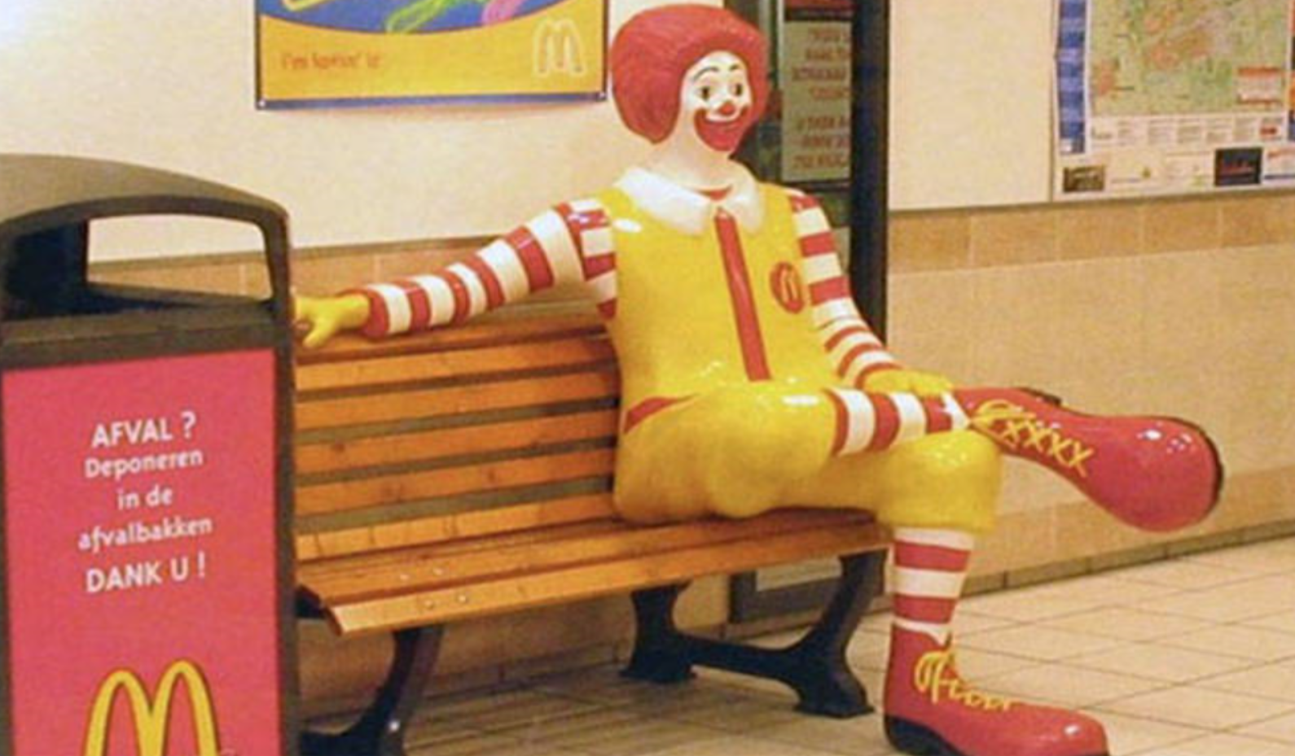
Speaking
Japan is truly the oddest and most interesting place on earth
In Japan,”Ronald Mcdonald” is called “Donald McDonald”
Because of the lack of a “R” sound

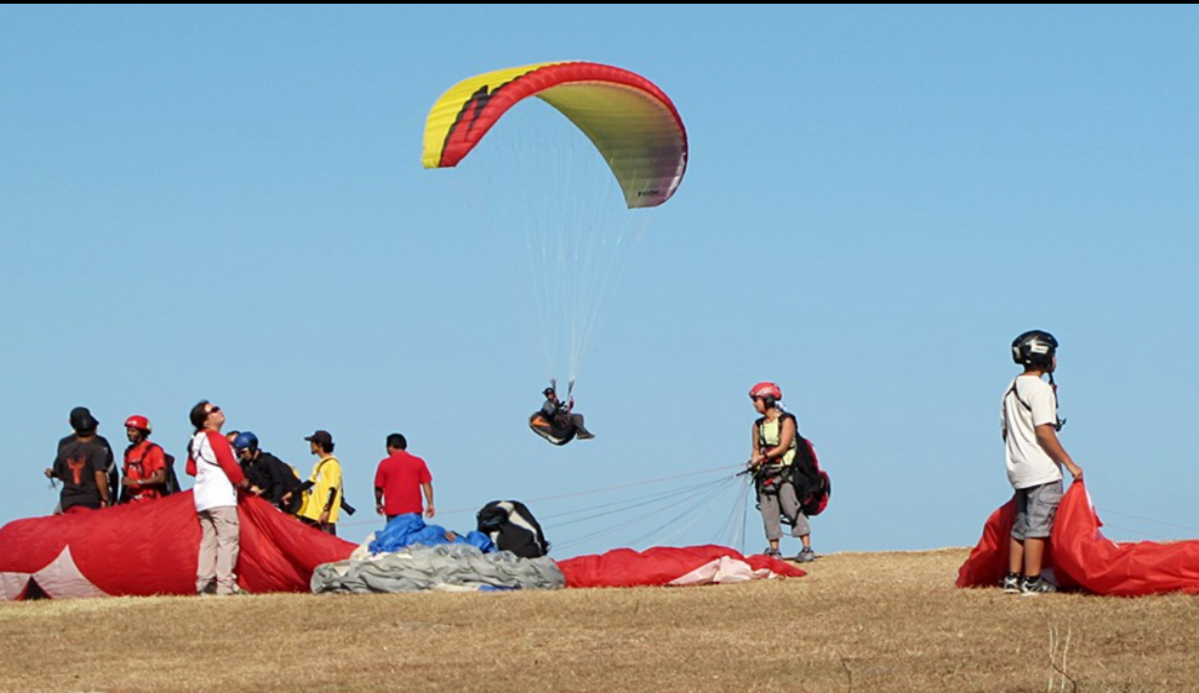
Speaking
Interesting place in Bali- Paragliding Tandem Introductory in Bali

Speaking
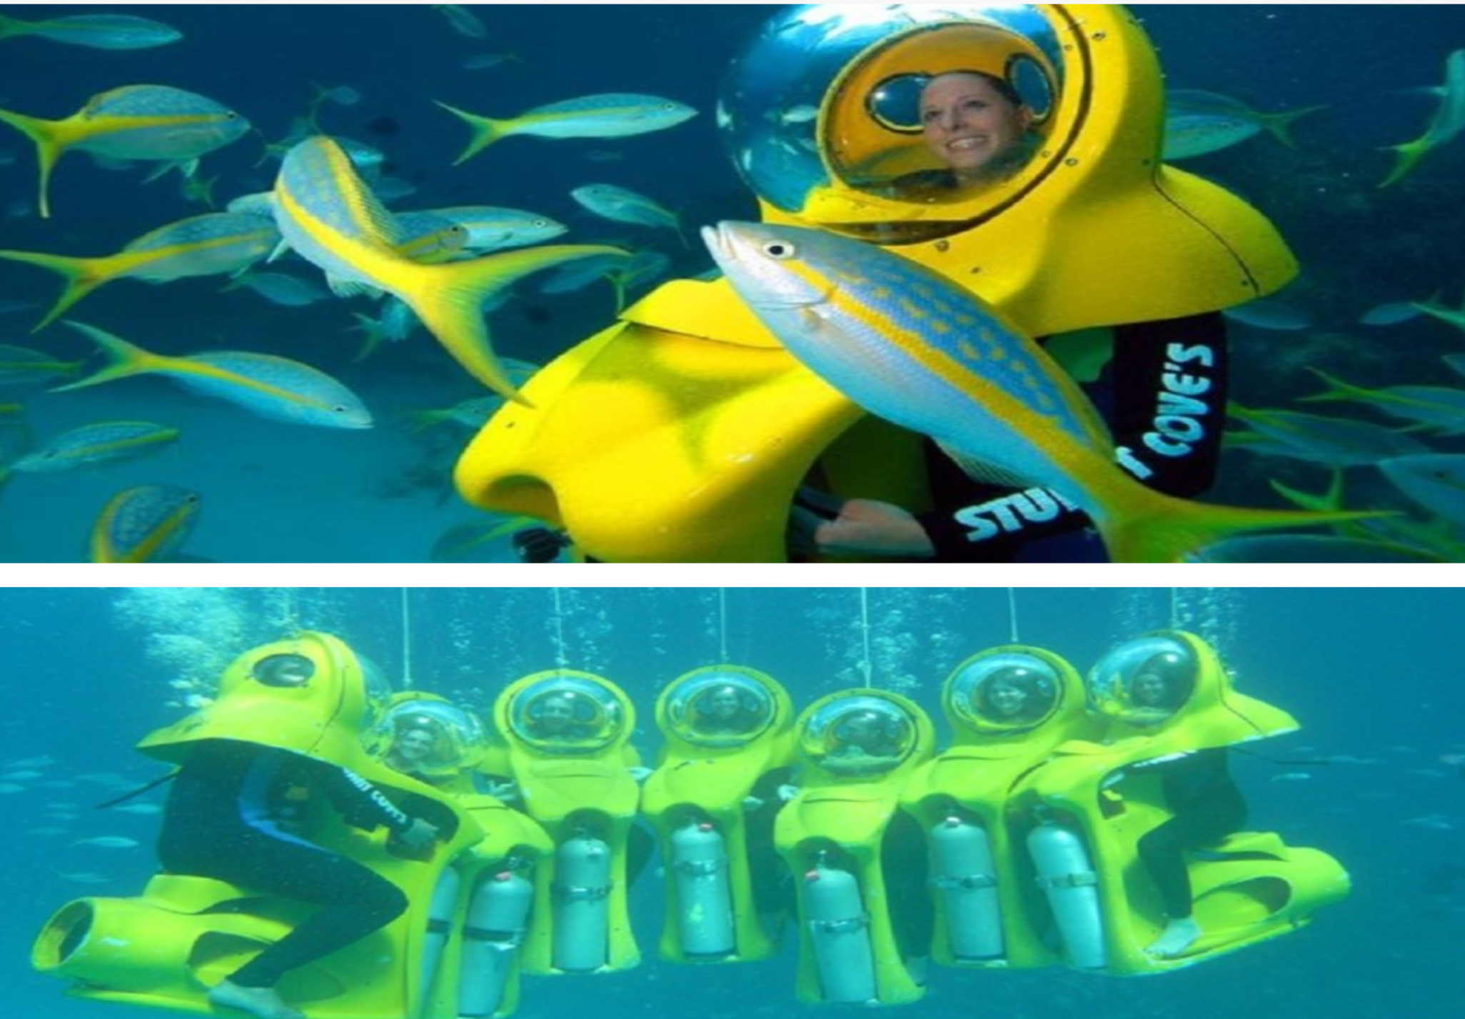
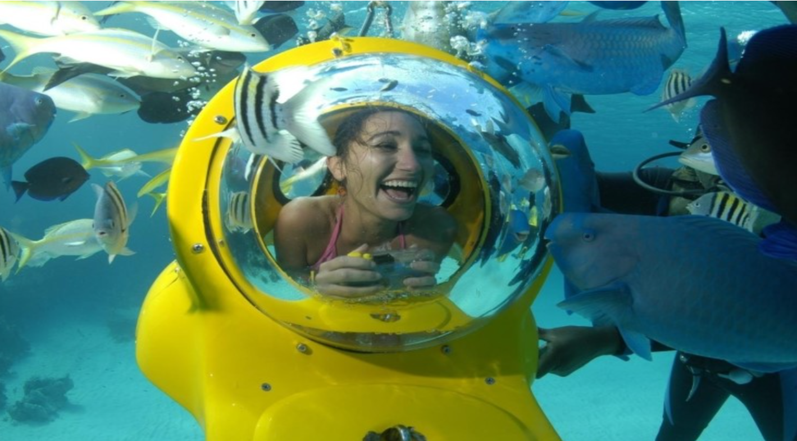

Submersible submarine Scooters game in the Bahamas Nassau (a capital of the country) – Caribbean Sea nearby Cuba
Speaking

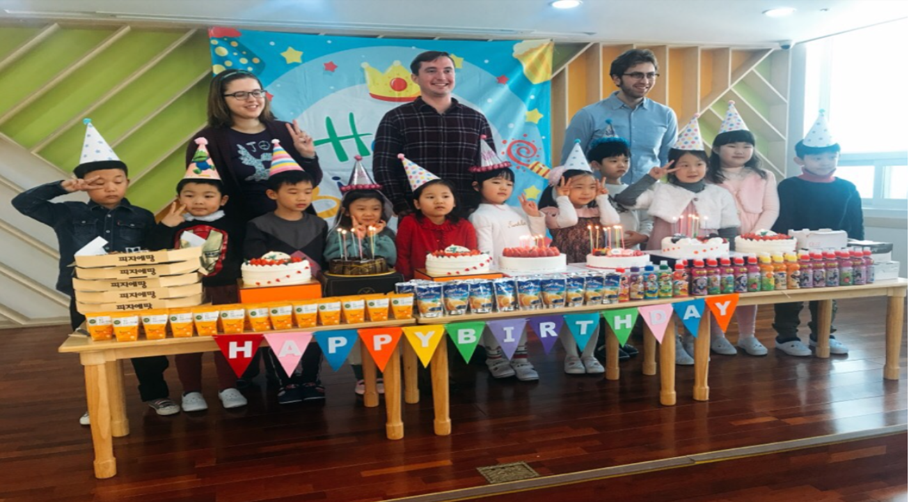
Speaking
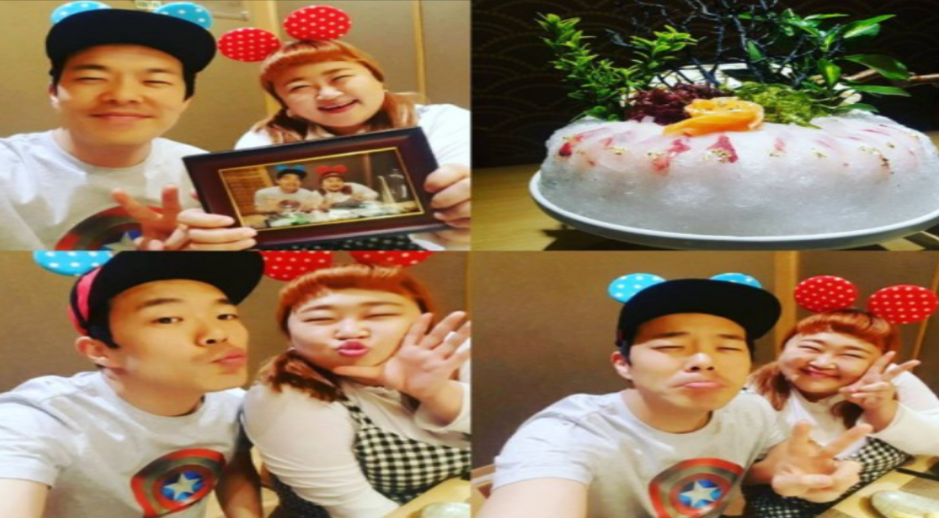

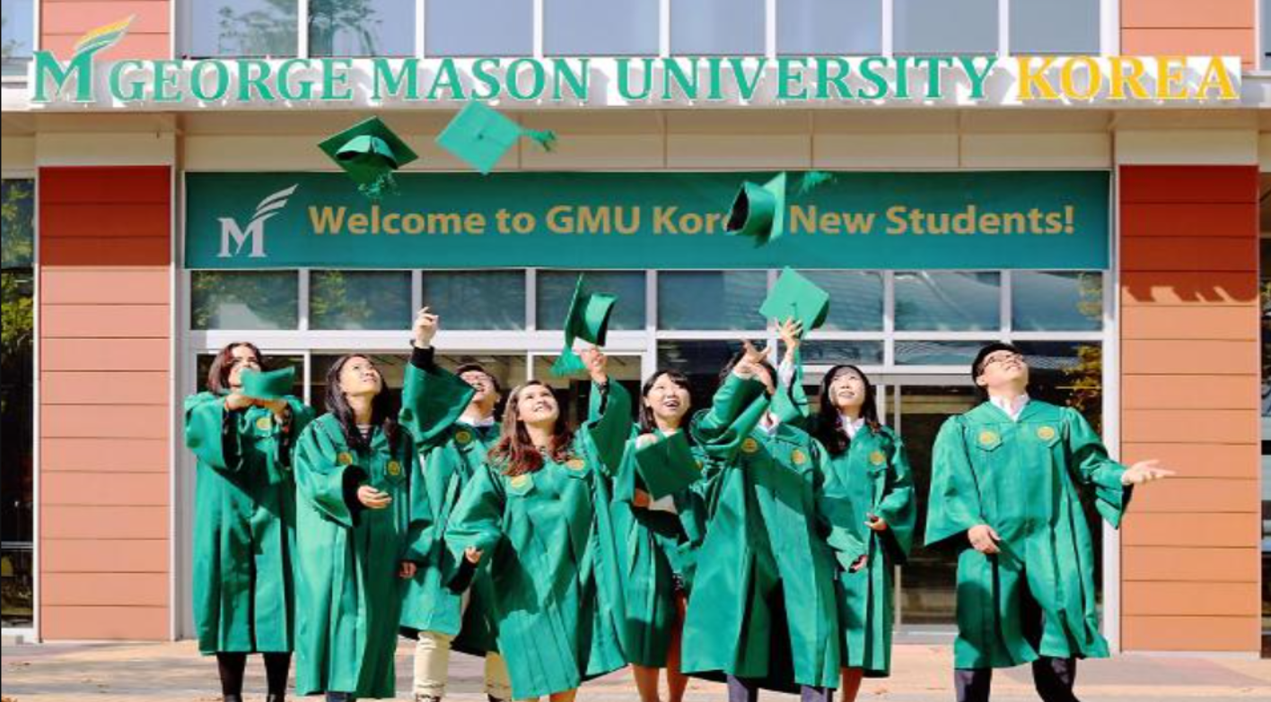
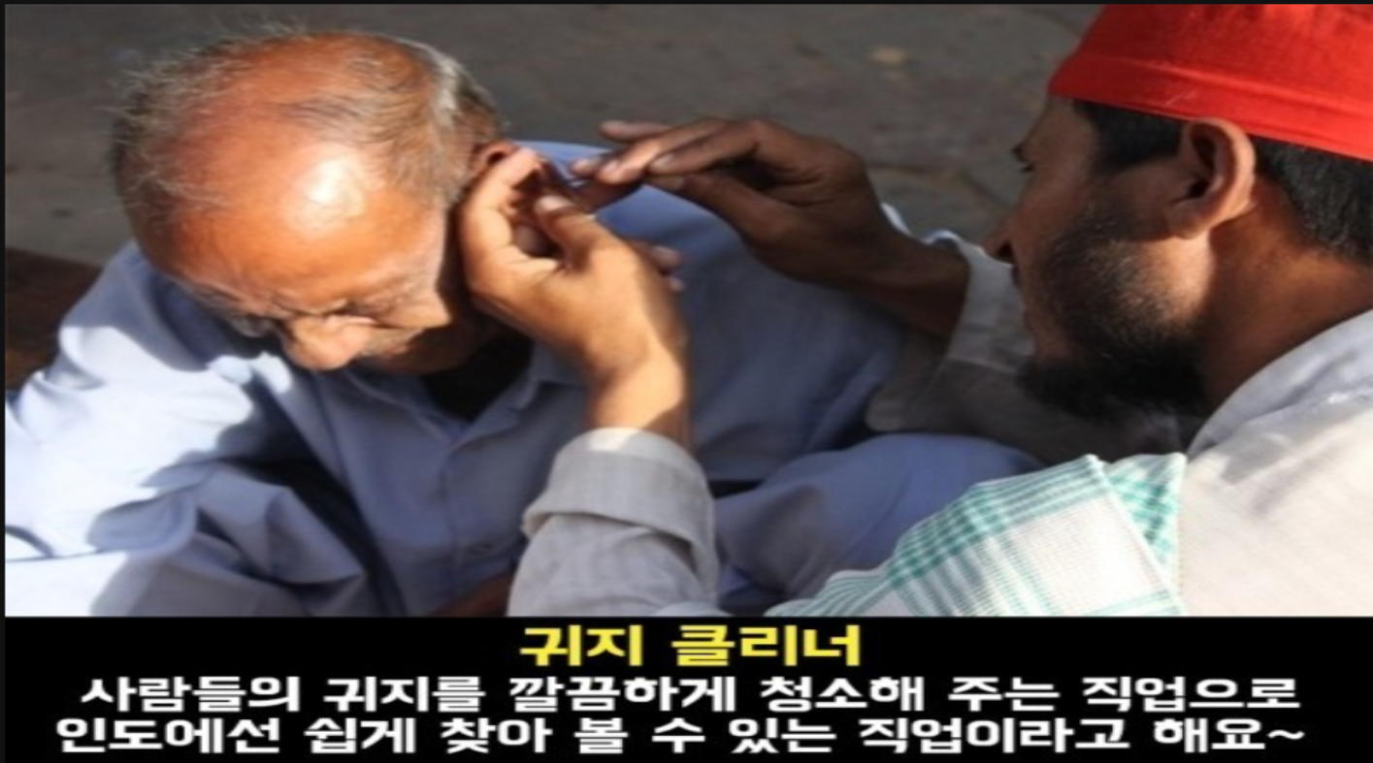
Speaking

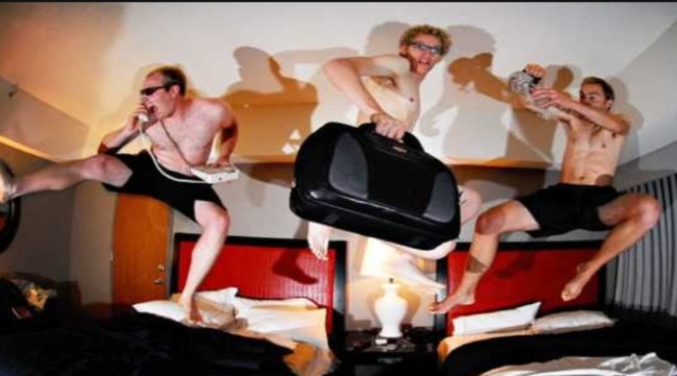

Speaking

Speaking

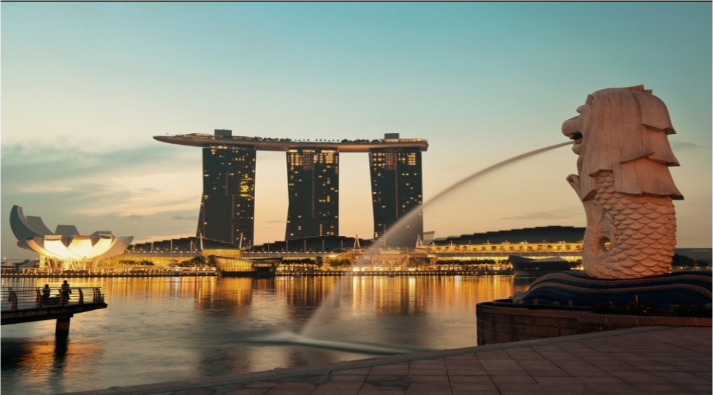
Speaking

