☐ Listening ✓Speaking ☐ Reading ☐ Grammar ☐ Writing
Topic: Human rights issues in the DPRK

Instructor:  Han Sin (Warren) Kim | Level:  Intermediate | Students:  6 | Length:  40 Minutes

Materials:
A desktop computer to access into YouTube.
A desktop computer to access viewing images.
White board, board markers and an eraser.
Video clips from YouTube.
A phonogram cards or List of key vocabularies.
Flashcards for note-taking.

Aims:
To improve speaking skills for students
To improve listening skills for students
To improve student’s comprehension skills.
To be able to explain and discuss about the topics they’ve learned.
Students are able to work cooperatively in a group or pairs by sharing their ideas and thoughts.

Language Skills:
Reading: read dictation notes and note-taking notes loudly with partner.
Listening: the
Speaking: by answering questions after listening & by having a discussion about it.
Writing: by writing down answers to the questions and from notes

Language Systems:
Discourse: Listen, watch video clips & read their notes.
Function: Having group or pair discussion & share ideas with teacher.
Grammar: Make a full sentence when writing down the ideas and information.
Lexis: Lean new vocabularies from video clips.
Phonology: Check student’s pronunciation, accents, and intonation by speaking and listening.

Assumptions:
Assumptions:
- Students are confident with pair and group work.
- Students already know the teacher’s style of teaching and pace of lecture.
- Students are aware to speak only English in the class.
- Students are unfamiliar with the human rights issues in the DPRK.

Anticipated Errors and Solutions:
- by writing down answers to the questions and from notes to check errors to correct them.
- If students ever find it difficult in listening from video clip. Have students listen them over time.
- When students are unable to understand details from video clip. Use chunk the speaking (Play over time).
- If students need more time to finish their main activity (cut-off plan). Cut the post-activity.
- If student finish their activity early (SOS plan)
Make students to listen and discuss one more time and have them organize their thought about it.

References:
http://www.ohchr.org/EN/HRBodies/HRC/CoIDPRK/Pages/CommissionInquiryonHRinDPRK.aspx
http://www.ohchr.org/EN/pages/home.aspx
https://www.hrnk.org/events/congressional-hearings-view.php?id=13
https://www.hrw.org/world-report/2017/country-chapters/north-korea
https://en.wikipedia.org/wiki/Human_rights_in_North_Korea
http://legalinsight.co.kr/wp-content/uploads/2013/10/%EC%98%81%ED%99%94%ED%81%AC%EB%A1%9C%EC%8B%B1.jpg
http://cfile1.uf.tistory.com/image/233AF642530C34D52F67E1
https://www.merriam-webster.com/
https://www.youtube.com/watch?v=K-cCjqak54Q

Pre-task
Materials: Pictures of people in the DPRK (North Korean).

Time | Set Up | Student Activity | Teacher Talk
4 Min | Whole Class | Students are expected and prepared to listen.  Look at the picture.  Guess and answer to questions | Greeting  Good morning everyone?  How are you today?  How was your weekend?  Well. Isn’t it cold today? It’s freezing outside.  Eliciting  Have a look at these pictures here.  What do you all see here?  What do you all think when you look at these pictures?  What do you think people’s emotions are like?  Why do you all think these people are being treated like this?  As you all know people in these pictures are depressed.

Task Preparation
Materials:
Use the phonogram cards or writing vocabularies on the white board. (Key Vocabularies)
After teaching key words. Hand out a list of vocabularies.

Time | Set Up | Student Activity | Teacher Talk
5 Min | Whole Class | Students are expected to learn new vocabularies before the class.  Listen and pay attention to the teacher.  Discover and understand key vocabularies.  As T explains, Students are expected to listen and learn new vocabularies to use it helpful to understand the concept of topic. | So. Today we’re going to learn new vocabularies that I think it’s vital for us to learn before we watch video clip from online.  There are 5 key words. First, I will explain the word ‘accountability’ and is similar to the word ‘account’, “accountable’. (word-buliding). So this word means “willingness to accept responsibility or to account for one's actions” (Definition)  Teach 4 more words  ‘coincidence’ (Definition), ‘flinching’ (demonstrate), tragedy (is a very sad, unfortunate, or upsetting situation. Something that causes strong feelings of sadness or regret). ‘contributing’ (Definition).  As teacher finishes explaining vocabularies, hand out a list of vocabularies (sheets).

Task Realization
Materials:
White board, board makers & an eraser.
Video stream (clip) from YouTube.
Notes for note-taking

Time | Set Up | Student Activity | Teacher Talk
10Min | Whole Class | Listen to teacher’s instruction  Listen to the teacher with full attention.  Students are watching the video clip from YouTube | Instruction  Now we’re going to watch and listen to the video clip that I’m going to show you in a minute.  Please use the vocabulary list that I’ve given to you. Use that list to write down (Note-take) things that you might think it’s important to you from the clip.  If you find difficult to listen, please let me know. I’ll hand you out a script for you.  Play the clip.  Monitor students and prepare for the upcoming activity.

Post Activity
Materials:
White board, board makers & an eraser.
Video stream (clip) from YouTube.
Note-taking notes & scripts

Time | Set Up | Student Activity | Teacher Talk
3Min  10 Min  5 Min | Whole Class  Pairs  Whole Class | Listen to the teacher with full attention.  Students will discuss as the teacher asks them to  Students will share their thoughts and ideas to classmates. | If students are not ready to discuss about the topic. Have students watch the clip once again to comprehend.  After the clip have students discuss about it in pairs.  Have students to share their thought and ideas with them including teacher.  Teacher will ask some of the questions about the topic.  - What did they do in that council?  - What were they talk about in that council?  - What were the things that happened in the DPRK?  - What are your opinion about the human rights issues in the DPRK?  - What are some of the solutions do you think it’s crucial to change for North Korean people?  More questions if needed.  Did you all enjoy my class today?  I hope you liked my class today!  Have a good rest of the day!  Thank you all very much!

SOS Activity
Materials:
Scripts of video clip.
Notes for making sentences

Time | Set Up | Student Activity | Teacher Talk
3Min | Individual | Students will make a sentence out of the list. | Teacher ask students to use the script and vocabulary list for students to make a full sentence out of one vocabulary in the list that is related to the human rights issues.  Have students to speak out loud to share student’s sentences to improve their speaking skills.
Human rights issues in the DPRK.

These are vocabularies from the stream. And the new vocabularies to comprehend.

- Accountability (noun) – a willingness to accept responsibility or to account for one's actions.

- Coincidence (noun) - a situation in which events happen at the same time in a way that is not planned or expected

- Flinching (verb) – to move suddenly because you are afraid of being hit or hurt. Or to show fear and to hesitate from doing something unpleasant or dangerous.

- Tragedy (noun) - is a very sad, unfortunate, or upsetting situation. Something that causes strong feelings of sadness or regret.

- Contributing (verb) - to give (something, such as money, goods, or time) to help a person, group, cause, or organization.

Some pictures of people in the DPRK
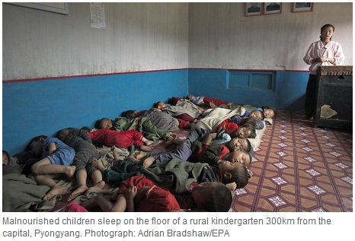

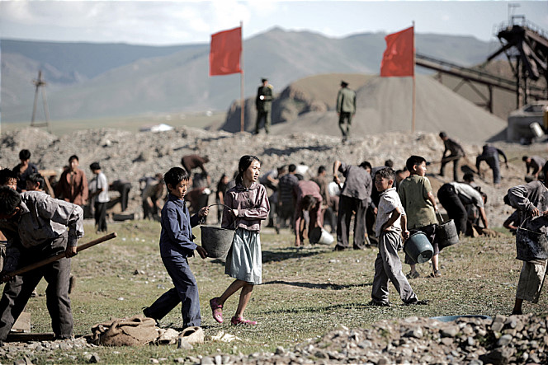
A script of United Nations Security Council on North Korean human rights
Elapsed time: (8:09 minutes) 1:34:47~1:42:56.
Point: 1:39:53~1:43:00
Mr. President, I’d like to express appreciation to the Chart Presidency for convicting today’s meeting on the situation in the DPRK. We also thank (Mr. ) for their briefings on the human rights situation in the DPRK. It is unfortunate that despite the International Community’s efforts to address the human rights issues of DPRK over several years. The situation has continued to worsen. Ultimately warranting the Security Council’s attention.
Earlier this year, commission of inquiry issued its landmark reports that raise international awareness on the gravity of the human rights situation in the DPRK. Following the reports released, we at the “United Nations” have dealt with the issue in the Human Rights Council and in the General Assembly. While the General Assembly has adopted multiple resolutions since 2005 on the human rights situation in the DPRK. This year’s resolution was unique. In that it contained recommendations on the council’s role in these efforts.
Therefore, the council’s decision to place the situation in the DPRK on this agenda. It is a necessary starting point for further discussion and engagements. Such engagements are crucial as we now understand the human rights violation in the DPRK. To be so systematic and wide-spread that they not only cause mass suffering among North Koreans, but also pulls the threat to regional and international peace and security.
The council has taken necessary measures in other cases in the past. Where human right’s violations will commit on a large scale to constitute the threat to peace and security. Likewise, the council needs to pay due attention to the grave situation in the DPRK. In this regard, we would like to stress the COI’s conclusion. That many of the violation found in the DPRK, amounted to crimes against humanity. It also recommended that the council play a crucial role in ensuring accountability including through considering refer of the DPRK’s situation to the international criminal court.
In addition, my government takes serious note of the announcement of the U.S. governments. On December 19th that North Korea carried out the cyber acts on “Sony Pictures Entertainment” and posed threats to movie theaters which also mentioned in Mr. Jerru’s briefing earlier. In this regard, we would like to express deep concern over such acts which seriously undermine the optimists and security of the cyberspace and escalating international tension.
Mr. President, we believe that addressing the North Korean human rights issue is vital not only promoting human rights as universal value, but also in maintaining peace and stability in the Korean Peninsula and in the region. In this context, the Republic of Korea has been working together with the international community to improve the human rights situation in the DPRK and to provide the assistance to the North Korean people. We will redouble these efforts in the coming years. We urged authorities of the DPRK to take steps to improve their human rights situation. As the DPRK previously expressed the willingness to do so. We hope that Pyongyang will begin engaging with the international community through human rights dialogues including with the special petrol in the situation of human rights in the DPRK and through technical cooperation with the “OHCHR”.
In closing, the Republic of Korea hopes that this council will continue to play a vital role in insuring that North Korean people will eventually be able to enjoy their in-alien of human rights and fundamental freedoms.
Mr. President, speaking at this meeting is probably my last duty in the Security Council. When we first came to the council two years ago, one of the first issues we tackled was the DPRK’s missile and nuclear issues. In the council, my country has dealt with many issues. We are not party two with the view to contributing to the work of the council. Yet somehow, our term on the council studied in these ending with the North Korean issue. This must be just coincidence, but I’m saying this with a heavy heart. Because for South Koreans people in North Korea are not just “any bodies”. Millions of South Koreans still have our family members and relatives living in North. Even though we never hear from them. Even though by now the pain of separation has become a cold factor of life. We know that they are there. Just a few hundred kilometers away from where we live. We cannot read what is described in the “COI” reports. Without it, breaking our hearts. We cannot watch video clips from North Korea without flinching every scene. We cannot listen to stories of North Korean defectors without sharing in their tears. Without feeling as if we are there with them experiencing the tragedies.
Therefore Mr. President, as we leave the council with the debate on the DPRK’s human rights. We do it whole heartedly with another to wish. With another to wish for people in North Korea. Our innocent sisters and brothers on the street in the country side. In the prisoner’s camp who are suffering for no reasons. We only hope that one day in the future when we look back on what we did today. We will be able to say that we did the right thing for the people of North Korea. For the lives of every man and woman, boy and girl who had same human rights as rest of us.
Thank you.

