☐ Listening ☐ Speaking v☐ Reading ☐ Grammar ☐ Writing

Topic: No sleep

Instructor: Grace | Level: Basic | Students: 10 | Length: 30min

Materials:

- 10 copies of the text “ No sleep”
- 10 copies of the crossword worksheet
- White Board and markers
- computer

Aims:

- Ss will be familiar with key Vocabulary through T’s explanation and CCQ
- Ss will be able to understand about the text by scanning the reading text and answering a guiding question
- Ss will improve scanning skill by answering the questions and crossword worksheet
- Ss will improve listening ability by listening T’s explanation.

Language Skills:

- Reading : Reading text “No sleep” / worksheet
- Writing : writing for the crossword worksheet answer
- Listening : Listening T’s explanation

Language Systems:

- Lexis :writing some words for the crossword answer
- Function : answering the crossword question

Assumptions:
- Some Ss may already know all the words
- Ss may know about the fact that some animals or insects do not sleep
- Ss know how to scan the text

Anticipated Errors and Solutions:
- Some Ss may not know some words
Explain and use CCQ for some words
- Ss may not understand the content
Make Ss Work with small group or pair
- Some Ss may finish the main tasks earlier than others
Share the answer with whole class

References:
http://www.eslflow.com/wp-content/uploads/2017/10/no_sleep.pdf

Lead-In
Materials: white board and markers
Time | Set Up | Student Activity | Teacher Talk
5min | Whole class | Ss share the answer | Hello every one. Good afternoon.  Aren’t you guys tired now?  (Random S) What time did you go to bed last night? (Ex. 1am or 2am)  What about you Minjeong? (Ex. 2am)  Ah,, you must be tired now.  Eliciting question  Do you sleep? (yes) Do I sleep? (sure)  Do you think is there any animals or insect which do not sleep?  (Make Ss Name them for the answer)  Do you think we can survive without any sleep? ( Ss answer no/ maybe)  Let’s find out some information.

Pre-Activity
Materials: white board and markers, copies of worksheet
Time | Set Up | Student Activity | Teacher Talk
5min | Whole class | Ss listen to the T | Ok. First I am going to tell you the short story. Please listen carefully.  Minjeong watched TV until 2 a.m. last night. Her mother ordered her to go to sleep, but she said that sleeping wasted her time. Then her mother told her a story.  CCQ  What time did she go to bed? (2am)  What does she think about sleeping?  (sleeping wasted her time)  I will give you this copy of the story that Minjeong’s mother told her.

Main Activity
Materials: computer, story worksheet
Time | Set Up | Student Activity | Teacher Talk
5min  5min | Individually work  Group work | Read the text  Share the information after reading a text | I will give you 5mins to read this text. Also I will give you some definitions of the words just in case if you don’t know.  Please refer to the computer for the meaning of the words.  CCQ  How much do we have time? (5mins)  After 5mins  Ok. Time’s up.  Now I want you to make a small group each 3 of you.  Please summarize any information or fact that you found out through this content.  I will give you 5mins!  After 5mins.  Ok please tell me any facts.  Group 1, what did you found out?  - Write the answer on a board  Group 2, what did you found out?  - Write the answer on a board  Group 3, what did you found out?  - Write the answer on a board

Post Activity
Materials: cross worksheet, white board and marker
Time | Set Up | Student Activity | Teacher Talk
5min  5min | Individually work  Whole class | Do the crossword worksheet  Share the answer | Now I will give you crossword worksheet.  I guess you can get all the answers through the text.  I will give you 5mins to compete this worksheet and let’s share the answer together.  Ok, time’s up. Let’s share the answer.  (write the answer on a board)  Yes. You guys did a really good job today

No Sleep

Have you ever heard that some animals and insects do not need any sleep? Butterflies, flies, and golden fish are examples of species which do not sleep every day. At times we see them being stationary, but this does not mean that they are sleeping. Their body temperatures decrease, and as a result they can not move. Is it surprising? What about us? Do you think that we can survive without any sleep? One woman in England broke the world record by not sleep for eighteen days and seventeen hours. According to doctor advice, people, in fact, will die if they do not sleep for more than five days. If we do not get enough sleep, we will feel tired and dizzy. In addition, our health will deteriorate. However, many children like playing computer games and watching TV until late at night. When they go to school, they are very sleepy and do not have enough energy to pay attention to the teacher in classes. Adequate sleep is very important for us. Children, please be smart and go to bed early from now on.

Species: a kind of sort
Stationary: not moving
Advice: opinion given about what to do or how to behave
Dizzy: unable to balance; confused
Deteriorate: become worse in condition
Adequate: sufficient and enough

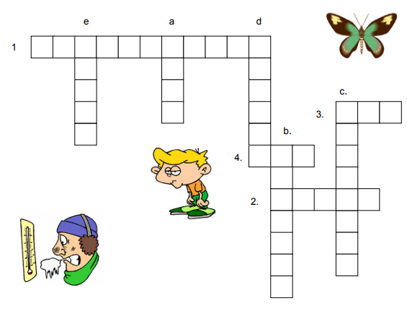
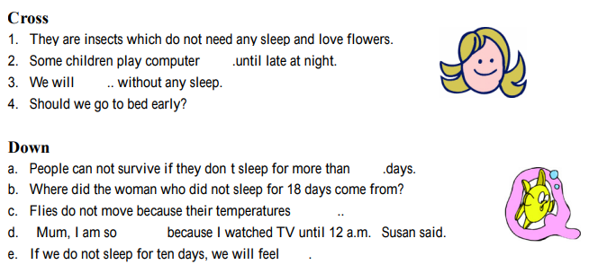
- crossword worksheet

