Mona Lisa’s popularity
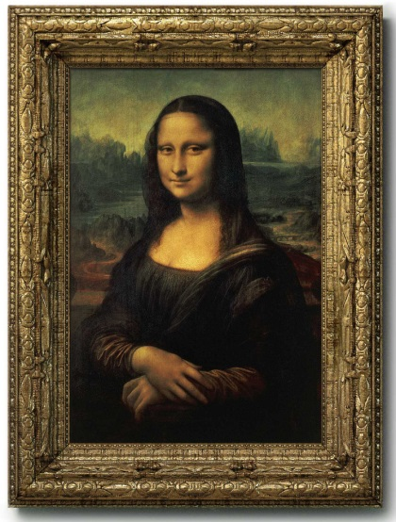
Mona Lisa( Alternative Title: “La Gioconda”),oil painting on a poplar wood panel by the Italian painter, sculptor, architect, and engineer Leonardo da Vinci(1452 -1519), probably the world’s most-famous painting. The name "Mona" means an honorific and faithful wife of a woman married in Italian. "Lisa" is the name of the woman who became a model of portrait.
There's a great deal of speculation about the person Da Vinci painted at the beginning of the 16th century Renaissance. It is surrounded by many suspicions that the model of this painting is either Da Vinci’s own mother or himself.But a more widely recognized interpretation is that Mona Lisa was Lisa del Giocondo, the wife of a Florence rich silk trader.
The painting landed by the enthusiastic fan of Da Vinci, FrenchKing Francois1who watched Da Vinci death's in 1519. Now, it placedin the Louvre Museum in Paris.
The "Mona Lisa" didn't really become famous until she disappeared. An Italian living in Paris stole the painting from the Louvre in 1911, wishing to take it back to Italy. It remained missing for two years before police arrested the man. The painting's return to Paris prompted an unprecedented storm of visitors to the Louvre. Since then, people who want to know Mona Lisa became more interested, they have wondered why she has no eyebrows and why she clothes were dark.
Countless scientists and art historians have analyzed the painting, unearthing surprising findings. In 2008, the mystery behindMona Lisa's enigmatic smile was solved: a painting technique called "Sfumato" Da Vinci applied several thin layers of paint over one another to create and blend the colors.
The "Mona Lisa" has not only prompted the greatest commentary ever in the history of art, it has inspired countless artists to create variations on it. Also one of the most valuable painting in the world. It holds the Guinness World Record for the highest known insurance valuation in history at $800 million in 2017.
(From Wikipedia and an article of Britannica.com)
Activity 1
Think about Vocabulary!!
1. The following words have hints on the left picture and the right question.
Enjoy guessing ^^
sculptor
--What is he doing now?
Is he carving something?
What’s a job this man?
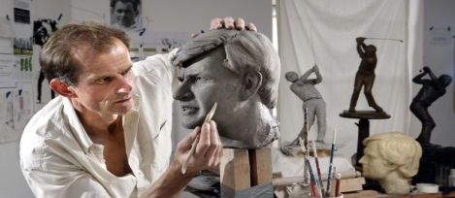

speculation
-What is yellow man doing?
Is it guessing?

enthusiastic
-They are crazy about the game.How do they feel now?
Are they veryexcited?

unprecedented storm
-Have you ever been hurt by storm or crowed suddenly blowing? It seems unexpected situation by flood or crowded people.

Unearthing
---What did discover in the ground?
What did find in the ground?

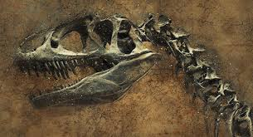
Enigmatic
--->What does this picture look like?
It’s like mysterious maze or puzzling something, isn’t it?
Sfumato
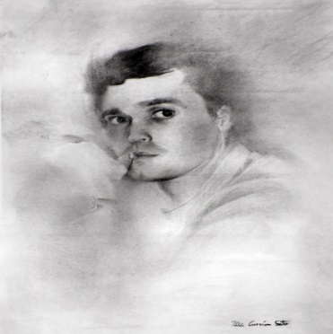
The Sfumato technique first started from the painting of Da Vinci is a shading method used to express delicate and soft color changes in paintings without lines or borders.
It gives foggy atmosphere to paint like smoke.

2. Complete the sentence with the words from the box
a) The ___________________ is working with clay in his studio.
(a person who is carving to make something)
b) Elsa is one of the most ___________________ figures in this story.
(It's puzzling and even mysterious)
c) A gold digger is _______________buried treasure. (Synonym; finding, discovering)
d) Her fine performance drew _________________ applause. (Synonym; passionate)
e) There is more ______________over the cause of death.
(Guessing possible answers to a question without having enough information)
f) This weather is _______________ for the first time in 100 years. (Synonym; unexpected)
sculptor ,speculation, enthusiastic ,unprecedented storm, unearthing, enigmatic
Activity 2 Q/A

*Talk about the question with your partner.

1. Q:Who painted the Mona Lisa?
A:

2. Q: Who is the fan of Da Vinci, Who watched Da Vinci’s death?
A:

3. Q:Why is the Mona Lisa’s painting famous?
A:

4. Q: What do you think about ‘Sfumato’ Technique ?
A:

5. Q: If you are a portrait painting artist, who do you want to paint?
A:

Activity 3
This activity, let’s draw a picture your partner like Leonardo Da Vinci and Mona Lisa.
Please draw your beautiful partner as described in the picture you have^^
Use ‘Sfumato’ painting technique for drawing.
*Drawing examples
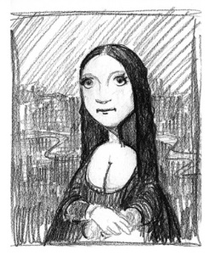

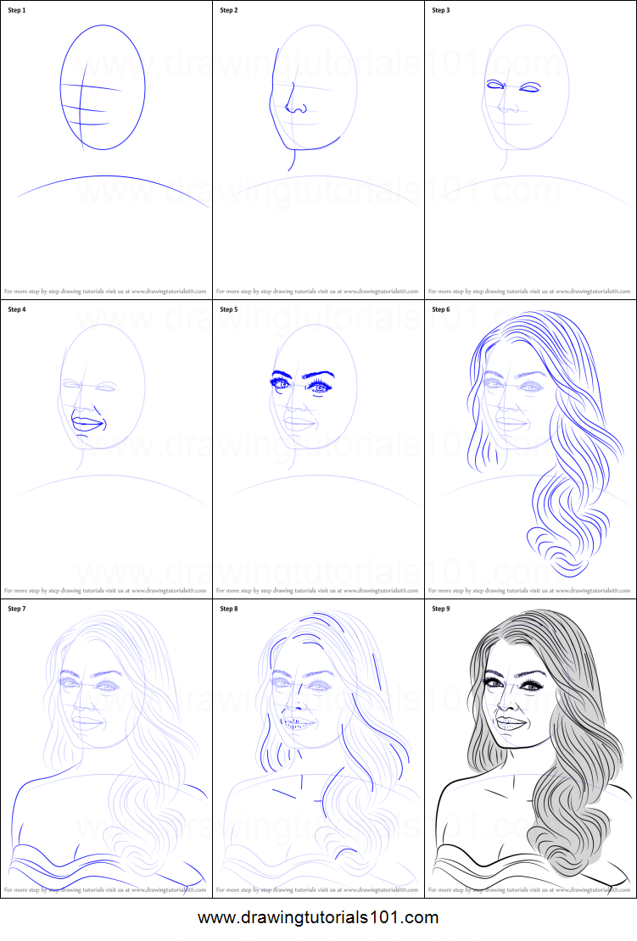
SOS Activity 4
Mona Lisa( Alternative Title: “La Gioconda”),oil painting on a poplar wood panel by the Italian painter, ( ), architect, and engineer Leonardo da Vinci (1452 -1519), probably the world’s most-famous painting. The name "Mona" means an honorific and faithful wife of a woman married in Italian. "Lisa" is the name of the woman who became a model of portrait.
There's a great deal of ( ) about the person Da Vinci painted at the beginning of the 16th century Renaissance. It is surrounded by many suspicions that the model of this painting is either Da Vinci’s own mother or himself. But a more widely recognized interpretation is that Mona Lisa was Lisa del Giocondo, the wife of a Florentine rich silk trader.
The painting landed by the ( ) fan of Da Vinci, French King Francois1 who watched Da Vinci death's in 1519. Now, it placed in the Louvre Museum in Paris.
The "Mona Lisa" didn't really become famous until she disappeared. An Italian living in Paris stole the painting from the Louvre in 1911, wishing to take it back to Italy. It remained missing for two years before police arrested the man. The painting's return to Paris prompted an ( ) storm of visitors to the Louvre. Since then, people who want to know Mona Lisa become more interested, they have wondered why she has no eyebrows and why she clothes were dark.
Countless scientists and art historians have analyzed the painting, unearthing surprising findings. In 2008, the mystery behind Mona Lisa's ( ) smile was solved: a painting technique called "( )" Da Vinci applied several thin layers of paint over one another to create and blend the colors.
The "Mona Lisa" has not only prompted the greatest commentary ever in the history of art, it has inspired countless artists to create variations on it. Also a one of the most valuable paintings in the world. It holds the Guinness World Record for the highest known ( ) valuation in history at $800 million in 2017.

sculptor /speculation / unprecedented / Sfumato /insurance / enthusiastic / enigmatic

Script for Activity 3; script that describes about painting.

The main character of this painting is beautiful Bella who burned her passion in the TIMES TESOL. The Sfumato technique, which expresses her long hair and the biggest eyes in her classmates, expresses her warmth and her amazing charm. We can see the artist’s affection.

The main character of this painting is beautiful Jean who burned her passion in the TIMES TESOL. The Sfumato technique that gives us comfort, warmth and an enigmatic smile expresses the painter’s heart.

The main character of this painting is beautiful Jiyoung who burned her passion in the TIMES TESOL. The Sfumato technique that gives us expresses her image of being faithful and intelligent. This painting is filled with love of the painter.

The main character of this painting is beautiful Julie who burned her passion in the TIMES TESOL. The Sfumato technique expresses her energetic vitality personality. Also hersmile face makes everyone happy and peace.

The main character of this painting is beautiful Nancy who burned her passion in the TIMESTESOL. The Sfumato technique that gives us expresses comfort and warmth. Alsoit expresses famous model Nancy’s character of elegance and kindness.

The main character of this painting is beautiful Heather who burned her passion in the TIMES TESOL. Using the Sfumato technique, the artist expresses her dazzling smile face.It gives us happiness and warmth. and expresses the model Header‘s kindness.

The main character of this painting is beautiful Annie who burned her passion in the TIMES TESOL. The Sfumato technique that gives us comfort and warmth and an enigmatic smile expresses the painter’s heart. The most famous modelAnnie’ eye-catching makes us fall into her charm.

The main character of this painting is a beautiful Gracewho burned her passion in the TIMES TESOL. The Sfumato technique that gives us comfort and warmth and an enigmatic smile expresses the painter’s heart. The model Grace makes us energetic and brightened.

The main character of this painting is the most beautiful in the world Soyeon who burned her passion in the TIMES TESOL. The Sfumato technique that gives us comfort and warmth express the painter’s heart. The painter sketched Model’s image of being pure makes us peaceful. It is revealed Model Soyeon’s elegance and attractive personality.

The main character of this painting is beautiful Minjeong who burned her passion in the TIMES TESOL. The Sfumato technique that gives us comfort and warmth and an enigmatic smile expresses the painter’s heart. The painter sketched Minjeong’s image of being pure makes us peaceful.

